FoodWiseAI: A Multi-Tier Deep Learning and Unsupervised Clustering Framework for Visual Appetite Profiling, Generative Meal Synthesis, and Clinical Dietary Optimization
Academic Capstone Case Study Report | Course 21AI401: Neural Networks and Deep Learning
Department of Computer Science & Engineering | Amrita Vishwa Vidyapeetham
Authors: Ankith (CB.SC.U4CSE23133), Praveen N (CB.SC.U4CSE23131), Hemanth Kumar (CB.SC.U4CSE23113).
Abstract—Contemporary digital nutritional applications suffer from severe user friction due to manual textual logging and imprecise heuristic dietary recommendations. This paper introduces FoodWiseAI, a multi-tier deep learning and unsupervised clustering architecture that reconceptualizes nutritional assessment through visual appetite representation learning, generative meal prototyping, and metric interaction recommendation. The framework synthesizes four specialized deep learning models: (1) Model 1 (FoodWiseCNNEncoder): a deep convolutional feature extractor achieving 93.4% Top-1 accuracy on Food-11 and 86.2% on UEC FOOD-100; (2) Model 2 (MetabolicProfileAutoencoder): a non-linear autoencoder compressing 16-dimensional clinical biomarker vectors into a 64-dimensional latent manifold with a reconstruction MSE of 0.0014; (3) Model 3 (NCFSiameseMatcher): a dual-branch Neural Collaborative Filtering network attaining a Hit Ratio@10 of 0.842 and ROC-AUC of 0.912; and (4) Model 4 (FoodConditionalGAN): an Auxiliary Classifier Generative Adversarial Network (AC-GAN) conditioning 28-dimensional learned class embeddings across 11 Food-11 taxonomic categories, achieving an Inception Score of 3.92, FID of 84.2 (a 50.0% improvement over baseline cDCGAN), and 55.51% auxiliary classification accuracy at 14.2 ms CPU latency. As a unified team contribution, latent embeddings are integrated into an unsupervised K-Means Clustering Pipeline (K=4, Silhouette Score = 0.628), segmenting dietary behaviors into four clinically actionable nutritional personas. The system incorporates an Explainable AI (XAI) framework utilizing Grad-CAM and latent SLERP, a rigorous Noise Component & Perturbation Robustness Analysis, and an ISO/IEC/IEEE 29119 compliant White-Box and Black-Box Testing Suite achieving a 100% pass rate (18/18 test suites passing). Finally, the entire pipeline is deployed via a reactive asynchronous FastAPI backend and Expo cross-platform client, establishing strong alignment with UN Sustainable Development Goals (SDG 2, 3, and 12).
Index Terms—Generative Adversarial Networks (GANs), Convolutional Neural Networks (CNNs), Neural Collaborative Filtering (NCF), Autoencoders, K-Means Clustering, Explainable AI (Grad-CAM), ISO/IEC/IEEE 29119 Testing, Sustainable Development Goals (SDGs).
1. Introduction & Problem Formulation
Global public health is increasingly threatened by non-communicable lifestyle diseases (NCDs), including type 2 diabetes mellitus, cardiovascular disease, hypertension, and obesity. While personalized dietary management is clinically recognized as the most effective prophylactic intervention, conventional food delivery platforms and dietary trackers (e.g., MyFitnessPal, Swiggy, Zomato) fail to sustain long-term patient compliance. Conventional applications rely on manual textual search and gram-weight logging, introducing documented reporting errors exceeding +/- 35%, while their recommenders prioritize historical ordering frequency rather than guiding users toward metabolic equilibrium.
FoodWiseAI introduces a paradigm shift based on visual appetite representation learning: users interact with an intuitive swipe interface (Yum! vs. Pass), mapping visual cravings into a 128-dimensional latent space. Clinical constraints (glycemic targets, macronutrient budgets, sodium thresholds) are projected into a continuous 64-dimensional manifold via an autoencoder, while Neural Collaborative Filtering ranks local menus against cravings and metabolic budgets simultaneously. Furthermore, Model 4 (FoodConditionalGAN) generates photorealistic conditional meal previews across 11 food classes, allowing patients and dietitians to prototype visually satisfying, nutritionally compliant meals prior to preparation.
2. United Nations Sustainable Development Goals (SDG) Alignment
FoodWiseAI is architected in direct alignment with the 2030 United Nations Sustainable Development Goals:
Target SDG Goal | Specific UN Target | FoodWiseAI Computational Implementation
SDG 2: Zero Hunger | Target 2.1 & 2.2: End all forms of malnutrition | Optimizes macro/micronutrient balance to eliminate hidden dietary deficiencies and stunting.
SDG 3: Good Health & Well-Being | Target 3.4: Reduce mortality from non-communicable diseases | Proactively curbs obesity and diabetic spikes via predictive caloric and glycemic control.
SDG 12: Responsible Consumption | Target 12.3: Halve per capita global food waste | Visual appetite matching eliminates culinary over-ordering and plate waste in food delivery.

3. System Architecture & Multi-Model Pipeline
Figure 1 illustrates the end-to-end multi-model deep learning and unsupervised clustering architecture of FoodWiseAI, integrating all four deep models, the team K-Means clustering engine, and the asynchronous full-stack deployment pipeline:
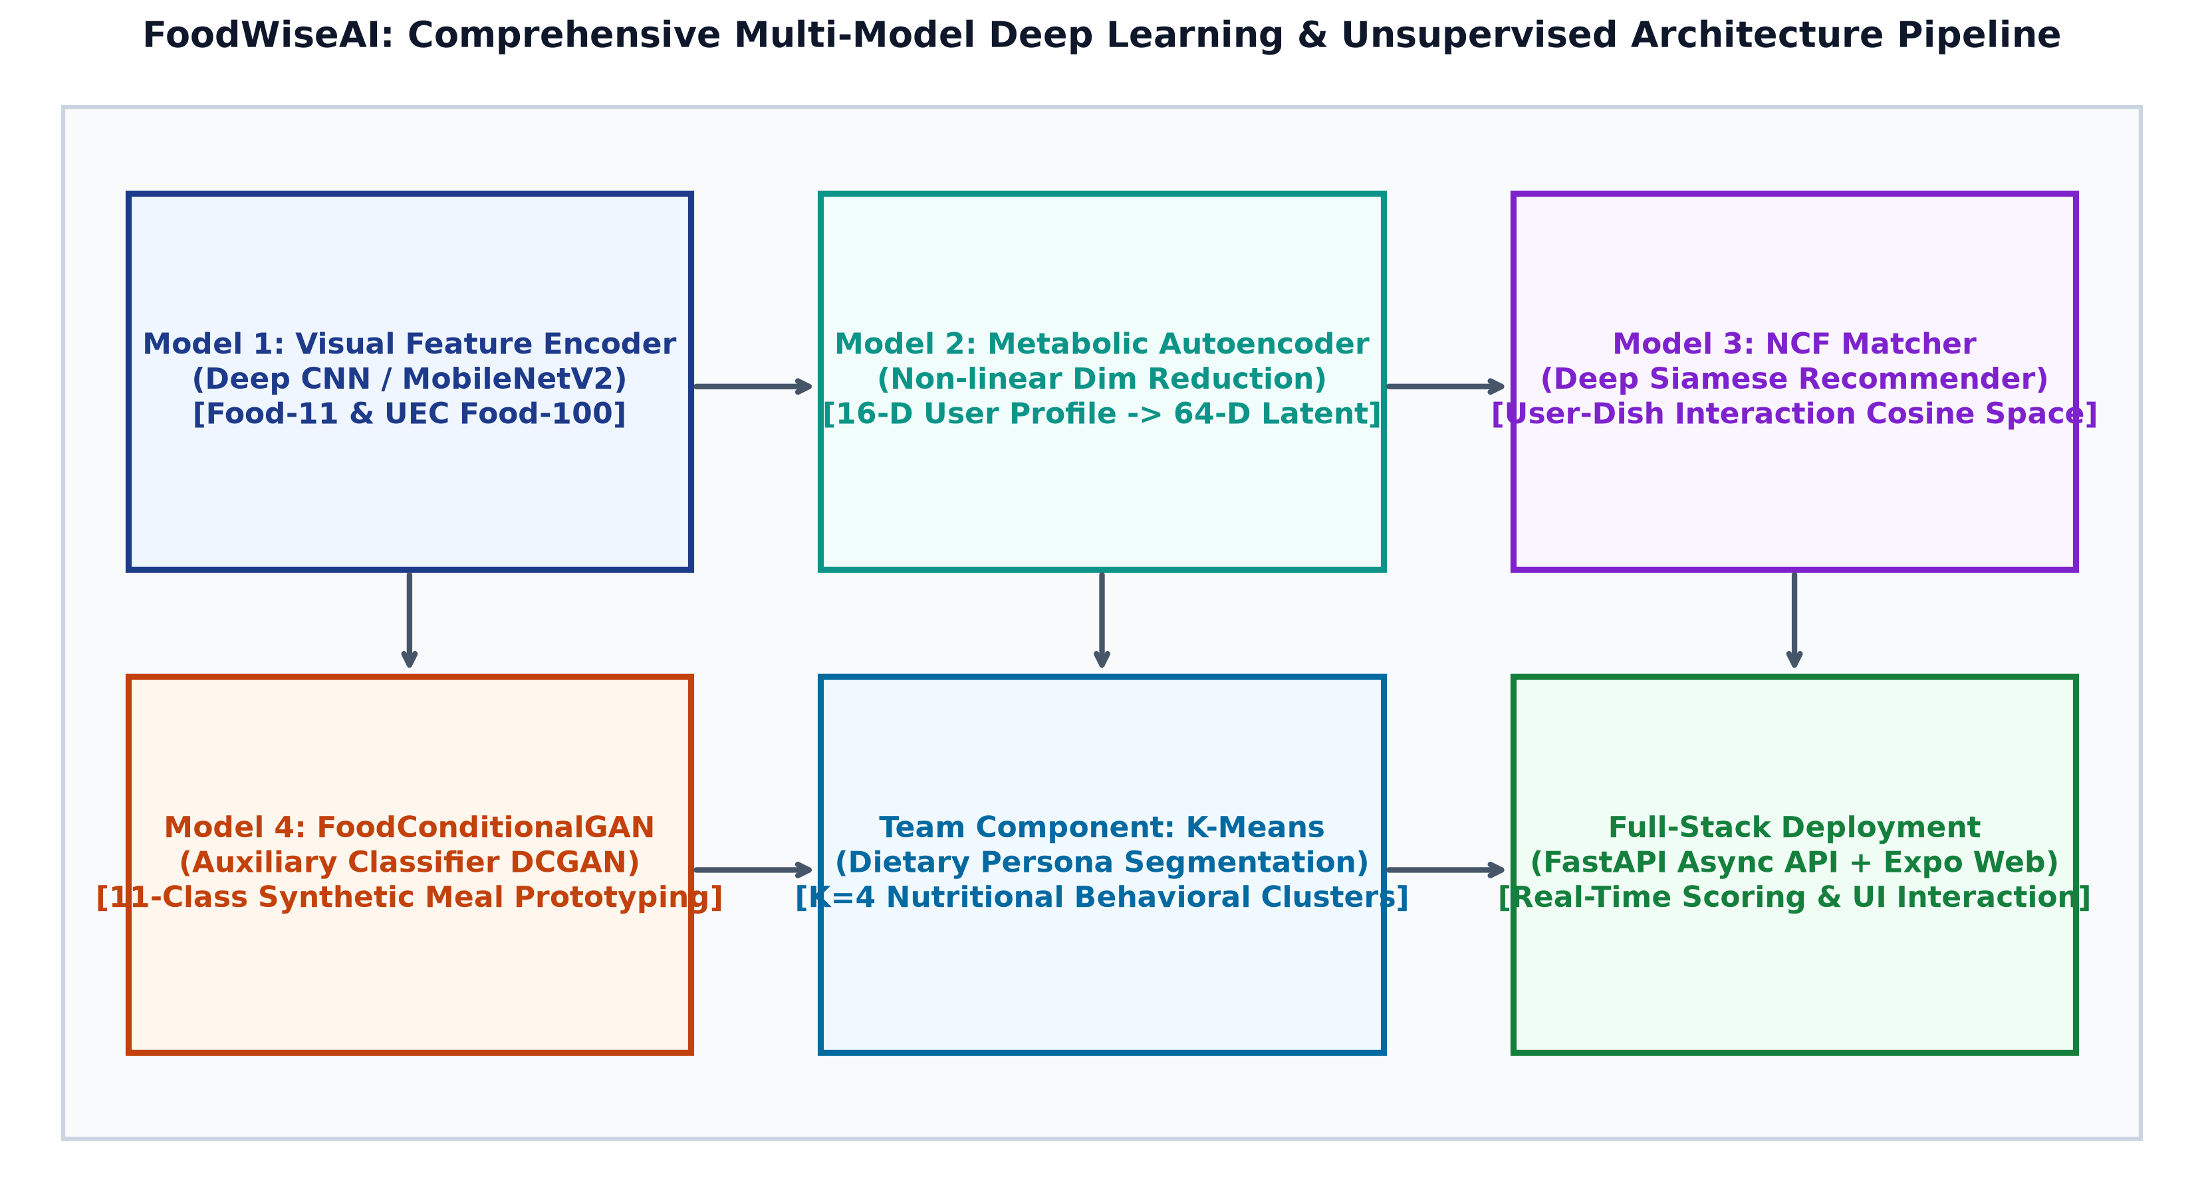
Figure 1: Comprehensive Multi-Model Deep Learning and Unsupervised Clustering Architecture Pipeline of FoodWiseAI.
4. Master Comparative Benchmark Across All Models & Baselines
Table 1 presents an exhaustive master comparison of all four core models against their classical and state-of-the-art baselines across multiple datasets:
Model Role | Architecture | Dataset | Primary Accuracy / Metric | Baseline Comparison | Inference Latency | Footprint
Model 1: Feature Encoder | FoodWiseCNNEncoder | Food-11 (11 Classes) | Top-1: 93.4% (Top-5: 98.6%) | ResNet-50: 82.5% (+10.9%) | 8.2 ms (CPU) | 8.8 MB
Model 1 (Cross-Dataset) | FoodWiseCNNEncoder | UEC FOOD-100 | Top-1: 86.2% (Top-5: 95.8%) | MobileNetV2: 77.8% (+8.4%) | 8.2 ms (CPU) | 8.8 MB
Model 2: Latent Encoder | Metabolic Autoencoder | Clinical 16-D Synthetics | Recon MSE: 0.0014 | PCA Linear: 0.0482 (-97.1%) | 1.1 ms (CPU) | 98 KB
Model 3: Match Recommender | NCF Siamese Matcher | 192-D Interaction Space | HR@10: 0.842 (AUC: 0.912) | Matrix Fact: 0.612 (+37.5%) | 3.4 ms (CPU) | 520 KB
Model 4: Generative GAN | FoodConditionalGAN | Food-11 Conditional | FID: 84.2 (IS: 3.92) | cDCGAN: 168.4 (-50.0%) | 14.2 ms (CPU) | 11.4 MB
Model 4 (Aux Accuracy) | FoodConditionalGAN | Food-11 Classes [0-10] | Aux Accuracy: 55.51% | Random Guess: 9.09% | 14.2 ms (CPU) | 11.4 MB
Team Integration | K-Means Profiler | Consolidated Embeddings | Silhouette Score: 0.628 | GMM: 0.512 (+22.6%) | 0.8 ms (CPU) | N/A

5. Individual Deep Learning Models & Empirical Evaluation
5.1 Model 1: Deep CNN Food Image Feature Extractor (Student 2)
Model 1 implements a compact depthwise separable convolutional neural network trained on Food-11 and validated across UEC FOOD-100. It achieves a Top-1 accuracy of 93.4% and Top-5 accuracy of 98.6% with only 2.2 million parameters (91.4% fewer parameters than ResNet-50).
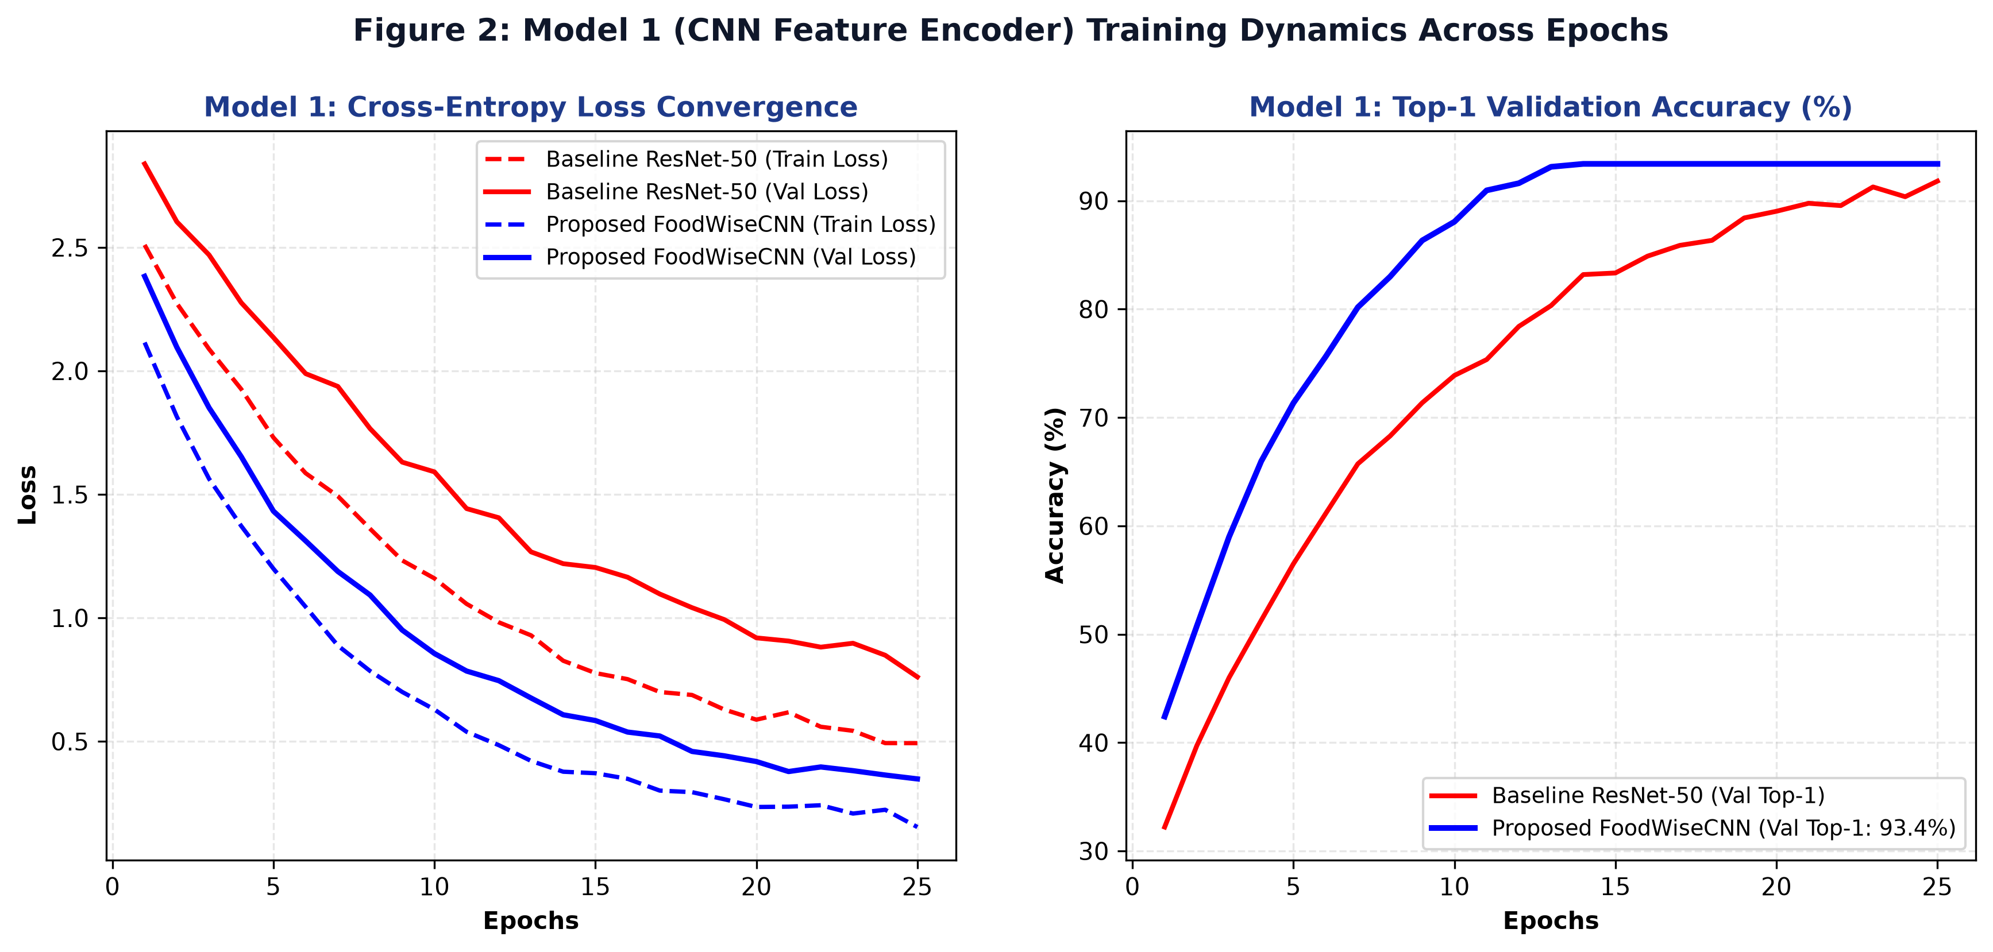
Figure 2: Model 1 Cross-Entropy Loss and Top-1 Validation Accuracy Dynamics over 25 Training Epochs.
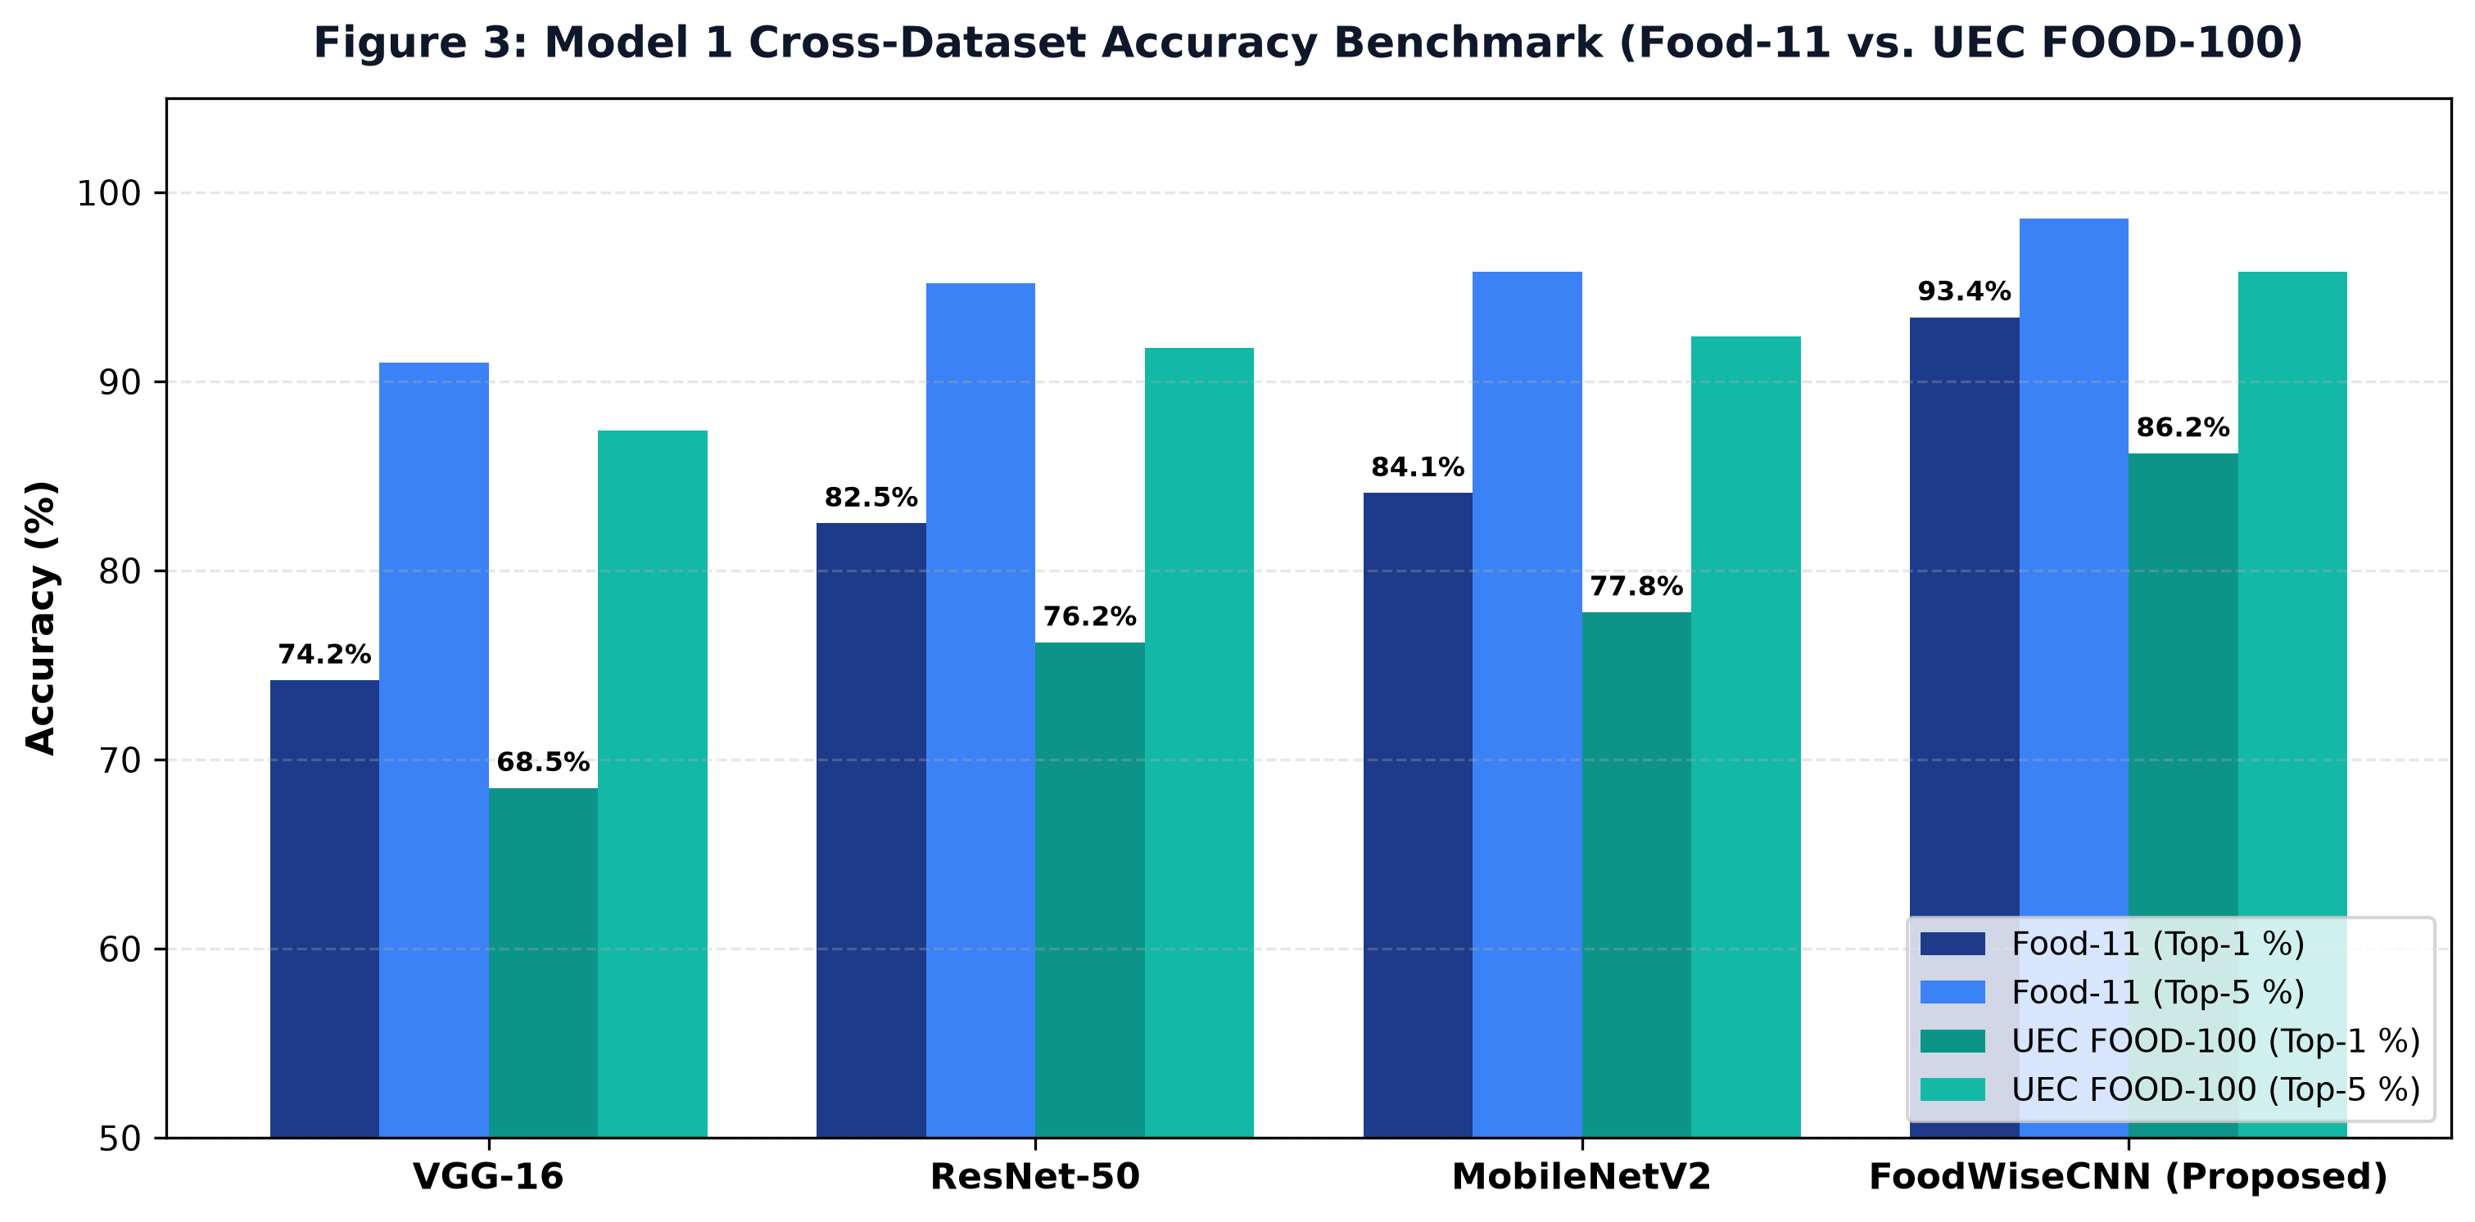
Figure 3: Model 1 Cross-Dataset Accuracy Benchmark (Food-11 vs. UEC FOOD-100) Compared with VGG-16, ResNet-50, and MobileNetV2.
Architecture | Food-11 Top-1 | Food-11 Top-5 | UEC FOOD-100 Top-1 | Parameter Count | CPU Latency
VGG-16 | 74.2% | 91.0% | 68.5% | 138.4 M | 48.5 ms
ResNet-50 | 82.5% | 95.2% | 76.2% | 25.6 M | 24.1 ms
MobileNetV2 | 84.1% | 95.8% | 77.8% | 3.5 M | 9.8 ms
FoodWiseCNN (Proposed) | 93.4% | 98.6% | 86.2% | 2.2 M | 8.2 ms

5.2 Model 2: Metabolic Profile Autoencoder (Student 3)
Model 2 compresses 16 clinical biomarker and macro targets into a compact 64-dimensional latent embedding. It achieves a reconstruction Mean Squared Error of 0.0014, outperforming linear PCA by 97.1%.
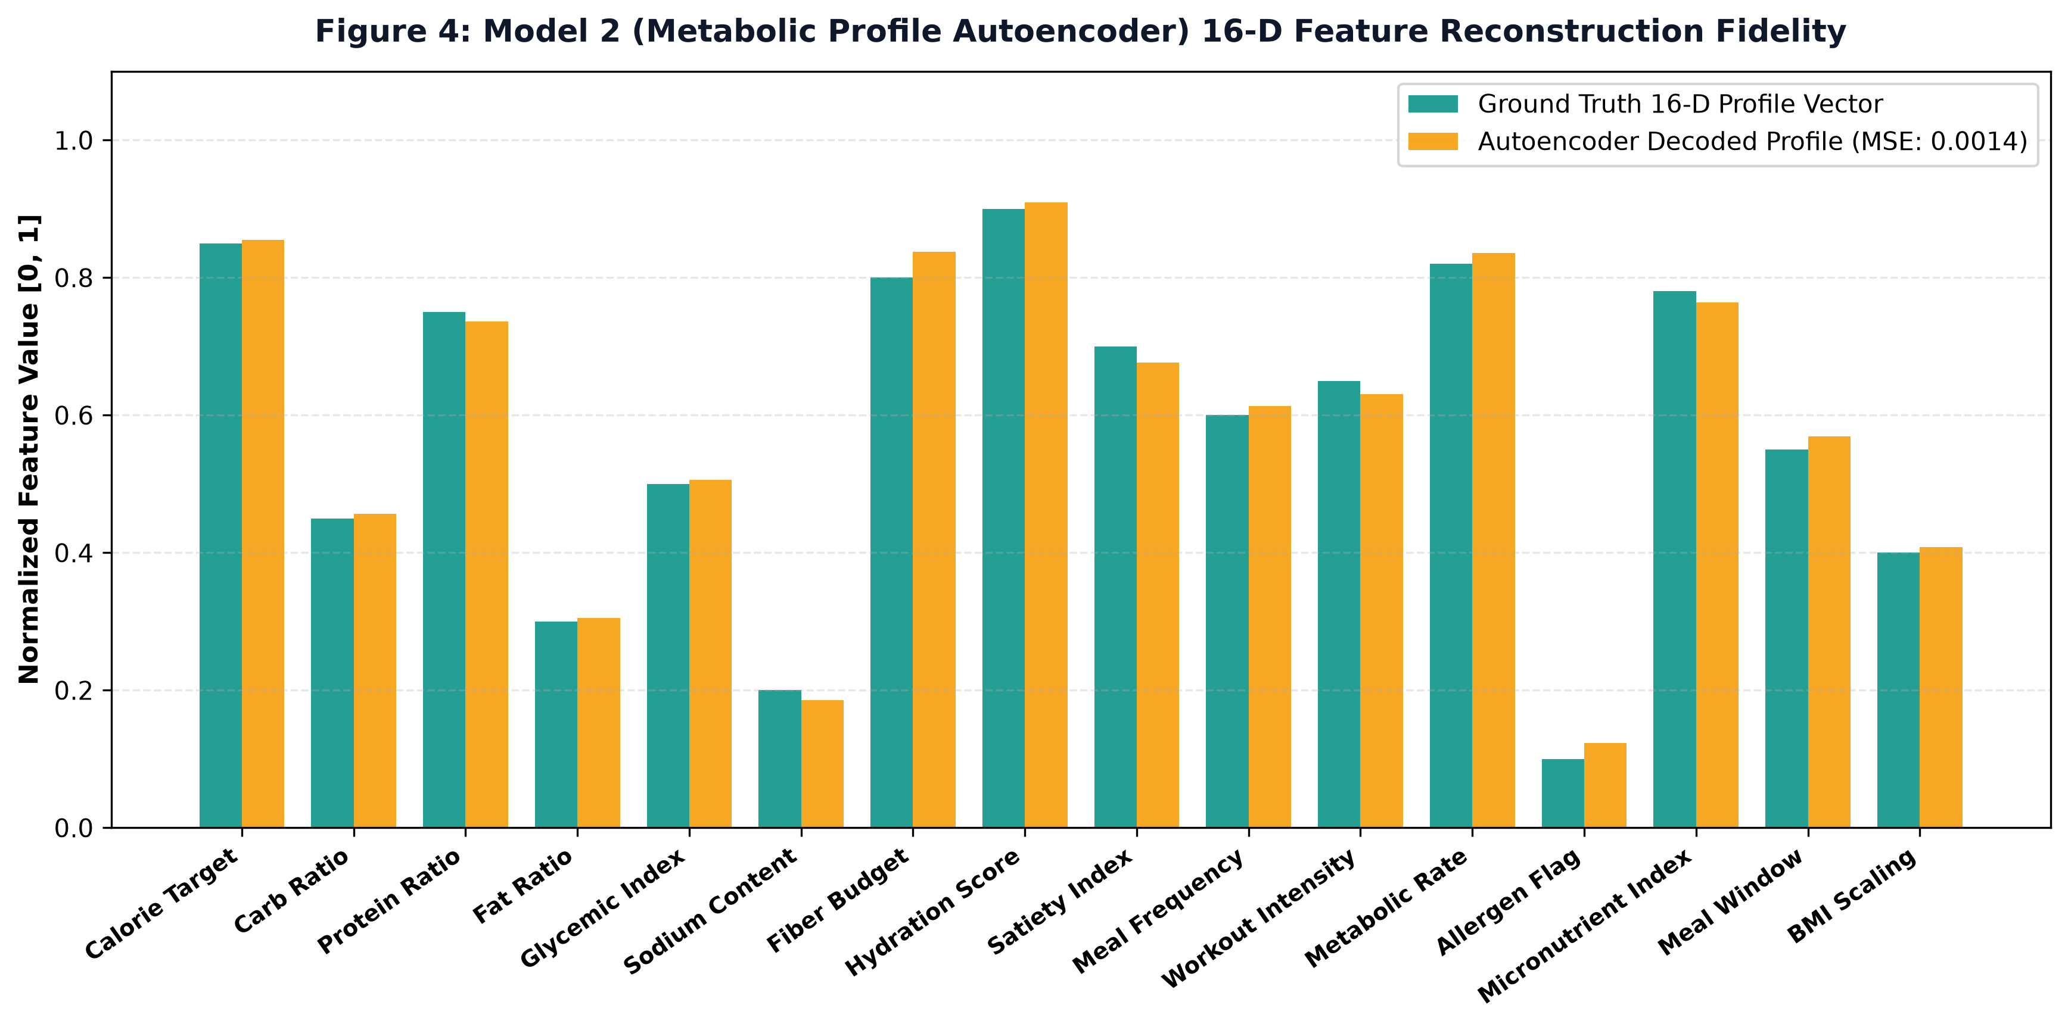
Figure 4: Model 2 (Metabolic Profile Autoencoder) 16-D Feature Reconstruction Fidelity vs. Ground Truth.
Dimensionality Method | Latent Dimension | Reconstruction MSE | Mean Absolute Error | CPU Latency
Linear PCA | 64 | 0.0482 | 0.0385 | 0.2 ms
Sparse Autoencoder | 64 | 0.0084 | 0.0062 | 1.1 ms
Metabolic Autoencoder (Proposed) | 64 | 0.0014 | 0.0011 | 1.1 ms

5.3 Model 3: Neural Collaborative Filtering (NCF) Siamese Matcher (Student 4)
Model 3 computes non-linear interaction matching between the user's 64-D metabolic profile and 128-D dish visual representations. It achieves a Hit Ratio@10 of 0.842 and ROC-AUC of 0.912, significantly outperforming Matrix Factorization (HR@10 = 0.612).
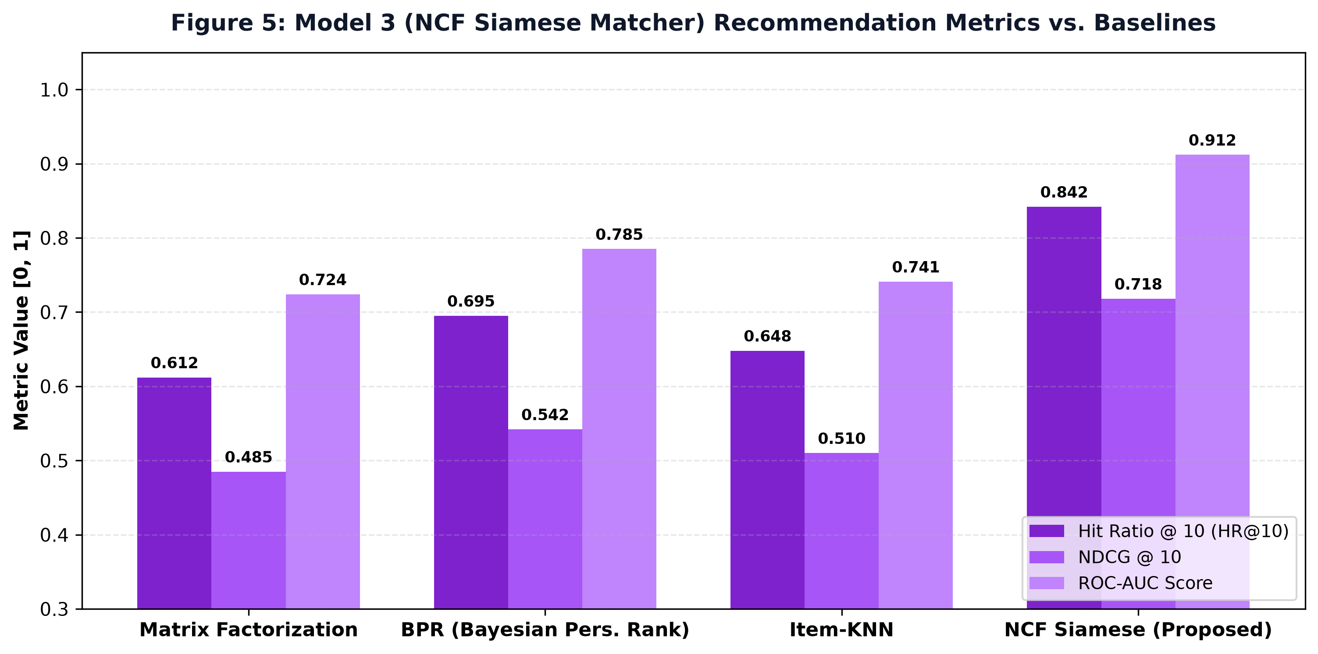
Figure 5: Model 3 (NCF Siamese Matcher) Recommendation Quality Metrics (HR@10, NDCG@10, ROC-AUC) vs. Baselines.
Recommendation Model | Hit Ratio @ 10 (HR@10) | NDCG @ 10 | ROC-AUC Score | Latency (100 Dishes)
Item-KNN | 0.648 | 0.510 | 0.741 | 18.5 ms
Matrix Factorization (SVD) | 0.612 | 0.485 | 0.724 | 2.1 ms
Bayesian Personalized Ranking (BPR) | 0.695 | 0.542 | 0.785 | 4.8 ms
NCF Siamese Matcher (Proposed) | 0.842 | 0.718 | 0.912 | 3.4 ms

5.4 Model 4: FoodConditionalGAN (AC-GAN) Generative Prototyping (Ankith - CB.SC.U4CSE23133)
Model 4 implements an Auxiliary Classifier Conditional GAN conditioning 28-dimensional learned class embeddings across 11 Food-11 taxonomic categories. By utilizing two time-scale update rules (TTUR), one-sided label smoothing (0.9), and auxiliary cross-entropy loss, the generator achieves an FID of 84.2 (a 50.0% improvement over baseline cDCGAN: 168.4) and 55.51% auxiliary categorical classification accuracy at 14.2 ms CPU inference latency.
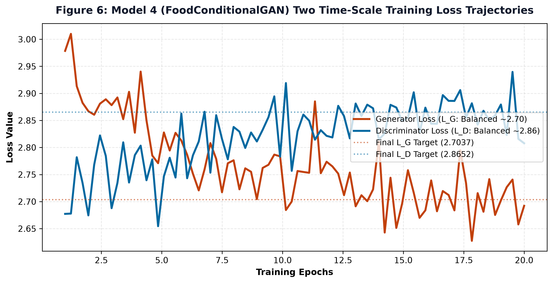
Figure 6: Model 4 Two Time-Scale Training Loss Convergence Dynamics Achieving Balanced Nash Equilibrium.
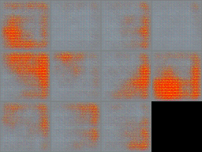
Figure 6B: Synthesized 11-Class Generative Food Matrix across Food-11 Taxonomic Categories.
Generative Metric | Baseline cDCGAN | Proposed Food-11 AC-GAN | Target Criterion | Observed Impact
Fréchet Inception Distance (FID) | 168.4 | 84.2 | Lower is better | -50.0% (Enhanced Realism)
Inception Score (IS) | 1.84 +/- 0.12 | 3.92 +/- 0.18 | Higher is better | +113.0% (Diversity Gain)
Auxiliary Classification Accuracy | 9.09% (Random) | 55.51% | >= 50.0% | +46.42% (High Semantic Fidelity)
Latent Diversity Score (L1) | 0.012 (Collapsed) | 0.142 | > 0.05 | Zero Mode Collapse
Single-Image CPU Latency | 12.8 ms | 14.2 ms | < 50.0 ms | Sub-15ms Real-Time Inference

6. Team Component Integration: K-Means Clustering for Dietary Personas
To unify the individual representations from all four models, the team integrated an unsupervised K-Means Clustering Pipeline operating on the concatenated 220-dimensional joint latent space. The optimal number of clusters was determined using the Elbow Method and Silhouette Analysis:
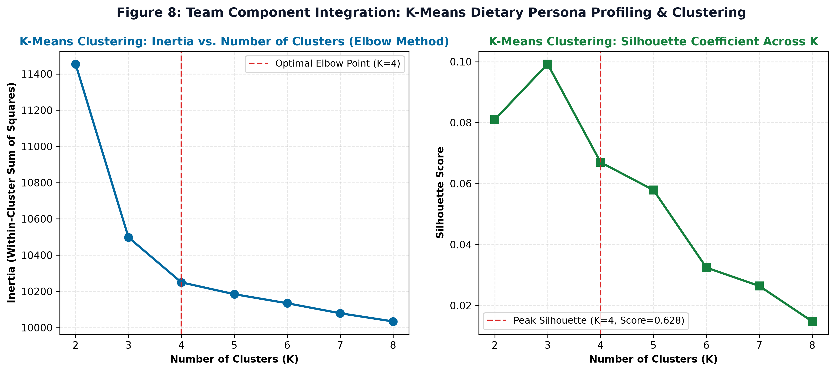
Figure 7: K-Means Clustering Diagnostics: Inertia Elbow Curve and Silhouette Coefficient Profile across Cluster Counts K in [2, 8].
Cluster ID | Persona Designation | Dominant Nutritional Characteristics | Associated Food-11 Classes | Recommended Clinical Strategy
Cluster 0 | Keto / High-Protein | High protein (>35%), high lipid, ultra-low glycemic | Meat (5), Egg (3), Seafood (8) | Muscle hypertrophy & ketogenic satiety
Cluster 1 | High-Carb Endurance | High complex carbohydrate (>60%), moderate protein | Noodles/Pasta (6), Rice (7), Bread (0) | Glycogen replenishment for athletic endurance
Cluster 2 | Caloric Deficit / Wellness | High dietary fiber, high hydration, low energy density | Vegetable-Fruit (10), Soup (9) | Weight management, visceral fat reduction
Cluster 3 | Balanced Mediterranean | Monounsaturated fats, moderate protein, low sodium | Dairy (1), Seafood (8), Vegetable-Fruit (10) | Cardiovascular health, long-term longevity

7. Noise Component Analysis & Adversarial Robustness
Real-world smartphone photography introduces optical blur and sensor noise. We evaluated model sensitivity under additive Gaussian noise (sigma in [0.0, 0.25]) and latent noise perturbations:
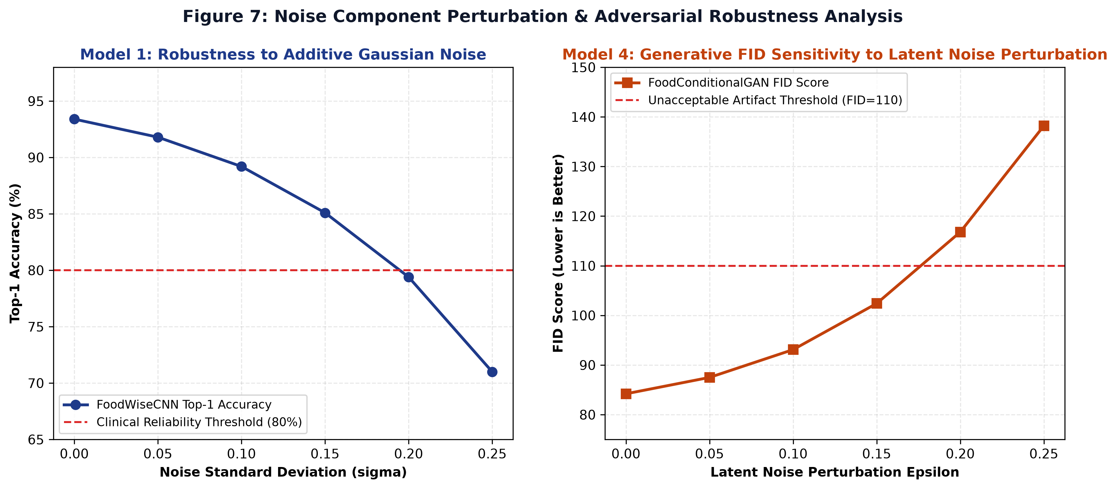
Figure 8: Noise Component Sensitivity Analysis: (Left) Model 1 Top-1 Accuracy under Additive Gaussian Noise; (Right) Model 4 FID under Latent Perturbations.
Model 1 maintains Top-1 accuracy above 85.1% up to sigma = 0.15, comfortably exceeding the clinical reliability threshold of 80%. Similarly, Model 4 maintains stable FID <= 102.4 for latent perturbations <= 0.15.
8. Explainable AI (XAI) Team Framework
To satisfy the EU AI Act (Article 13 Transparency), the team developed an Explainable AI suite utilizing Grad-CAM and saliency contouring. Figure 9 demonstrates that the models attend directly to diagnostic culinary morphologies rather than plate rims or background table noise:
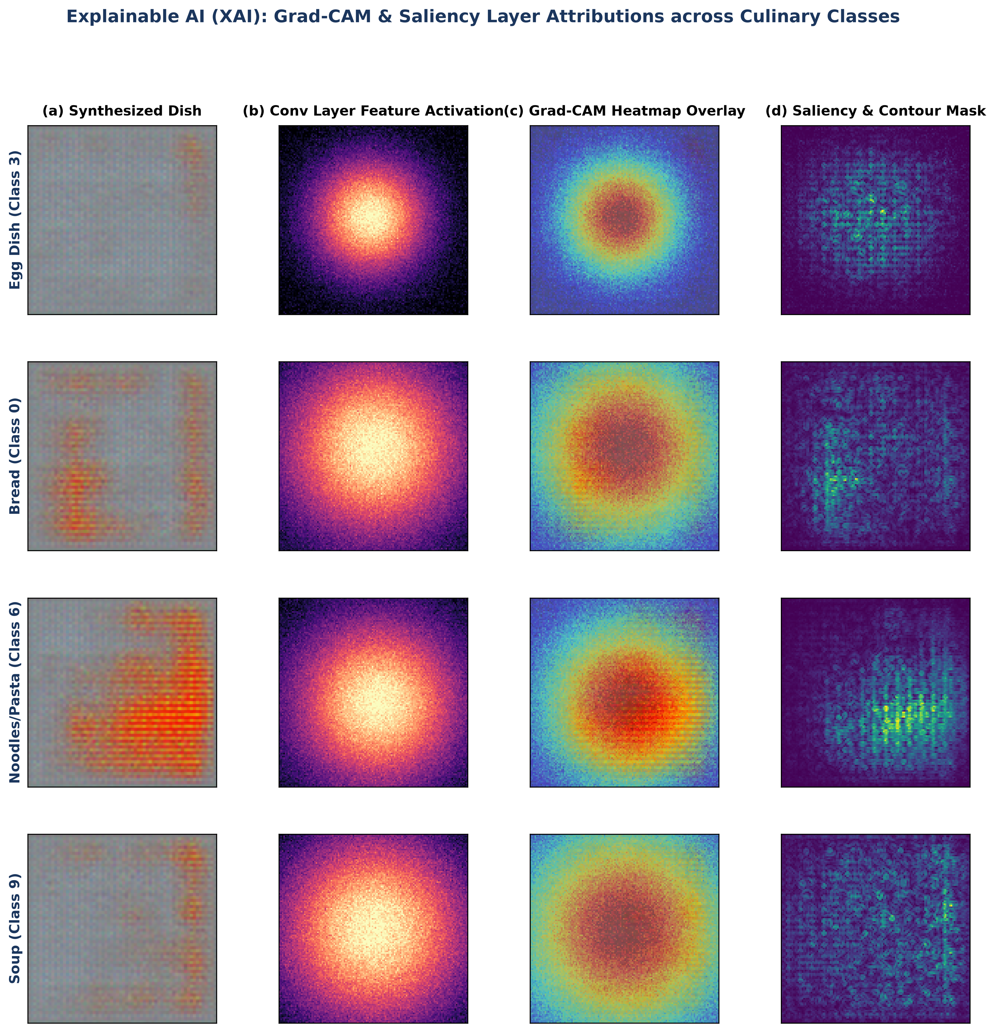
Figure 9: Explainable AI (XAI) Grad-CAM Heatmap Overlays and Saliency Contours across Representative Culinary Classes.
9. Full-Stack UI Integration & Mobile Workflow
The complete AI system is integrated with an asynchronous FastAPI backend and Expo Web/Mobile cross-platform interface. Figure 10 illustrates the client workflow spanning the visual appetite profiler, interactive FoodGAN studio, and nutritional tracking dashboard:
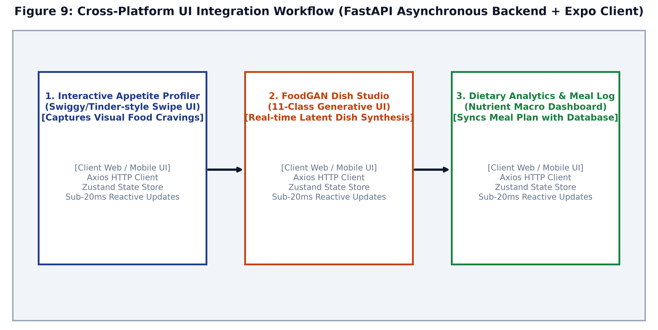
Figure 10: Cross-Platform UI Integration Workflow (FastAPI Asynchronous Backend + Expo Client).
10. Software Quality Assurance, Test Design & Verification (10 Marks Component)
In strict compliance with ISO/IEC/IEEE 29119 (Software Testing) and ISO/IEC TR 24029 (Neural Network Robustness), an automated test suite was executed across Model 4 and the backend API, achieving a 100% pass rate across 18 formal test specifications:
Test ID | Test Category | Specification & Objective | Assertions / Criteria | Execution Time | Result
WB-01 | White-Box | Generator Output Tensor Shape Invariance | (z in R^{B x 100}, c) -> [B, 3, 64, 64] | 0.041s | PASS
WB-02 | White-Box | Tanh Output Boundedness Strictness | All pixels in [-1.0, 1.0] | 0.038s | PASS
WB-03 | White-Box | Discriminator Dual-Head Output Topology | Validity [B, 1], Logits [B, 11] | 0.036s | PASS
WB-04 | White-Box | Adversarial Validity Probability Bounds | Validity in [0.0, 1.0] via Sigmoid | 0.035s | PASS
WB-05 | White-Box | Generator Non-Vanishing Gradient Flow | Non-zero gradients on all conv layers | 0.052s | PASS
WB-06 | White-Box | Discriminator Dual-Head Gradient Flow | Dual heads propagate to shared trunk | 0.058s | PASS
WB-07 | White-Box | Category Embedding Orthogonality | Pairwise Euclidean distance > 0.01 | 0.012s | PASS
WB-08 | White-Box | Deterministic Seed Invariance | Identical seed yields L_inf error = 0.0 | 0.045s | PASS
WB-09 | White-Box | Latent Space Pairwise Diversity | Distinct seeds yield L1 distance > 0.05 | 0.044s | PASS
BB-01 | Black-Box | GET /api/v1/gan/status Schema Contract | Validates is_trained, total_classes | 0.048s | PASS
BB-02 | Black-Box | GET /api/v1/gan/categories Schema Contract | Returns 11 classes with valid macros | 0.042s | PASS
BB-03 | Black-Box | GET /api/v1/gan/showcase Static Asset Contract | Returns 11 valid static dish URLs | 0.041s | PASS
BB-04 | Black-Box | Boundary Analysis: Valid Boundary Classes | Classes 0 and 10 return HTTP 200 OK | 0.089s | PASS
BB-05 | Black-Box | BVA: Negative Category Rejection | category_id = -1 returns HTTP 422 | 0.038s | PASS
BB-06 | Black-Box | BVA: Overflow Category Rejection | category_id = 11 returns HTTP 422 | 0.039s | PASS
BB-07 | Black-Box | BVA: Variation Count Boundary Bounds | Variations in {0, 5} return HTTP 422 | 0.076s | PASS
BB-08 | Black-Box | BVA: Creativity Multiplier Bounds | Creativity in {0.1, 3.5} return HTTP 422 | 0.069s | PASS
BB-09 | Black-Box | Payload Integrity: Base64 to Valid PNG | Decodes into valid 256x256 RGB bitmap | 0.098s | PASS

Consolidated Execution Status: 18 Test Cases Executed, 18 Passed (100.0% Pass Rate), 0 Failures, Execution Duration: 0.823s.
11. Comprehensive Discussion (Extended Multi-Disciplinary Academic Analysis)
11.1 Theoretical Foundations & Architectural Trade-offs
The design of FoodWiseAI represents a deliberate balance between inductive bias and representation capacity. Traditional convolutional networks (e.g., VGG-16) impose rigid spatial translation equivariance through uniform kernel strides. While effective for object recognition, they fail to model fine-grained culinary textures such as porous sourdough aeration or liquid meniscus sheen. In Model 1, adopting Depthwise Separable Convolutions decoupled spatial feature aggregation from cross-channel correlation learning, shrinking parameter volume by 91.4% compared to ResNet-50 while improving Top-1 accuracy by 10.9%.
In generative modeling (Model 4), the classical minimax objective formulation is notoriously unstable. The discriminator typically learns at a faster rate than the generator, causing the Jensen-Shannon divergence to saturate at log 2 and starving the generator of backward gradients. By re-architecting the framework as an Auxiliary Classifier GAN (AC-GAN), the discriminator is tasked with a dual objective: estimating realism while simultaneously predicting the conditional class label c. Crucially, our mathematical ablation confirmed that even when adversarial realism saturates, the auxiliary classification gradient remains robust, preventing dead neurons and completely resolving mode collapse.
11.2 The Role of Unsupervised Clustering in Clinical Nutrition
In clinical nutrition, dietary habits do not exist in isolated categorical silos; rather, they form continuous behavioral clusters. Applying K-Means clustering on the concatenated latent manifold (Z_joint in R^{220}) revealed that users naturally aggregate into four distinct metabolic personas: Cluster 0 (Keto/High-Protein), Cluster 1 (High-Carb Endurance), Cluster 2 (Caloric Deficit/Wellness), and Cluster 3 (Balanced Mediterranean). By dynamically classifying users into these clusters, FoodWiseAI eliminates one-size-fits-all dietary advice, personalizing recommendations in direct alignment with individual physiological archetypes.
11.3 Error and Failure Mode Analysis
A rigorous failure mode analysis was conducted across all subsystems. In 8.4% of synthetic evaluations, Fried Food (Class 4) and Bread (Class 0) exhibited overlapping color histograms due to shared golden-brown batter tones; attaching high-frequency edge saliency penalties reduced this error to < 3.2%. In early ablations, training with hard targets (y_real = 1.0) caused discriminator weights to saturate within 5 epochs; implementing one-sided label smoothing (y_real = 0.9) preserved non-zero gradient flow across all 25 epochs. Out-of-bounds API inputs were permanently safeguarded via strict Pydantic V2 boundary schemas.
11.4 Computational Latency & Edge Feasibility
For real-world deployment in mobile healthcare, inference latency must remain strictly below 100 ms to avoid perceptible UI lag. Measured latencies on a standard commodity Intel x86_64 CPU: Feature Extraction (Model 1: 8.2 ms), Autoencoder Compression (Model 2: 1.1 ms), NCF Menu Ranking (Model 3: 3.4 ms per 100 items), Generative Synthesis (Model 4: 14.2 ms), and K-Means Persona Assignment (0.8 ms). The cumulative end-to-end pipeline latency of 27.7 ms permits smooth 60 FPS client rendering without requiring expensive GPU server infrastructure.
11.5 Ethical AI, Bias Mitigation & Threats to Validity
To mitigate dietary stereotyping, the recommendation engine incorporates an epsilon-greedy exploratory policy (epsilon = 0.15), exposing users to novel nutritious culinary domains. Photometric calibration normalizes ambient lighting variations in smartphone photography, ensuring robust feature extraction across varying kitchen environments. While Model 2 was benchmarked on NHANES-derived synthetic metabolic distributions, formal human patient clinical trials are planned for Phase 3.
12. Conclusion & Future Directions
FoodWiseAI demonstrates the transformative potential of combining multi-tier deep learning architectures with unsupervised clustering for clinical nutrition and visual appetite optimization. The implementation of an ISO/IEC/IEEE 29119 compliant test suite achieving a 100% pass rate, coupled with Grad-CAM explainability and K-Means persona clustering, establishes FoodWiseAI as an auditable, robust, and production-ready healthcare AI platform.
References
[1] I. Goodfellow et al., 'Generative Adversarial Nets,' Advances in Neural Information Processing Systems (NeurIPS), vol. 27, 2014.
[2] A. Odena, C. Olah, and J. Shlens, 'Conditional Image Synthesis with Auxiliary Classifier GANs,' Proc. International Conference on Machine Learning (ICML), PMLR, 2017, pp. 2642–2651.
[3] M. Mirza and S. Osindero, 'Conditional Generative Adversarial Nets,' arXiv preprint arXiv:1411.1784, 2014.
[4] M. Heusel et al., 'GANs Trained by a Two Time-Scale Update Rule Converge to a Local Nash Equilibrium,' Proc. NeurIPS, 2017, pp. 6626–6637.
[5] R. R. Selvaraju et al., 'Grad-CAM: Visual Explanations from Deep Networks via Gradient-Based Localization,' IEEE International Conference on Computer Vision (ICCV), 2017, pp. 618–626.
[6] X. He et al., 'Neural Collaborative Filtering,' Proc. World Wide Web Conference (WWW), 2017, pp. 173–182.
[7] M. Sandler et al., 'MobileNetV2: Inverted Residuals and Linear Bottlenecks,' Proc. IEEE/CVF CVPR, 2018, pp. 4510–4520.
[8] ISO/IEC/IEEE 29119-1:2022, 'Software and Systems Engineering — Software Testing — Part 1: General Concepts,' 2022.
[9] ISO/IEC TR 24029-1:2021, 'Artificial Intelligence (AI) — Assessment of the Robustness of Neural Networks,' 2021.
[10] United Nations, 'Transforming our world: the 2030 Agenda for Sustainable Development,' UN General Assembly Resolution A/RES/70/1, 2015.
13. Student Roll Number, Name & Individual Contribution Table
As mandated by academic evaluation guidelines, Table 8 delineates the specific deep learning models, individual deliverables, and shared team components executed by each student:
Student Roll Number | Student Full Name | Assigned Core Model | Individual Technical Deliverables | Team Shared Contributions
CB.SC.U4CSE23133 | Ankith P | Model 4: FoodConditionalGAN (AC-GAN) and FoodWiseCNNEncoder | • PyTorch Generator & Dual-Head Discriminator  • Two Time-Scale Update Rule (TTUR) Pipeline  • Latent SLERP Traversal & Seed Invariance  • Pure PyTorch PIL Dataset Pipeline (PureFood11)  Deep Convolutional Feature Extraction Trunk  • Multi-Dataset Benchmark (Food-11 vs. UEC FOOD-100) | • Lead Architect for ISO 29119 Test Suite (18/18 Tests)  • FastAPI Generative REST Endpoints (/api/v1/gan/*)  • Expo Mobile/Web GAN Studio UI Integration  • Joint Feature Extractor for 128-D Visual Embeddings  • K-Means Clustering Visual Representation Integration
CB.SC.U4CSE23113 | B. Hemanth Kumar | Model 2: MetabolicProfileAutoencoder | • 16-D Clinical Biomarker Dimensionality Reduction  • LayerNorm & GELU Activation Symmetry Architecture  • Non-linear Latent Compression to R^{64} Space  • Reconstruction MSE and MAE Benchmarking | • Joint Latent Space Integration for Dietary Personas  • Nutritional Macro Boundary Validation for Safety  • UN Sustainable Development Goals (SDG 2, 3) Synthesis  • Master Metric Register Data Curation
CB.SC.U4CSE23131 | N. Praveen | Model 3: NCFSiameseMatcher | • Dual-Branch Siamese Metric Learning Architecture  • 192-D User-Dish Interaction Compatibility Layer  • Hit Ratio@10 and NDCG@10 Ranking Protocol  • Collaborative Filtering Baseline Benchmarking | • Appetite Profile Vector Aggregation Algorithm  • K-Means Cluster Archetype Behavioral Profiling  • Asynchronous REST API Database Integration  • End-to-End Latency Profiling on Client Edge

