**------------------------------Module 1----------------------------------**

**SQLSERVER Task 1-Perform the Normalization**

**------------------------------2NF Normalization tables----------------------------**

---Table using Normalization---

---create parent and child table—

---ER DIAGRAM---

**create** **table** healthcare

(

Patient_Id **int** **primary** **key**,

Patient_Name **varchar**(50),

Hospital_Address **varchar**(50),

Disease_Identified **varchar**(50),

Doctor_Id **int**

)

**create** **table** Doctors

(

Doctor_id **int** **primary** **key**,

Doctor_Name **varchar**(50),

Department_id **int**,

Mobile_Number **float**

)

**create** **table** hospital

(

hospital_address **varchar**(50) **primary** **key**,

hospital_id **int**,

location_id **int**

)

---inserting healthcare table values---

**insert** **into** Healthcare **values**(100,'John','Mangalore','Dengue',1),

(101,'Maggi','Bangalore','Leprosy',2),(102,'Julie','Moodbidri','Chikungunya',3),

(103,'Kris','Mumbai','Malaria',3),(104,'Jia','Venur','Rabies',6),(105,'Mia','Chikmangalore','Snakebite',7),

(106,'Sheela','Moodbidri','Trachoma',4),(107,'Ravi','Mangalore','Leprosy',2),(108,'Malkova','Ujire','Scabies',4),

(109,'Mel','Venur','Trematodiases',5),(110,'Manoj','Belthangady','Dengue',1),(111,'Randy','Pune','Chikungunya',3),

(112,'Jorge','Mangalore','Rabies',6),(113,'Lavanya','Ujire','Scabies',4),(114,'Vishal','Mangalore','Leprosy',2),

(115,'Manish','Belthangady','Snakebite',7),(116,'Rishab','Mangalore','Snakebite',7),(117,'Ria','Mumbai','Dengue',1),

(118,'Raj','Ujire','Scabies',4),(119,'Anviraj','Bangalore','Trematodiases',5),(120,'Shashi','Bangalore','Trematodiases',5),

(121,'Chandra','Bangalore','Dengue',1),(122,'Desmond','Pune','Trachoma',4),(123,'Kiran','Venur','Dengue',1),

(124,'Laxmi','Pune','Chikungunya',3),(125,'Ashish','Chikmangalore','Malaria',3),(126,'Mohan','Belthangady','Rabies',6)

**select** * **from** Healthcare h

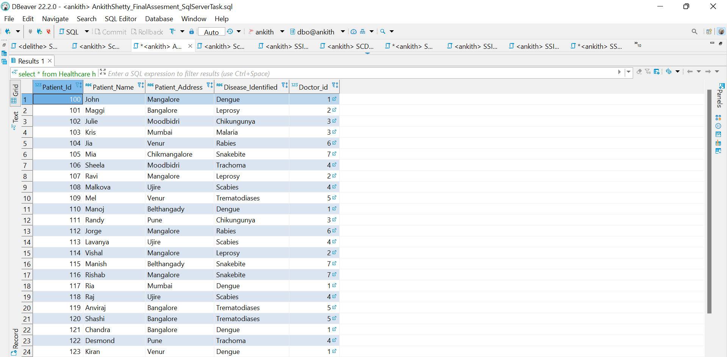

---inserting doctors table values---

**insert** **into** Doctors **values** (1,'Jeevan',301,9325784212),(2,'Mark',302,9648376849),(3,'Anderson',303,9257371846),

(4,'Jaya',304,9845284736),(5,'Lawrence',305,9327164573),(6,'Lloyd',306,9628547264),(7,'Joyal',306,9746372438)

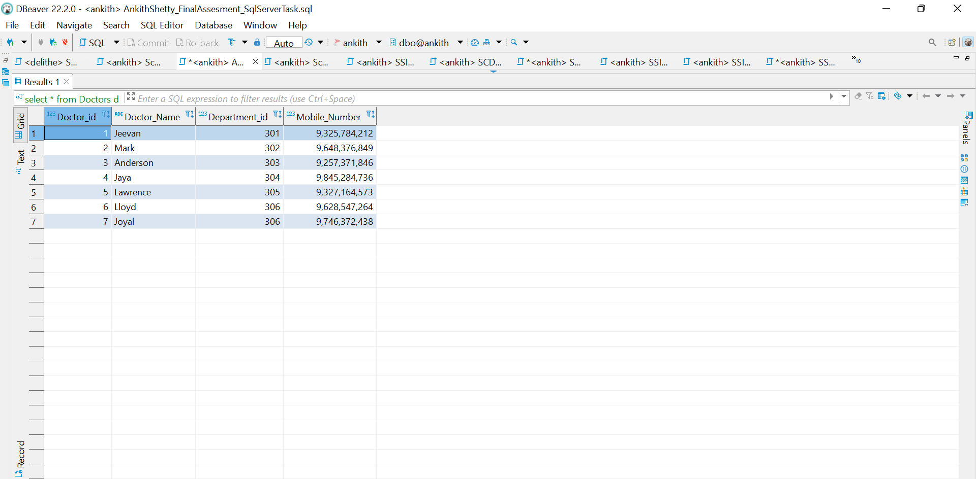

---insert hospital table value---

**insert** **into** hospital **values**('Mangalore',10000,575001),('Bangalore',10001,472024),

('Moodbidri',10002,574217),('Mumbai',10003,217483),('venur',10004,574001),

('Chikmangalore',10005,574217),

('Ujire',10006,470832),('Pune',10007,832944),('Belthangady',10008,224217)

---foreign key reference---

**Alter** **table** Healthcare

**add** **constraint** FK_Doctor_Id

**foreign** **key**(Doctor_id)

**references** Doctors

---foreign key reference---

**Alter** **table** Healthcare

**add** **constraint** FK_Hospital_address

**foreign** **key**(hospital_address)

**references** hospital

**select** * **from** Healthcare

---foreign key reference in source healthcare parent table---

---foreign key confirmation---

**insert** **into** Healthcare **values**(128,'george','mangalore','Cancer',8)

**

---foreign key confirmation---

**insert** **into** Healthcare **values**(102,'george','Jammu','Cancer',6)

**select** * **from** Healthcare

--- inner join ---

**select** H.Patient_Id ,H.Patient_Name ,H.Hospital_Address,H.Disease_Identified,H.Doctor_id,

Doc.Doctor_name,Doc.Department_id,Doc.Mobile_Number

**from** Healthcare **as** H

**inner** **join** Doctors **as** Doc **on** H.Doctor_id=Doc.Doctor_id

---Left join---

**select** H.Patient_Id ,H.Patient_Name ,H.Patient_Address,H.Disease_Identified,H.Doctor_id,

Doc.Doctor_name,Doc.Department_id,Doc.Mobile_Number

**from** Healthcare **as** H

**Left** **join** Doctors **as** Doc

**on** H.Doctor_id=Doc.Doctor_id

---Right join---

**select** H.Patient_Id ,H.Patient_Name ,H.Patient_Address,H.Disease_Identified,H.Doctor_id,

Doc.Doctor_name,Doc.Department_id,Doc.Mobile_Number

**from** Healthcare **as** H

**Right** **join** Doctors **as** Doc

**on** H.Doctor_id=Doc.Doctor_id

---full join---

**select** H.Patient_Id ,H.Patient_Name ,H.Patient_Address,H.Disease_Identified,H.Doctor_id,

Doc.Doctor_name,Doc.Department_id,Doc.Mobile_Number

**from** Healthcare **as** H

**full** **join** Doctors **as** Doc

**on** H.Doctor_id=Doc.Doctor_id

---Inner Join with all 3 tables----

**select** H.Patient_Id ,H.Patient_Name ,H.Hospital_Address,H.Disease_Identified,H.Doctor_id,

Doc.Doctor_name,Doc.Department_id,Doc.Mobile_Number,hosp.Hospital_Address ,hosp.hospital_id, hosp.location_id

**from** ((Healthcare **as** H

**inner** **join** Doctors **as** Doc

**on** H.Doctor_id=Doc.Doctor_id)

**inner** **join** hospital **as** hosp

**on** h.hospital_address=hosp.hospital_address);

**---------------------------------Creating views------------------------------------------**

**create** **view** new_healthcare

**as** **select** * **from** Healthcare h

**select** * **from** new_healthcare

---DDL,DQL and inner join commands on view---

**alter** **view** new_healthcare

**as** **select** H.Patient_Id ,H.Patient_Name ,H.Patient_Address,H.Disease_Identified,H.Doctor_id,

Doc.Doctor_name,Doc.Department_id,Doc.Mobile_Number

**from** Healthcare **as** H

**inner** **join** Doctors **as** Doc

**on** H.Doctor_id=Doc.Doctor_id

**select** * **from** new_healthcare

---Left join---

**alter** **view** new_healthcare

**as** **select** H.Patient_Id ,H.Patient_Name ,H.Patient_Address,H.Disease_Identified,H.Doctor_id,

Doc.Doctor_name,Doc.Department_id,Doc.Mobile_Number

**from** Healthcare **as** H

**left** **join** Doctors **as** Doc

**on** H.Doctor_id=Doc.Doctor_id

**

---Right join---

**alter** **view** new_healthcare

**as** **select** H.Patient_Id ,H.Patient_Name ,H.Patient_Address,H.Disease_Identified,H.Doctor_id,

Doc.Doctor_name,Doc.Department_id,Doc.Mobile_Number

**from** Healthcare **as** H

**Right** **join** Doctors **as** Doc

**on** H.Doctor_id=Doc.Doctor_id

**select** * **from** new_healthcare

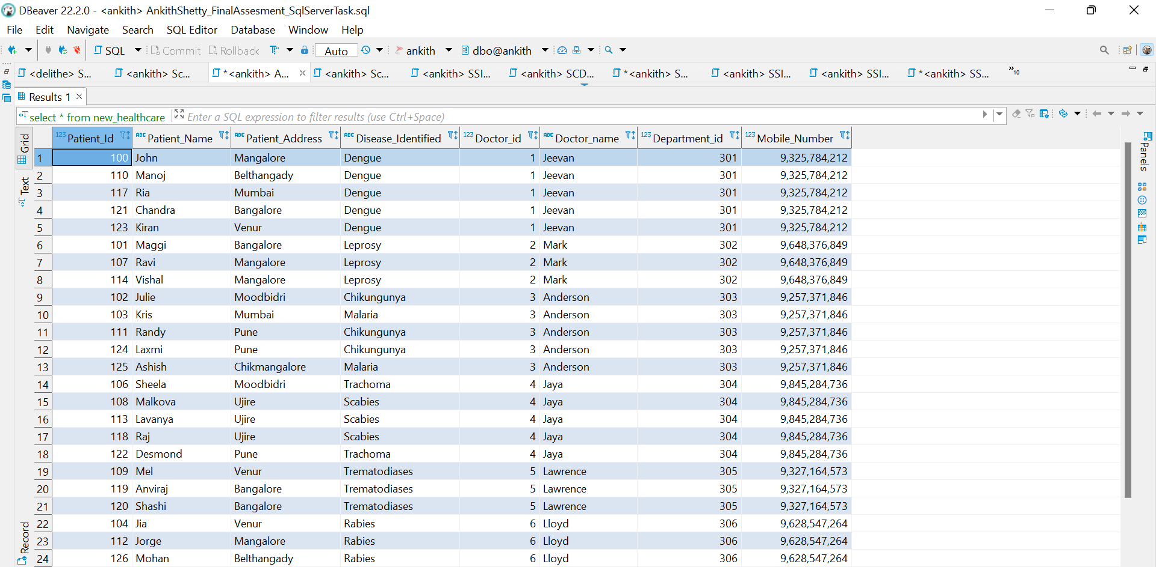

---Full join---

**alter** **view** new_healthcare

**as** **select** H.Patient_Id ,H.Patient_Name ,H.Patient_Address,H.Disease_Identified,H.Doctor_id,

Doc.Doctor_name,Doc.Department_id,Doc.Mobile_Number

**from** Healthcare **as** H

**Full** **join** Doctors **as** Doc

**on** H.Doctor_id=Doc.Doctor_id

**select** * **from** new_healthcare

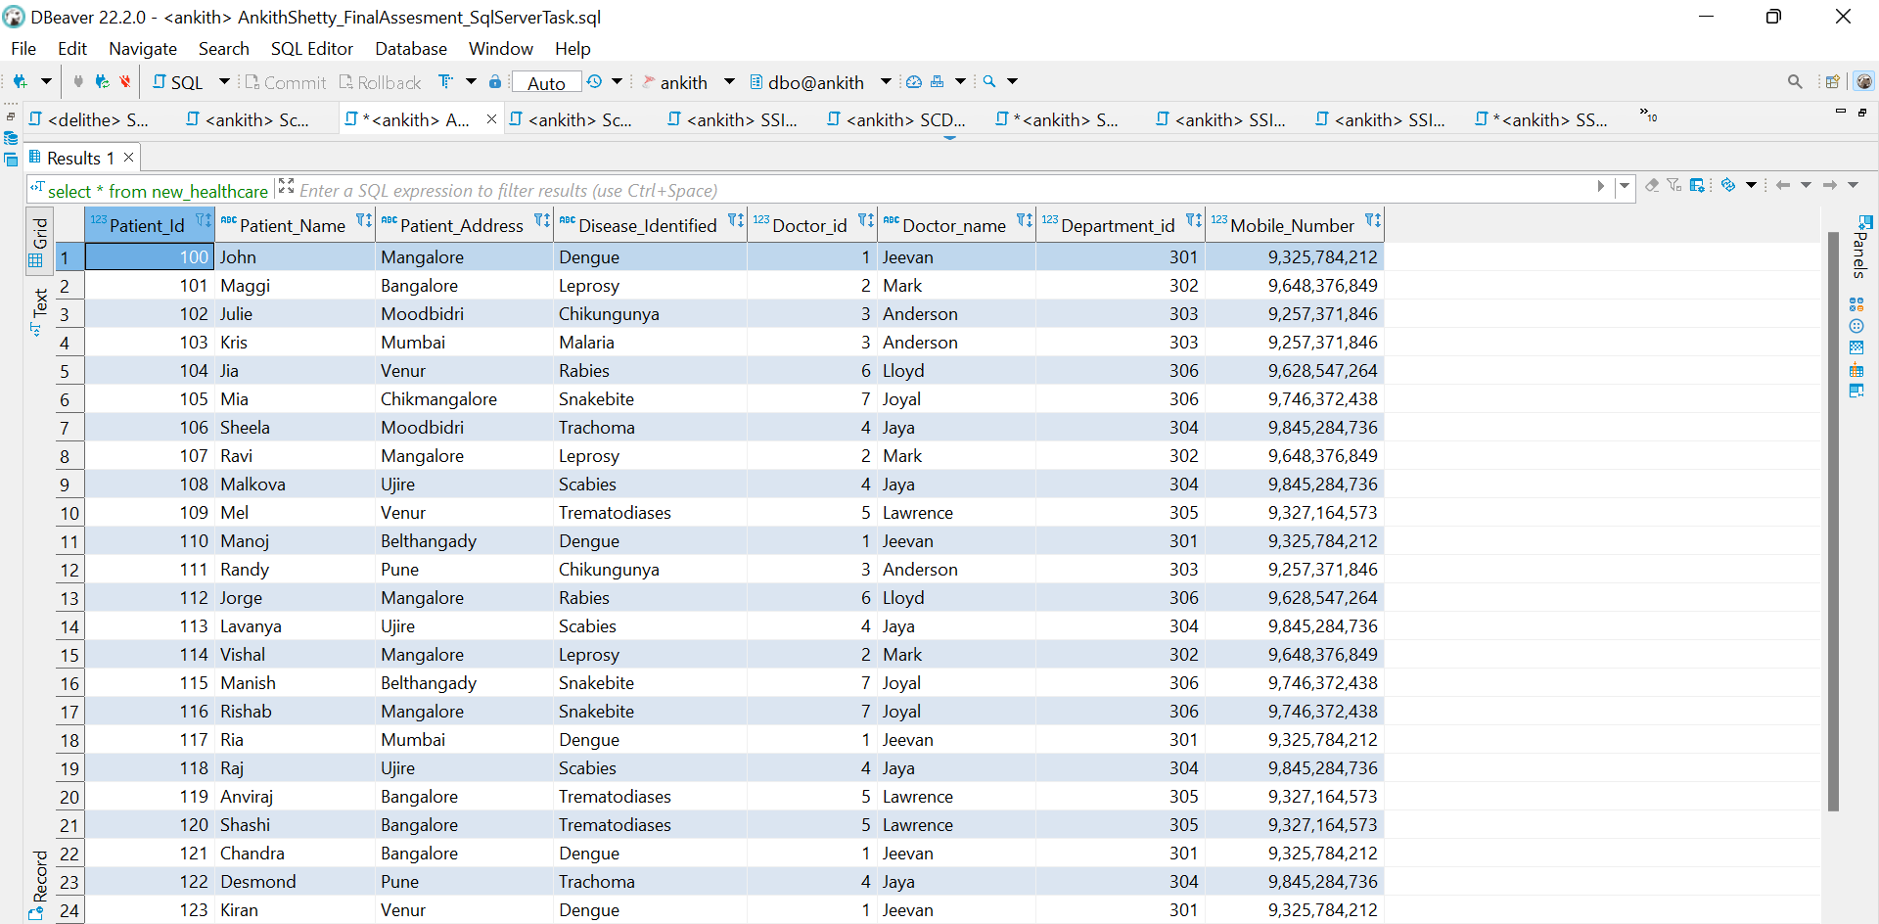

**--------------Module 1--------------**

**SQLSERVER Task 2- Using transaction table perform various operations ( DDL,DML,DCL,TCL)**

---Create Cinema Table---

**CREATE** **TABLE** Cinema(

[Film_Type] **nvarchar**(255),

[film_code] **float**,

[cinema_code] **float**,

[total_sales] **float**,

[tickets_sold] **float**,

[tickets_out] **float**,

[show_time] **float**,

[occu_perc] **float**,

[ticket_price] **float**,

[ticket_use] **float**,

[capacity] **float**,

[date] **float**,

[month] **float**,

[quarter] **float**,

[day] **float**

)

---dml,dql,ddl on cinema---

**select** * **from** cinema

**alter** **table** cinema

**add** **Year** **int**

**select** * **from** cinema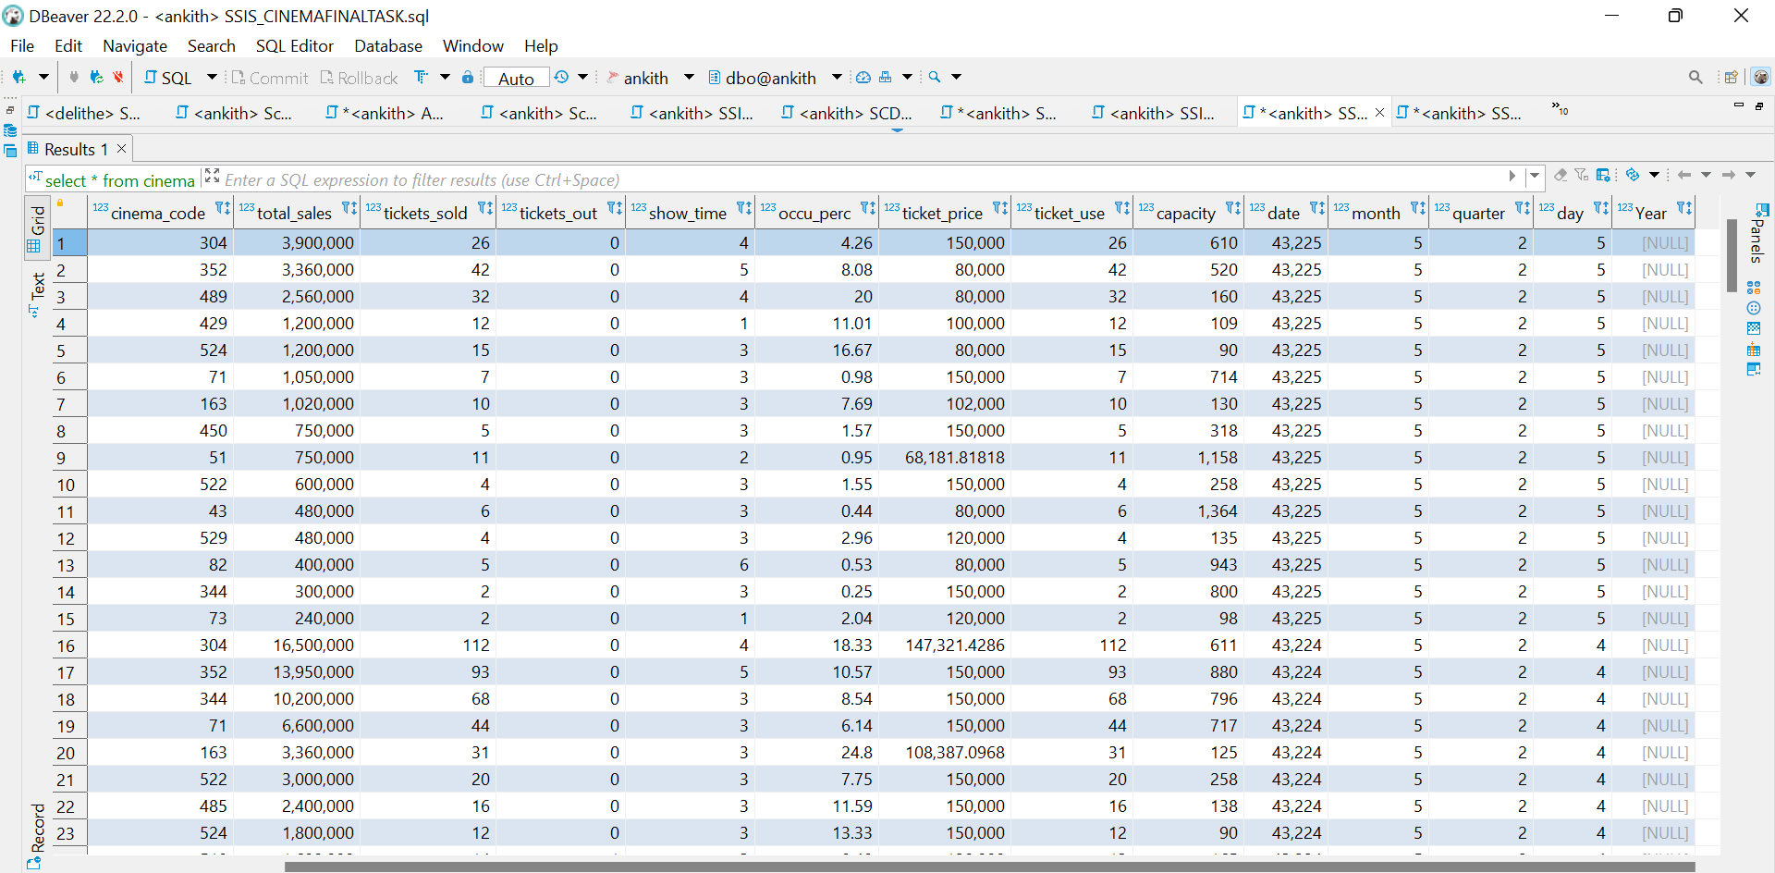

**update** Cinema **set**

**year**=2022

**select** * **from** cinema

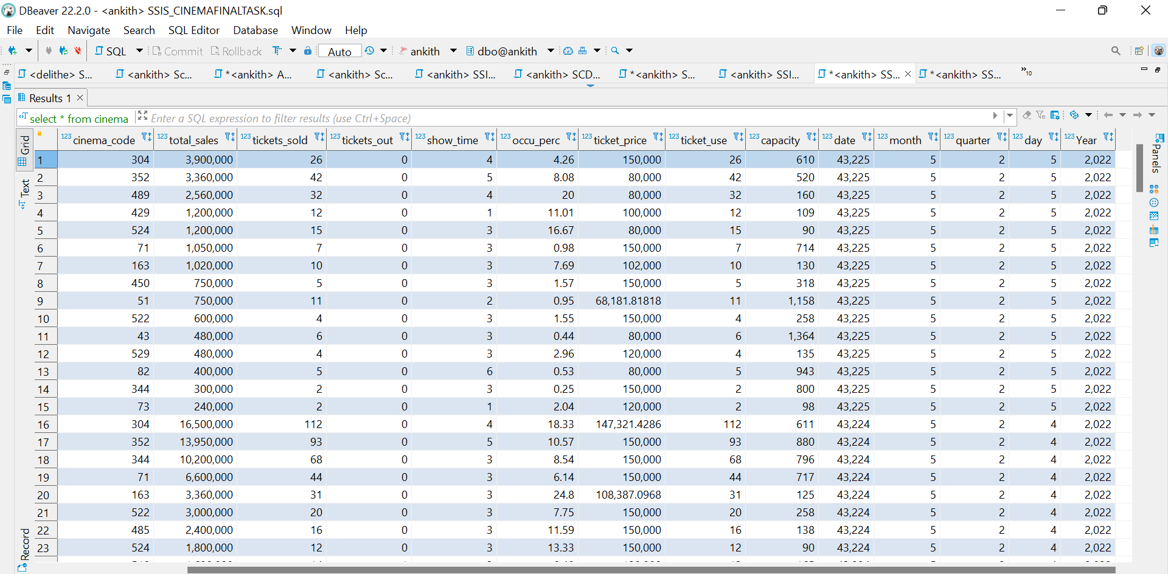

**alter** **table** cinema

**drop** **column** **year**

**select** * **from** cinema

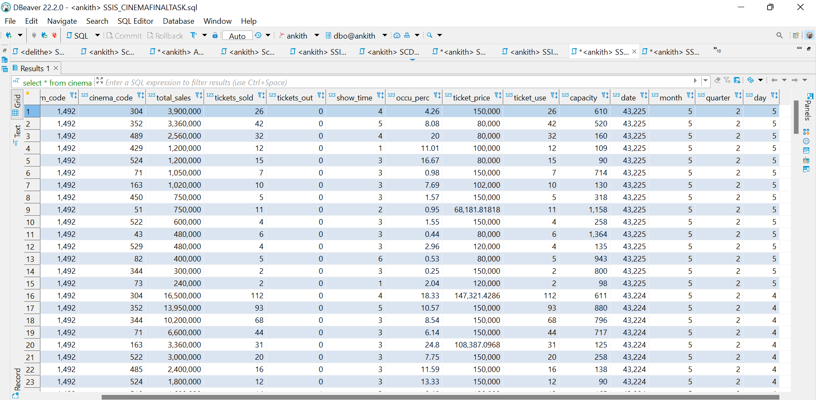

**----------2nd DATA SOURCE-----------**

-------create Loan Table----------

**CREATE** **TABLE** Loan (

LoanNr_ChkDgt **float**,

Name **nvarchar**(255),

City **nvarchar**(255),

State **nvarchar**(255),

Zip **float**,

Bank **nvarchar**(255),

BankState **nvarchar**(255),

NAICS **float**,

ApprovalDate **datetime**,

ApprovalFY **float**,

Term **float**,

NoEmp **float**,

NewExist **float**,

CreateJob **float**,

RetainedJob **float**,

FranchiseCode **float**,

UrbanRural **float**,

RevLineCr **nvarchar**(255),

LowDoc **nvarchar**(255),

ChgOffDate **datetime**,

DisbursementDate **datetime**,

DisbursementGross **nvarchar**(255),

BalanceGross **nvarchar**(255),

MIS_Status **nvarchar**(255),

ChgOffPrinGr **nvarchar**(255),

GrAppv **nvarchar**(255),

SBA_Appv **nvarchar**(255)

)

**select** * **from** loan

---DDL commands(alter)---

**alter** **table** Loan

**add** country **varchar**(50);

**select** * **from** loan

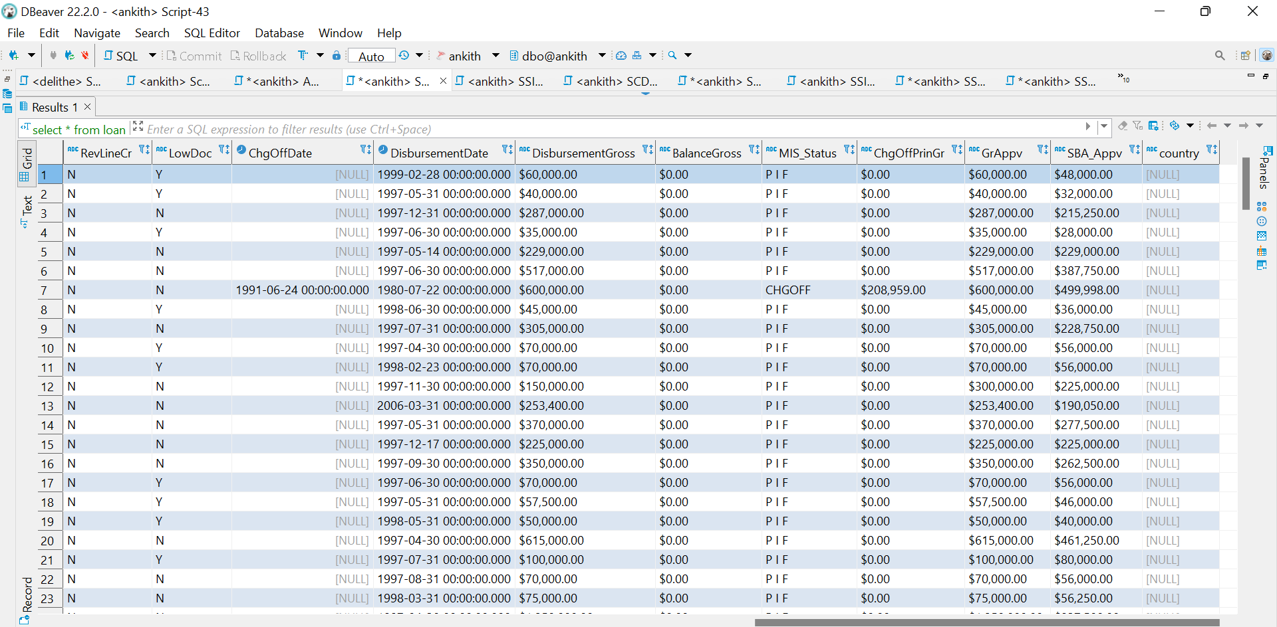

---DML command(Update) and TCL command(SET)---

**update** [Loan]

**SET** country='Indiana'

**where** city='EVANSVILLE';

**select** * **from** Loan

---DQL Command---

**select** * **from** loan **where** city='EVANSVILLE';

**alter** **table** Loan

**drop** **column** country

**select** * **from** Loan

