**FINALASSIGNMENT_IICSTASK**

**1. Make connection to different data source ( Oracle DB, Flat file, SQL Server )**

**2. Extract**

**3. Transform**

**4. Load to new target system - SQL Server**

---create insurance source table---

**CREATE** **TABLE** INSURANCE

(

[PID] **float**,

[AGE] **float**,

[GENDER] **nvarchar**(255),

[CASTE_NAME] **nvarchar**(255),

[CATEGORY_CODE] **nvarchar**(255),

[CATEGORY_NAME] **nvarchar**(255),

[SURGERY_CODE] **nvarchar**(255),

[SURGERY] **nvarchar**(255),

[VILLAGE] **nvarchar**(255),

[MANDAL_NAME] **nvarchar**(255),

[DISTRICT_NAME] **nvarchar**(255),

[PREAUTH_DATE] **datetime**,

[PREAUTH_AMT] **float**,

[CLAIM_DATE] **datetime**,

[CLAIM_AMOUNT] **float**,

[HOSP_NAME] **nvarchar**(255),

[HOSP_TYPE] **nvarchar**(255),

[HOSP_DISTRICT] **nvarchar**(255),

[SURGERY_DATE] **datetime**,

[DISCHARGE_DATE] **datetime**,

[Mortality Y / N] **nvarchar**(255),

[MORTALITY_DATE] **datetime**,

[SRC_REGISTRATION] **nvarchar**(255),

)

**select** * **from** insurance

----create TE_ANKITH_FINALASSIGNMENT_IICSINSURANCE destination---

**create** **table** TE_ANKITH_FINALASSIGNMENT_IICSINSURANCES

(

[PID] **float**,

[AGE] **float**,

[GENDER] **nvarchar**(255),

[CASTE_NAME] **nvarchar**(255),

[CATEGORY_CODE] **nvarchar**(255),

[CATEGORY_NAME] **nvarchar**(255),

[SURGERY_CODE] **nvarchar**(255),

[SURGERY] **nvarchar**(255),

[VILLAGE] **nvarchar**(255),

[MANDAL_NAME] **nvarchar**(255),

[DISTRICT_NAME] **nvarchar**(255),

[PREAUTH_DATE] **datetime**,

[PREAUTH_AMT] **float**,

[CLAIM_DATE] **datetime**,

[CLAIM_AMOUNT] **float**,

[HOSP_NAME] **nvarchar**(255),

[HOSP_TYPE] **nvarchar**(255),

[HOSP_DISTRICT] **nvarchar**(255),

[SURGERY_DATE] **datetime**,

[DISCHARGE_DATE] **datetime**,

[Mortality Y / N] **nvarchar**(255),

[MORTALITY_DATE] **datetime**,

[SRC_REGISTRATION] **nvarchar**(255),

)

----IICS TRANSFORMATION----

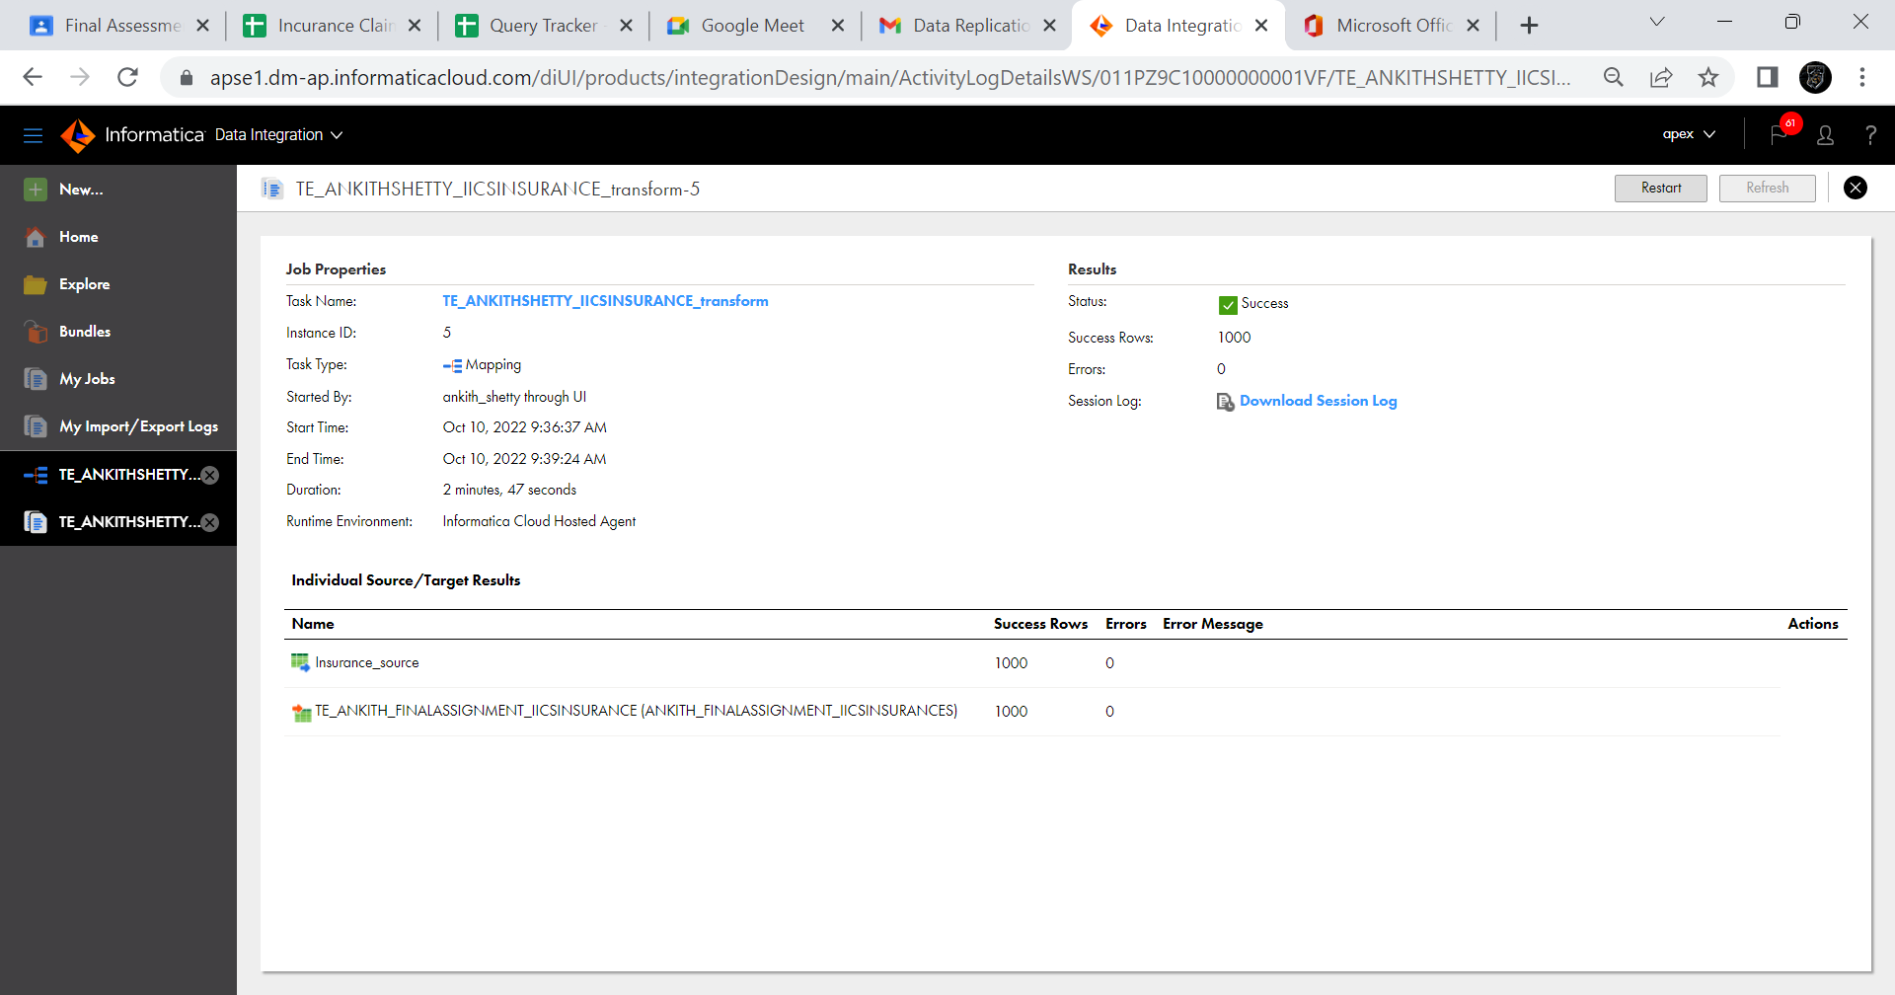

**

**----SCD1 Transformation---**

**---Insurance source table---**

**CREATE** **TABLE** INSURANCE_IICS(

[PID] **float**,

[AGE] **float**,

[CATEGORY_NAME] **varchar**(255),

[DISTRICT_NAME] **varchar**(255),

[PREAUTH_AMT] **float**,

[CLAIM_AMOUNT] **float**,

[HOSP_NAME] **varchar**(255),

)

**---Insurance Target Table---**

**create** **table** ANKITH_FINALASSIGNMENT_IICSINSURANCETarget

(

[PID] **float**,

[AGE] **float**,

[CATEGORY_NAME] **varchar**(255),

[DISTRICT_NAME] **varchar**(255),

[PREAUTH_AMT] **float**,

[CLAIM_AMOUNT] **float**,

[HOSP_NAME] **varchar**(255),

[PATIENT_KEY] **Float**,

[CHECKSUM] **varchar**(255)

)

**

**---SCD1 Output---**

---Update in SCD transformation---

**UPDATE** insurance_IICS

**SET** CATEGORY_NAME='Medical Oncology' **WHERE** PID=9;

---IICS SCD Transform---

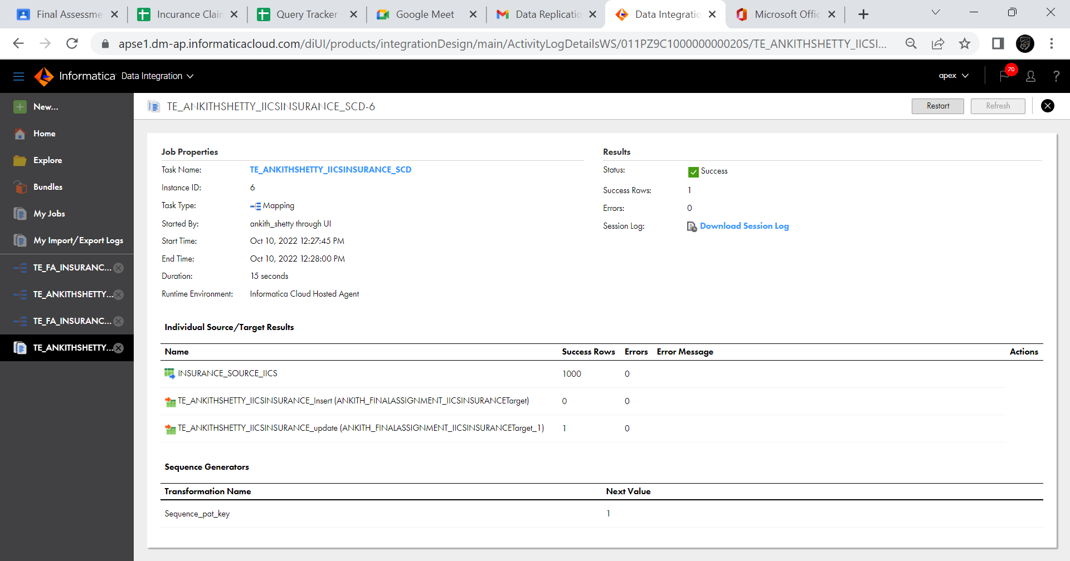

---output of updated value on **Insurance destination table---**

**SELECT** PID, CATEGORY_NAME,PREAUTH_AMT,CLAIM_AMOUNT,

HOSP_NAME, PATIENT_KEY,CHECKSUM **FROM** ANKITH_FINALASSIGNMENT_IICSINSURANCETarget ;

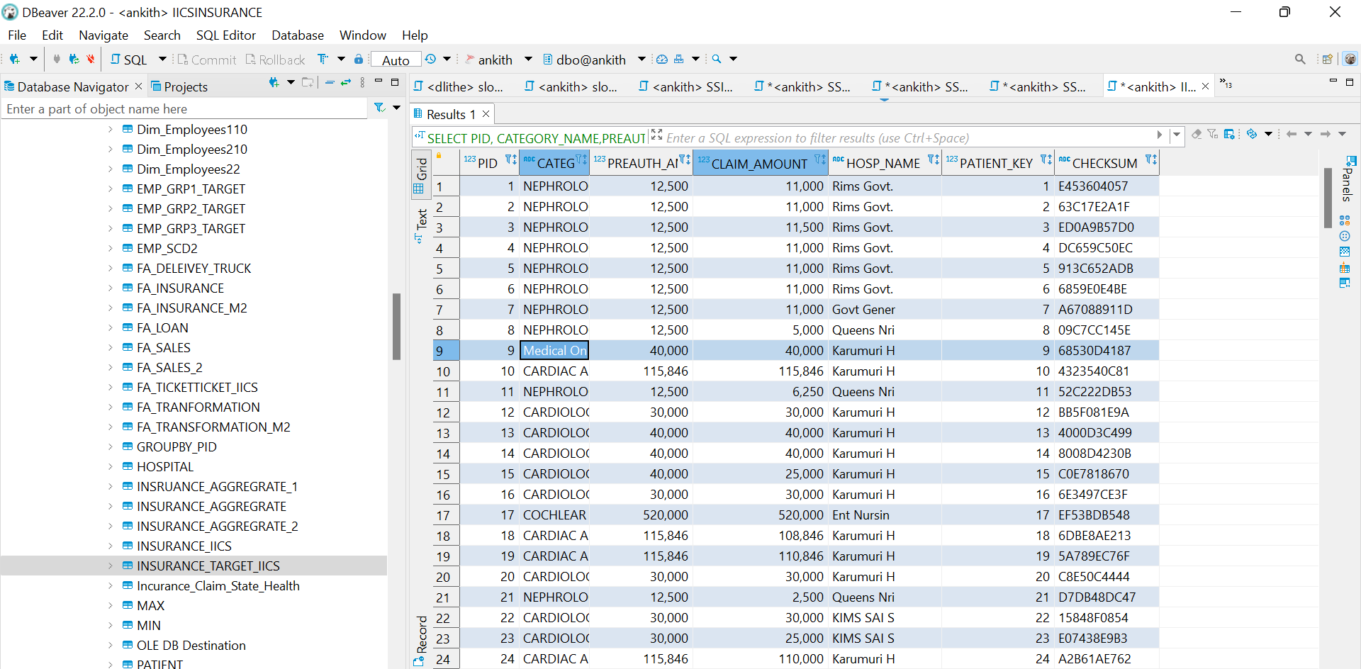

**---IICS SCD2 Transformation---**

---Insurance source table---

**CREATE** **TABLE** INSURANCE_IICS(

[PID] **float**,

[AGE] **float**,

[CATEGORY_NAME] **varchar**(255),

[DISTRICT_NAME] **varchar**(255),

[PREAUTH_AMT] **float**,

[CLAIM_AMOUNT] **float**,

[HOSP_NAME] **varchar**(255),

)

---create SCD2 Insurance Destination Table---

**create** **table** ANKITH_FINALASSIGNMENT_SCD2TargetInsurance

(

[PID] **float**,

[AGE] **float**,

[CATEGORY_NAME] **varchar**(255),

[DISTRICT_NAME] **varchar**(255),

[PREAUTH_AMT] **float**,

[CLAIM_AMOUNT] **float**,

[HOSP_NAME] **varchar**(255),

[PATIENT_KEY] **Float**,

[START_DATE] **datetime**,

[END_DATE] **datetime**,

[CHECKSUM] **varchar**(255)

)

---IICS Steps---

**---SCD2 Output---**

---update Insurance source table---

**UPDATE** INSURANCE_IICS

**SET** CATEGORY_NAME='CARDIOLOGY' **WHERE** DISTRICT_NAME='GUNTUR';

**---IICS SCD2 Transform---**

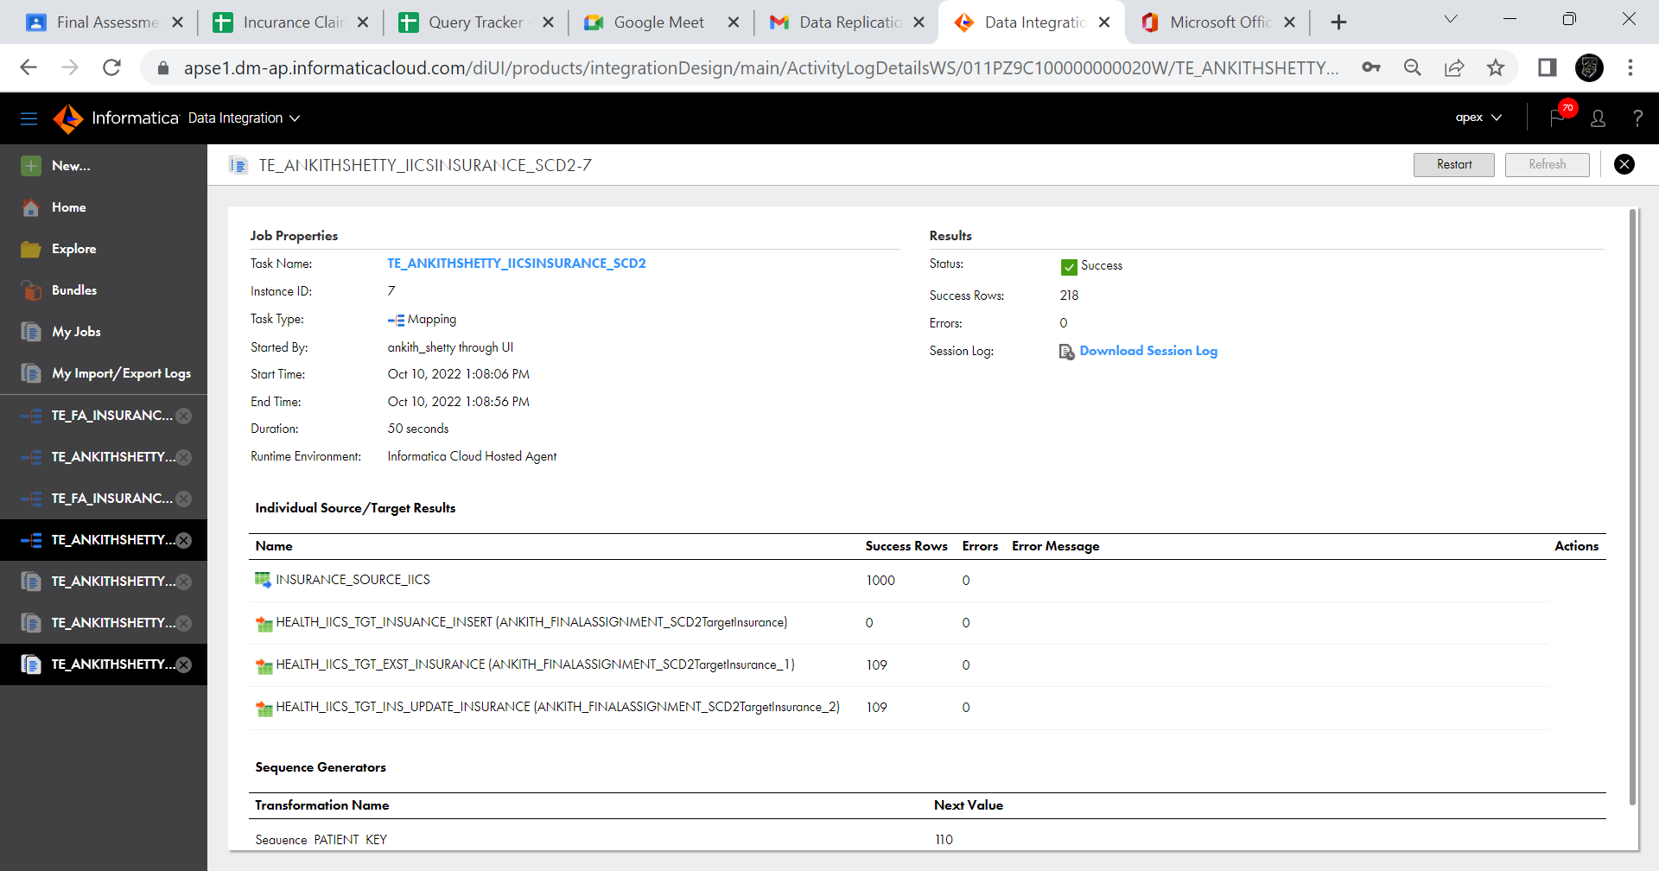

**---Updated value output in Insurance destination---**

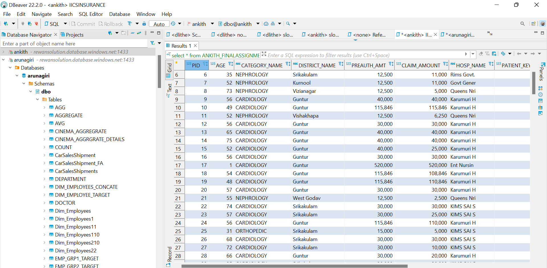

**---AGGREGATE Function---**

**---Source table---**

**select** * **from** insurance_IICS

---Create Aggregate destination table---

**create** **table** Insurance Aggregate

(

Max_Claim_Amt **float**,

Sum_Claim_Amt **float**,

Min_Claim_Amt **float**

)

**---IICS Aggregate Transform---**

**---AGGREGATE Function Output in Insurance_aggregate destination---**

**select** * **from** Insurance_Aggregate

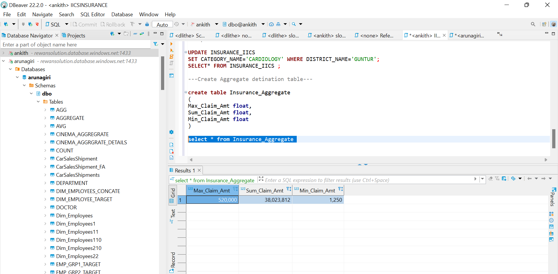

**------REPLICATION Task Steps for single table-----**

**1.SOURCE CONNECTION**

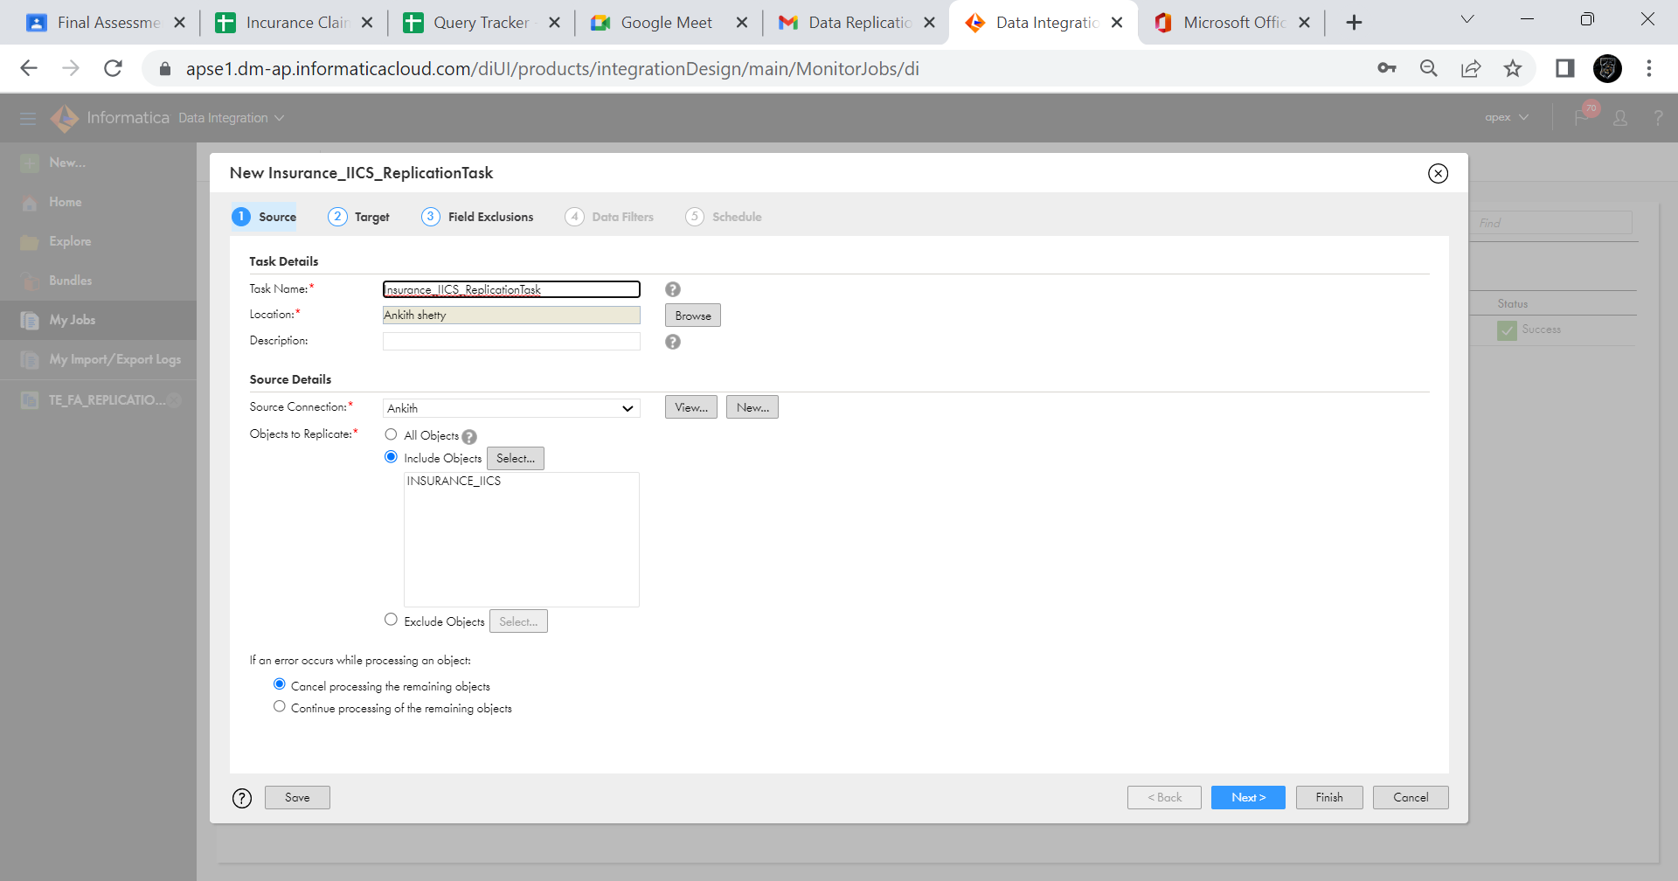

**2.TARGET CONNECTION**

**3.FIELD EXCLUSION**

**4.DATA FIELDS**

**4.SCHEDULE THE TASK**

**5.OUTPUT OF REPLICATION TASK**

**6. TARGET TABLE UPDATE OUTPUT**

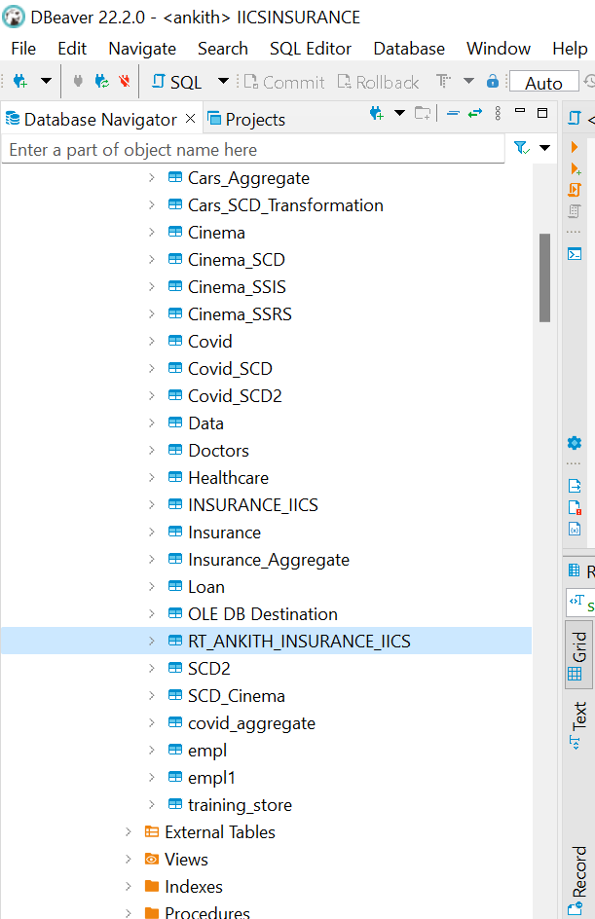

**7. TARGET TABLE UPDATED OUTPUT**

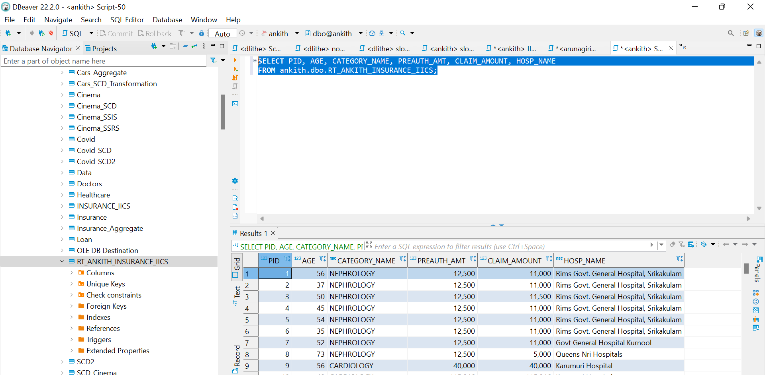

**---REPLICATION TASK FOR ENTIRE DB---**

**1.SOURCE CONNECTION**

**2.TARGET CONNECTION**

**3.FIELD EXCLUSION**

**4.DATA FIELDS**

**4.SCHEDULE THE TASK**

**5.OUTPUT OF REPLICATION TASK**

**6. TARGET TABLE UPDATE OUTPUT**



---REPLICATION TASK FOR FULLDB---

---IICS Task---

---IICS OUTPUT---

