  FILM TYPE WISE TICKETS SOLD AND TOTAL SALES
  10/13/2022 12:20:21 PM
  This report gives us a brief report about Film type wise tickets sold and total sales
  CORPINDIA\EI13070
 |  |  |  |  | 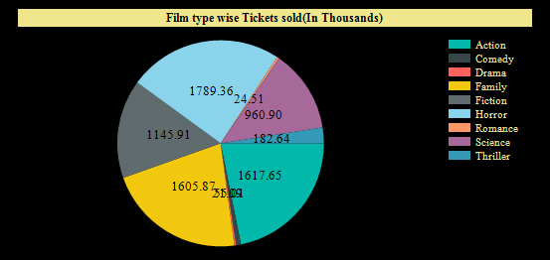
  Film Type | Film_type | Month | Cinema_code | tickets sold
  Action | Action | 4 | 448 | 2015
  Comedy | Comedy | 6 | 155 | 44
  Drama | Drama | 6 | 448 | 84
  Family | Family | 5 | 448 | 714
  Fiction | Fiction | 7 | 181 | 25
  Horror | Horror | 4 | 448 | 814
  Romance | Romance | 5 | 304 | 26
  Science | Science | 5 | 448 | 1656
  Thriller | Thriller | 3 | 448 | 379
  Total |  |  |  | 7402921
 |  | 