FLIGHT STATUS ANALYSIS

(Data Analytics)

By - Ankitha Kundal

ABSTRACT

The "Flight Status Analysis" project aims to develop a comprehensive and visually engaging Power BI dashboard to analyze and monitor the status of flights. This dashboard will leverage Power BI's robust features to provide stakeholders, including airline operators, airport authorities, and travellers, with valuable insights into the performance and status of flights. The total number of flights (incoming and departing flights), the total number of flight delays (arrivals and departures), ground processing time, and the passenger feedback section can all be included in the summary page of this project’s dashboard. In case of flight changes, emergencies, or delays, this analysis could assist airport management authorities in making timely data-driven choices. It helps in analysing the flight status (on time, delayed, cancelled) month wise and airline wise. Also have a look at average delay time for that duration. Air traffic analysis is performed which gives insights as when is the best time to book a flight and what is the peak hour when the maximum flights are available.

CONTENTS

Certificate |  | I
Abstract |  | II
Contents |  | III
List of Figures |  | IV
List of Data Set |  | VI
Abbreviations |  | VII
Chapter 1 | Introduction | 1
 | 1.1 Section | 2
 | 1.2 Section | 2
 | 1.3 Section | 3
Chapter 2 | Review of Relevant Literature | 4-5
Chapter 3 | Methodology | 6-7
Chapter 4 | Results and Discussions | 8
Chapter 5 | Conclusions and Future Scope of Study | 9
References |  | 10
Appendix A : Sample Source Code |  | 11

LIST OF FIGURES

Figure | Title | Page
1.1 | A typical operation of a commercial flight | 02
2.1 | Dataset | 06
2.2  3.1  4.1 | Image of some applied steps  Fully cleaned dataset  Dashboard | 06  07  08

LIST OF DATASET

Table | Title | Page
1.1 | Flight Status | 7

LIST OF ABBREVIATIONS

FAA Federal Aviation Administration
ANSP Air Navigation Service Providers

CHAPTER 1

INTRODUCTION

Power BI is the technical and procedural representation of data. It is an infrastructure that collects, stores and analyse the data produced by a company’s activity. Power BI parses all the data generated by a business and presents easy-to-digest reports, performance measures and trends that inform management decisions. BI components and software comes in wide variety of Power query, Power map, Power pivot, Power view, Power Q&A, Power BI desktop. There are many others parts for Power Bl as well such as, Power BI.com Websites, Power BI Mobile Apps. Power BI is cloud-based data analysis, which can be used for reporting and data analysis from wide range of data source. Power BI is simple and user friendly enough that business analysts and power users can work with it and get benefits of it. On other hand Power BI is powerful and mature enough that can be used in enterprise systems by BI developers for complex data mashup and modelling scenarios.
Flight status analysis in Power BI offers a comprehensive approach to understanding and optimizing various aspects of flight operations. By collecting and preparing relevant flight data, including information such as flight numbers, departure/arrival times, delays, cancellations, and reasons for delays, users can gain valuable insights into the performance of airlines, airports, and routes. Power BI's robust data modeling capabilities enable the creation of a structured data model that accurately reflects the relationships between different entities in the flight data. Through intuitive dashboard design, users can access key metrics such as on-time performance, average delay time, and cancellation rates, presented using a variety of visualizations like line charts, bar charts, maps, and tables. Interactive filters and slicers empower users to drill down into the data and identify trends or anomalies, while alerts and highlights draw attention to areas of concern. Moreover, performance analysis tools facilitate root cause analysis, trend analysis, and predictive analytics, empowering stakeholders to make data-driven decisions and improve overall flight operations. Finally, by sharing the Power BI report and encouraging collaboration, stakeholders can foster a culture of continuous improvement, ensuring that the flight status analysis remains relevant and effective over time.

  - SECTION
PROBLEM STATEMENT:
As stated before, the dataset was originally hosted on Kaggle and was purposed for projecting whether a given flight will be delayed, on-time or cancelled when given information about scheduled departure. For the purpose of this project, it will just be used to write a story about flight delay experience across the listed airports.
The Federal Aviation Administration (FAA) considers a flight to be delayed when it is 15 minutes later than its scheduled time.

  - SECTION

The flight delay scenario Commercial aviation is a complex distributed transportation system. It deals with valuable resources, demand fluctuations, and a sophisticated origin-destination matrix that need orchestration to provide smooth and safety operations. Furthermore, individual passenger follows her itineraries while airlines plan various schedules for aircrafts, pilots and flight attendants. Figure 1 illustrates a typical operation of a commercial flight. Stages can take place at terminal boundaries, airports, runways, and airspace, being susceptible to different kinds of delays. Some examples include mechanical problems, weather conditions, ground delays, air traffic control, runway queues and capacity constraints.
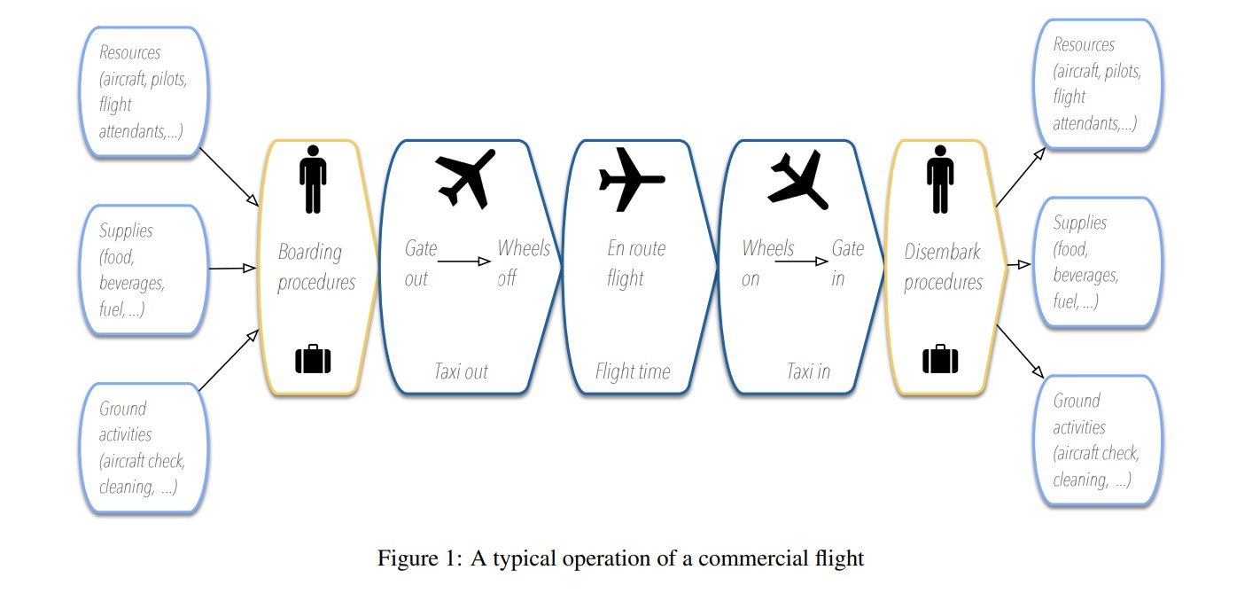
  - SECTION

This scheme is repeated several times throughout the day for each flight in the system. Pilots, flight attendants and aircrafts may have different schedules due to legal rests, duties, and maintenance plans for airplanes. So, any disruption in the system can impact the subsequent flights of the same airline. Moreover, disturbances may cause congestion at airspace or other airports, creating queues and delaying some flights from other carriers. In this way, the prediction of flight delays is an essential subject for airlines, airports, Air Navigation Service Providers (ANSP), and network managers, like FAA and Euro control. The flight delay prediction problem can be treated by different points of view: (i) delay propagation, (ii) root delay and cancellation. In delay propagation, one study how delay propagates through the network of the transportation system. On the other hand, considering that new problems may happen eventually, it is also important to predict further delays and understand their causes. Such occurrences, in this paper, are named as a root delay problem. Finally, under specific situations, delays can lead to cancellations, forcing airlines and passengers to reschedule their itineraries. So, researchers focused on cancellation analysis try to figure out which conditions lead to cancellations. Moreover, it explores the airlines’ decision-making process for choosing the flights to be cancelled.

CHAPTER 2
REVIEW OF RELEVANT LITERATURE

A literature survey on flight status analysis involves examining multiple sources that analyse flight data to understand factors affecting flight delays and cancellations.

1. Predictive Modelling for Flight Delays:
Flight delay forecasting often employs predictive modelling with machine learning algorithms, statistical methods, and historical flight data. Relevant research papers are available.
"A Data Mining Approach to Predict Flight Delays Based on Arrival Performance Data" by Ruxandra Bologa, Alexandru Isar, and Dragos Vieru.
"A Predictive Model for Flight Delays Using Logistic Regression Analysis" by Hana Brůhová-Foltýnová and Jiří Foltýn.

2. Factors Influencing Flight Delays:
Various factors contribute to flight delays, including weather conditions, airspace congestion, airport operations, and airline-specific issues. These analyses aim to identify key drivers of delays and their impact on flight punctuality.
- "Analysis of Airline Flight Delays Using Machine Learning Algorithms" by Md Zabed Hossain and Rajib Biswas.
- "Analysis of Flight Delays and Cancellations at Major U.S. Airports" by Xiaowen Fu and Tarek S. Abdel‐Hamid.

3. Visualization and Dashboarding for Flight Data:
- Using data visualization tools like Power BI, researchers monitor flight status and performance through informative dashboards and visualizations. Although there's limited literature on flight status analysis in Power BI, broader resources on data visualization and dashboarding principles can be helpful. Examples include:
-"Mastering Microsoft Power BI" by Brett Powell.

4. Impact of External Events on Flight Operations:
- Some studies investigate the impact of external events such as natural disasters, geopolitical events, and public health crises on flight operations. These analyses contribute to understanding how external factors influence flight status and may inform strategies for mitigating disruptions. Relevant literature might include academic journals and conference proceedings in fields such as transportation management and aviation studies.

5. Operational Strategies for Improving Flight Performance:
Research can be conducted to investigate the operational strategies implemented by airlines, airports, and air traffic management agencies to improve flight performance and reduce disruptions. These strategies may include optimizing flight schedules and implementing proactive maintenance practices. Valuable insights into effective operational approaches can be derived from academic journals, industry reports, and case studies.

A holistic understanding of flight status analysis and its implications for aviation stakeholders can be gained through comprehensive literature survey.

CHAPTER 3
METHODOLOGY

Data Collection: Gather relevant data from various sources, ensuring its accuracy and completeness. This may involve structured data from databases, unstructured data from text sources, or even data from APIs.

Data Cleaning and Preparation: Cleanse the data to remove errors, inconsistencies, and missing values. Transform and prepare the data in a format suitable for analysis, which may include normalization, aggregation, or feature engineering.

Data Cleaning and Transformation
From Power BI, the data was loaded into Power Query for transformation. Cleaning started with the first row being made into headers. The column distribution, profile, and quality were then checked for irregularities and then information. This helped show that the dataset was fairly clean with no duplicates or empty cells.

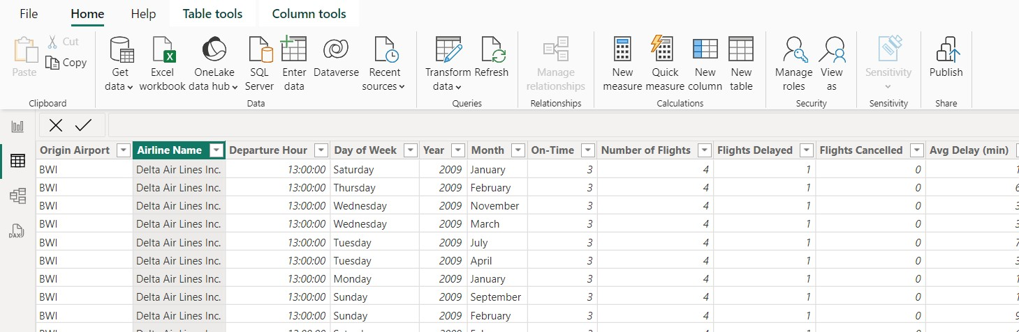
Figure 2

Some select flight lengths and airports were also confirmed with a search engine to validate the data.
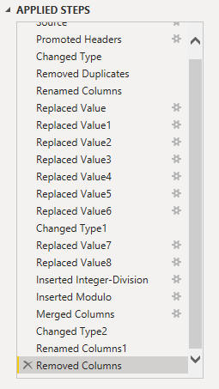
Figure 3 Image of some applied steps
Cleaning and Transformation(cont’d):
For the purpose of the project, time of departure was considered, as it has a stronger claim.
The time conversion problem was then resolved by creating two fields (integer, modulo) with the calculation;

INT (time/60) hours + MOD (value,60) minutes.

For example, given the value of 1439 on the time column,
Integer Column was calculated with “1439/60” and was formatted to the integer type. This gives the value 23(hours).
Modulo Column was calculated with modulo “1439,60”. This gave the value 59(minutes).
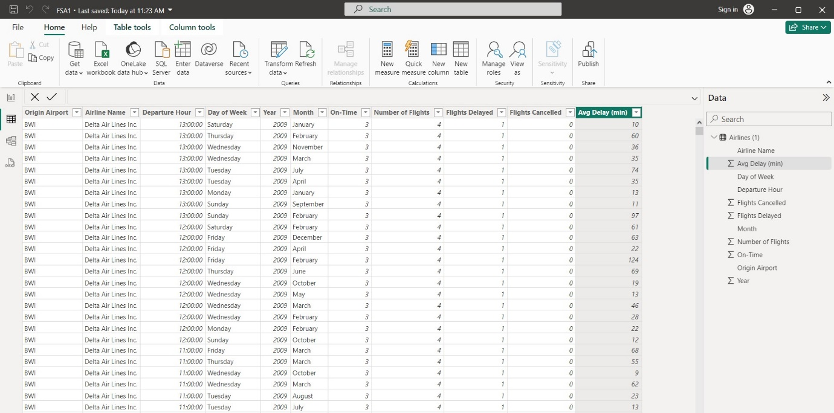
Figure 4 Fully cleaned dataset

CHAPTER 4
RESULT AND CONCLUSION

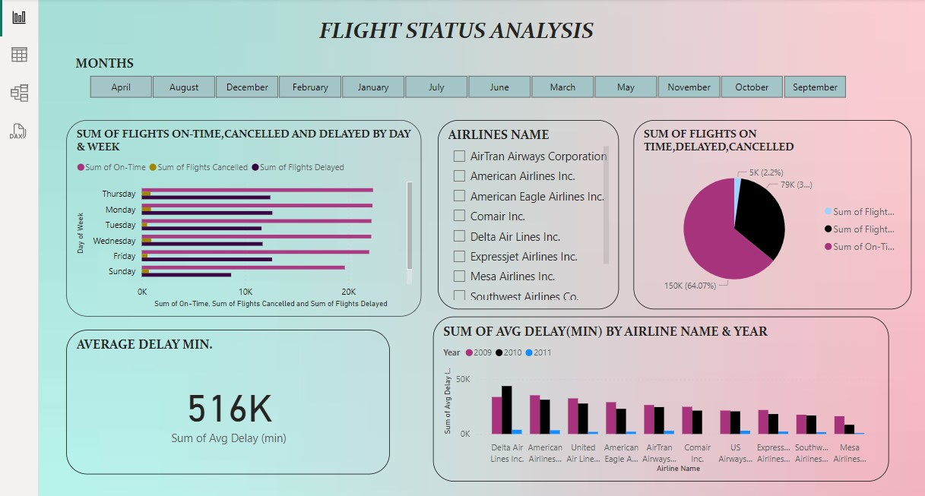
Figure 5 Dashboard
In the dashboard above, we have included a slicer that allows us to select the month and obtain the flight status for that particular month. This provides direct information to the user. In the next visualization, we have included the days and weeks of the month, making it easy to see the flights that are on-time, delayed or cancelled on a particular day of the week. We also have another slicer which allows us to filter by airline name, enabling us to get the status of a particular airline regarding on-time, delayed or cancelled flights. This helps us to obtain specific information about a particular airline. In the next visualization, we have included a pie chart to show how many flights are on-time, delayed or cancelled.

We have also used a card to display the average delay minutes of the flight. Another visualization shows the sum of average delay minutes by airline name and year, allowing us to know which airline experienced how many delayed minutes in the years 2009, 2010, and 2011. This helps us to understand the flight status of a particular airline in a specific year. We can create more dashboards to learn about different airlines and how they have improved from year to year.

CHAPTER 5
CONCLUSION AND FUTURE SCOPE OF STUDY

- A dashboard is used for presenting a real-time flight status performance in Airlines. An effective dashboard is able to facilitate decisionmaking process and to quickly trigger actions by delivering information to end users. To achieve a better data visualization, Microsoft power BI is integrated to visualize and display sales data through dashboard.
- We will get an automated dashboard providing quick and latest sights in order to support data driven decision making.
- In future we can publish the report to the web version of PowerBI and accessing the dashboard as the mobile application.
- Leveraging Power BI for flight status analysis offers a powerful solution for understanding, optimizing, and improving flight operations.
- By harnessing the capabilities of Power BI, airlines, airports, and aviation authorities can gain valuable insights into key performance metrics, identify trends, and address issues that impact the overall efficiency and reliability of air travel.
- Through intuitive dashboard design, interactive features, and advanced analytics, stakeholders can make data-driven decisions to enhance on-time performance, reduce delays, and mitigate cancellations.
- As technology and data continue to evolve, Power BI remains a versatile and indispensable tool for driving innovation and excellence in flight status analysis.

REFERENCES
[1] S. Ahmadbeygi, A. Cohn, and M. Lapp. Decreasing “Airline delay propagation” by re-allocating scheduled slack. IIE Transactions (Institute of Industrial Engineers), 42(7):478–489, 2010.
[2] BTS. The Bureau of Transportation Statistics databases. Technical report, http://www.rita.dot.gov/bts/home, 2009.
[3] B. Bubalo and J. Daduna. Airport capacity and demand calculations by simulation-the case of BerlinBrandenburg International Airport. NETNOMICS: Economic Research and Electronic Networking, 12(3):161– 181, 2011.
[4] K. Cai, Y. Jia, Y. Zhu, and M. Xiao. A novel biobjective risk-based model for stochastic air traffic network flow optimization problem. Scientific World Journal, 2015, 2015.
[5] B. Campanelli, P. Fleurquin, V. Egu´ıluz, J. Ramasco, A. Arranz, I. Extebarria, and C. Ciruelos. Modeling reactionary delays in the European air transport network. In SIDs 2014 - Proceedings of the SESAR Innovation Days, 2014.
[6] F. Carr, G. Theis, J.-P. Clarke, and E. Feron. Evaluation of improved pushback forecasts derived from airline ground operations data. Journal of Aerospace Computing, Information and Communication, (JAN.):25–43, 2005.

APPENDIX

= Csv.Document(File.Contents("C:\Users\mruh\Downloads\Airlines (1).csv"),[Delimiter=",", Columns=11, Encoding=1252, QuoteStyle=QuoteStyle.None])
= Table.PromoteHeaders(Source, [PromoteAllScalars=true])
= Table.TransformColumnTypes(#"Promoted Headers",{{"Origin Airport", type text}, {"Airline Name",

