

Course Name: Software Engineering
Course Code: IS1103-1
Assignment 1: Software Process Models and Requirements Engineering
Submitted to
Dr. JASON ELROY MARTIS
On
15th February 2026
By
Ankitha - NNM24IS031
IV-A


Information Science & Engineering
NMAM INSTITUTE OF TECHNOLOGY
2026

ABSTRACT:

Student attendance and how well they do in the school, shows how much value learning. Unfortunately, many schools still use old ways like paper sign-in sheets or other digital tools, which cause mistakes, slow updates and makes it hard to get the important information. As schools grow and the requirements for learning change, it can get harder to manage all the information involved.
A ‘Student Attendance and Performance Tracking System’ will make it more easy and more automatic. Using this, Faculties can quickly check the attendance and input the grades through the internet. Students can check their attendance and their performance in the school anytime. This method helps to keep the data correct, saves the time and makes everything clearer for all the people involved.
Building such a system needs careful planning to handle different tasks like keeping track of the attendance, managing grades and updating details. Using a step-by-step approach like Software Development Life Cycle (SDLC) can help plan, create, check and keep the system working properly. The goal is to compare various SDLC models such as to find out which one works the best for handling the changing needs, managing risks and adjusting to new academic rules.

GitHub Repository Link:

GitHub URL:

INTRODUCTION:

The Software Development Life Cycle (SDLC) is a fundamental framework that governs the process of software development, encompassing planning, design, implementation, testing, deployment, and maintenance stages. As software engineering practices continue to evolve, various SDLC models have emerged, each offering distinct approaches to managing the development process [1]
As software systems starts to grow in size and complexity, choosing the right SDLC model has become very important. Nowadays, educational institutions heavily depend on the software solutions to maintain the academic processes accurately, efficiently and in a timely manner.
The goal of this report is to Study and compare different SDLC models using a student attendance and performance tracking system as the chosen case study. The case study is compared and analysed using three widely used SDLC models i.e Waterfall Model, Incremental Development Model and Spiral Model to understand their suitable in developing such an academic management system.

CASE STUDY:

The chosen case study is about student attendance and performance tracking software system. It is basically the software solution designed to easily automate and manage the academic records with in an educational institution.Earlier , attendance and performance records were maintained manually, which resulted in errors, consumed more time and lacked transparency. This system highlightes these issues by providing a centralized and digital platform to manage student data efficiently.
This system allows the faculty members to record daily attendance , enter the internal marks and generate the performance reports. It automatically calculates the attendance percentages and also helps in identifying the students having shortage in their attendance. Students can also securely log in to the system and check their attendance ,academic performance and performance reports. Administrators can monitor the overall data of the performance of the class.
The aim or main goal of the system is to improve the accuracy , reduce administrative workload and enhance transparency and provide real rime academic insights. Since the rules in academic system may change regularly,the system ought to be flexible, secure, and scalabe at the same time.

- Implementation of the SDLC Models:

- Waterfall Model:
The classical waterfall model which is also known as the linear-sequential life cycle model is an essential software development model which can be understandable from the structure itself. The model is straightforward yet idealistic. [2]
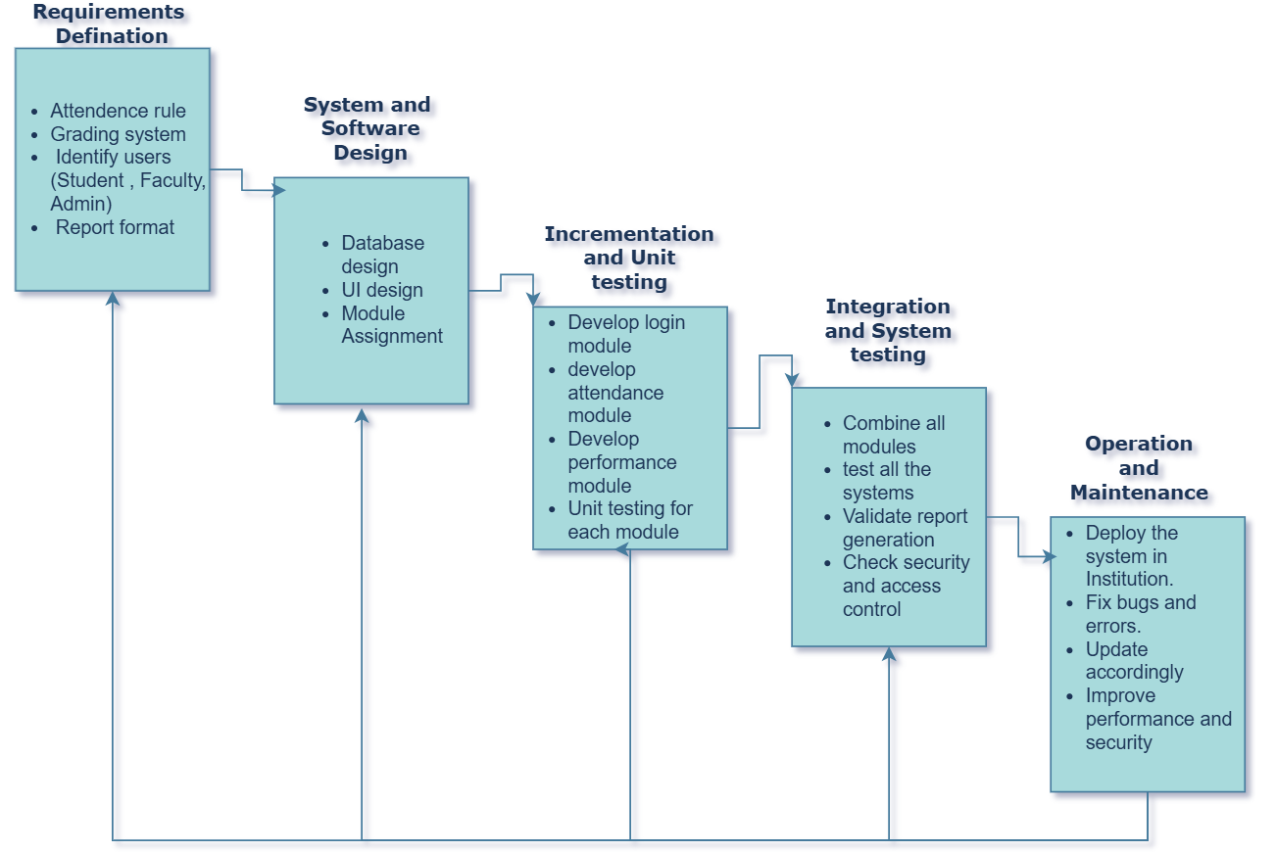
Figure 1-Waterfall model

With respect to ‘Student Attendence and Performance Tracking System’ all the requirements such as attendance rules, grading structure, report formats and user roles must be clearly defined at the beginning of the project itself. As this particular model has a very low flexibility , any changes in the academic policies or evaluation methid will be difficult and costly after the start of development .
Comparitively the Waterfall Model is less flexible and doesnot easily accommodate evolving requirements .However, this type is suitable Requirements of the system are are well-defined , stable and very much unlikely to change.

- Incremental Development Model:
In incremental model the whole requirement is divided into various builds. Multiple development cycles take place here, making the life cycle a “multi-waterfall” cycle. Cycles are divided up into smaller, more easily managed modules. Each module passes through the requirements, design, implementation and testing phases. A working version of software is produced during the first module, so you have working software early on during the software life cycle. Each subsequent release of the module adds function to the previous release. The process continues till the complete system is achieved [3]
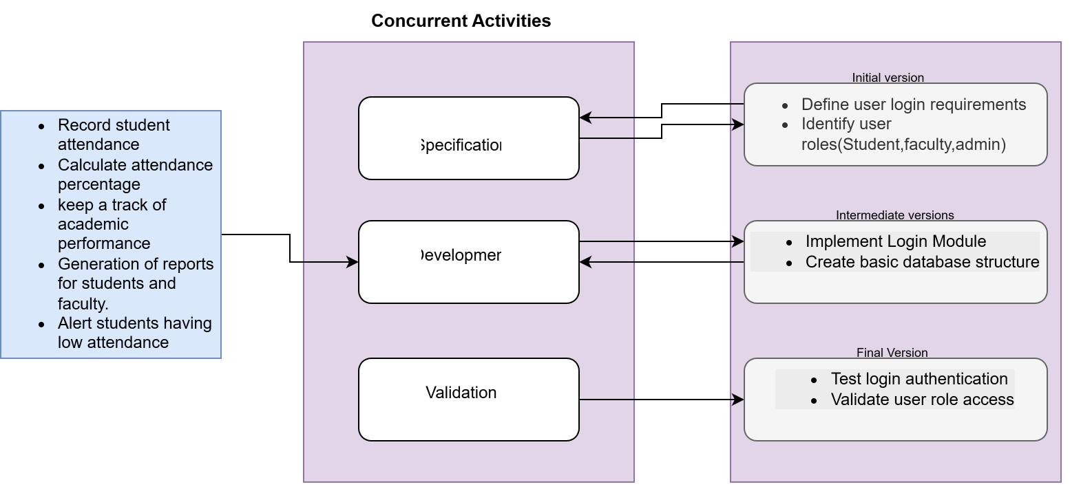
Figure 2-Incremental Development Model
This approach allows easy delivery for the chosen software system and allows the stakeholders i.e faculty and administrators , to provide their feedback at every stages . Since the educational rules and regulations .m criteria to calculate the attendance and the grading system changes frequently,this particular model provides with the flexibility to handle the modifications without affecting the complete system. It also reduces the development risks ,improves the testing efficiency and manages the time for development. Overall , Incremental model offers a balanced and practical approach for successfully implementing the chose case study.

- Spiral Model:
The spiral model is a software development process combines elements of both design and prototyping in stages for the sake of combining the advantages of top down and bottom up concepts. It is a meta-model, which means that it can be used by other models . In addition, it focuses on risk assessment and minimizing project risk. [4]
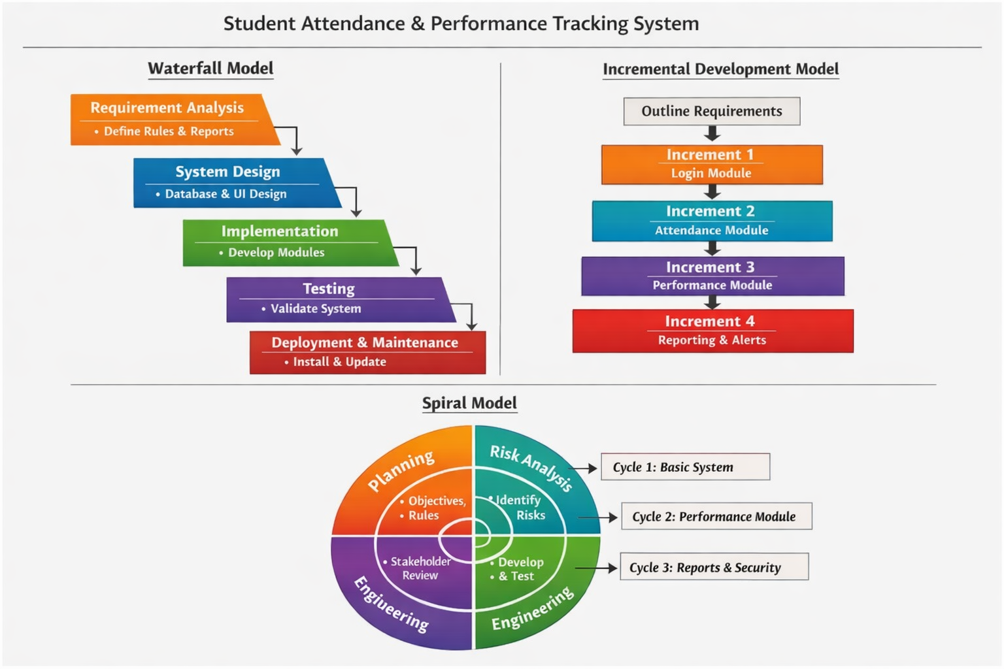
This model can be implemented in multiple cycle each consisting of different tasks.In the initial cycle, some basic feature like login and attendance recording can be implemented . The next cycles can add features dealing with tracking the overall performance ,generating the report and improvements in the security. At each and every stage the potential risks like issues related to security of the data,improper calculations or failure in the systems are identified and addressed before proceeding to the next. Also the stakeholder’s feedback is collected after each cycle to refine the system.although this particular model provides a strong risk management and flexibility,it requires more time and cost.

- Functional Requirements:
- Login informations of student and the faculty.
- Marking of the attendance.
- Calculation of Attendance percentage.
- Overall performance.
- Generation of the report.
- Alerts if there is any shortage in the attendance.

- Non- Functional Requirements:

- Security
- Accuracy
- Reliabilty
- Scalability
- Usability

Requirement Validation Strategy:

Requirement validation makes sure that the documented requirements of the system reflects the expectations of the stakeholders accurately and that the system is being developed in a complete, feasible and consistent way.
The main objectives are:
- To make sure that all the requirements and defined clearly.
- To verify all the non functional requirements of the system.
- To ensure that all the requirements coincide with the academic rules and policies,
- To identify if there is any inconsistencies or any missing requirements before beginning of the developmental phase.

- Challenges in Requirement Validation:

- Stakeholders usually descried the requirements in vague and general terms which are unclear and to interpret in different ways.This ambiguity makes it difficult to verify whether the requirements of the stakeholders are implemented in the right way or not.
- Some requirements requested from the stakeholders might be unintentionally omitted,which might lead to system rework later.
- As expectations of one stakeholder can differ from eachother,,these conflicting needs makes the validation more complex.
- Educational institutions frequently revises its criteria to calculate the attendance percentage,the grading scheme which makes it difficult to finalize and validate the requirements .

- Conclusion:

This report presents the detailed analysis of a student Attendance and Performance tracking from the perspective of a software engineer.The covers the System requirements,requirement validation strategies, challenges faced and comparative evaluation evaluation of SDLC models like waterfall model, Incremental development and spiral model.

The report clearly highlights the importance of selecting the appropriate SDLC model in the successful development of a system software.Waterfall model provides a structure and systematic approach, but it lacks the flexibility in managing the requirements as it goes on changing frequently. The Spiral model offers a strong feature to handle the iterative requirement but results in the increase in the developmental cost and also the complexity of the same. The Incremental development model is the most practical and and balanced approach for this chosen system software as it supports phase by phase or modular development , early validation , can implement based on the continuous feedbacks given by stakeholders and most importantly can also handle the frequent change in the educational system.

References

[1] | S. Pargaonkar. [Online]. Available: https://www.ijsrp.org/research-paper-0823.php?rp=P14012999.
[2] | W3SCHOOLS. [Online]. Available: https://www.w3schools.in/sdlc/waterfall-model.
[3] | D. S. H. C. M. Ankit Thakur, “,” A Survey on Incremental Software Development Life Cycle Model, vol. Volume 3, no. 2, p. 103.
[4] | A. A. a. A. Bahattab, “JCSI International Journal of Computer Science,” A Comparison Between Three SDLC Models Waterfall , vol. Volume 12, no. ,Issue 1, p. 107, January 2015 .

Declaration of Academic Integrity
I hereby declare that this assignment is my original work and has not been copied or plagiarized from any source. All references and resources used have been properly cited. Any ambiguities will lead to forfeiting my marks.
Student Signature:
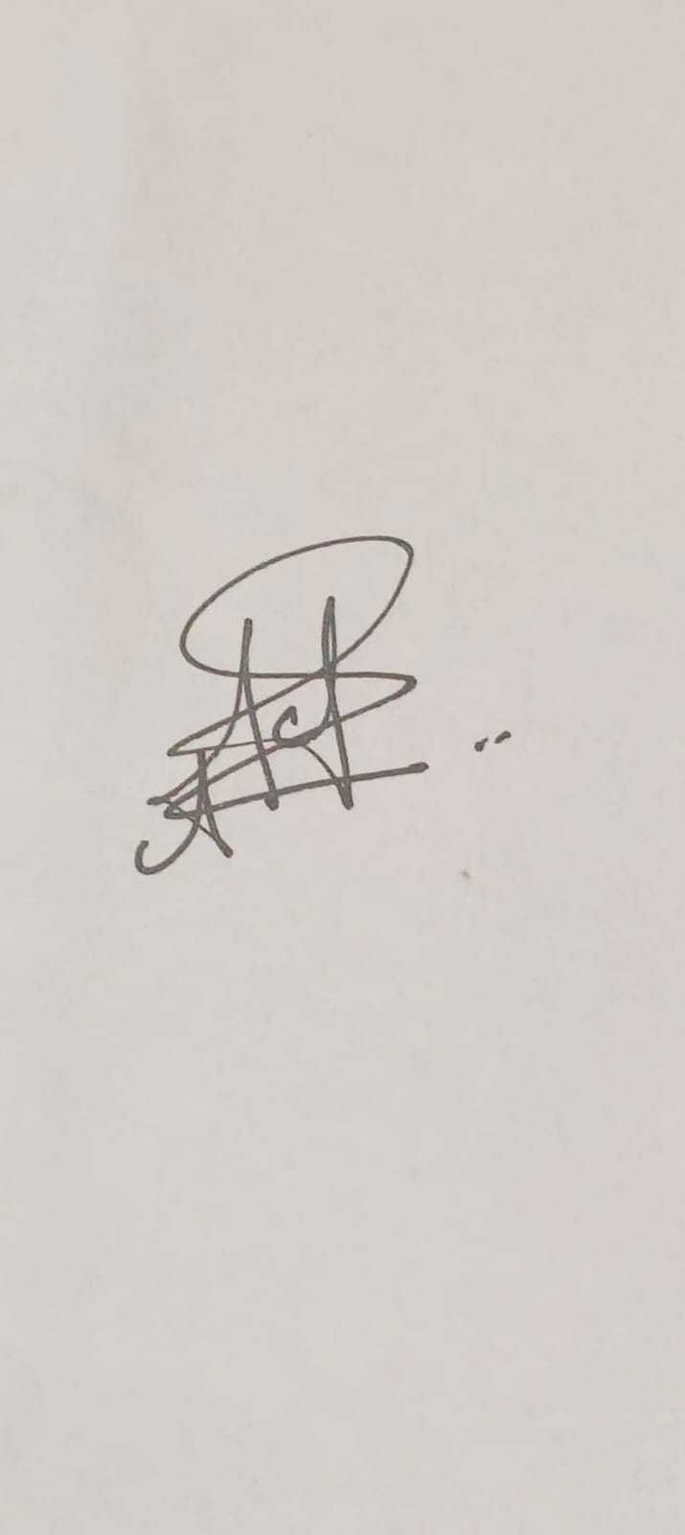
Date:15-02-2026

