Assignment-1: **Write a JavaScript to design a simple calculator to perform the following operations: sum, product, difference and quotient**.

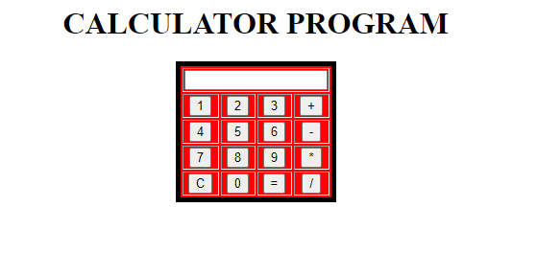

|  |  |  |  |  |
| --- | --- | --- | --- | --- |
| **Test No** | **Input parameters** | **Expected Output** | **Obtained Output** | **Remarks** |
| 1. | |  |  | | --- | --- | | Value 1 | 8 | | Value 2 | 4 | | |  |  | | --- | --- | | Addition | 12 | | Subtraction | 4 | | Multiplication | 32 | | Division | 2 | | |  |  | | --- | --- | | Addition | 12 | | Subtraction | 4 | | Multiplication | 32 | | Division | 2 | | |  | | --- | | Pass | | Pass | | Pass | | Pass | |
| 2. | |  |  | | --- | --- | | Value 1 | 1000 | | Value 2 | 30 | | |  |  | | --- | --- | | Addition | 1030 | | Subtraction | 970 | | Multiplication | 30000 | | Division | 33.333333 | | |  |  | | --- | --- | | Addition | 1030 | | Subtraction | 970 | | Multiplication | 30000 | | Division | 33.333333 | | |  | | --- | | Pass | | Pass | | Pass | | Pass | |
| 3. | |  |  | | --- | --- | | Value 1 | 0 | | Value 2 | 86 | | |  |  | | --- | --- | | Addition | 86 | | Subtraction | 86 | | Multiplication | 0 | | Division | 0 | | |  |  | | --- | --- | | Addition | 86 | | Subtraction | 86 | | Multiplication | 0 | | Division | 0 | | |  | | --- | | Pass | | Pass | | Pass | | Pass | |
| 4. | |  |  | | --- | --- | | Value 2 | 20 | | Value 1 | 0 | | |  |  | | --- | --- | | Addition | 20 | | Subtraction | 20 | | Multiplication | 0 | | Division | Infinity | | |  |  | | --- | --- | | Addition | 20 | | Subtraction | 20 | | Multiplication | 0 | | Division | Infinity | | |  | | --- | | Pass | | Pass | | Pass | | Pass | |

<!DOCTYPE html>

<html>

<head>

<script>

function dis(val)

{

document.getElementById("result").value+=val

}

function solve()

{

let v1 = document.getElementById("result").value

let v2 = eval(v1)

document.getElementById("result").value = v2

}

function clr()

{

document.getElementById("result").value = ""

}

</script>

<title>Assignment-1</title>

<style type="text/css">

table, td, th{

border: 2px ridge;

text-align: center;

background-color: red;

margin: auto;

}

input{

text-align: center;

}

</style>

</head>

<body>

<tr>

<h3><center colspan="5">SIMPLE CALCULATOR</center></h3>

<table border="1">

</tr>

<tr>

<td colspan="4"><input type="text" id="result"/></td>

</tr>

<tr>

<td><input type="button" value="1" onclick="dis('1')"/> </td>

<td><input type="button" value="2" onclick="dis('2')"/> </td>

<td><input type="button" value="3" onclick="dis('3')"/> </td>

<td><input type="button" value="/" onclick="dis('/')"/> </td>

</tr>

<tr>

<td><input type="button" value="4" onclick="dis('4')"/> </td>

<td><input type="button" value="5" onclick="dis('5')"/> </td>

<td><input type="button" value="6" onclick="dis('6')"/> </td>

<td><input type="button" value="-" onclick="dis('-')"/> </td>

</tr>

<tr>

<td><input type="button" value="7" onclick="dis('7')"/> </td>

<td><input type="button" value="8" onclick="dis('8')"/> </td>

<td><input type="button" value="9" onclick="dis('9')"/> </td>

<td><input type="button" value="+" onclick="dis('+')"/> </td>

</tr>

<tr>

<td><input type="button" value="c" onclick="clr()"/> </td>

<td><input type="button" value="0" onclick="dis('0')"/> </td>

<td><input type="button" value="=" onclick="solve()"/> </td>

<td><input type="button" value="*" onclick="dis('*')"/> </td>

</tr>

</table>

</body>

</html>