1. Features:
2. Pages:
3. Dashboard
4. Planner
5. Report
6. Project View
7. Admin
8. Timesheet
9. DMS
10. Requirement

## Dashboard

Every [Project Manager](http://www.projectmanager.com/) wants to know if their projects are on track. Using this intelligent Project Dashboard, you can view the health of your projects online. With stunning charts and tables, this Project Dashboard will help you keep projects on track at all times.

Health

Progress - 2

Cost - 6

Resources

Efficiency - 2

Time - 7

Risk - 5

Issues - 5

Changes -5

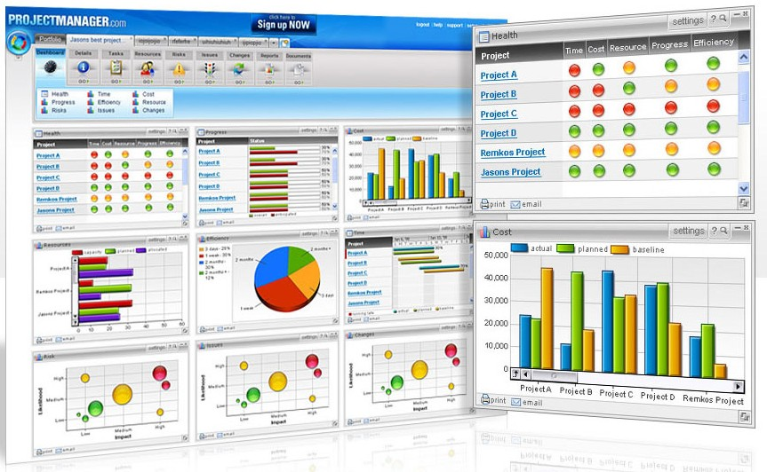

Dashboard:

List project’s status

Progress

Time

Efficiency

Issue Status (high level)

Cost

## Planner - Task management

Creating Project Plans is now as easy as 1-2-3. This stylish Project Planner offers you all of the Microsoft Project features for managing tasks, and much more. You can build a new task list, schedule your tasks, allocate resources and monitor progress. It’s that easy!

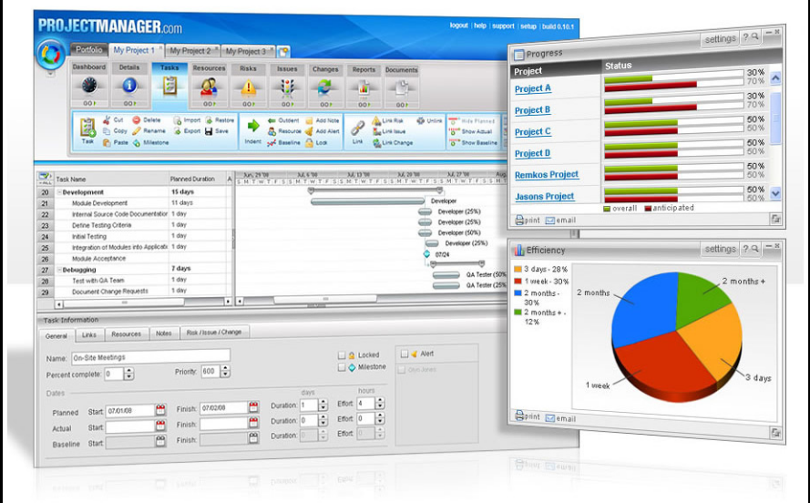

Planner: create, edit, and remove, assign

Microsoft project (import, edit, save, export)

Task status: updated by member (assignee)

## Reporting

It's now super easy to create your weekly Project Status Report. Just select the report you want to run, choose your Project Reporting period and click "View" to run the report across your projects. You can also print and export these professionally designed reports, to send to your team.

Report:

1 Project Status Report: (basic infor + PM’ notes)

* Report always based on stats?

4 number: total, current done, intended this week, done this week

Like Dashboard.

Project Status

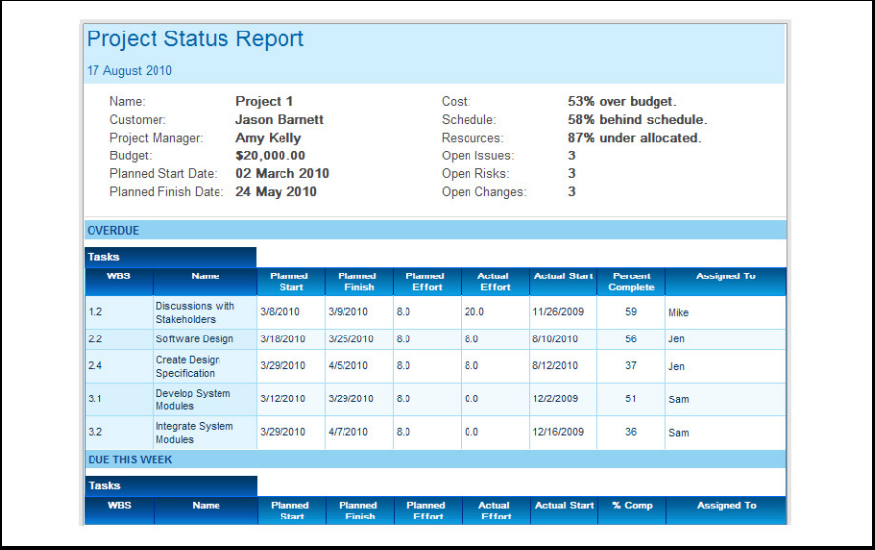

Progress Report

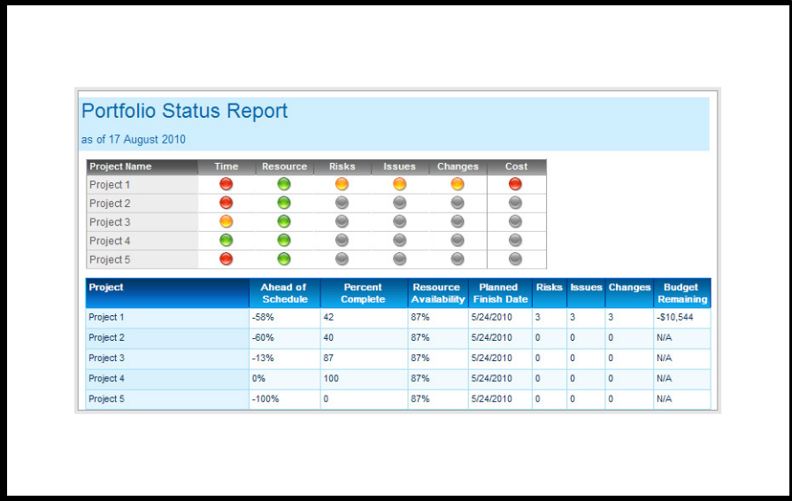

Resource Report

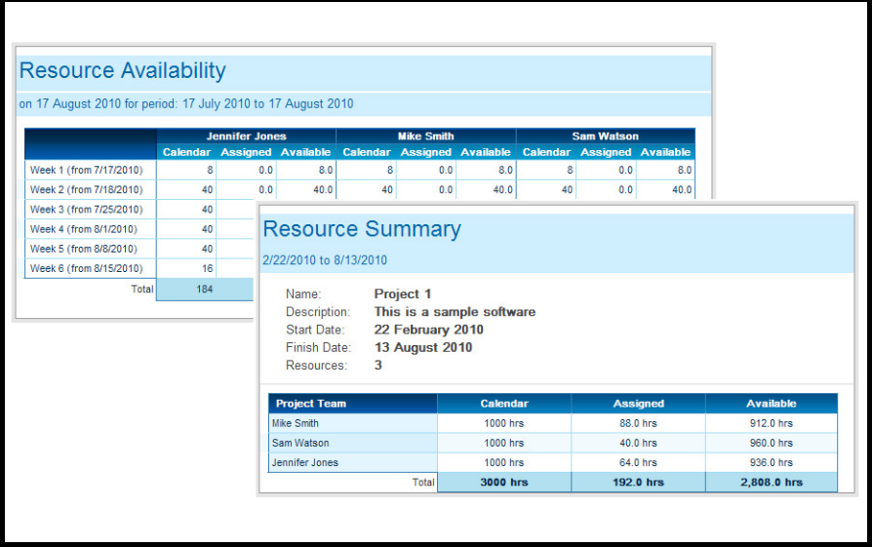

## Manage Team

List of users.

Add user to a project.

Project’s users.

## [Risks, Issues, Changes](http://www.projectmanager.com/risk-issues-changes.php)

Display Information

## [Expense Tracking](http://www.projectmanager.com/expense-tracking.php)

Monitor your project expenses with this Expense Tracking Software. You can track any type of expense such as people, materials, equipment and office expenses. As you enter each expense, the Project Dashboard tells you whether you're still under budget.

Budget:

People, material, equipment, office expenses.

## [Time Tracking](http://www.projectmanager.com/time-tracking-software.php)

Use this Time Tracking Software to complete your Timesheets online. Simply login and fill-in your timesheet. Your project dashboards, plans and reports will automatically be updated with your Timesheet information, so you're always kept up-to-date.

Timesheet – (real number).

## Project View

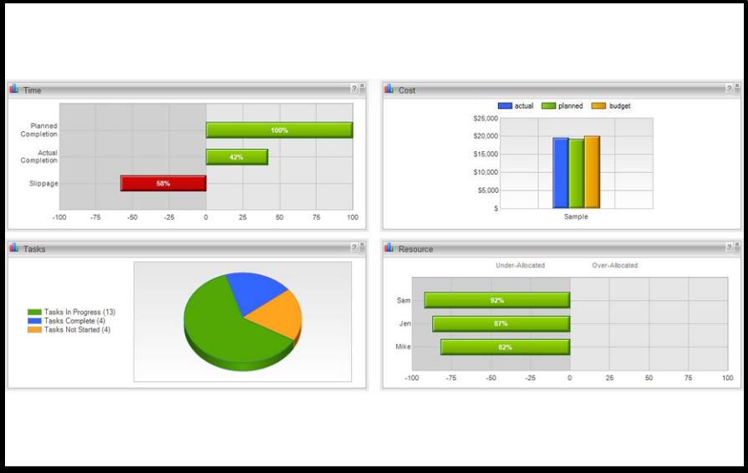

## DMS

## Requirement

List Usecase (design, review, code, test, release, appoved by Cus)

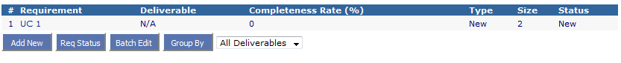

User register new PM.

Required infor and optional some features.

Super user.

Invite user.

Estimation

15 Week

* 2 : Study Requirement
* 7 : Development (Design + Code)
* 5 : Testing (Unit, Integration, Performance)
* 1 : Delivery