**Name :- Ankit Kumar**

**Roll no. :- 24**

**Registration no. :- 11902813**

**Section :- K19CJ**

**Submitted to :- Dr. Joshva Raj G**

**Topic: - Simulating LCR Circuit**

Content:

1. Theory and formulas
2. C++ code
3. Python code
4. Output
5. Graph

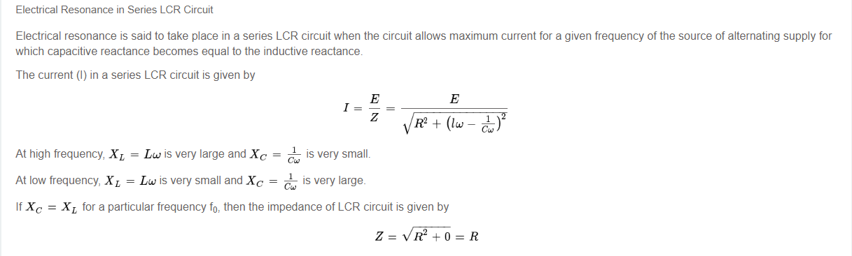

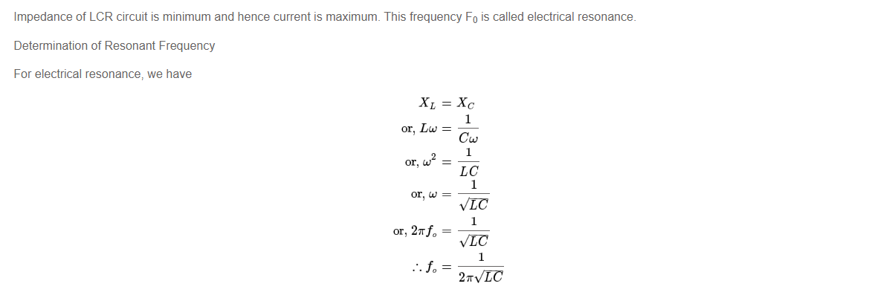



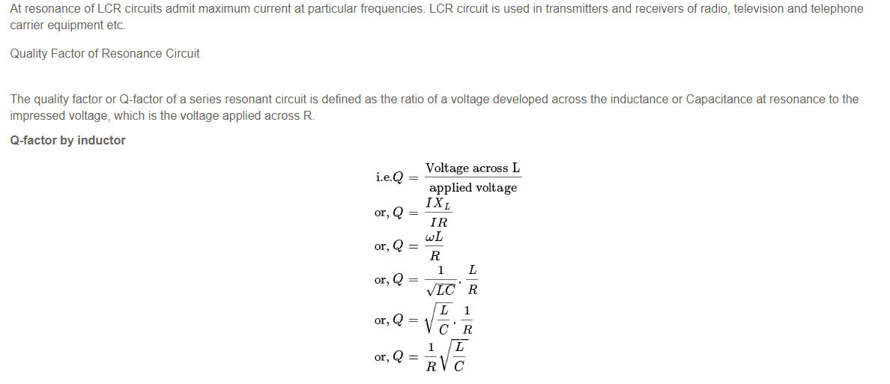

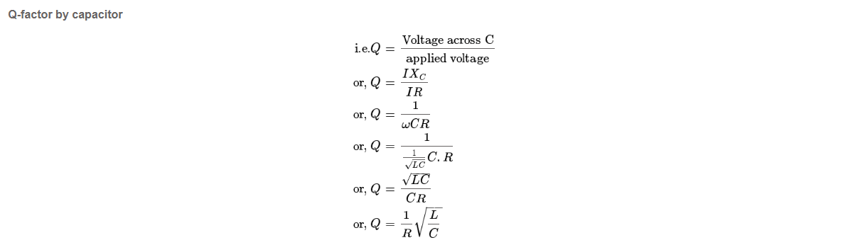

Now taking the formula which gives the relation of the frequency and the current in the LCR ckt. we have performed experiment virtually. By incrementing the of frequency from 1Hz to 100Hz and calculating the value of current.

We have also taken the input of the of the L, C, and R value to calculate :-

1. Quality factor
2. Band Width
3. And Resonance Frequency

I have used two languages here C++ (for taking inputs) and Python (mainly for calculation and graph).

