**High-level Document**

##### **Amazon customers**

Last date of revision: 20/01/2023

Ankit Kumar

# Document Version Control

|  |  |  |  |
| --- | --- | --- | --- |
| **Date Issued** | **Version** | **Description** | **Author** |
| **15 october** | 1.0 | First Version of Complete HLD | Ankit Kumar |
|  |  |  |  |
|  |  |  |  |
|  |  |  |  |
|  |  |  |  |
|  |  |  |  |
|  |  |  |  |

**Contents**

Document Version Control 2

Abstract 3

1 Introduction 5

1.1 Why this High-Level Design Document? 5

1.2 Scope 5

2 General Description 6

2.1 Product Perspective & Problem Statement 6

2.2 Tools used 6

3 Design Details 7

3.1 Functional Architecture 7

3.2 Optimization 8

4 KPIs 9

4.1 KPIs (Key Performance Indicators) 9

5 Deployment 9

# Abstract

E-commerce (electronic commerce) is the buying and selling of goods and services, or the transmitting of funds or data, over an electronic network, primarily the internet. These business transactions occur either as business-to-business (B2B), business-to-consumer (B2C), consumer-to-consumer or consumer-to-business.

Ecommerce dashboards

An ecommerce dashboard is a curated set of metrics, KPIs and other data that's designed to highlight, in the clearest possible way, trends, anomalies and information related to an online store that regularly warrants attention

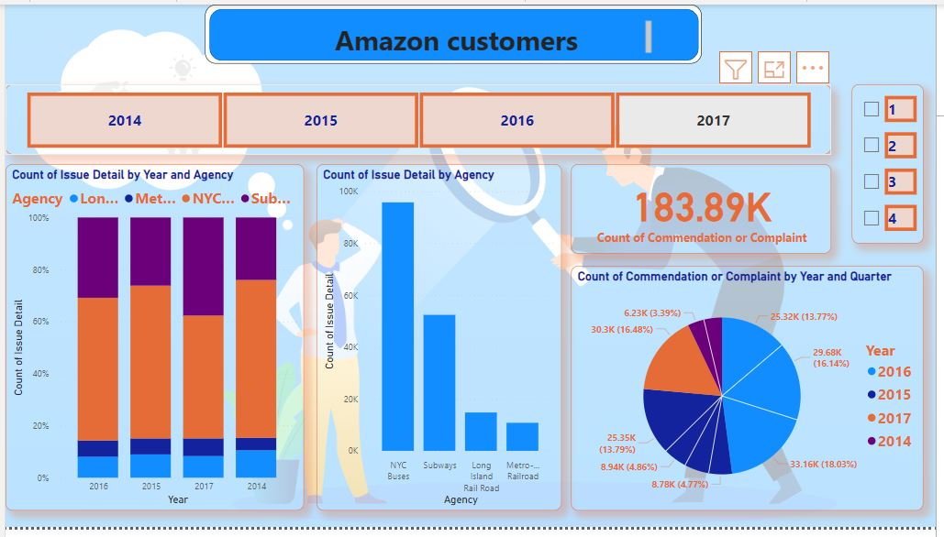

Fig01- Amazon customers

# Introduction

## Why this High-Level Design Document?

The purpose of this High-Level Design (HLD) Document is to add the necessary detail to the current project description to represent a suitable model for coding. This document is also intended to help detect contradictions prior to coding, and can be used as a reference manual for how the modules interact at a high level.

The HLD will:

* + - Present all of the design aspects and define them in detail
    - Describe the user interface being implemented
    - Describe the hardware and software interfaces
    - Describe the performance requirements
    - Include design features and the architecture of the project
    - List and describe the non-functional attributes like:
      * Securit
      * Reliability
      * Maintainability
      * Portability
      * Reusability
      * Application compatibility
      * Resource utilization
      * Serviceability

## Scope

The HLD documentation presents the structure of the system, such as the database architecture, application architecture (layers), application flow (Navigation), and technology architecture. The HLD uses non-technical to mildly-technical terms which should be understandable to the administrators of the system.

# General Description

## Product Perspective & Problem Statement

**Ecommerce dashboards**

An ecommerce dashboard is a curated set of metrics, KPIs and other data that's designed to highlight, in the clearest possible way, trends, anomalies and information related to an online store that regularly warrants attention

The objective of the project is to perform data visualization techniques to understand the insight of the data. This project aims apply various Business Intelligence tools such as Excel, Tableau or Power BI to get a visual understanding of the data.

## Tools used

1. Power BI :- Turn data into opportunity with Microsoft Power BI data visualization tools. Drive better business decisions by analysing your enterprise data for insights. programming language called Visual Basic for Applications. Power BI forms part of the Microsoft Office suite of software

  
Pandas - pandas is a fast, powerful, flexible and easy to use open source data analysis and manipulation tool, built on top of the Python programming language.

# Design Details

## Functional Architecture

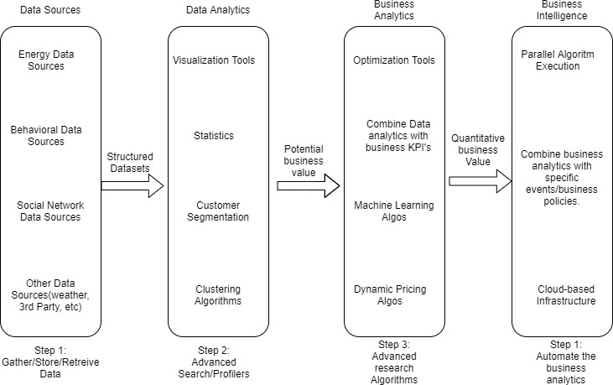

Figure 1: Functional Architecture of Business Intelligence

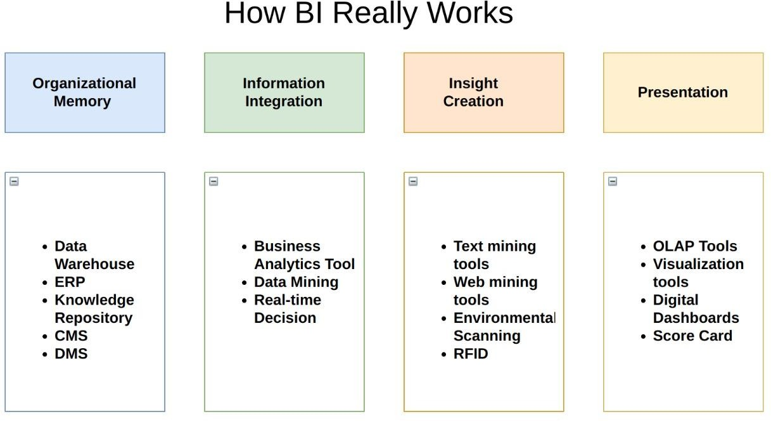

## Optimization

### Your data strategy drives performance

* + - Minimize the number of fields
    - Minimize the number of records
    - Optimize extracts to speed up future queries by materializing calculations, removing columns and the use of accelerated views

### Reduce the marks (data points) in your view

* + - Practice guided analytics. There’s no need to fit everything you plan to show in a single view. Compile related views and connect them with action filters to travel from overview to highly-granular views at the speed of thought.
    - Remove unneeded dimensions from the detail shelf.
    - Explore. Try displaying your data in different types of views.

### Limit your filters by number and type

* + - Reduce the number of filters in use. Excessive filters on a view will create a more complex query, which takes longer to return results. Double-check your filters and remove any that aren’t necessary.
    - Use an include filter. Exclude filters load the entire domain of a dimension, while include filters do not. An include filter runs much faster than an exclude filter, especially for dimensions with many members.
    - Use a continuous date filter. Continuous date filters (relative and range-of-date filters) can take advantage of the indexing properties in your database and are faster than discrete date filters.
    - Use Boolean or numeric filters. Computers process integers and Booleans (t/f) much faster than strings.
    - Use parameters and action filters. These reduce the query load (and work across data sources).

### Optimize and materialize your calculations

* + - Perform calculations in the database
    - Reduce the number of nested calculations.
    - Reduce the granularity of LOD or table calculations in the view. The more granular the calculation, the longer it takes.
      * LODs - Look at the number of unique dimension members in the calculation.
      * Table Calculations - the more marks in the view, the longer it will take to calculate.
    - [Where possible, use MIN or MAX instead of AVG](http://onlinehelp.tableau.com/current/pro/online/windows/en-us/help.htm#calculations_aggregation.html). AVG requires more processing than MIN or MAX. Often rows will be duplicated and display the same result with MIN, MAX, or AVG.

* + - [Make groups with calculations](http://kb.tableau.com/articles/knowledgebase/creating-groups-using-calculated-fields). Like include filters, calculated groups load only named members of the domain, whereas Tableau’s group function loads the entire domain.
    - [Use Booleans or numeric calculations instead of string calculations](http://onlinehelp.tableau.com/current/pro/online/mac/en-us/help.htm#functions_functions_string.html). Computers can process integers and Booleans (t/f) much faster than strings. Boolean>Int>Float>Date>DateTime>String

# KPIs



Dashboards will be implemented to display and indicate certain KPIs and relevant indicators for the disease.

As and when, the system starts to capture the historical/periodic data for a user, the dashboards will be included to display charts over time with progress on various indicators or factors

## KPIs (Key Performance Indicators) in Power Pivot

Key performance indicators (KPIs) are visual measures of performance. Supported by a specific calculated field, a KPI is designed to help users quickly evaluate the current value and status of a metric against a defined target. The KPI gauges the performance of the value, defined by a [Base](https://support.microsoft.com/en-us/office/key-performance-indicators-kpis-in-power-pivot-e653edef-8a21-40e4-9ece-83a6c8c306aa#__base_value) measure (also known as a calculated field in Power Pivot in Excel 2013), against a [Target](https://support.microsoft.com/en-us/office/key-performance-indicators-kpis-in-power-pivot-e653edef-8a21-40e4-9ece-83a6c8c306aa#__target_value) value, also defined by a measure or by an absolute value. If your model has no measures, see [Create a measure](https://support.microsoft.com/en-us/office/create-a-measure-in-power-pivot-d3cc1495-b4e5-48e7-ba98-163022a71198).

Here's a PivotTable with Employee Full Name in rows and Sales KPI in values.

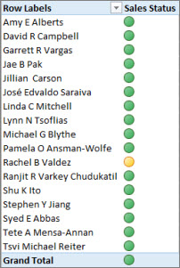

Learn more about KPIs below, and then continue reading in the section that follows to see how easy it is to create your own KPI.

## More about KPIs

A KPI is a quantifiable measurement for gauging business objectives. For example, the sales department of an organization might use a KPI to measure monthly gross profit against projected gross profit. The accounting department might measure monthly expenditures against revenue to evaluate costs, and a human resources department might measure quarterly employee turnover. Each of these is an example of a KPI. Various business professionals frequently group KPIs together in a performance scorecard to obtain a quick and accurate historical summary of business success or to identify trends.

A KPI includes a base value, a target value, and status thresholds.

### Base value

A Base value is a calculated field that must result in a value. This value, for example, can be an aggregate of sales or the profit for a specific period.

### Target value

A Target value is also a calculated field that results in a value—perhaps an absolute value. For example, a calculated field could be used as a target value, in which the business managers of an organization want to compare how the sales department is tracking toward a given quota, where the budget calculated field would represent the target value. An example in which an absolute value would be used as a target value is the common case of an HR manager needing to evaluate the number of paid-time-off hours for each employee—and then compare it the average. The average number of PTO days would be an absolute value.

### Status thresholds

A Status threshold is defined by the range between a low and high threshold. The Status threshold displays with a graphic to help users easily determine the status of the Base value compared to the Target value.

## Create a KPI

Follow these steps:

1. In Data View, click the table containing the measure that will serve as the Base measure. If necessary, learn how to Create a base measure.
2. Ensure that the Calculation Area appears. If not, then click Home > Calculation Area to display the Calculation Area appears beneath the table.
3. In the Calculation Area, right-click the calculated field that will serve as the base measure (value), and then click Create KPI.
4. In Define target value, select from one of the following:
   1. Select Measure, and then select a target measure in the box.
   2. Select Absolute value, and then type a numerical value.

Note: If there are no fields in the box, there are no calculated fields in the model. You need to create a measure.

1. In Define status thresholds, click-and-slide to adjust both the low and high threshold values.
2. In Select icon style, click an image type.
3. Click Descriptions, and then enter descriptions for KPI, Value, Status, and Target.

## Edit a KPI

In the Calculation Area, right-click the measure that serves as the base measure (value) of the KPI, and then click Edit KPI Settings.

## Delete a KPI

In the Calculation Area, right-click the measure that serves as the base measure (value) of the KPI, and then click Delete KPI.

Remember, deleting a KPI does not delete the base measure or target measure (if one was defined).

## Example

The sales manager at Adventure Works wants to create a PivotTable she can use to quickly display whether or not sales employees are meeting their sales quota for a specific year. For each sales employee, she wants the PivotTable to display the actual sales amount in dollars, the sales quota amount in dollars, and a simple graphic display showing the status of whether or not each sales employee is below, at, or above their sales quota. She wants to be able to slice the data by year.

To do this, the sales manager chooses to add a Sales KPI to the AdventureWorks workbook. The sales manager will then create a PivotTable with the fields (calculated fields and KPI) and slicers to analyze whether or not the sales force is meeting their quotas.

In Power Pivot, a calculated field on the SalesAmount column in the FactResellerSales table, which gives the actual sales amount in dollars for each sales employee is created. This calculated field will define the Base value of the KPI. The sales manager can select a column and click AutoSum on the Home tab or type a formula in the formula bar.

The Sales calculated field is created with the following formula:

Sales:=Sum(FactResellerSales[SalesAmount])

The SalesAmountQuota column in the FactSalesQuota table defines a sales amount quota for each employee. The values in this column will serve as the Target calculated field (value) in the KPI.

The SalesAmountQuota calculated field is created with the following formula:

Target SalesAmountQuota:=Sum(FactSalesQuota[SalesAmountQuota])

Note: There is a relationship between the EmployeeKey column in the FactSalesQuota table and the EmployeeKey in the DimEmployees table. This relationship is necessary so that each sales employee in the DimEmployee table is represented in the FactSalesQuota table.

Now that calculated fields are ready to serve as the Base value and Target value of the KPI, the Sales calculated field is extended to a new Sales KPI. In the Sales KPI, the Target SalesAmountQuota calculated field is defined as the Target value. The Status threshold is defined as a range by percentage, the target of which is 100% meaning actual sales defined by the Sales calculated field met the quota amount defined in the Target SalesAmountQuota calculated field. Low and High percentages are defined on the status bar, and a graphic type is selected.

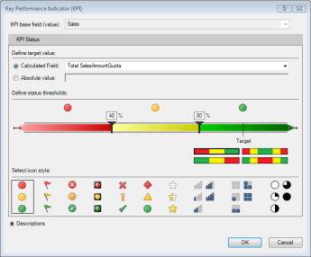

### Summarizing﻿ the example with the tangible benefits of KPIs

The sales manager can now create a PivotTable by adding the KPI Base value, Target value, and Status to the Values field. The Employees column is added to the RowLabel field, and the CalendarYear column is added as a Slicer.

The sales manager can now quickly view sales status for the sales department, slice by year the actual sales amount, sales quota amount, and status for each sales employee. She can analyze sales trends over years to determine whether or not she needs to adjust the sales quota for a sales employee.