SISTec/BTech/CS/2027/6/MinorProject_2/48
SMART ATTENDANCE SYSTEM
A
MINOR PROJECT-II REPORT
Submitted in partial fulfillment of the requirements for the degree of
BACHELOR OF TECHNOLOGY
in
COMPUTER SCIENCE & ENGINEERING
By
GROUP NO. 48
Anuj Kumar 0187CS231047
Ankit Kumar 0187CS231040
Under the guidance of
Prof. Nitin Jain
(Associate Professor)
Department of Computer Science & Engineering
Sagar Institute of Science & Technology (SISTec), Bhopal (M.P.)
Approved by AICTE, New Delhi & Govt. of M.P.
Affiliated to Rajiv Gandhi Proudyogiki Vishwavidyalaya, Bhopal (M.P.)
June - 2026

SISTec/BTech/CS/2027/6/MinorProject_2/48
Sagar Institute of Science & Technology (SISTec), Bhopal (M.P.)
Department of Computer Science & Engineering
CERTIFICATE
We hereby certify that the work presented in the B.Tech. Minor Project-II Report entitled SMART ATTENDANCE SYSTEM, submitted in partial fulfillment of the requirements for the award of the degree of Bachelor of Technology in Computer Science & Engineering, is an authentic record of our own work carried out during the period from January 2026 to June 2026 under the supervision of Prof. Nitin Jain.
The content presented in this project has not been submitted by us for the award of any other degree elsewhere.
Anuj Kumar | Ankit Kumar
0187CS231047 | 0187CS231040

This is to certify that the above statement made by the candidates is correct to the best of my knowledge.
Date:
Prof. Nitin Jain | Prof. Nargish Gupta | Dr. Manish Billore
Project Guide | HOD, CSE | Principal

ACKNOWLEDGEMENT
We would like to express our sincere thanks to Dr. Manish Billore, Principal, SISTec, and Dr. Swati Saxena, Vice Principal, SISTec Gandhi Nagar, Bhopal, for providing us the opportunity to undertake this project.
We also express our gratitude to Prof. Nargish Gupta, Head of the Department of Computer Science & Engineering, for her support and encouragement throughout the project work.
We extend our sincere and heartfelt thanks to our project guide, Prof. Nitin Jain, for providing the right guidance, advice, and technical direction at crucial stages of the project.
We are thankful to the project coordinator, Prof. Mayank Kurchaniya, for his valuable time, coordination, and continuous support during the project development and documentation process.
We would also like to thank all faculty members, friends, and colleagues who helped us directly or indirectly in completing this project.

Table of Contents
Title | Page No.
Abstract | i
List of Abbreviations | ii
List of Figures | iii
List of Tables | iv
Chapter 1 Introduction | 1
Chapter 2 Software & Hardware Requirements | 4
Chapter 3 Problem Description | 7
Chapter 4 Literature Survey | 9
Chapter 5 Software Requirements Specification | 12
Chapter 6 Software and Hardware Design | 17
Chapter 7 ML and Face Recognition Module | 23
Chapter 8 Coding and Implementation | 28
Chapter 9 Result and Output Screens | 34
Chapter 10 Conclusion and Future Work | 38
References | 40
Annexure: Project Details | 41

Abstract
Smart Attendance System is a full-stack web application designed to digitize and secure attendance management in academic institutions. The updated system combines QR-code based attendance, face verification, geofence-assisted validation, role-based access control, real-time session updates, and machine-learning based attendance shortage prediction. The system provides separate dashboards for administrators, faculty members, and students, allowing each user group to perform only the operations relevant to its role.
The backend is developed using Node.js, Express.js, MongoDB, Mongoose, JWT authentication, and Socket.IO. The frontend is implemented using HTML, CSS, and JavaScript with modular dashboard components. A Python-based face recognition worker handles face registration and verification, while a separate Flask-based ML service predicts shortage risk using attendance percentage and absent-days features derived from MongoDB attendance records. The project reduces manual effort, limits proxy attendance, improves transparency, and provides actionable insights for early academic intervention.

List of Abbreviations
Abbreviation | Full Form
API | Application Programming Interface
CSV | Comma Separated Values
DB | Database
HTTP | Hyper Text Transfer Protocol
JWT | JSON Web Token
ML | Machine Learning
MVC | Model View Controller
QR | Quick Response
REST | Representational State Transfer
SRS | Software Requirements Specification
UI | User Interface

List of Figures
Figure No. | Title
Figure 1.1 | Use Case Overview
Figure 6.1 | System Architecture
Figure 6.2 | Attendance Session Workflow
Figure 6.3 | Database Entity Overview
Figure 7.1 | ML Shortage Prediction Pipeline

List of Tables
Table No. | Title
Table 2.1 | Software Requirements
Table 2.2 | Hardware Requirements
Table 5.1 | Functional Requirements
Table 5.2 | Database Collections
Table 8.1 | Important API Endpoints

Chapter 1: Introduction

1.1 About Project
Attendance is a critical academic process, but traditional attendance registers are time-consuming, error-prone, and difficult to audit. Smart Attendance System replaces manual attendance with a secure digital workflow where faculty members can start class sessions, students can mark attendance using QR codes and verification checks, and administrators can monitor departments, courses, schedules, users, and reports from a centralized dashboard.
The updated version of the project extends the earlier QR-based prototype into a more complete attendance platform. It now includes face registration and verification, real-time session updates through Socket.IO, geofence-based location checks, manual attendance fallback for faculty, CSV export, administrative face-registration controls, and attendance shortage prediction using a Python ML service.

1.2 Project Objectives
- To provide a secure and efficient digital attendance system for educational institutions.
- To reduce manual attendance work for faculty members during classroom sessions.
- To prevent proxy attendance using QR token expiry, device/location checks, and face verification.
- To provide role-based dashboards for admin, faculty, and student users.
- To enable real-time attendance monitoring and structured attendance reports.
- To predict attendance shortage risk early using machine learning so faculty and students can intervene on time.

1.3 Scope of the Project
The project covers user authentication, academic setup, timetable management, attendance session management, student attendance marking, face registration, attendance analytics, ML prediction, and deployment preparation. It is suitable for college-level academic attendance where students, faculty, and administrators operate through a browser-based interface.

1.4 Existing System and Proposed System
Aspect | Existing Manual System | Proposed Smart System
Attendance entry | Faculty marks attendance manually in register or sheet. | Faculty starts a QR/verified digital session.
Proxy prevention | Difficult to prevent reliably. | Uses token expiry, location data, face verification, and unique records.
Reporting | Manual calculation and repeated effort. | Dashboard, reports, CSV export, and analytics.
Risk detection | Late identification of shortage. | ML service predicts shortage risk from attendance features.
Data access | Physical records or isolated files. | MongoDB-backed centralized web application.

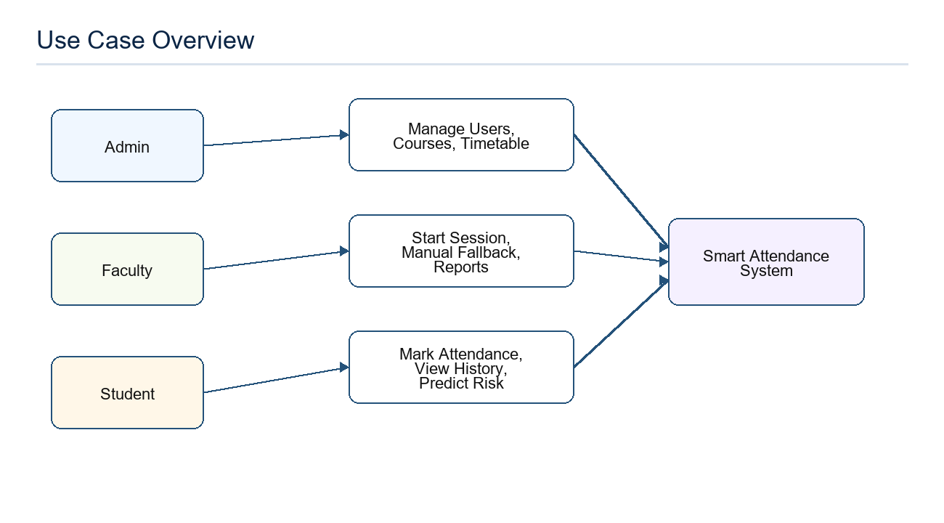
Figure 1.1: Use Case Overview

Chapter 2: Software & Hardware Requirements

2.1 Software Requirements
Component | Technology / Tool | Purpose
Backend runtime | Node.js | Runs Express server and application logic.
Backend framework | Express.js | Defines REST APIs and static frontend serving.
Database | MongoDB with Mongoose | Stores users, classes, sessions, attendance records, face metadata, and logs.
Authentication | JWT and bcryptjs | Token-based login and password hashing.
Real-time updates | Socket.IO | Class room updates for live attendance sessions.
Frontend | HTML5, CSS3, JavaScript | Browser-based dashboards and user workflows.
Charts and QR | Chart.js and QRious | Analytics visualization and QR generation.
Face recognition | Python, face-recognition, OpenCV, Pillow | Face descriptor generation and verification.
ML service | Flask, pandas, scikit-learn, pymongo, joblib | Shortage-risk model training and prediction.
Deployment | Render, Docker, EC2/Nginx support files | Cloud deployment and reverse proxy preparation.

2.2 Hardware Requirements
Hardware | Minimum Requirement
Processor | Intel i3 or equivalent for development; higher recommended for face-recognition dependencies.
RAM | 4 GB minimum; 8 GB recommended.
Storage | 1 GB free space for source code, dependencies, and model artifacts.
Student device | Smartphone or laptop with camera and browser.
Faculty device | Laptop/desktop or smartphone with browser and network access.
Network | Internet or local LAN connection for API, database, and ML services.

2.3 Environment Variables
- MONGO_URI: MongoDB connection string.
- JWT_SECRET and JWT_EXPIRES_IN: JWT signing and expiry configuration.
- DEFAULT_ADMIN_EMAIL, DEFAULT_ADMIN_PASSWORD, DEFAULT_ADMIN_NAME: default admin bootstrap values.
- ML_PREDICT_URL and ML_TRAIN_SECRET: Flask ML service URL and retraining authorization secret.
- FACE_ML_TIMEOUT_MS and FACE_PYTHON_BIN: optional face-worker runtime configuration.
- EMAIL_HOST, EMAIL_PORT, EMAIL_USER, EMAIL_PASS: optional email configuration.

Chapter 3: Problem Description
Manual attendance systems create delays during lectures, consume faculty time, and often lead to inaccurate records. Students may mark proxy attendance for absent classmates, and paper-based records are difficult to search, analyze, or convert into actionable reports. Even digital spreadsheets require manual entry and do not provide built-in authentication or real-time validation.
The key problem addressed by this project is the need for a secure, scalable, and institution-friendly attendance system that handles classroom attendance, role-based administration, reporting, and early shortage detection. The system must be usable by students and faculty on normal browsers without requiring a separate mobile application.

3.1 Problem Statements
- Manual attendance wastes valuable classroom time.
- Proxy attendance is difficult to detect using registers or simple spreadsheets.
- Department, section, course, faculty, and timetable data are often managed separately.
- Students do not always receive early warning before attendance shortage becomes serious.
- Administrators need structured reports instead of scattered records.

3.2 Proposed Solution
The proposed solution provides an integrated web platform in which administrators configure academic data, faculty members start attendance sessions from scheduled classes, and students mark attendance using QR-based workflows supported by verification checks. Attendance data is stored in MongoDB and can be used for reports, dashboards, and ML-based prediction.

Chapter 4: Literature Survey
Attendance automation has been implemented using biometric systems, RFID cards, QR codes, mobile applications, and face recognition. Each approach has advantages and limitations. Biometric devices are accurate but require dedicated hardware and maintenance. RFID systems are fast but cards can be shared. QR-based systems are inexpensive and easy to deploy, but require additional checks to reduce proxy attempts. Face recognition improves identity assurance but depends on camera quality, lighting, and runtime dependencies.
Approach | Advantages | Limitations
Manual register | Simple and low-cost. | Slow, error-prone, poor analytics, proxy risk.
RFID card | Fast scanning and simple operation. | Requires cards/readers; cards can be exchanged.
Biometric device | Strong identity verification. | Hardware cost, maintenance, limited flexibility.
QR attendance | Low-cost, browser-friendly, fast deployment. | Needs token, device, location, or face checks for stronger security.
Face recognition | Improves identity verification. | Lighting, camera quality, and dependency setup affect reliability.
ML prediction | Enables proactive intervention. | Depends on enough historical attendance data.

The updated Smart Attendance System combines practical QR attendance with face and ML modules, giving a balance between usability, cost, and security.

Chapter 5: Software Requirements Specification

5.1 Functional Requirements
Module | Functional Requirement
Authentication | Users must log in using email and password; passwords are stored as bcrypt hashes.
Authorization | Admin, faculty, and student routes must be protected by role-based middleware.
Admin | Admin can manage users, departments, sections, courses, classes, timetables, faculty schedules, promotion, graduation, ML retraining, and face registration controls.
Faculty | Faculty can view schedules, start/end attendance sessions, view students, save attendance, mark manual attendance, and export reports.
Student | Students can view profile, timetable, classes, attendance history, active sessions, today's attendance, and mark attendance.
Attendance | System must generate unique QR tokens, enforce session expiry, avoid duplicate records, and store attendance records.
Face verification | Students can register and verify faces; admin can inspect/reset/disable registrations.
ML prediction | System can request attendance shortage prediction and admin can retrain or inspect training status.
Analytics | System can generate overview reports and CSV exports.

5.2 Non-Functional Requirements
- Security: JWT authentication, bcrypt hashing, role checks, unique attendance records, and token expiry.
- Performance: API responses should support normal classroom concurrency and dashboard refreshes.
- Reliability: Centralized error handling and graceful ML/face-worker error mapping should inform users when services are unavailable.
- Usability: Interfaces should be simple for admin, faculty, and students with browser-based access.
- Maintainability: Backend follows route-controller-model separation and frontend uses reusable JS components.
- Scalability: MongoDB collections and service separation allow future scaling of backend, ML, and face modules.

5.3 Database Collections
Collection / Model | Purpose
User | Stores admin, faculty, and student identity, role, academic fields, status, and face descriptor metadata.
Department | Stores academic department data.
Section | Stores department, semester, and section mapping.
Course | Stores course code, name, department, semester, and credits.
Class | Stores course and faculty mapping with enrolled students.
FacultySchedule | Stores faculty weekly schedule slots.
TimeTable | Stores department/semester/section weekly timetable and current-class lookup.
AttendanceSession | Stores class session, QR token, expiry, active status, location, and radius.
AttendanceRecord | Stores student attendance status and geofence audit fields.
FaceVerification | Stores short-lived verification tokens and confidence values.
FaceRegistrationLog | Stores face registration, verification, reset, disable, and enable audit events.

5.4 Security Requirements
- Only authenticated users can access protected API routes.
- Only admins can manage academic master data and face-registration controls.
- Only faculty users can start or close attendance sessions for their classes.
- Only students can mark their own attendance.
- Attendance records must be unique per session and student.
- Face verification tokens must expire and become unusable after consumption.

Chapter 6: Software and Hardware Design

6.1 System Architecture
The system follows a three-tier architecture. The presentation layer consists of browser-based HTML, CSS, and JavaScript pages. The application layer is the Express.js backend that exposes REST APIs, serves static files, handles Socket.IO communication, and coordinates with Python services. The data layer is MongoDB, which stores users, academic data, attendance sessions, records, face metadata, and logs.
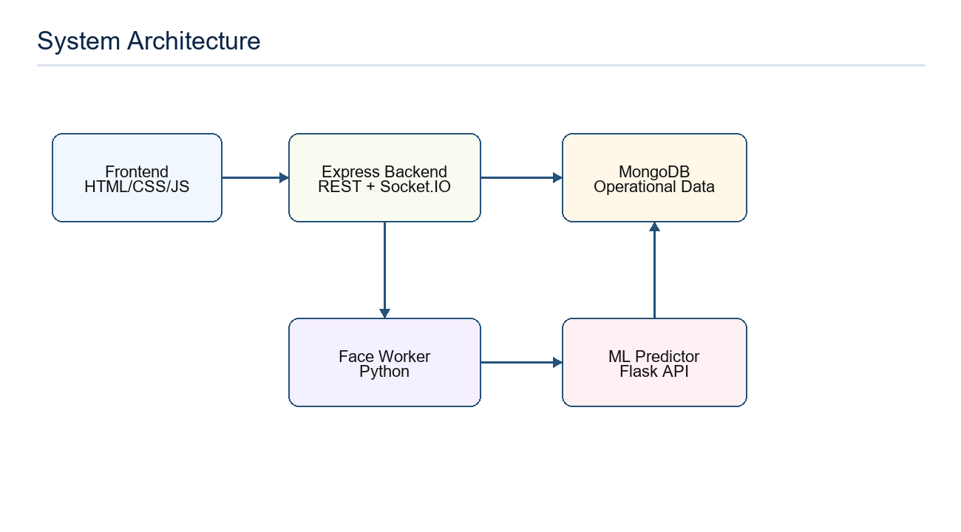
Figure 6.1: System Architecture

6.2 Attendance Workflow
Faculty members start an attendance session from their dashboard or current class context. A unique QR token is generated with an expiry time. Students scan the QR token and submit attendance data. The backend validates the student role, session status, token, duplicate record condition, and optional location/face verification before saving the attendance record.
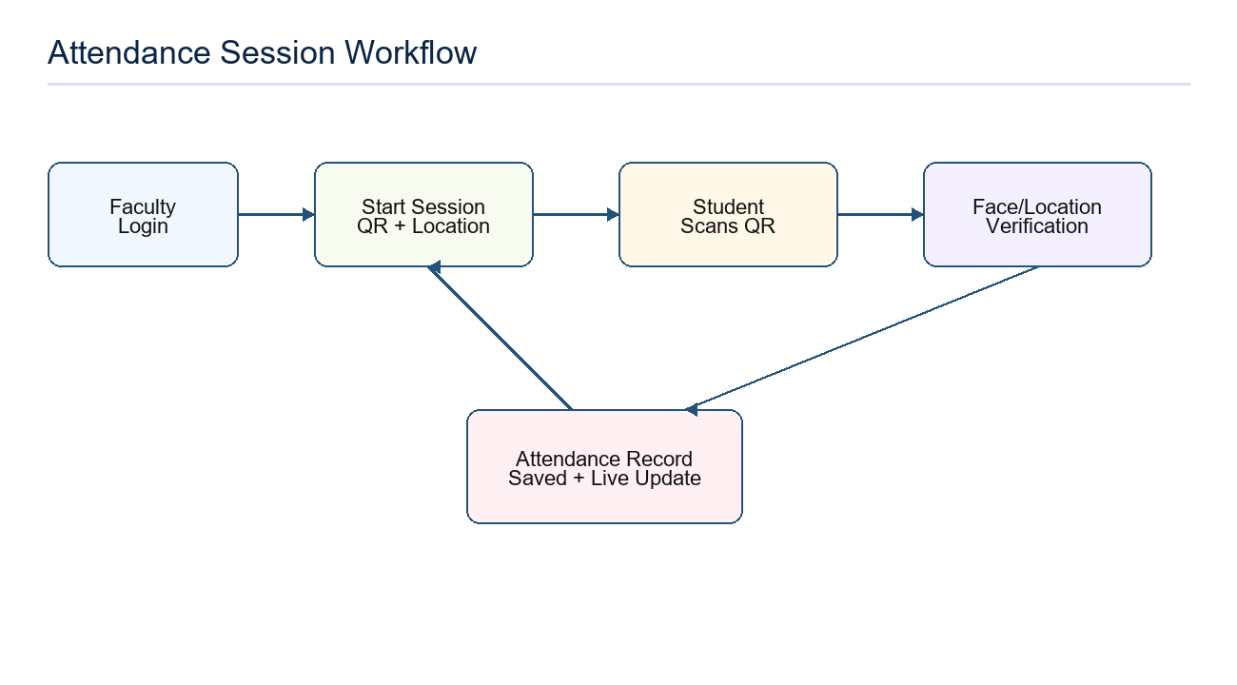
Figure 6.2: Attendance Session Workflow

6.3 Database Design
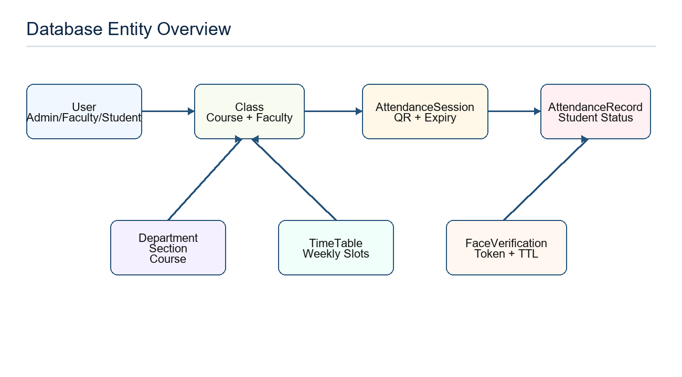
Figure 6.3: Database Entity Overview

6.4 Module Design
Module | Design Responsibility
Routes | Define endpoint URLs and role protection for auth, admin, faculty, student, analytics, and ML APIs.
Controllers | Implement business logic such as user creation, session start, attendance marking, reports, and ML proxy calls.
Models | Define MongoDB schemas and indexes for application data.
Middleware | Authenticate JWT token, enforce roles, and handle errors.
Utilities | Provide JWT helpers, mailer, geofence distance calculation, face-worker bridge, and ML HTTP client.
Frontend components | Reusable layout, navigation, dashboard cards, tables, and dashboard pages.

Chapter 7: ML and Face Recognition Module

7.1 Attendance Shortage Prediction
The attendance shortage module is a separate Python Flask service under the ml directory. It uses MongoDB attendance data to build features per student and train a Logistic Regression model. The main backend communicates with the service through an isolated ML prediction client.
- attendance_percentage is calculated from present sessions divided by total class sessions.
- absent_days is calculated from missed sessions.
- shortage_risk is marked as 1 when attendance percentage is below the institutional threshold, commonly 75 percent.
- The trained model is stored as attendance_model.pkl and can be retrained from live MongoDB data.
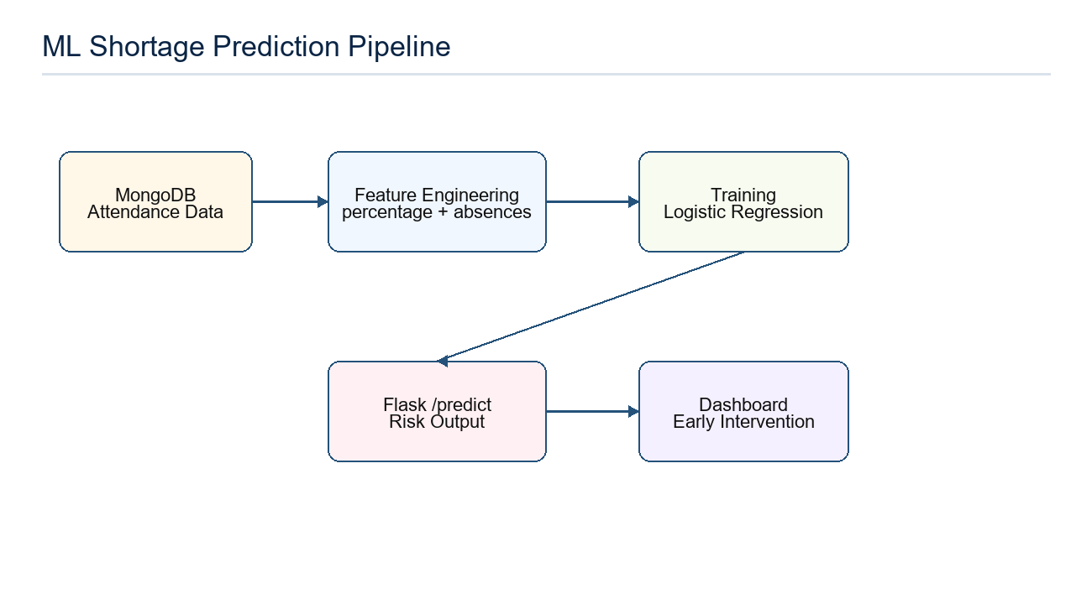
Figure 7.1: ML Shortage Prediction Pipeline

7.2 Face Recognition Module
Face recognition is handled through a local Python worker in backend/ml. The Node.js backend spawns the worker, sends a JSON payload, and receives JSON output. Student face descriptors are stored in the User model so registrations remain available across restarts and deployments.
- Face registration stores a 128-length descriptor, registration timestamp, update timestamp, and disabled status.
- Face verification creates a short-lived token through the FaceVerification model.
- Tokens expire automatically using a TTL index and are consumed after successful use.
- FaceRegistrationLog stores registration, update, reset, disable, enable, and verify audit events.

7.3 ML and Face Service Error Handling
The backend maps ML timeout, connection, and validation errors into HTTP-friendly responses. The face worker also reports missing Python, missing dependencies, timeout, bad output, and execution failures so that administrators can diagnose runtime issues without crashing the main application.

Chapter 8: Coding and Implementation

8.1 Project Structure
Path | Description
backend/server.js | Express application entry point, static serving, REST routes, Socket.IO setup, and default admin creation.
backend/routes | Route definitions for authentication, admin, faculty, student, analytics, and ML APIs.
backend/controllers | Business logic for each route group.
backend/models | Mongoose schemas for users, academic data, attendance, face verification, and logs.
backend/utils | Reusable helpers for JWT, mailer, geofence, face worker, and ML service calls.
frontend | Static HTML pages and JavaScript dashboard code.
frontend/assets/js/components | Reusable UI components such as cards, navigation, profile dropdown, and responsive tables.
ml | Flask ML API, feature engineering, training core, and model artifacts.
backend/ml | Python face recognition service and worker.

8.2 Important API Endpoints
Role | Endpoint | Purpose
Public | POST /api/auth/login | Authenticate user and return JWT token.
Public | POST /api/auth/register | Register user from frontend flow.
Admin | GET/POST /api/admin/users | List and create users.
Admin | POST /api/admin/students/create-basic | Create student identity before academic assignment.
Admin | POST /api/admin/students/assign-academic | Assign department, semester, and section.
Admin | GET/POST /api/admin/ml/retrain | Trigger ML retraining and inspect training status.
Admin | GET /api/admin/face-registrations | Review face registrations.
Faculty | POST /api/faculty/auto-session | Start session from current schedule context.
Faculty | POST /api/faculty/manual-attendance | Manual fallback attendance marking.
Student | POST /api/student/mark-attendance | Mark attendance for active session.
Student | GET /api/student/attendance | View attendance history.
ML | POST /api/ml/predict-shortage | Request shortage-risk prediction.
ML | POST /api/ml/register-face | Register student face descriptor.
ML | POST /api/ml/verify-face | Verify student face and create verification token.

8.3 Key Implementation Points
- server.js configures CORS, JSON parsing, morgan logging, static frontend serving, REST route mounting, Socket.IO, and default admin bootstrap.
- authMiddleware verifies JWT and attaches user id and role to request context.
- requireRole protects admin, faculty, and student routes from unauthorized access.
- AttendanceRecord has a compound unique index on sessionId and studentId to prevent duplicate marking.
- TimeTable provides a getCurrentClass static method to detect ongoing or upcoming classes.
- The geofence utility calculates distance with the Haversine formula.
- ML prediction payloads are validated before forwarding to Flask.

8.4 Setup Commands
- Install backend dependencies: cd backend && npm install
- Create backend .env with MONGO_URI, JWT_SECRET, default admin credentials, and optional ML/face configuration.
- Start backend: npm start or npm run dev
- Install ML dependencies: cd ml && pip install -r requirements.txt
- Start ML API: python app.py
- Open application in browser at the backend server URL.

Chapter 9: Result and Output Screens
The implemented system provides separate browser dashboards for each user role. Since the frontend is served by the backend, users can access the login page and role-specific dashboards directly through the application URL.

9.1 Login and Role Redirection
The login page accepts user email and password. After successful authentication, the frontend stores the JWT token and user object in local storage and redirects users to admin, faculty, or student dashboard according to the authenticated role.

9.2 Admin Dashboard Result
- Admin can create and manage departments, sections, courses, users, classes, and timetables.
- Admin can create students in two steps: basic identity first, then academic assignment.
- Admin can manage faculty schedules and perform promotion/graduation workflows.
- Admin can inspect analytics, export reports, retrain the ML model, and manage face registration status.

9.3 Faculty Dashboard Result
- Faculty can view today's classes, full weekly schedule, and current class context.
- Faculty can start an attendance session and display QR code for students.
- Faculty can end sessions and view class-wise attendance reports.
- Manual attendance fallback is available when QR or verification workflow cannot be completed.

9.4 Student Dashboard Result
- Student can view profile, timetable, active sessions, and attendance history.
- Student can mark attendance from an active QR session.
- Student can register and verify face when face workflow is enabled.
- Student can request or view shortage prediction depending on frontend integration.

9.5 Testing Summary
Test Area | Expected Result
Authentication | Valid users receive JWT; invalid users are rejected.
Role protection | Users cannot access endpoints outside their role.
Attendance session | Faculty can create active session with unique QR token and expiry.
Duplicate attendance | Same student cannot mark multiple records for same session.
Face verification | Successful verification returns short-lived token; expired token is rejected.
ML prediction | Valid numeric payload returns prediction; invalid payload returns validation error.
Reports | Faculty/admin can view attendance data and export CSV where implemented.

Chapter 10: Conclusion and Future Work

10.1 Conclusion
Smart Attendance System successfully demonstrates a practical full-stack solution for attendance management in academic institutions. The project improves the earlier QR-only workflow by adding stronger verification, real-time updates, better administrative controls, and ML-based shortage prediction. The system reduces manual effort, improves attendance record reliability, and provides structured data for academic decision-making.
The use of Node.js, Express, MongoDB, static frontend assets, Python face-recognition tooling, and Flask-based ML service creates a modular architecture in which each component has a clear responsibility. This makes the project maintainable and ready for future improvements such as mobile applications, richer analytics, and institutional integration.

10.2 Future Work
- Develop a dedicated Android or iOS mobile application for smoother QR scanning and push notifications.
- Add parent portal or mentor dashboard for low-attendance alerts.
- Improve face liveness detection to reduce spoofing attempts.
- Add bulk Excel import/export for students, courses, and attendance records.
- Integrate SMS/email alerts for students nearing shortage threshold.
- Add advanced analytics such as department-wise trends, subject-wise risk, and semester comparison.
- Introduce audit dashboards for attendance changes and manual overrides.
- Harden deployment with HTTPS, production logging, monitoring, and backup strategy.

References
- Pressman, R. S. Software Engineering: A Practitioner's Approach, McGraw-Hill.
- Sommerville, I. Software Engineering, Pearson Education.
- MongoDB Documentation. Mongoose ODM and MongoDB database modeling.
- Express.js Documentation. Routing, middleware, and REST API development.
- Socket.IO Documentation. Real-time bidirectional event-based communication.
- Scikit-learn Documentation. Logistic Regression and model training workflow.
- Flask Documentation. Python web API development.
- face-recognition Python Library Documentation. Face encoding and comparison workflow.
- OWASP Web Security Guidelines. Authentication, authorization, and input validation practices.

Annexure: Project Details
Field | Details
Project Title | Smart Attendance System
Semester | 6
Project Type | Minor Project-II
Group Number | 48
Team Members | Anuj Kumar (0187CS231047), Ankit Kumar (0187CS231040)
Project Guide | Prof. Nitin Jain
Development Model | Agile iterative development
Architecture | Three-tier architecture: frontend, backend, database, with Python service modules.
Backend | Node.js, Express.js, MongoDB, Mongoose, JWT, Socket.IO
Frontend | HTML, CSS, JavaScript
ML | Python, Flask, pandas, scikit-learn, pymongo, joblib
Face Recognition | Python face-recognition, OpenCV, Pillow, local worker bridge
Database Collections | User, Department, Section, Course, Class, FacultySchedule, TimeTable, AttendanceSession, AttendanceRecord, FaceVerification, FaceRegistrationLog

