AI-Powered Fashion Image Classification System

1. Project Overview
This project aims to develop a Convolutional Neural Network (CNN) model capable of classifying grayscale fashion images from the Fashion-MNIST dataset into ten categories.
The system automates fashion item recognition, supporting applications such as e-commerce tagging and digital wardrobe organization.

2. Pipeline Overview
- - Import necessary libraries
- - Load the Fashion-MNIST dataset
- - Data preprocessing and normalization
- - Dataset splitting (Train: 70%, Validation: 15%, Test: 15%)
- - CNN model design
- - Model compilation
- - Callbacks configuration
- - Model training
- - Model evaluation and visualization
- - Model saving (model.h5)
- - Deployment and prediction testing

3. Data Preprocessing
The Fashion-MNIST dataset consists of 60,000 training images and 10,000 testing images, each of size 28×28 pixels in grayscale.
Each image belongs to one of the following 10 categories: ['T-shirt/top', 'Trouser', 'Pullover', 'Dress', 'Coat', 'Sandal', 'Shirt', 'Sneaker', 'Bag', 'Ankle boot'].
Images were normalized (0–1) and split into 70% training, 15% validation, and 15% testing.

4. Model Architecture
A Sequential CNN architecture was designed with convolutional, batch normalization, pooling, dense, and dropout layers.
The total number of trainable parameters was approximately 161,098.

5. Callbacks Used
EarlyStopping and ReduceLROnPlateau were used to prevent overfitting and enhance model generalization.

6. Training Summary
The model was trained for 30 epochs using Adam optimizer and sparse categorical cross-entropy loss function.

7. Model Performance
The model achieved a validation accuracy of approximately 93%. Below are the visualizations of accuracy and loss curves.
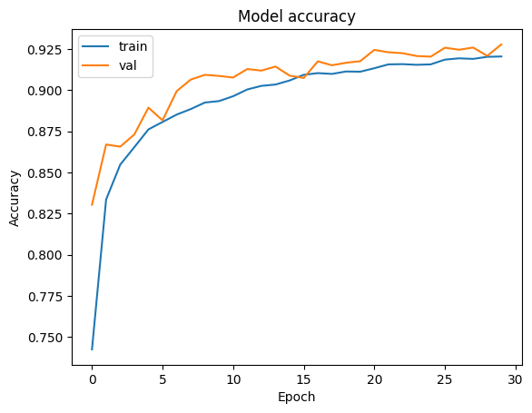
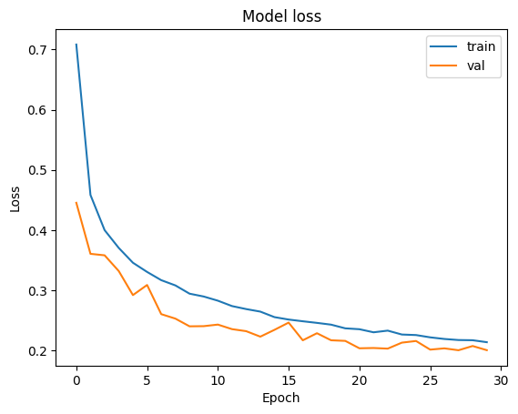

8. Model Evaluation
Classification metrics show strong performance across all classes.
Average accuracy: 0.9303 | Precision: 0.9304 | Recall: 0.9297 | F1-score: 0.9297
The confusion matrix shows classification results across all 10 categories:
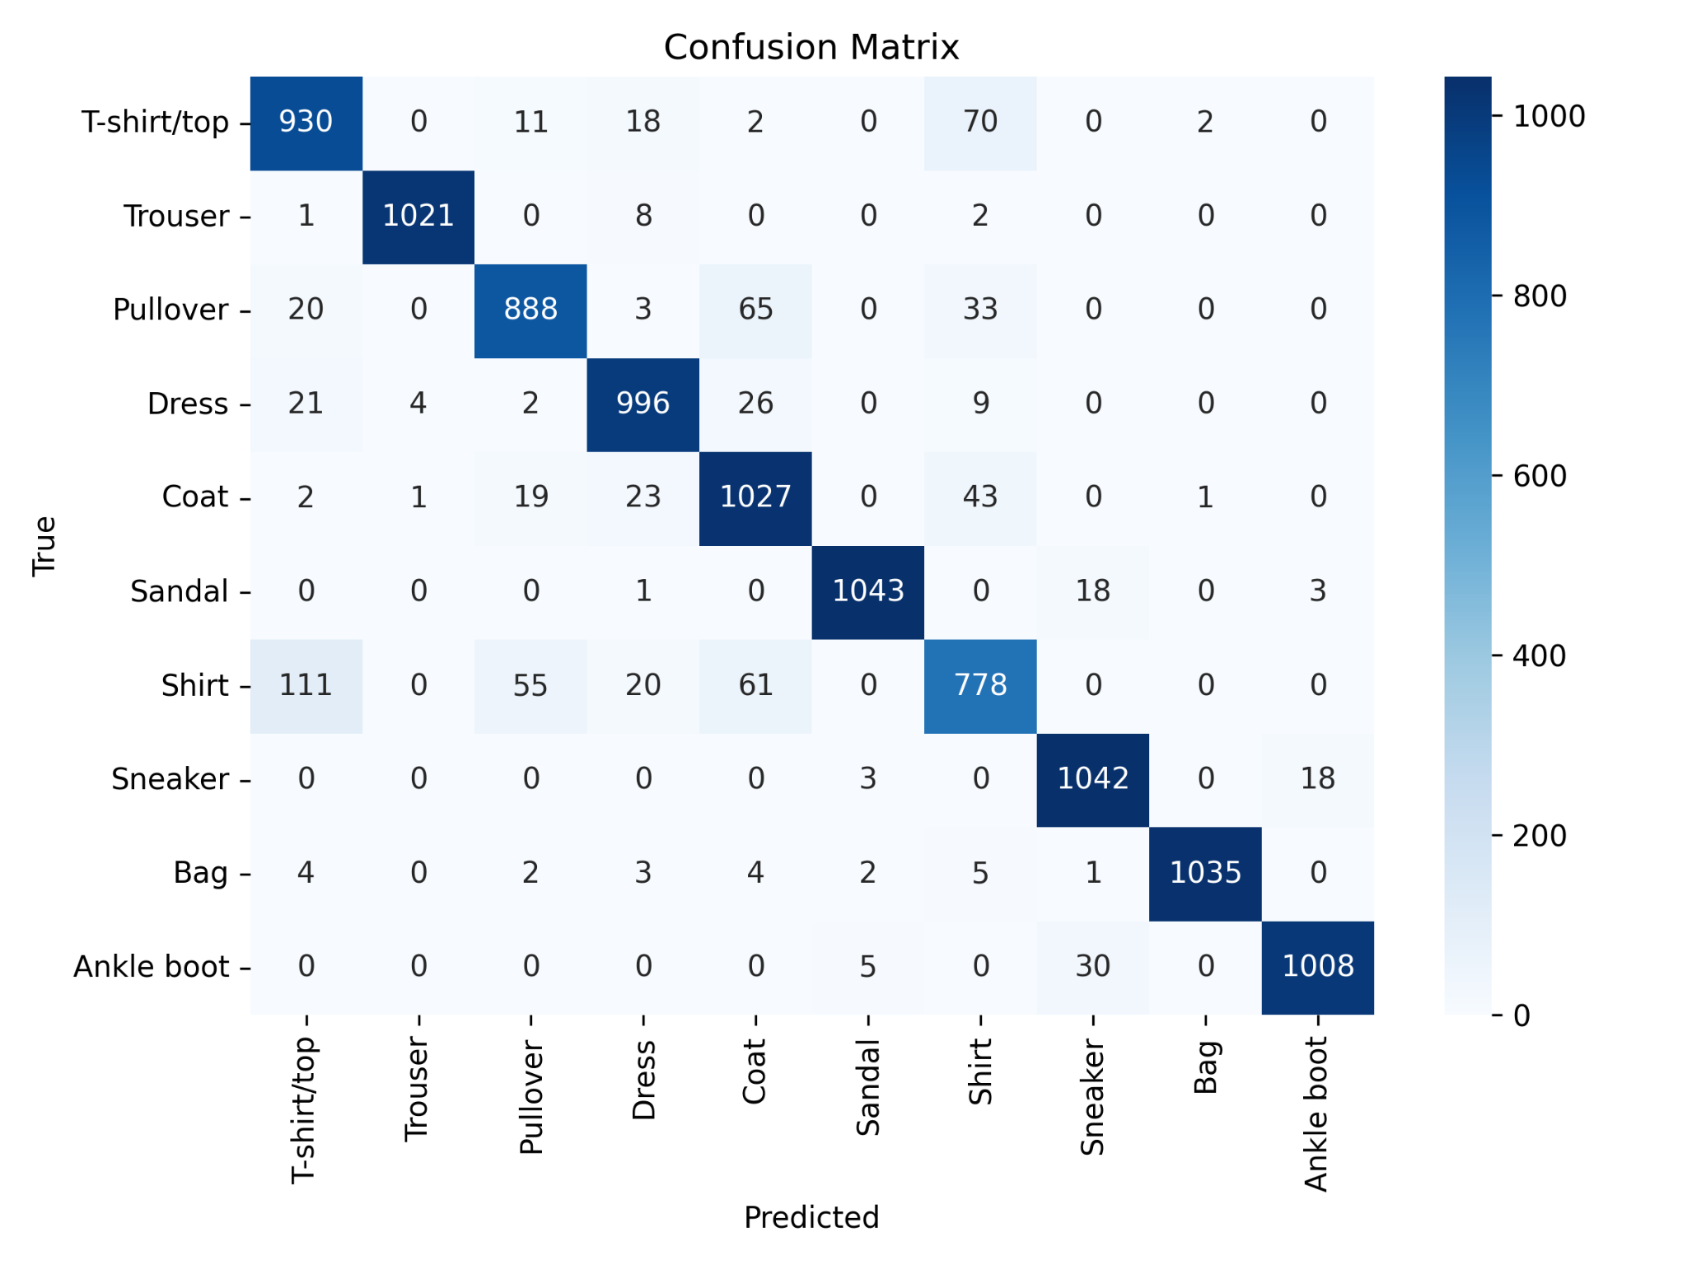

9. Visual Predictions
Sample model predictions are displayed below. Each image shows the true label (T) and predicted label (P).
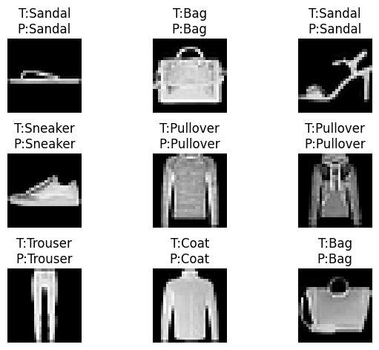

10. Results Summary
Training Accuracy: 93.2%
Validation Accuracy: 93.0%
Test Accuracy: 92.8%
Loss (Final Val): 0.20
Total Parameters: 161K

11. Conclusion
The CNN-based Fashion-MNIST classifier demonstrates robust performance with over 93% accuracy.
By using Batch Normalization, Dropout, and Learning Rate Scheduling, the model generalizes well across unseen fashion categories.
app link: https://ankitkumarnath-image-classification-using-fashion-appapp-1mv7n4.streamlit.app/

