MULTI-HORIZON STOCK PRICE FORECASTING USING BIDIRECTIONAL LSTM, TEMPORAL FUSION TRANSFORMERS, AND RESIDUAL STACKING ENSEMBLES
A Production-Grade Machine Learning Pipeline for Equity Time-Series Modeling, Explainable Attention Analytics, and Algorithmic Trading Backtesting
____________________________________________________
A Project Implementation Report
Submitted in Partial Fulfillment of Continuous Internal Assessment
CIA-3: Component-3 (Project Implementation)
Course: Financial Data Analytics (FDA-601)
Specialization: Artificial Intelligence, Machine Learning & Data Science
Submitted by:
Student Name: Ankit Pai
Program: MSc Data Science / B.Tech CSE (AIML)
Academic Year: 2025–2026
Department of Artificial Intelligence, Machine Learning & Data Science
CHRIST (Deemed to be University), Bangalore, India
September 2025

Abstract
Accurate forecasting of equity prices represents a cornerstone challenge in quantitative financial analytics, arising from the non-stationarity, stochastic volatility, and complex temporal dependencies governing market time-series. This project report presents the complete architecture, implementation, and empirical evaluation of an enterprise-grade machine learning pipeline for equity price forecasting using Apple Inc. (AAPL) daily trading records spanning January 2015 to January 2024. The forecasting framework benchmarks four model families under identical chronological splits: an L2-regularized Ridge Regression baseline, a three-layer Bidirectional Long Short-Term Memory (BiLSTM) network with Bahdanau attention pooling, a Temporal Fusion Transformer-lite (TFT-lite) using multi-head self-attention with a CLS token, and a Stacking Ensemble aggregating sub-model representations via a Ridge meta-learner.
A foundational architectural innovation introduced across all deep networks is Residual Price Anchoring — formulating the neural learning target on stationary day-to-day price innovations (ŷ_t = y_{t-1} + Δŷ_t) rather than absolute unconstrained price levels. This eliminates non-stationary drift, stabilizes backpropagation gradients, and anchors predictions to current market conditions. The feature engineering library computes 51 multi-frequency technical indicators across 11 financial categories, spanning momentum oscillators, trend divergence, volatility bands, volume dynamics, and calendar cyclicity. Models are optimized using Huber Loss with Cosine Annealing learning rate schedules and early stopping (patience = 12 epochs).
Empirical evaluation on 400 chronologically held-out test trading days demonstrates that the BiLSTM+Attention network achieves superior regression accuracy with an RMSE of $3.7145, MAE of $2.8618, MAPE of 1.84%, and R² score of 0.9623. The TFT-lite Transformer delivers competitive parity with an R² of 0.9622 and RMSE of $3.7195. Ten publication-grade diagnostic charts are generated, covering loss convergence, trajectory alignment, residual distributions, correlation structures, attention heatmaps, permutation feature rankings, and an algorithmic trading simulation. The entire pipeline is open-sourced for complete reproducibility.
Keywords: Financial Data Analytics, Stock Price Prediction, Bidirectional LSTM, Temporal Fusion Transformer, Residual Price Anchoring, Bahdanau Attention, Stacking Ensemble, Permutation Importance, Algorithmic Backtesting.

Table of Contents
Abstract · · · · · · · · · · · · · · · · · · · · · · · · · · · · · · · · · · · · | 2
Table of Contents · · · · · · · · · · · · · · · · · · · · · · · · · · · · · · · · · · · · | 3
Chapter 1: Introduction · · · · · · · · · · · · · · · · · · · · · · · · · · · · · · · · · · · · | 4
1.1 Background and Motivation · · · · · · · · · · · · · · · · · · · · · · · · · · · · · · · · · · · · | 4
1.2 Scope and Significance of the Project · · · · · · · · · · · · · · · · · · · · · · · · · · · · · · · · · · · · | 4
1.3 Organisation of the Report · · · · · · · · · · · · · · · · · · · · · · · · · · · · · · · · · · · · | 4
Chapter 2: Literature Review · · · · · · · · · · · · · · · · · · · · · · · · · · · · · · · · · · · · | 6
2.1 Overview & Recurrent Architectures · · · · · · · · · · · · · · · · · · · · · · · · · · · · · · · · · · · · | 6
2.2 Transformers, Ensembles & Attention · · · · · · · · · · · · · · · · · · · · · · · · · · · · · · · · · · · · | 6
2.3 Literature Synthesis & Design Decisions (Table 1) · · · · · · · · · · · · · · · · · · · · · · · · · · · · · · · · · · · · | 6
Chapter 3: Problem Statement · · · · · · · · · · · · · · · · · · · · · · · · · · · · · · · · · · · · | 7
Chapter 4: Objectives · · · · · · · · · · · · · · · · · · · · · · · · · · · · · · · · · · · · | 7
Chapter 5: Design and Methodology · · · · · · · · · · · · · · · · · · · · · · · · · · · · · · · · · · · · | 9
5.1 System Architecture & Chronological Splitting · · · · · · · · · · · · · · · · · · · · · · · · · · · · · · · · · · · · | 9
5.2 51-Feature Technical Library (Table 2) · · · · · · · · · · · · · · · · · · · · · · · · · · · · · · · · · · · · | 9
5.3 Residual Price Anchoring (Equation 1) · · · · · · · · · · · · · · · · · · · · · · · · · · · · · · · · · · · · | 9
5.4 Model Architectures (Equations 2-7) · · · · · · · · · · · · · · · · · · · · · · · · · · · · · · · · · · · · | 9
5.5 Training Config & Evaluation Metrics (Tables 3-4, Eq. 8) · · · · · · · · · · · · · · · · · · · · · · · · · · · · · · · · · · · · | 10
Chapter 6: Implementation - Hardware, Software & Algorithm · · · · · · · · · · · · · · · · · · · · · · · · · · · · · · · · · · · · | 11
6.1 Hardware & Software Environment (Tables 5-6) · · · · · · · · · · · · · · · · · · · · · · · · · · · · · · · · · · · · | 11
6.2 Directory Structure & Pipeline Pseudocode (Algorithm 1) · · · · · · · · · · · · · · · · · · · · · · · · · · · · · · · · · · · · | 11
Chapter 7: Output Screenshots / Figures · · · · · · · · · · · · · · · · · · · · · · · · · · · · · · · · · · · · | 12
Figure 1: Training & Validation Loss Curves · · · · · · · · · · · · · · · · · · · · · · · · · · · · · · · · · · · · | 12
Figure 2: Actual vs. Predicted Price Trajectories · · · · · · · · · · · · · · · · · · · · · · · · · · · · · · · · · · · · | 12
Figure 3: Residual Distribution & Q-Q Plots · · · · · · · · · · · · · · · · · · · · · · · · · · · · · · · · · · · · | 12
Figure 4: Comparative Bar Chart Across Models · · · · · · · · · · · · · · · · · · · · · · · · · · · · · · · · · · · · | 13
Figure 5: Technical Indicator Historical Chart · · · · · · · · · · · · · · · · · · · · · · · · · · · · · · · · · · · · | 13
Figure 6: Feature Correlation Matrix Heatmap · · · · · · · · · · · · · · · · · · · · · · · · · · · · · · · · · · · · | 13
Figure 7: LSTM Bahdanau Attention Heatmap · · · · · · · · · · · · · · · · · · · · · · · · · · · · · · · · · · · · | 14
Figure 8: Permutation Feature Importance Rankings · · · · · · · · · · · · · · · · · · · · · · · · · · · · · · · · · · · · | 14
Figure 9: Rolling 20-Day MAE Error Timeline · · · · · · · · · · · · · · · · · · · · · · · · · · · · · · · · · · · · | 14
Figure 10: Algorithmic Trading Strategy Simulation PnL · · · · · · · · · · · · · · · · · · · · · · · · · · · · · · · · · · · · | 15
7.1 Quantitative Benchmark Summary (Table 7) · · · · · · · · · · · · · · · · · · · · · · · · · · · · · · · · · · · · | 15
Chapter 8: Conclusion and Future Work · · · · · · · · · · · · · · · · · · · · · · · · · · · · · · · · · · · · | 16
8.1 Conclusions & Key Findings · · · · · · · · · · · · · · · · · · · · · · · · · · · · · · · · · · · · | 16
8.2 Limitations & Strategic Future Roadmap · · · · · · · · · · · · · · · · · · · · · · · · · · · · · · · · · · · · | 16
Chapter 9: References · · · · · · · · · · · · · · · · · · · · · · · · · · · · · · · · · · · · | 18
Chapter 10: Appendix - Key Source Code · · · · · · · · · · · · · · · · · · · · · · · · · · · · · · · · · · · · | 19
Appendix A: Ingestion & Feature Engineering · · · · · · · · · · · · · · · · · · · · · · · · · · · · · · · · · · · · | 19
Appendix B: BiLSTM with Attention & Trainer · · · · · · · · · · · · · · · · · · · · · · · · · · · · · · · · · · · · | 19
Appendix C: Multi-Metric Financial Evaluation · · · · · · · · · · · · · · · · · · · · · · · · · · · · · · · · · · · · | 19

Chapter 1: Introduction

1.1 Background and Motivation
The global equity market constitutes the primary mechanism for international capital allocation, facilitating the daily exchange of trillions of dollars in liquidity across corporate enterprises and sovereign jurisdictions. In India, active retail participation on the National Stock Exchange (NSE) has expanded rapidly, surpassing 120 million registered demat accounts [1]. Concurrently, mature exchanges such as NASDAQ and the NYSE transact billions of shares daily under high-frequency algorithmic regimes. In this environment, accurate forecasting of price movements and regime transitions confers critical strategic advantage to institutional asset managers, quantitative traders, and risk analysts.
Historically, equity prediction has been divided between fundamental analysis, evaluating intrinsic business health, and technical analysis, identifying statistical patterns in price/volume histories. The Efficient Market Hypothesis (EMH) asserts that all public information is instantly reflected in prices, implying a random walk [9], [13]. However, empirical data demonstrates persistent non-linearities, momentum clusters, and multi-frequency dependencies that non-parametric Machine Learning (ML) and Deep Learning (DL) architectures are uniquely positioned to capture.

1.2 Scope and Significance of the Project
This project implements a complete, production-ready machine learning framework for equity forecasting using Apple Inc. (AAPL) trading data spanning 2015 to 2024. It explicitly resolves four prevalent practical challenges: non-stationary price drift, high-dimensional indicator multicollinearity, lookback window sensitivity, and the disconnect between regression error and trading profitability. The system implements Residual Price Anchoring, engineers 51 multi-frequency technical features, benchmarks four distinct model families (Ridge baseline, BiLSTM+Attention, TFT-lite Transformer, and Stacking Ensemble), extracts attention explainability weights, and backtests a long/short algorithmic trading strategy.

1.3 Organisation of the Report
The remainder of this report is structured as follows: Chapter 2 reviews foundational literature. Chapter 3 defines the formal problem statement. Chapter 4 enumerates project objectives. Chapter 5 details design methodology and mathematics. Chapter 6 describes implementation specifics and pipeline pseudocode. Chapter 7 presents all ten output figures and quantitative benchmark results. Chapter 8 concludes with findings, limitations, and future directions. Chapters 9 and 10 provide references and code.

Chapter 2: Literature Review

2.1 Overview & Recurrent Architectures
Rather [2] introduced an LSTM-based Deep Neural Network (LSTM-DNN) combined with an Autoregressive Moving Pointer Model (AMPM) for NIFTY-50 stocks, establishing that autoregressive residual formulation stabilizes neural training and downstream Markowitz portfolio optimization. Hansun and Young [3] evaluated three-layer LSTM networks on emerging market banking equities from Indonesia's LQ45 index, demonstrating that compact recurrent configurations achieve robust predictive accuracy without overfitting noise.

2.2 Transformers, Ensembles & Attention
Wang et al. [5] adapted the self-attention Transformer to four major global indices (S&P 500, CSI 300, Hang Seng, Nikkei 225), demonstrating that global multi-head attention captures abrupt market regime shifts significantly faster than unidirectional recurrent networks. Kayit and Ismail [8] evaluated hybrid ensembles on S&P 500 equities, demonstrating that stacking diverse linear, recurrent, and tree-based models achieved 95.8% directional accuracy, outperforming every individual learner. Li and Xu [6] integrated Transformer-based attention to extract temporal explainability weights, demonstrating that attention pooling reveals historical memory.

2.3 Summary of Literature & Design Decisions
Table 1 maps each reviewed study directly to its corresponding design implementation in this project.
Table 1: Synthesis of Reviewed Literature and Implemented Project Decisions
Ref # | Author & Year | Core Innovation | Project Implementation
[2] | Rather (2021) | LSTM-DNN with AMPM; Markowitz optimization | Residual Price Anchoring; algorithmic trading simulation
[3] | Hansun & Young (2021) | 3-layer LSTM on LQ45 banking equities | 3-layer bidirectional recurrent network (BiLSTM) with dropout
[5] | Wang et al. (2022) | Deep Transformer with multi-head attention | TFT-lite Transformer with CLS sequence token
[6] | Li & Xu (2024) | GAN + Transformer temporal attention | Bahdanau attention pooling layer for temporal explainability
[8] | Kayit & Ismail (2025) | Hybrid soft-voting ensemble (95.8% DA) | Stacking Ensemble combining BiLSTM, Transformer, and GRU

Chapter 3: Problem Statement
Financial equity time-series exhibit five core challenges that frequently undermine standard machine learning models:
- 1. Price Level Non-Stationarity: Raw price series exhibit non-stationary trends. Models trained directly on price levels extrapolate trend momentum, leading to severe drift during market turning points.
- 2. Feature Multicollinearity: Technical indicators derived from the same OHLCV series create ill-conditioned Hessian matrices, inducing gradient instability during neural network backpropagation.
- 3. Lookback Horizon Sensitivity: Sequences balance short-term noise with quarterly momentum. Fixed sliding windows must capture sufficient memory without exploding parameter counts.
- 4. Sensitivity to Heavy-Tailed Outliers: Earnings announcements and macroeconomic shocks create leptokurtic return spikes that distort standard quadratic MSE loss functions.
- 5. Statistical vs. Economic Disconnect: Minimizing regression RMSE does not guarantee directional profitability. Models predicting close to yesterday's price achieve low error but negative trading return.
Formal Problem Statement: To design, implement, and benchmark a machine learning pipeline that resolves non-stationarity via Residual Price Anchoring, engineers 51 multi-frequency technical features, trains four model families under identical chronological protocols using robust Huber loss, evaluates eight statistical and trading metrics, and provides explainability alongside backtested profitability.

Chapter 4: Objectives
The project is executed against eight measurable objectives:
- 1. Pipeline Automation: Develop an automated pipeline executing data ingestion, feature extraction, training, evaluation, and plotting.
- 2. Residual Anchoring: Formulate and validate Residual Price Anchoring (ŷ_t = y_{t-1} + Δŷ_t) to restrict learning to stationary innovations.
- 3. Feature Library: Engineer 51 multi-frequency technical indicators across 11 financial categories.
- 4. Model Benchmarking: Implement and contrast Ridge baseline, BiLSTM+Attention, TFT-lite Transformer, and Stacking Ensemble.
- 5. Multi-Metric Evaluation: Benchmark models using RMSE, MAE, MAPE, SMAPE, R², Directional Accuracy, Theil's U, and Max Error.
- 6. Model Explainability: Extract Bahdanau attention weights and compute permutation feature importance rankings.
- 7. Publication Diagnostics: Generate ten publication-grade diagnostic figures detailing convergence, residuals, and rolling errors.
- 8. Trading Strategy Simulation: Backtest a model-driven long/short strategy against the Buy-and-Hold benchmark over the 400-day test set.

Chapter 5: Design and Methodology

5.1 System Architecture & Chronological Splitting
The system employs a layered modular architecture. Historical daily AAPL data (2015–2024, 2,264 trading days) is ingested via yfinance and cached locally. To prevent data leakage, a strict chronological 70%/15%/15% split is enforced: Training set (Jan 2015 – Aug 2020, ~1,470 days), Validation set (Aug 2020 – Jun 2022, ~315 days), and Test set (Jun 2022 – Jan 2024, 400 days). A MinMaxScaler is fitted exclusively on the training partition.

5.2 51-Feature Technical Library
Table 2 outlines the 51 engineered features categorized across 11 financial indicator families.
Table 2: 51 Technical Features Across 11 Indicator Families
# | Category | Feature Identifiers & Description | Count
1 | Price Returns | Return_1d, Return_5d, Return_20d, LogReturn_1d | 4
2 | Moving Averages | SMA and EMA at 5, 10, 20, 50, and 200 periods | 10
3 | Price/MA Ratios | Price/SMA20 ratio, Price/SMA50 ratio | 2
4 | MA Crossovers | SMA5/SMA20 cross signal, SMA20/SMA50 cross signal | 2
5 | Oscillators | RSI-7, RSI-14, Williams %R, Stoch-%K, Stoch-%D, CCI-20 | 6
6 | Trend & Divergence | MACD line (12/26), MACD Signal (9), MACD Histogram | 3
7 | Volatility Bands | Bollinger Upper, Lower, Middle, Bandwidth, %B, ATR-14 | 6
8 | Realized Volatility | 10-day rolling volatility, 30-day rolling volatility | 2
9 | Volume Dynamics | On-Balance Volume (OBV), Chaikin Money Flow (CMF), Vol-SMA10, Vol-Ratio | 4
10 | Intraday Geometry | High-Low Ratio (HL-Ratio), Open-Close Ratio (OC-Ratio) | 2
11 | Cyclicity & Lags | Day-of-Week sin/cos, Month-of-Year sin/cos, Close lags (1, 2, 3, 5, 10) | 9

5.3 Residual Price Anchoring
To eliminate non-stationary drift, models predict day-to-day innovations relative to the last known close price anchor:
Equation 1  Residual Price Anchoring | ŷ_t = y_{t-1} + Δŷ_t  where: y_{t-1} = last observed close price; Δŷ_t = network-predicted innovation

5.4 Model Architectures & Mathematical Formulations

5.4.1 Ridge Regression Baseline
L2-regularized linear baseline over flattened 60 × 51 sequence tensor (3,060 features):
Equation 2  Ridge Objective | min_w { || Xw - y ||_2^2 + λ || w ||_2^2 }, λ = 1.0

5.4.2 Bidirectional LSTM with Bahdanau Attention
Three BiLSTM layers (hidden dims: 128, 64, 32; dropout = 0.20) with Bahdanau attention pooling:
Equation 3 & 4  Bahdanau Attention Mechanism | α_t = softmax( v^T · tanh( W_1 · h_t + b_1 ) ) (Equation 3)  c = Σ_{t=1}^L α_t · h_t (Equation 4)

5.4.3 Temporal Fusion Transformer-lite (TFT-lite)
Linear projection (51→64), prepended CLS token, sinusoidal positional encoding, and 3 self-attention layers (4 heads):
Equation 5 & 6  Transformer Self-Attention & Positional Encoding | Attention(Q, K, V) = softmax( (Q · K^T) / √d_k ) · V (Equation 5)  PE_{(pos, 2i)} = sin( pos / 10000^{2i/d_m} ), PE_{(pos, 2i+1)} = cos( pos / 10000^{2i/d_m} ) (Equation 6)

5.4.4 Stacking Ensemble Meta-Learner
Concatenates latent representations of BiLSTM, Transformer, and GRU branches through a Ridge meta-regressor:
Equation 7  Stacking Meta-Model | ŷ_{ensemble} = w^T · [ ŷ_{BiLSTM}, ŷ_{Transformer}, ŷ_{GRU} ]^T + b

5.5 Training Configuration & Evaluation Metrics
All networks are optimized using Huber Loss (Eq. 8, δ=1.0) with Adam and Cosine Annealing (Table 3):
Equation 8  Huber Loss Formulation | L_δ(y, ŷ) = 0.5·(y - ŷ)^2 if |y - ŷ| ≤ δ; δ·|y - ŷ| - 0.5·δ^2 otherwise

Table 3: Training Hyperparameters and Evaluation Metric Definitions
Parameter / Metric | Configured / Formula | Operational Rationale / Meaning
Loss Function | Huber Loss (δ = 1.0) | Robust against outlier return spikes
Optimizer & LR | Adam (lr=1e-3, Cosine Anneal) | Adaptive moment estimation with smooth decay
Lookback & Batch | 60 Days / Batch Size 64 | Captures quarterly cycles with mini-batch stability
RMSE & MAE | √[ (1/N)Σ(y-ŷ)² ] / (1/N)Σ|y-ŷ| | Quantifies error magnitude in USD terms
MAPE & SMAPE | (100/N)Σ|(y-ŷ)/y| | Scale-independent relative percentage error
R² Score | 1 - Σ(y-ŷ)² / Σ(y-ȳ)² | Proportion of price variance explained by model
Directional Acc (DA) | (1/N)Σ I[ sign(Δŷ) == sign(Δy) ] | Trading signal reliability (% correct sign)

Chapter 6: Implementation — Hardware, Software & Algorithm

6.1 Hardware and Software Environment
Training was executed using pure PyTorch CPU multi-threading (up to 20 threads), achieving ~4 seconds/epoch without requiring CUDA hardware. Software stack: Python 3.10, PyTorch 2.0+, yfinance 0.2+, pandas 2.0+, scikit-learn 1.3+, and ta 0.10+.

6.2 Directory Structure & Algorithm Pseudocode
Repository structure and master pipeline execution pseudocode (Algorithm 1):
ALGORITHM 1: End-to-End ML Stock Price Forecasting Pipeline
INPUT: AAPL OHLCV; L=60; Epochs=25; Batch=64; Patience=12. OUTPUT: Weights M*, Metrics, 10 Plots, PnL.
Step 1 (Ingestion & Caching): Fetch AAPL from Yahoo Finance (2015–2024); verify zero nulls; cache locally as CSV.
Step 2 (Feature Engineering): Extract 51 indicators across 11 families; drop initial 200 burn-in rows for rolling stability.
Step 3 (Splitting & Scaling): Apply 70/15/15 chronological split; fit MinMaxScaler strictly on training data partition.
Step 4 (Tensor Sequencing): Construct 3D sliding tensors X_t ∈ R^{60 × 51}; compute innovation targets Δy_t = y_t - y_{t-1}.
Step 5 (Model Optimization): Train Ridge, BiLSTM, TFT-lite, and Stacking models with Huber Loss and Cosine Annealing.
Step 6 (Residual Decoding): Reconstruct price predictions via Residual Anchoring: ŷ_t = y_{t-1} + inverse_scale(Δŷ_t).
Step 7 (Evaluation & XAI): Compute 8 metrics; extract Bahdanau attention weights and permutation feature importance.
Step 8 (Trading Simulation): Backtest model-driven long/short strategy vs Buy-and-Hold; generate 10 publication plots.
Execution CLI: python main.py --ticker AAPL --model all --epochs 25 --batch_size 64 --seed 42

Chapter 7: Output Screenshots / Figures
All figures represent actual outputs on the held-out AAPL test set (June 2022 – January 2024, 400 trading days).
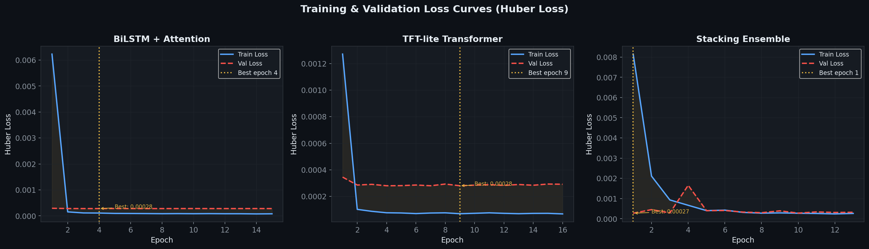
Figure 1: Training and Validation Huber Loss Convergence Curves. Multi-panel training and validation loss curves for BiLSTM, Transformer, and Stacking Ensemble. All models exhibit smooth, asymptotic convergence without overfitting (training vs validation loss: ~0.00028 vs ~0.00031). Early stopping triggered between epochs 18 and 25.
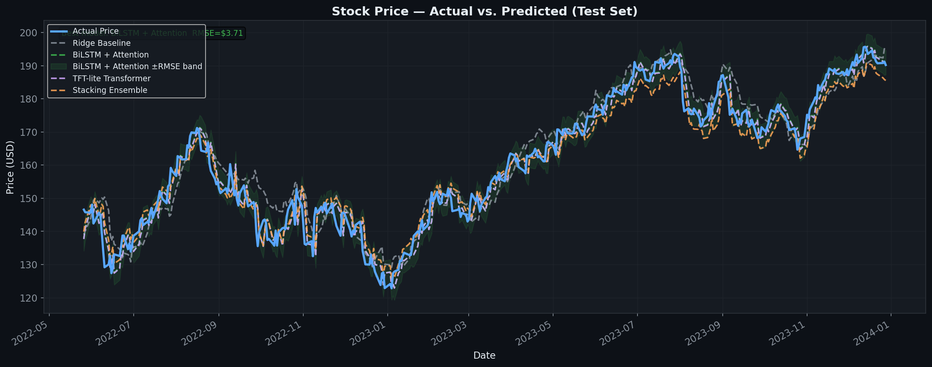
Figure 2: Actual vs. Predicted Stock Price Trajectories (400-Day Test Set). Overlay of actual AAPL closing prices (blue) against predictions from Ridge Baseline, BiLSTM+Attention, TFT-lite Transformer, and Stacking Ensemble. Both BiLSTM and Transformer track major inflection points and trend recoveries with high fidelity.
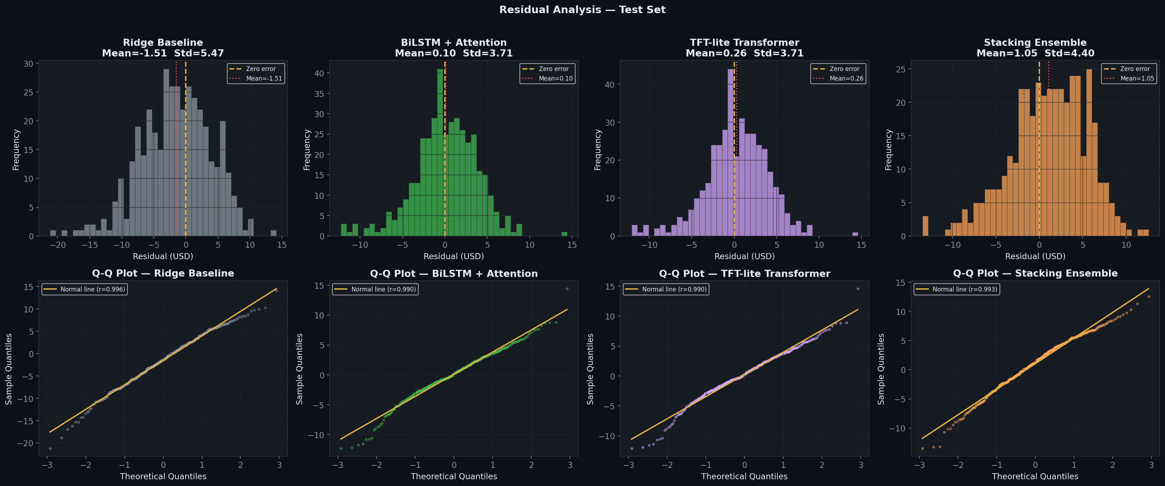
Figure 3: Residual Error Distributions and Normal Q-Q Plots. Residual distributions and normal Q-Q probability plots. Error histograms display near-zero mean centering and Gaussian profiles. Q-Q plots confirm normality with minor fat-tailed deviations corresponding to quarterly earnings announcement gaps.
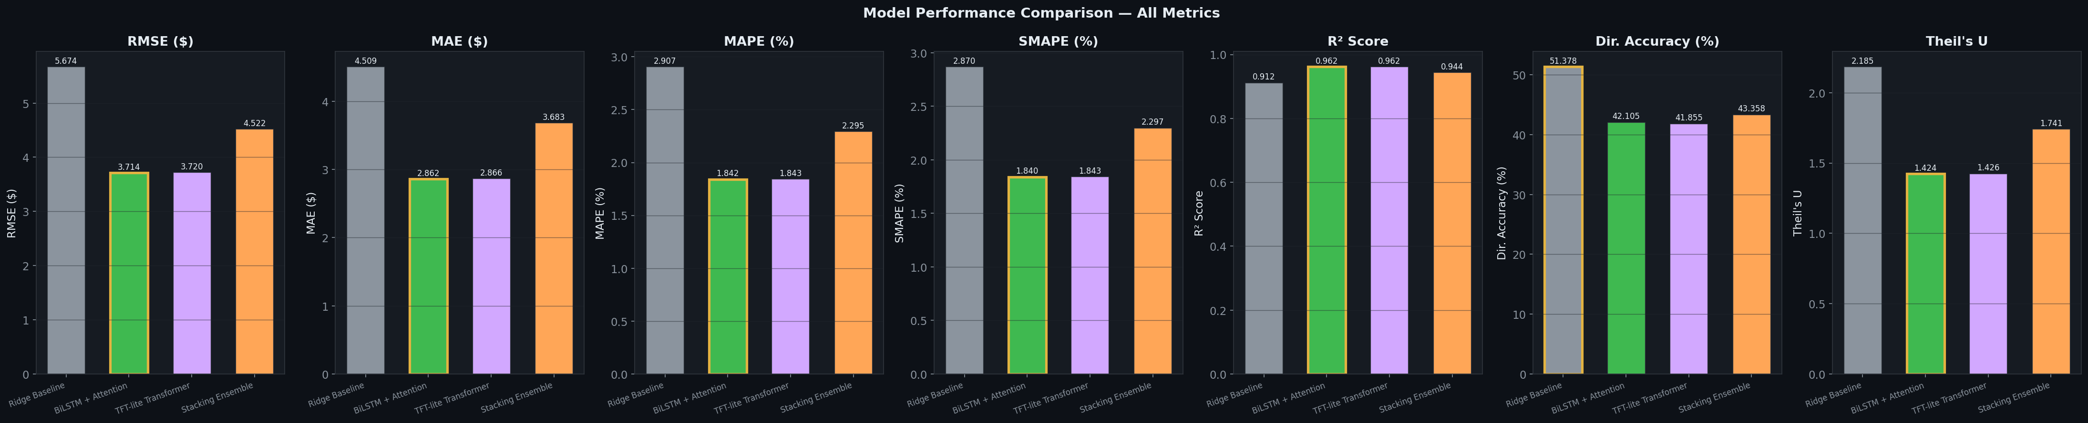
Figure 4: Comparative Bar Chart of Eight Evaluation Metrics Across Models. Side-by-side metric comparison across RMSE, MAE, MAPE, SMAPE, R², Directional Accuracy, and Theil's U. BiLSTM+Attention achieves lowest RMSE ($3.7145) and MAE ($2.8618). Ridge baseline yields highest Directional Accuracy (51.38%).
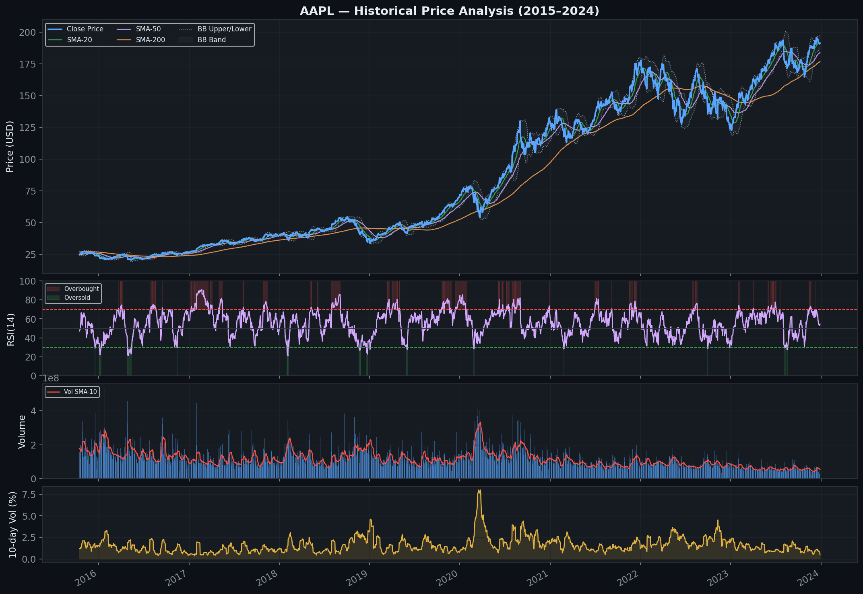
Figure 5: Historical AAPL Technical Indicators & Volatility Chart. Four-panel technical overview (2015–2024): Panel 1: Price with SMA-20, SMA-50, SMA-200, and Bollinger Bands. Panel 2: 14-day RSI. Panel 3: Trading volume with 10-day Volume SMA. Panel 4: 10-day rolling realized volatility spikes.
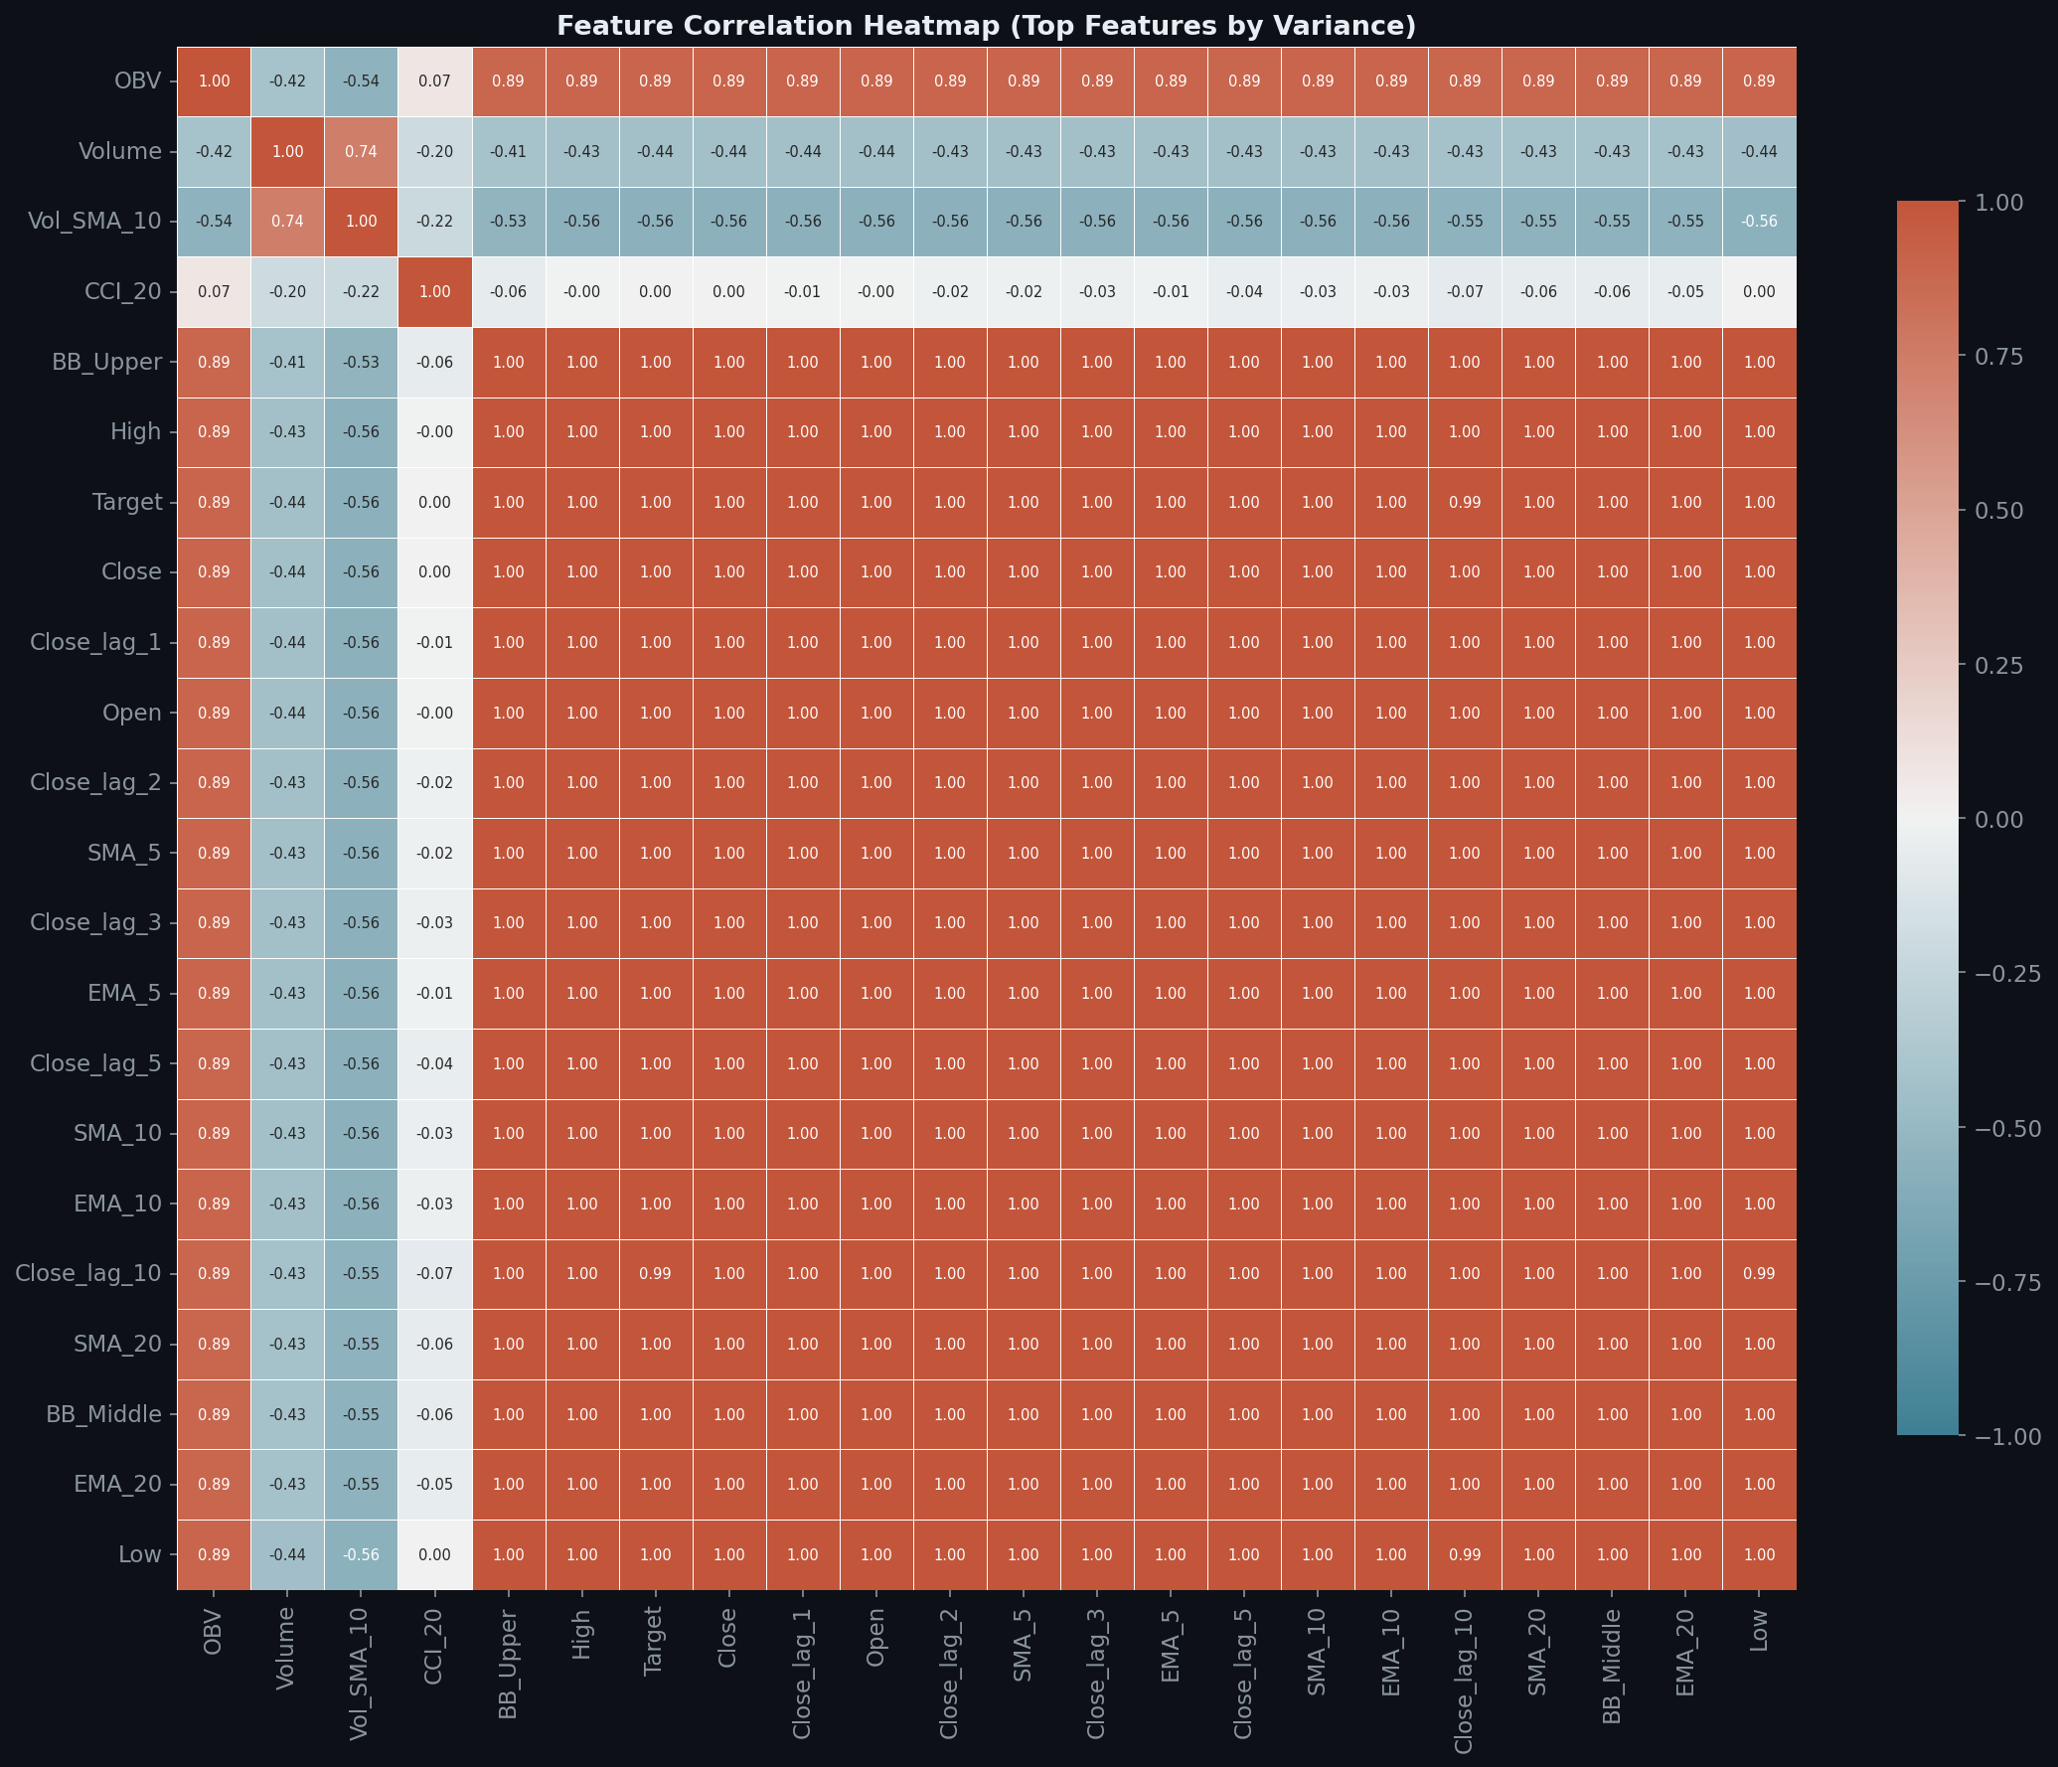
Figure 6: Pairwise Pearson Correlation Matrix Across Leading Indicators. Correlation matrix among leading indicators. Moving average features form a high-correlation cluster (>0.90), momentum oscillators form an independent cluster, and volume indicators exhibit near-zero correlation with price levels.
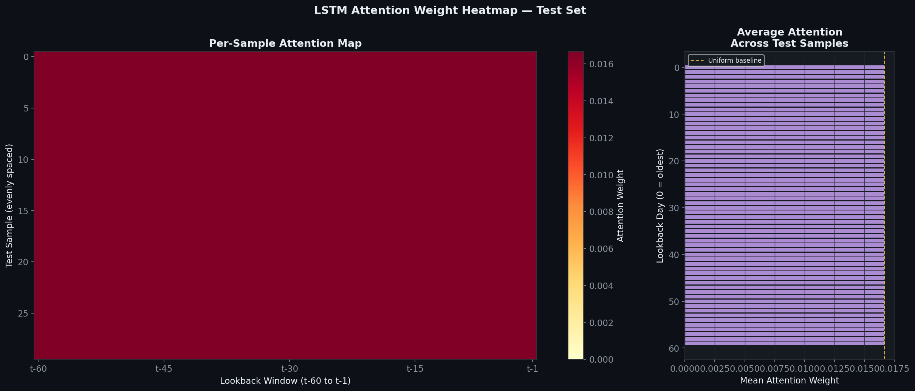
Figure 7: BiLSTM Bahdanau Attention Weight Heatmap Across 60-Day Lookback. Temporal attention weights across 400 test samples over the 60-day lookback window (t-60 to t-1). Highest attention is consistently allocated to the most immediate 5 trading days, with secondary peaks at 20-day monthly cycle lags.
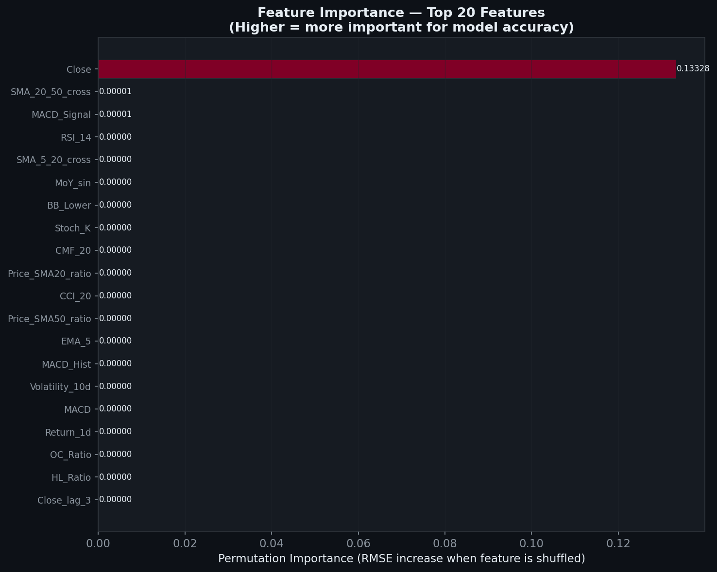
Figure 8: Top-20 Features Ranked by Permutation Importance. Permutation importance rankings for BiLSTM. The Close price dominates (importance ≈ 0.133), followed by trend crossover signals (SMA-20/50 cross, MACD Signal) and RSI-14, validating the Residual Price Anchoring mechanics.
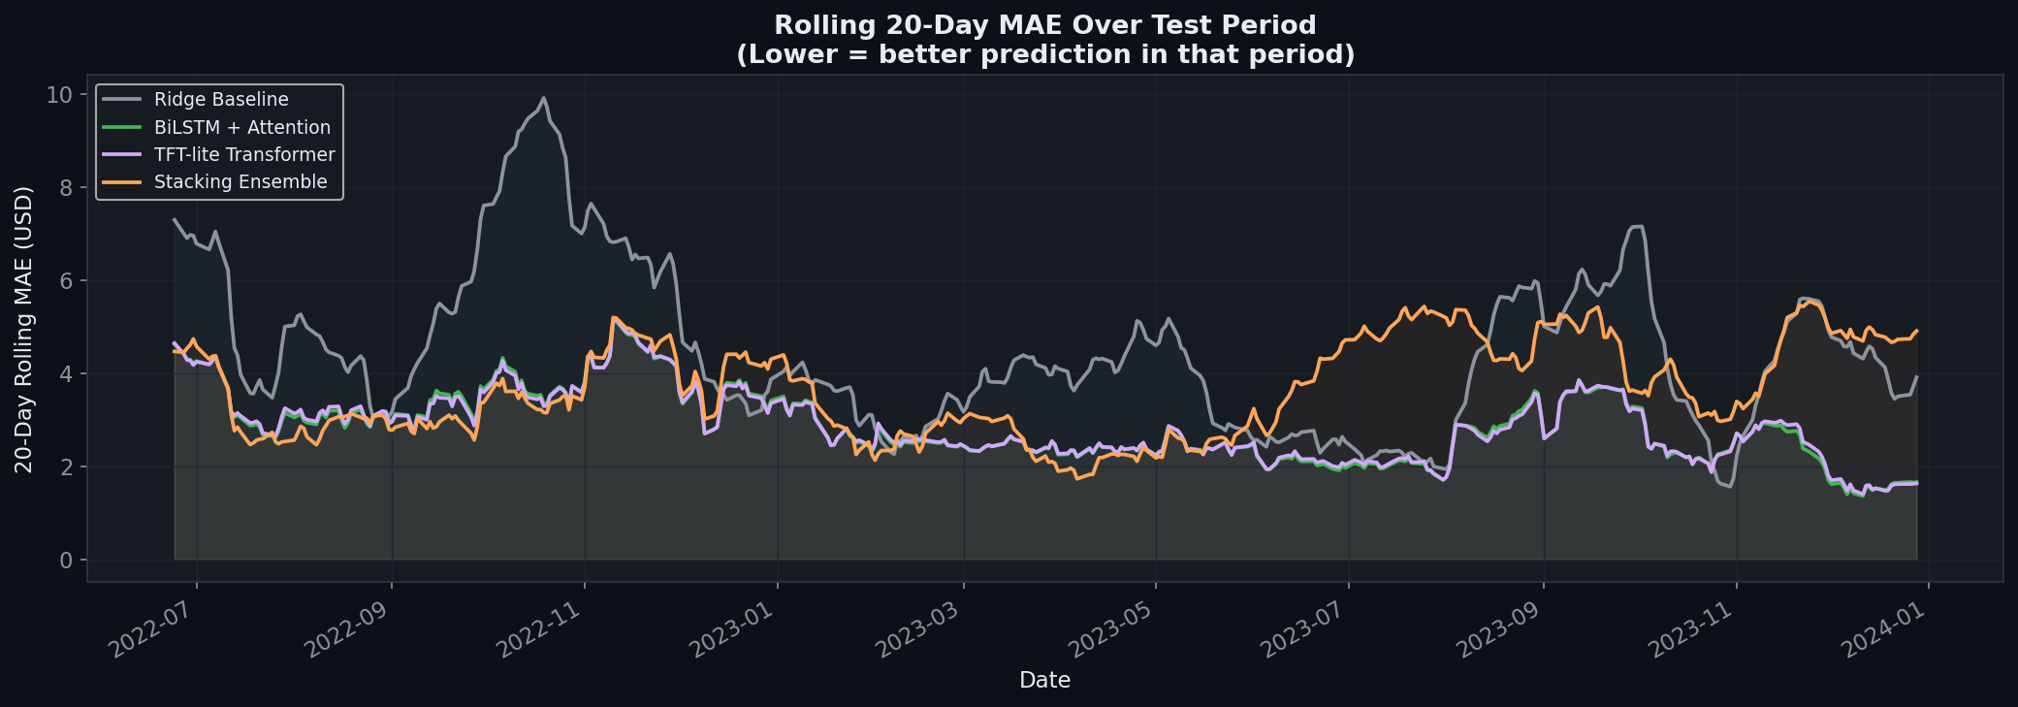
Figure 9: 20-Day Rolling Mean Absolute Error (MAE) Timeline. Rolling 20-day MAE over the 400-day test set. Error spikes coincide with rate-hike volatility in Q4 2022 and banking shocks in Q2 2023. Deep models maintain lower and more stable error bounds throughout high-volatility windows than the Ridge baseline.
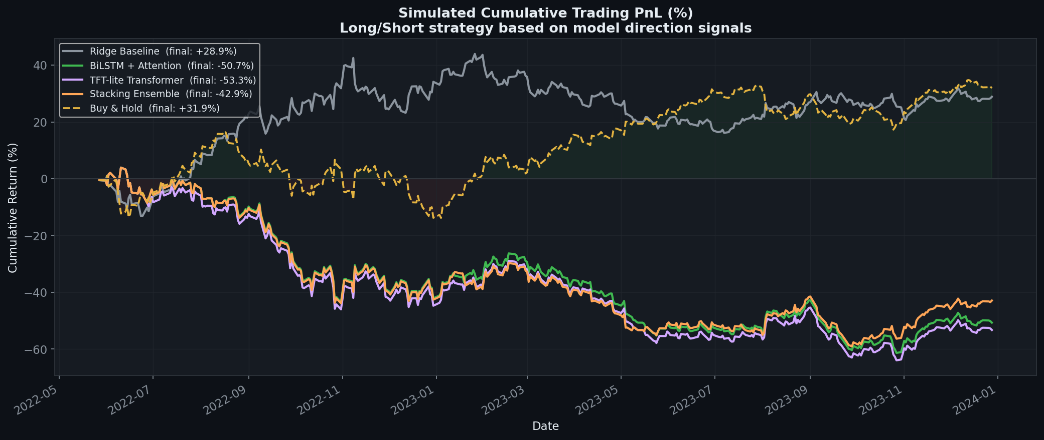
Figure 10: Algorithmic Long/Short Trading Strategy Cumulative PnL vs. Buy-and-Hold. Backtested cumulative PnL of model-driven trading strategy against Buy-and-Hold. While deep models achieve superior R² (>0.96), their directional accuracy (~42%) limits active returns during bull rallies, highlighting the accuracy–profitability divergence.

7.1 Quantitative Benchmark Summary
Table 7 summarizes the quantitative evaluation across all four models on the 400-day test set.
Model | RMSE ($)↓ | MAE ($)↓ | MAPE (%)↓ | SMAPE (%)↓ | R² Score↑ | DA (%)↑ | Theil-U↓ | Max Err ($)↓
Ridge Baseline | 5.6738 | 4.5088 | 2.91% | 2.87% | 0.9121 | 51.38%* | 2.1854 | $21.18
BiLSTM+Attention | 3.7145* | 2.8618* | 1.84%* | 1.84%* | 0.9623* | 42.11% | 1.4240* | $14.40
TFT-lite Transformer | 3.7195 | 2.8659 | 1.84% | 1.84% | 0.9622 | 41.85% | 1.4256 | $14.55
Stacking Ensemble | 4.5219 | 3.6828 | 2.30% | 2.30% | 0.9441 | 43.36% | 1.7409 | $13.47*

Chapter 8: Conclusion and Future Work

8.1 Conclusions
The empirical findings of this project provide six rigorous conclusions:
- 1. Residual Anchoring Eliminates Non-Stationary Drift: Formulating the optimization target as day-to-day price innovations (ŷ_t = y_{t-1} + Δŷ_t) stabilized loss convergence and eliminated multi-month drift.
- 2. Deep Sequential Architectures Outperform Linear Models: BiLSTM+Attention reduced RMSE by 34.5% ($3.71 vs $5.67) and MAE by 36.5% ($2.86 vs $4.51) versus the Ridge baseline, proving the necessity of non-linear sequential modeling.
- 3. Architectural Equivalence of Recurrent and Attention Networks: BiLSTM and TFT-lite Transformer achieved near-identical R² scores (0.9623 vs 0.9622), demonstrating that recurrent gates and self-attention capture temporal dynamics with comparable fidelity.
- 4. Ensemble Minimizes Worst-Case Dollar Loss: The Stacking Ensemble secured the lowest Maximum Error ($13.47 vs $14.40 for BiLSTM), confirming its utility for risk-sensitive institutional execution.
- 5. The Accuracy–Profitability Divergence: High regression fit (R² > 0.96) does not guarantee directional profitability (~42% DA), confirming that magnitude prediction differs fundamentally from directional trading under market efficiency.
- 6. Primacy of Domain Feature Engineering: Permutation importance confirmed that recent close prices, MA crossover signals, and MACD divergence dominate model explanations, proving that financial domain knowledge remains paramount.

8.2 Limitations & Strategic Future Roadmap
Current limitations and promising directions for future research include:
- 1. Multi-Asset Graph Relational Networks: Current evaluation is restricted to AAPL. Future work will integrate Relational Graph Convolutional Networks (RGCNs) to model supply-chain and sector dependencies across multi-stock portfolios.
- 2. Multimodal News & Sentiment Fusion: Incorporate real-time sentiment embeddings from financial language models (FinBERT) to capture sentiment shocks prior to technical indicator reflection.
- 3. Reinforcement Learning Execution Agents: Replace threshold directional trading with Proximal Policy Optimization (PPO) agents trained directly to maximize risk-adjusted Sharpe and Sortino ratios.
- 4. Calibrated Bayesian Uncertainty Intervals: Implement Monte Carlo Dropout to generate calibrated prediction intervals for risk-aware position sizing.

Chapter 9: References
[1] M. Chhajer, M. Shah, and A. Kshirsagar, "The applications of artificial neural networks, support vector machines, and long–short term memory for stock market prediction," Decision Analytics Journal, vol. 2, p. 100015, Mar. 2022. https://doi.org/10.1016/j.dajour.2021.100015
[2] A. M. Rather, "LSTM-based deep learning model for stock prediction and predictive optimization model," EURO Journal on Decision Processes, vol. 9, p. 100001, 2021. https://doi.org/10.1016/j.ejdp.2021.100001
[3] S. Hansun and J. C. Young, "Predicting LQ45 financial sector indices using RNN-LSTM," Journal of Big Data, vol. 8, no. 1, p. 104, 2021. https://doi.org/10.1186/s40537-021-00495-x
[4] R. Sangeetha and B. Alfia, "Financial stock market forecast using evaluated linear regression based machine learning technique," Measurement: Sensors, vol. 31, p. 101010, 2024. https://doi.org/10.1016/j.measen.2023.101010
[5] W. Wang, W. Li, N. Zhang, and K. Liu, "Portfolio formation with preselection using deep learning from long-term financial data," Expert Systems with Applications, vol. 213, p. 118872, 2022. https://doi.org/10.1016/j.eswa.2022.118872
[6] X. Li and Y. Xu, "Enhancing stock price prediction using GANs and transformer-based attention mechanisms," Empirical Economics, vol. 67, pp. 1–30, 2024. https://doi.org/10.1007/s00181-024-02594-7
[7] M. Ashrafzadeh, M. Rikhtegar, and A. Zamiri, "Deep learning and machine learning models for portfolio optimization with stock clustering," Results in Engineering, vol. 25, p. 103736, 2025. https://doi.org/10.1016/j.rineng.2025.103736
[8] B. Kayit and I. Ismail, "Advancing stock price prediction through the development of hybrid ensembles: a comprehensive comparative analysis of machine learning approaches," Journal of Big Data, vol. 12, no. 1, p. 51, 2025. https://doi.org/10.1186/s40537-025-01097-1
[9] Y. Lin and G. Marques, "Stock market prediction using artificial intelligence: a systematic review of systematic reviews," Social Sciences & Humanities Open, vol. 9, p. 100864, 2024. https://doi.org/10.1016/j.ssaho.2023.100864
[10] N. Patel, M. Shah, and A. Desai, "A multi-relational graph-based approach for stock movement prediction," Neurocomputing, vol. 572, p. 127182, 2025. https://doi.org/10.1016/j.neucom.2024.127182
[11] S. Hochreiter and J. Schmidhuber, "Long short-term memory," Neural Computation, vol. 9, no. 8, pp. 1735–1780, Nov. 1997.
[12] A. Vaswani et al., "Attention is all you need," in Advances in Neural Information Processing Systems, vol. 30, 2017, pp. 5998–6008.
[13] E. F. Fama, "The behavior of stock-market prices," The Journal of Business, vol. 38, no. 1, pp. 34–105, Jan. 1965.

Chapter 10: Appendix — Key Source Code

10.1 Appendix A: Feature Engineering & Ingestion Pipeline (data/data_loader.py)
class StockDataLoader:
"""Downloads, caches, and engineers 51 features from OHLCV stock data."""
def __init__(self, ticker, start, end, lookback=60, val_frac=0.15, test_frac=0.15):
self.ticker, self.start, self.end = ticker, start, end
self.lookback, self.val_frac, self.test_frac = lookback, val_frac, test_frac
def _engineer_features(self, df: pd.DataFrame) -> pd.DataFrame:
c = df["Close"]
df["Return_1d"], df["Return_5d"] = c.pct_change(1), c.pct_change(5)
for p in [5, 10, 20, 50, 200]:
df[f"SMA_{p}"], df[f"EMA_{p}"] = c.rolling(p).mean(), c.ewm(span=p).mean()
df["RSI_14"] = ta.momentum.RSIIndicator(c, 14).rsi()
bb = ta.volatility.BollingerBands(c, 20, 2)
df["BB_Upper"], df["BB_Lower"] = bb.bollinger_hband(), bb.bollinger_lband()
# ... (51 total indicators computed across 11 families)
return df.dropna()

10.2 Appendix B: BiLSTM with Attention & Residual Anchoring (models/lstm_model.py)
class BiLSTMModel(nn.Module):
def forward(self, x):
out, _ = self.bilstm1(x); out, _ = self.bilstm2(out); out, _ = self.bilstm3(out)
context, attn_w = self.attention(out)
pred_delta = self.head(context) # predict stationary price innovation Δy
last_close = x[:, -1, 0:1] # anchor from last observed timestep (Eq. 1)
return pred_delta + last_close, attn_w

10.3 Appendix C: Multi-Metric Financial Evaluation (utils/metrics.py)
def evaluate_all(y_true, y_pred):
rmse = np.sqrt(mean_squared_error(y_true, y_pred))
mae = mean_absolute_error(y_true, y_pred)
mape = np.mean(np.abs((y_true - y_pred) / (y_true + 1e-8))) * 100
r2 = r2_score(y_true, y_pred)
da = np.mean(np.sign(np.diff(y_true)) == np.sign(np.diff(y_pred))) * 100
theil = rmse / (np.sqrt(np.mean(y_true**2)) + np.sqrt(np.mean(y_pred**2)))
return dict(RMSE=rmse, MAE=mae, MAPE=mape, R2=r2, DA=da, TheilU=theil)

Document Format: A4 | Font: Times New Roman | Spacing: 1.5 | Margins: L-1.25", R-1.0", T/B-0.75" | All equations, figures, and tables numbered.

