Assignment-1

1. **package** com.day3;

**import** java.util.*;

**public** **class** Product_Details {

**public** **static** **void** main(String[] args) {

Scanner s= **new** Scanner(System.***in***);

String name;

**float** price;

**float** discount=0,total=0;

System.***out***.println("Enter the Product_Details");

name=s.nextLine();

System.***out***.println("Enter price");

price=s.nextFloat();

**if**(price>2000)

{

discount=(price*10)/100;

total= price - discount;

System.***out***.println("Product Name:-" + name);

System.***out***.println("Product Price:-" + price);

System.***out***.println("Total Price:-" + total);

}

**else**

{

discount = (price*7)/100;

total = price - discount;

System.***out***.println("Product Name:-" + name);

System.***out***.println("Product Price:-" + price);

System.***out***.println("Total Price:-" + total);

}

}

}

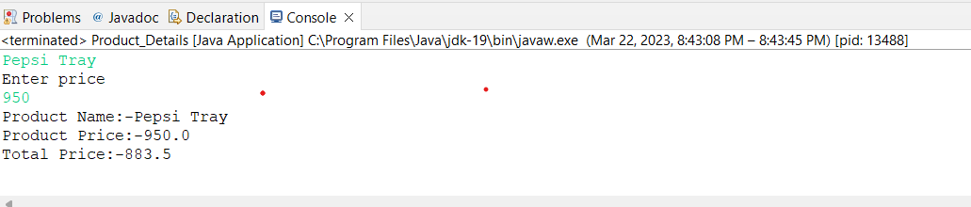

2.

**package** com.day3;

**import** java.util.*;

**public** **class** Even_Odd {

**public** **static** **void** main(String[] args) {

Scanner s= **new** Scanner(System.***in***);

System.***out***.println("Enter the no.");

**int** a=s.nextInt();

String b;

b=(a%2==0)? "Even":"Odd" ;

System.***out***.println(a+ "is " +b);

}

}

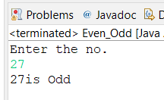

3.

**package** com.day3;

**import** java.util.*;

**public** **class** Grading_System {

**public** **static** **void** main(String[] args) {

Scanner s=**new** Scanner(System.***in***);

System.***out***.println("Enter the marks");

**int** marks;

marks=s.nextInt();

**if** (marks<25)

{

System.***out***.println("F");

}

**else** **if**(marks>=25 && marks<45)

{

System.***out***.println("E");

}

**else** **if**(marks>=45 && marks< 50) {

System.***out***.println("D");

}

**else** **if**(marks>=50 && marks< 60) {

System.***out***.println("C");

}

**else** **if**(marks>=60 && marks< 80) {

System.***out***.println("B");

}

**else** **if**(marks>=80)

System.***out***.println("A");

}

}

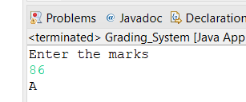

4.

**package** com.day3;

**import** java.util.*;

**public** **class** Greatest {

**public** **static** **void** main(String[] args) {

Scanner s=**new** Scanner(System.***in***);

**int** a,b,c;

System.***out***.println("Enter the values");

a=s.nextInt();

b=s.nextInt();

c=(a>b)?a:b;

System.***out***.println("Greatest Number " + c);

}

}

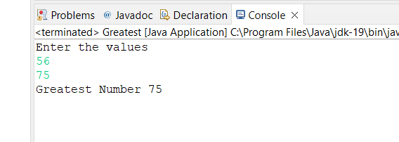

5.

**package** com.day3;

**import** java.util.*;

**public** **class** Numbers {

**public** **static** **void** main(String[] args) {

Scanner s=**new** Scanner(System.***in***);

System.***out***.println("Enter the number");

**int** n =s.nextInt();

String result = (n > 0) ? "Positive" : "Negative";

// **TODO** Auto-generated method stub

System.***out***.println(result);

}

}

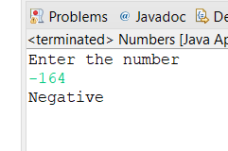

6.

**package** com.day3;

**import** java.util.*;

**public** **class** Employee_details {

**public** **static** **void** main(String[] args) {

Scanner s=**new** Scanner(System.***in***);

//String name;

//int age;

//float salary;

System.***out***.println("Enter the Name:-");

String name= s.nextLine();

System.***out***.println("Enter the salary:-");

**float** salary=s.nextFloat();

System.***out***.println("Enter the age:-");

**int** age=s.nextInt();

System.***out***.println(name);

System.***out***.println(age);

System.***out***.println(salary);

}

}

7.

**package** com.day3;

**import** java.util.*;

**public** **class** Student_marks {

**public** **static** **void** main(String[] args) {

Scanner s=**new** Scanner(System.***in***);

System.***out***.println("Enter the marks");

**int** marks=s.nextInt();

String result = (marks > 40) ? "Pass" : "Fail";

// **TODO** Auto-generated method stub

System.***out***.println(result);

}

}

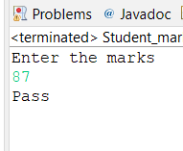

8.

**package** com.day3;

**import** java.util.*;

**public** **class** Swapping_using_2variable {

**public** **static** **void** main(String[] args) {

Scanner s=**new** Scanner(System.***in***);

**int** a,b;

System.***out***.println("Enter the values of A and B" );

a=s.nextInt();

b=s.nextInt();

System.***out***.println("Before Swapping" + a + " " +b);

a=a+b;

b=a-b;

a=a-b;

System.***out***.println("After Swapping" + a + " " + b);

}

}

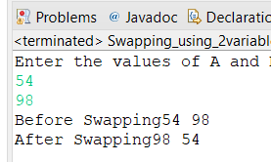

9.

**package** com.day3;

**import** java.util.*;

**public** **class** Largest3_no {

**public** **static** **void** main(String[] args) {

Scanner s=**new** Scanner(System.***in***);

System.***out***.println("Enter the values");

**int** a,b,c,max;

a=s.nextInt();

b=s.nextInt();

c=s.nextInt();

max=(a>b)?(a>c?a:c):(b>c?b:c);

System.***out***.println("Greatest Number "+ max);

}

}

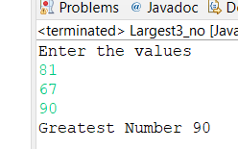

10.

**package** com.day3;

**import** java.util.*;

**public** **class** Swapping {

**public** **static** **void** main(String[] args) {

**int** a,b,c;

Scanner s=**new** Scanner(System.***in***);

System.***out***.println("Enter the values of A and B");

a=s.nextInt();

b=s.nextInt();

System.***out***.println("Before Swapping" + a + " " + b );

//Swapping

c=a;

a=b;

b=c;

System.***out***.println("After Swapping" + a + " " + b);

}

}

