1. What is software? What is software engineering?
Software refers to a set of instructions or programs that tell a computer what to do. It is a collection of data, instructions, and algorithms that are used to operate computers, manage data, and perform specific tasks. Software can be thought of as the intangible, non-physical components of a computer system, as opposed to hardware, which refers to the physical components such as the central processing unit (CPU), memory, and storage devices. • Software types
- System software
- Application software
What is software engineering
Software engineering is the application of engineering principles and techniques to the design, development, testing, and maintenance of software systems. It is a disciplined approach to software development that aims to produce high-quality software products that meet the requirements of users and stakeholders
• software engineering types
- Requirements gathering
- Design
- Implementation
- Testing
- Maintenance
- Project management

2. Explain types of software
Software is a set of programs (sequence of instructions) that allows the users to perform a well-defined function or some specified task
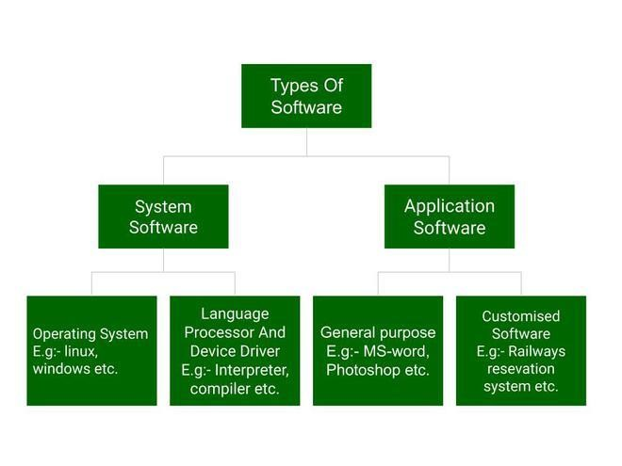
- Types of Software
- System Software
Operating Systems (OS): Manage computer hardware and provide a platform for running application software. Examples: Windows, macOS, Linux.
- Application Software
Productivity Software: Enhance user productivity. Examples: Microsoft Office, Google Docs.

- Programming Languages and Development Tools
Compilers: Translate source code into machine code. Examples: GCC, Java Compiler.

- Malicious Software (Malware)

Viruses: Replicate and spread to other systems. Examples: Trojan horses, worms.
Spyware: Monitor and collect user data without consent. Examples: keyloggers, adware.

- Open-Source Software

Free and open-source software that can be modified and distributed by anyone. Examples: Linux, Apache, Mozilla Firefox

- Freeware

Free software that can be used without any cost or restrictions. Examples: Audacity, VLC Media Player.

- Cloud Software

Software that is hosted and delivered over the internet, rather than installed on a local machine. Examples: Google Drive, Microsoft Office 365.

- Mobile Software
Software designed for mobile devices, such as smartphones and tablets. Examples: mobile apps, mobile games.

3. What is SDLC? Explain each phase of SDLC
SDLC stands for Software Development Life Cycle. It is a process used to design, develop, test, and deliver software products. SDLC provides a framework for managing and controlling the software development process, ensuring that software is delivered on time, within budget, and meets the required quality standards.
Phases of SDLC

• Planning
- Define project scope, goals, and deliverables.
- Identify stakeholders and their roles.
- Determine project timelines, budget, and resources.

▪ Requirements Gathering
- Collect and document user requirements.
- Define functional and non-functional requirements.
- Create a Software Requirements Specification (SRS) document.

• Analysis

- Break down requirements into smaller, manageable components.
- Identify potential risks and develop mitigation strategies.
- Create a detailed design document.

• Design

- Create a detailed design of the software architecture.
- Develop prototypes or mockups.
- Define the user interface and user experience

• Implementation (Coding)

- Write the code for the software application.
- Develop and integrate individual components. ▪ Conduct unit testing and integration testing.

• Testing

- Verify that the software meets the requirements.
- Identify and fix defects.
- Conduct various types of testing, such as functional, performance, and security testing.

• Deployment

- Release the software to the production environment.
- Configure and set up the software for use.
- Provide training and support to end-users.

• Maintenance

- Monitor and fix issues reported by users.
- Update and enhance the software to meet changing requirements.
- Perform regular maintenance tasks, such as backups and security updates

4. What is DFD? Create a DFD diagram on Flipkart
DFD is the abbreviation for Data Flow Diagram. The flow of data in a system or process is represented by a Data Flow Diagram (DFD). It also gives insight into the inputs and outputs of each entity and the process itself
- Zero level
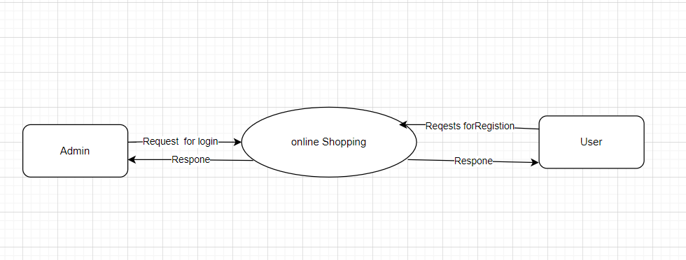
- Frist level
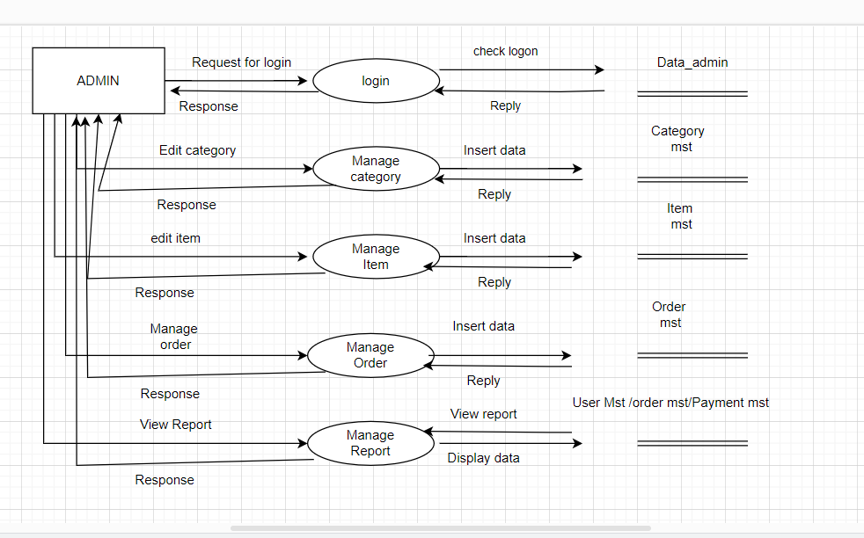

- Second level
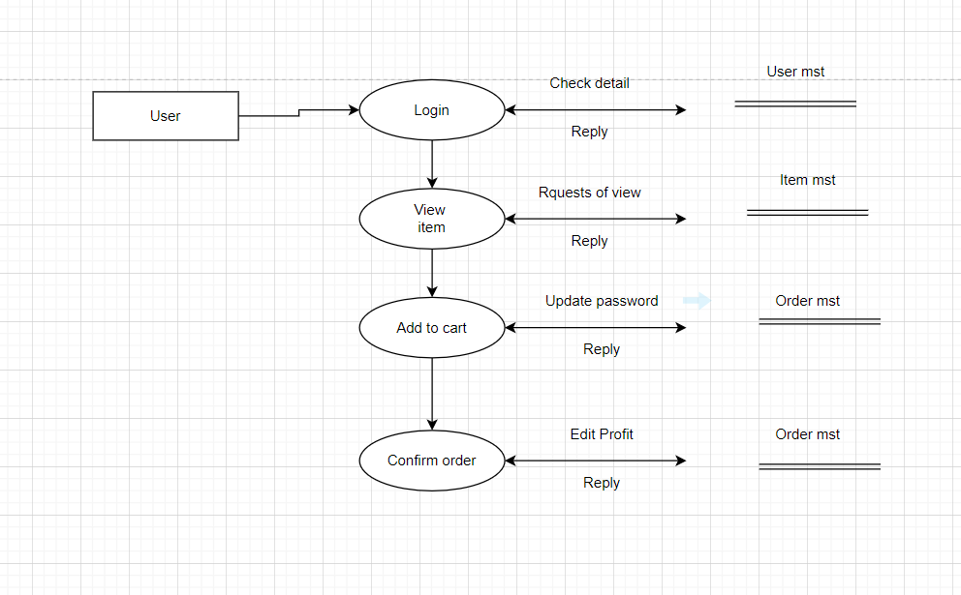

5. What is Flow chart? Create a flowchart to make addition of two numbers
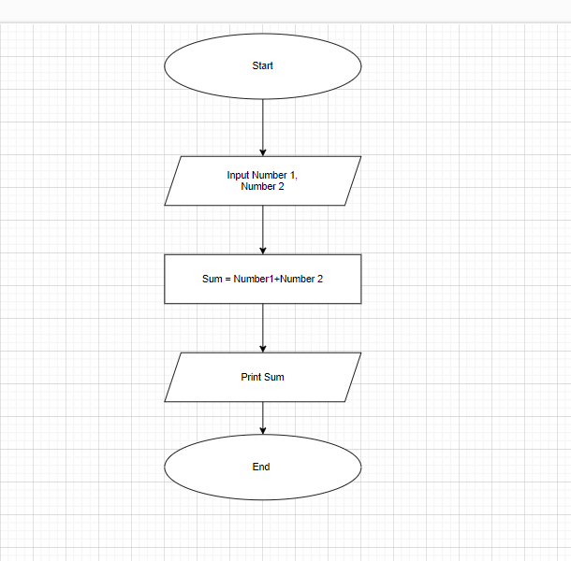
7. What is Use case Diagram? Create a use-case on bill payment on paytm.

