**CoSignSapiUMBasicSample**

The CoSignSapiUMBasicSample java code sample demonstrates how to fetch #n users from a CoSign Server using CoSign web services interface. The code sample resides in a Net Beans project. The code itself implements a simple console application that gets from the user (#n, admin_user, admin_user_pass) and fetches the first #n users from the server. In the reminder of this document I describe how to add and configure the CoSign SapiUM web services reference in the project.

1. Net Beans final project layout  
   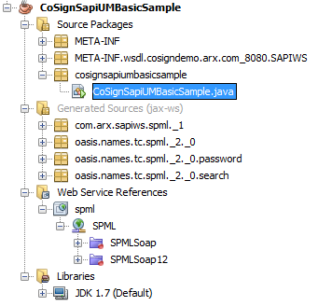
2. How to add the CoSign web services reference to the project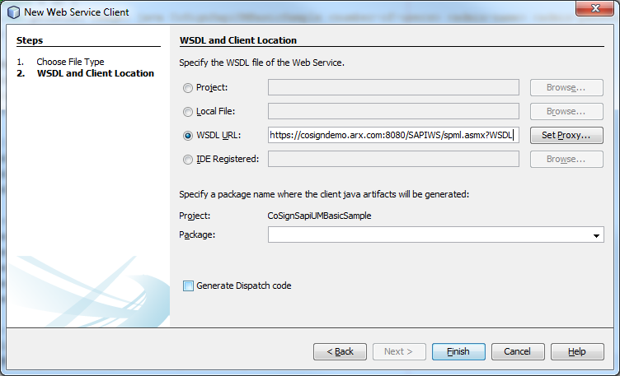
3. The Net Beans IDE asks the programmer to accept the CoSign Server as a trusted site (adds its certificates to the JRE certificate store)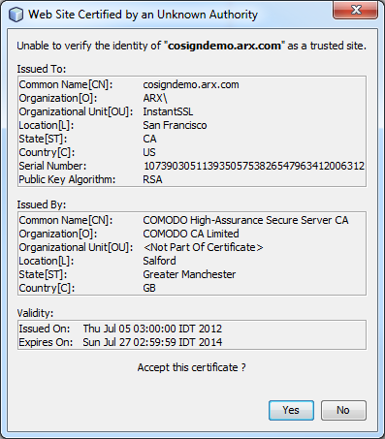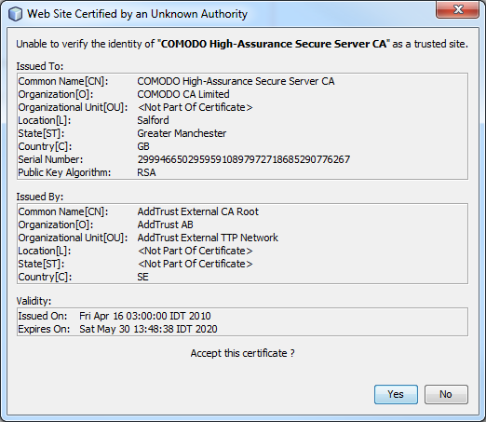

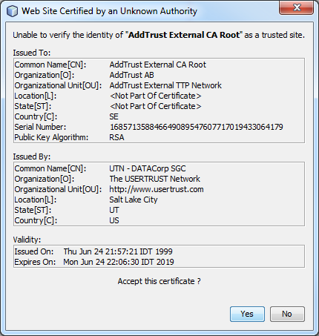

1. The Net Beans IDE invokes the wsimport java tool to create the necessary stubs for the web services client. Here is the wsimport output:

