EXPERIMENTS

1) N-trial experiments + CSV output (proposal Phase C)

1.1 What & why
Your proposal promised:
“Run N-trial experiments (e.g., 50–200 trials) to measure success rates/time-to-poison … and compare no-DNSSEC vs DNSSEC.”
Right now, you only click Start Attack manually. We’ll add a host-side experiment runner that:
- Calls the backend via HTTP.
- Runs N attacks.
- Records:
  - trial number
  - DNSSEC mode (OFF / VALIDATING)
  - whether attack succeeded or was blocked
  - time taken per attack
- Saves results to CSV in backend/measurements/.

1.3 How to run and test
Pre-requisites:
- From repo root DNS/:
- docker-compose up -d
- In a separate terminal, start backend:
- cd DNS/attacker
- # (create venv if you want, then)
- python poison.py
- Start frontend (optional for this step):
- cd DNS/frontend
- npm install
- npm run dev
Run experiments:
- Without DNSSEC:
- cd DNS/backend/measurements
- python run_experiments.py --mode unsigned --trials 100 --out unsigned_100.csv
- Now open unsigned_100.csv you can see as below.
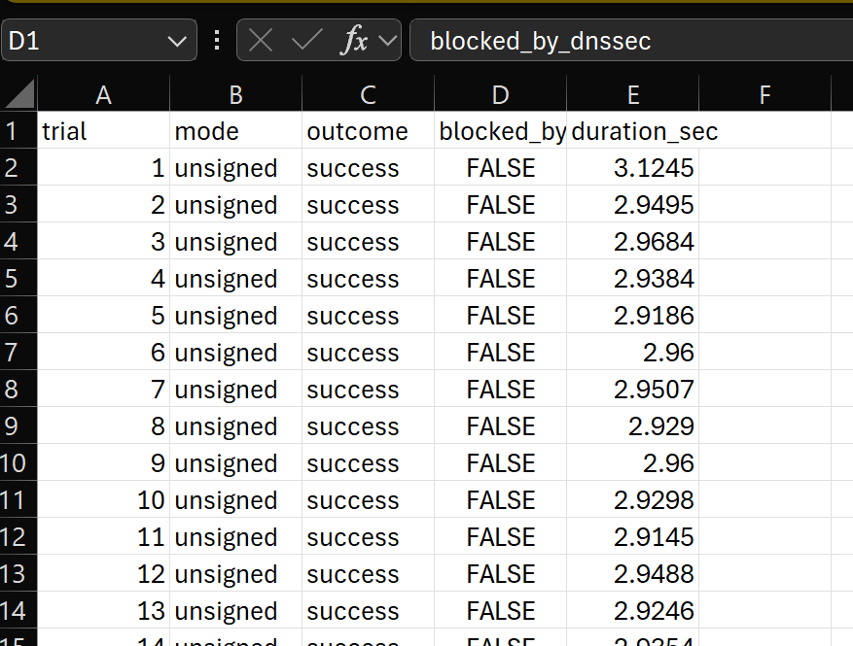
- With DNSSEC validation:
- python run_experiments.py --mode dnssec --trials 100 --out dnssec_100.csv
- Now open dnssec_100.csv
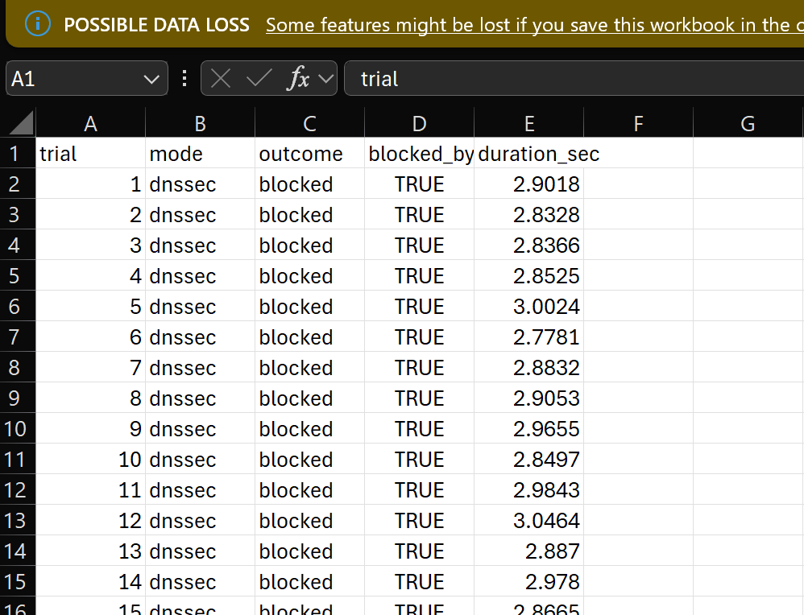
You’ll get two CSV files (e.g., unsigned_100.csv, dnssec_100.csv) that you can:
- Check in UI the attempts made with or without validation:
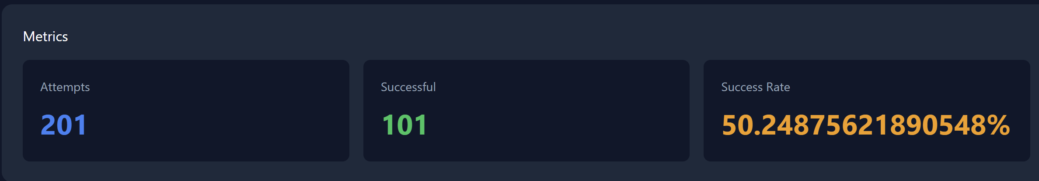
- Load in Excel / Python / R / Power BI
- Compute success rate vs blocked
- Compute mean/median duration_sec (≈ time-to-poison/attempt)
Add plotting script for experiment CSVs:

How to install requirements (once)
From your DNS/backend/measurements folder:
cd DNS/backend/measurements
pip install pandas matplotlib

How to generate plots
Still in DNS/backend/measurements:
python plot_results.py --unsigned unsigned_100.csv --dnssec dnssec_100.csv --out-prefix results_100
It will give:
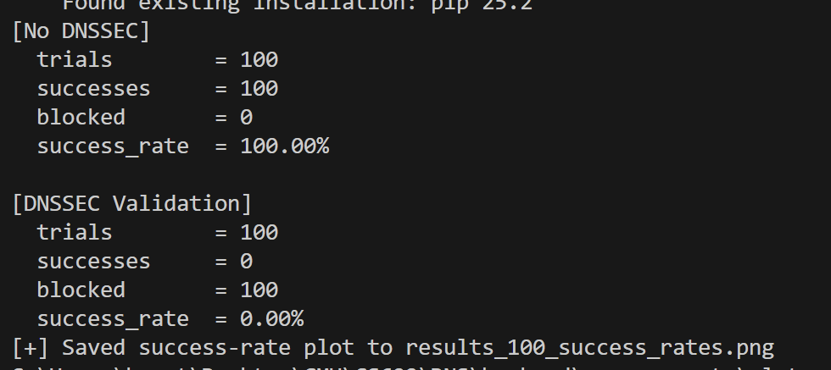
And it will create:
- results_100_success_rates.png
  - Stacked bar chart: Successful vs Blocked for No DNSSEC vs DNSSEC Validation.
- 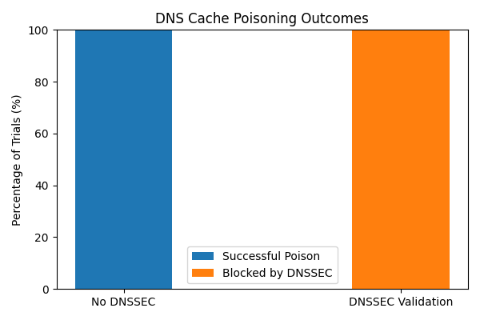

- results_100_duration_boxplot.png
  - Boxplot of duration_sec (approx “time to attempt/attack”) under both modes.
- 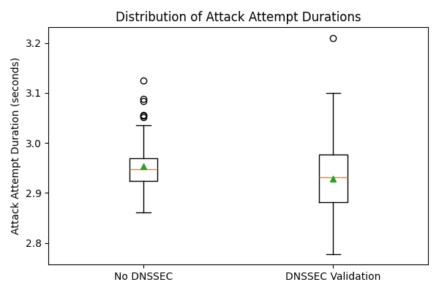

These directly satisfy the proposal’s N-trial experiment requirement.

2) Latency & CPU overhead measurements (proposal Phase C)

2.1 What & why
Proposal promised:
“Measure DNSSEC validation overhead (latency and CPU).”
We’ll add one separate script that:
- Pings resolver_dns with standard DNS queries using dig inside the attacker container.
- Measures round-trip time for each query (latency).
- Optionally samples CPU via docker stats (basic approximate).
File to create:
DNS/backend/measurements/latency_benchmark.py

2.3 How to run & interpret
- First run without DNSSEC (zone unsigned & validation off):
  - Either click “Setup / Off DNSSEC” in UI until DNSSEC is OFF,
or call python run_experiments.py --mode unsigned --trials 1 (it will unsign).
  - Then:
  - cd DNS/backend/measurements
  - python latency_benchmark.py --n 50\
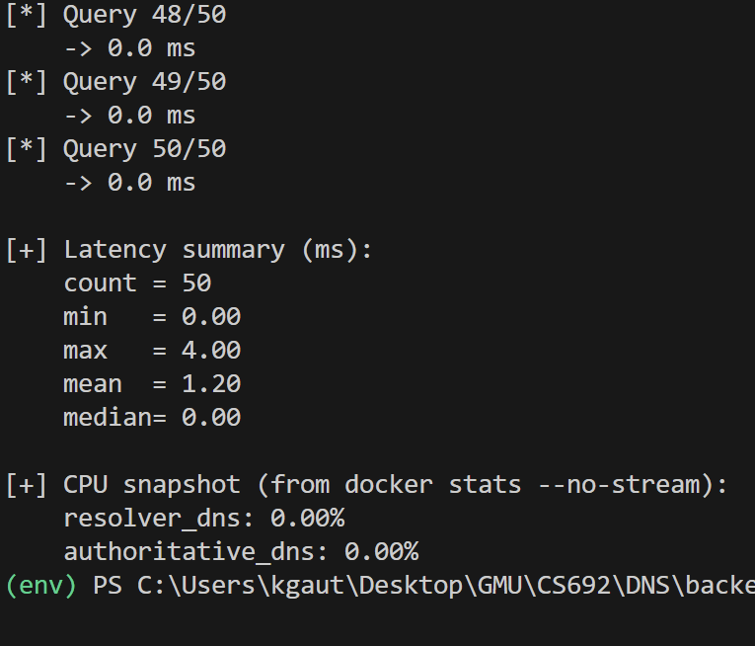
- Then run with DNSSEC validation ON:
  - Use:
  - python run_experiments.py --mode dnssec --trials 1
(This ensures signed zone + validation ON, but only 1 trial.)
  - Then:
  - python latency_benchmark.py --n 50
- Compare:
  - Mean / median latency for unsigned vs DNSSEC.
  - CPU snapshot for resolver_dns and authoritative_dns.
You can paste these numbers into your report graphs to satisfy the “DNSSEC overhead” requirement.

3) PCAP capture + using detector.py (proposal Phase D)

3.1 What & why
Proposal promised:
“A short detector prototype that scans logs/PCAPs for anomalous responses.”
You already have attacker/detector.py.
We only need to:
- Show how to capture PCAPs.
- Show how to run detector.py on those PCAPs and logs.
- Mention this clearly in your report.

3.2 How to capture PCAPs
We’ll use tcpdump (already installed in attacker container via Dockerfile).
Example: capture 1 attack experiment:
cd DNS

# 1) Start a tcpdump capture on resolver_dns (port 53)
docker exec resolver_dns tcpdump -i eth0 port 53 -w /tmp/dns_attack.pcap &

# 2) Run one or more attacks from UI (or run_experiments.py)

# 3) After done, stop tcpdump by killing the process in resolver_dns
docker exec resolver_dns pkill tcpdump

# 4) Copy the PCAP out of container
docker cp resolver_dns:/tmp/dns_attack.pcap ./backend/measurements/dns_attack.pcap
Now you have DNS/backend/measurements/dns_attack.pcap.

3.3 How to use detector.py
Log analysis (text logs):
If you export BIND or resolver logs to a text file (say resolver.log), you can run:
cd DNS/attacker
python detector.py ../backend/measurements/resolver.log
PCAP analysis:
For the PCAP we just captured:
cd DNS/attacker
python detector.py ../backend/measurements/dns_attack.pcap
detector.py will print anomalies like:
- multiple answers for same query with different IPs
- suspicious TTLs
- repeated query IDs with conflicting data
You don’t need to change detector.py – just document this in your report under Detection & Reporting.

