Roll no 10
Program 10:-
Algorithm
- Get input from the user for number of process =limit.
- Get arrival and burst time .=at,bt.
- Get time quantum=n.
- Check for the arriving time with lowest burst time
- If arrival time is not free run process one for n and
- Bt=bt-n
- Then check again and give priority to q1
- Then do this till (i=0,i<limit)
- Then calculate turnaround time
- Turnaround time=completion time-arrival time
- Then calculate Waiting time
- Waiting time= turnaround time-burst time
- Calculate total turnaround time
- Total Turnaround time+=Turnaround time
- Calculate average =total turnaround time/limit
- Calculate total wait time
- Total wait time+=wait time
- Calculate average wait=total wait time/limit
- Print all these
- end
Description :-
This program is done in c language, where I used loops ,variables and condition statement for making a program which can show shortest remaining time using preemptive scheduling using time quantum value and giving priority to time quantum then Srot.
Test Case:- valid test case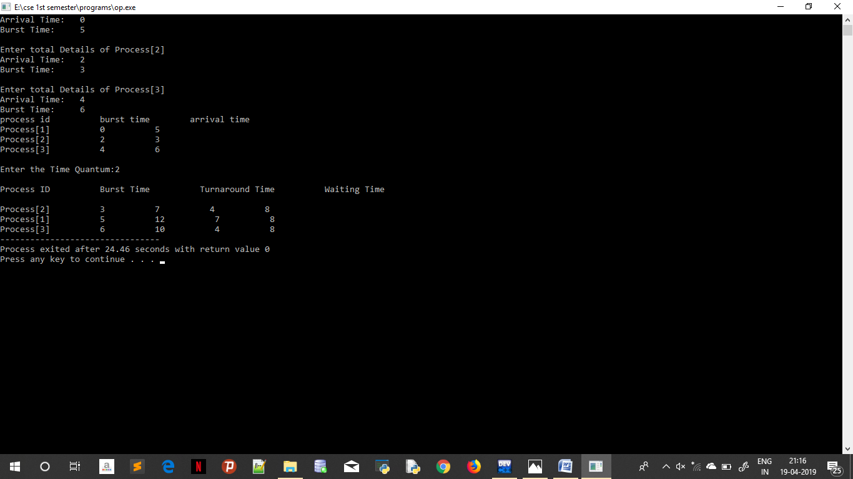
Invalid test case when conflict occur after process 2
