QUERIES

Ankit Verma
2016BCS0007

1.CREATE

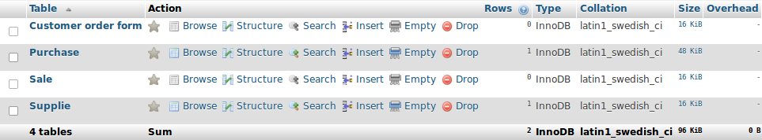

CREATE TABLE `Kayoto`.`Purchase` ( `Engine no.` VARCHAR(10) NOT NULL , `Key no.` INT NOT NULL , `Mfg year` YEAR NOT NULL , `Model no.` TEXT NOT NULL , `Quantity` INT NOT NULL , `Supplie Id` TEXT
NOT NULL , `Color` TEXT NOT NULL , `Amt` INT NOT NULL , PRIMARY KEY (`Engine no.`)) ENGINE = InnoDB;

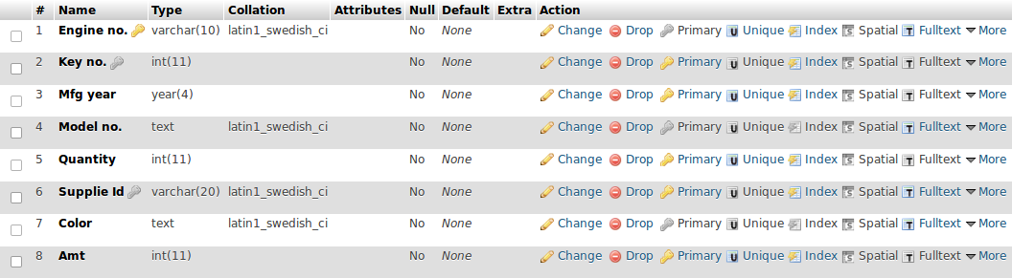

CREATE TABLE `Kayoto`.`Customer order form` ( `Cof` INT NOT NULL , `Date` DATE NOT NULL , `Phone no.` INT NOT NULL , `Address` VARCHAR(50) NOT NULL , `Model` VARCHAR(20) NOT NULL , `Balance` INT NOT NULL , `Name` VARCHAR(25) NOT NULL , PRIMARY KEY (`Cof`)) ENGINE = InnoDB;

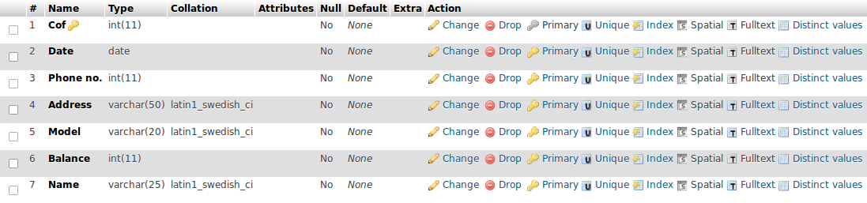

CREATE TABLE `Kayoto`.`Sale` ( `Engine no.` VARCHAR(10) NOT NULL , `Delivery Date` DATE NOT NULL , `Cof` INT NOT NULL ) ENGINE = InnoDB;

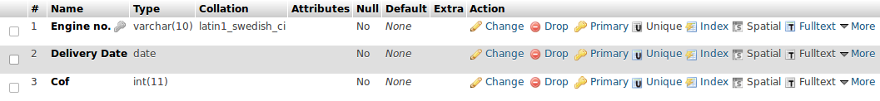

CREATE TABLE `Kayoto`.`Supplie` ( `Supplie Id` VARCHAR(10) NOT NULL , `name` VARCHAR(25) NOT NULL , `Email Id` VARCHAR(40) NOT NULL , `Contact no.` INT(10) NOT NULL , `address` VARCHAR(50) NOT NULL , PRIMARY KEY (`Supplie Id`)) ENGINE = InnoDB;

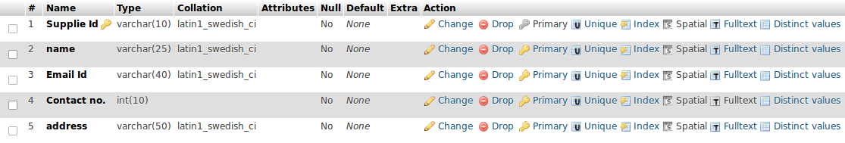

2.ALTER

ALTER TABLE `Purchase` ADD UNIQUE(`Supplie Id`);

ALTER TABLE `Purchase` ADD CONSTRAINT `Foriegn` FOREIGN KEY (`Supplie Id`) REFERENCES `Supplie`(`Supplie Id`) ON DELETE RESTRICT ON UPDATE RESTRICT;

ALTER TABLE `Sale` ADD CONSTRAINT `hgfgjv` FOREIGN KEY (`Engine no.`) REFERENCES `Purchase`(`Engine no.`) ON DELETE RESTRICT ON UPDATE RESTRICT;

3.INSERT

INSERT INTO `Supplie` (`Supplie Id`, `name`, `Email Id`, `Contact no.`, `address`) VALUES ('76-tford', 'Amazon', 'Amazon17@amazon.co.in', '6754377', '27th street, goregaon east, Mumbai');

INSERT INTO `Purchase` (`Engine no.`, `Key no.`, `Mfg year`, `Model no.`, `Quantity`, `Supplie Id`, `Color`, `Amt`) VALUES ('tford19203', '21354', '2016', 'tftgbyf-kihik-7y6t', '2', '76-tford', 'Matte Black', '1275000');

4.UPDATE

UPDATE `Supplie` SET `address` = '27th street, goregaon east, Mumbai, 228975' WHERE `Supplie`.`Supplie Id` = '76-tford';

5.DELETE

DELETE FROM `Sale` WHERE `Sale`.`Engine no.` = \'tford19203\'"

6.DROP

DROP TABLE PURCHASE;

7.SELECT

SELECT name, address FROM Supplie;

8.SELECT DISTINCT

SELECT `Engine no.` , Quantity FROM Purchase WHERE Quantity IN (SELECT DISTINCT Quantity FROM Purchase);

9.ORDER BY

SELECT `Engine no.`, `Model no.` FROM Purchase ORDER BY Quantity;

10.MIN

SELECT MIN(Quantity) AS Min_quan FROM Purchase;

10.MAX

SELECT MAX(Quantity) AS Max_quan FROM Purchase;

11.COUNT

SELECT COUNT(`Engine no.`) FROM Purchase WHERE Quantity>1;

11.AVG

SELECT AVG(Quantity) FROM Purchase;

12.SUM

SELECT SUM(Quantity) FROM Purchase;

13.LIKE

SELECT * FROM `Supplie` WHERE `Email Id` LIKE '%amazon%';

14.BETWEEN

SELECT `Engine no.`, Amt FROM Purchase WHERE Quantity
BETWEEN 1 AND 4;

15.UNION

SELECT Name FROM `Customer order form`
UNION (SELECT name FROM Supplie);

16.GROUP BY

SELECT Quantity FROM Purchase WHERE 1 GROUP BY Quantity;

17.HAVING

SELECT Quantity FROM Purchase GROUP BY Quantity
HAVING COUNT(Quantity) >0;

18.EXISTS

SELECT * FROM Purchase WHERE
EXISTS
(SELECT * FROM Sale
WHERE Purchase.`Engine no.`= Sale.`Engine no.`);

19.INNER JOIN

SELECT *
FROM Purchase
INNER JOIN Sale ON Purchase.`Engine no.`= Sale.`Engine no.`;

20.LEFT JOIN

SELECT *
FROM Purchase
LEFT JOIN Sale ON Purchase.`Engine no.`= Sale.`Engine no.`;

`````````````````````````````````````````````````````

