AUTOMOBILE PURCHASE MANAGEMENT SYSTEM

ANKIT VERMA
2016BCS0007

Introduction

This project deals with the management for purchase, sale and supplie of the automobiles. This project is done with the help of ER Relationship model and mysql id used for the database.

ER Diagram

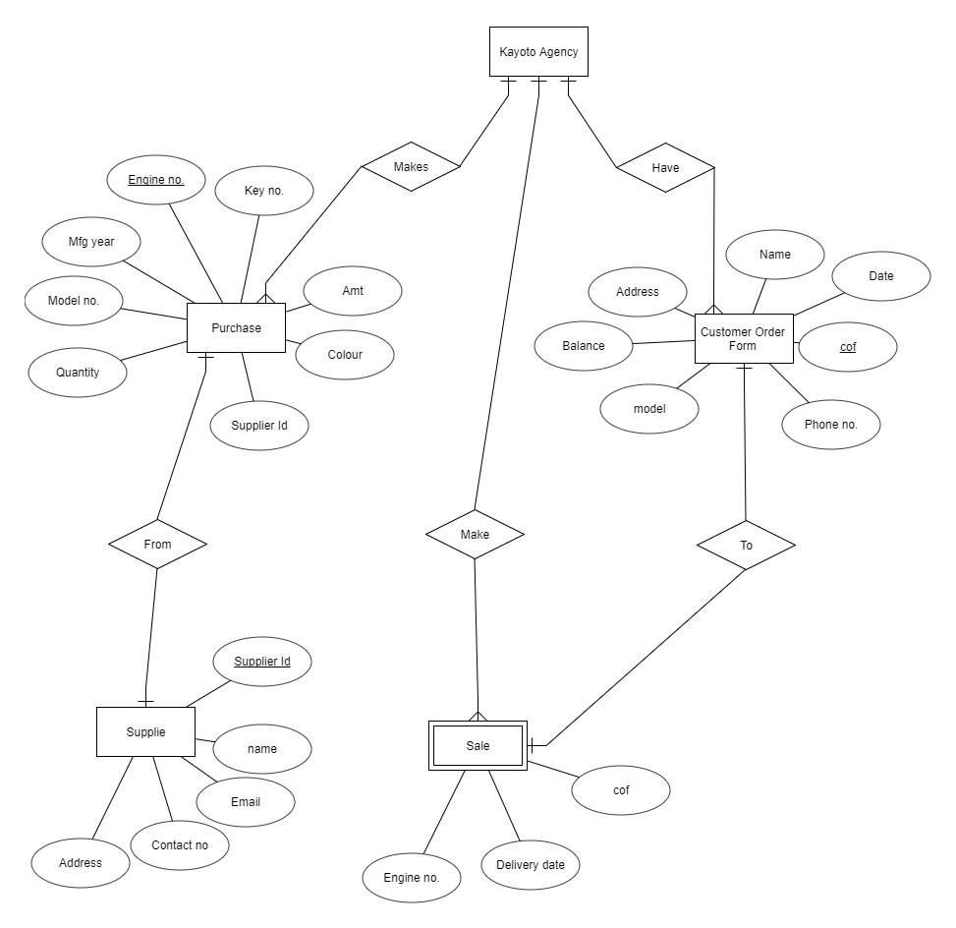
Relational Schema and keys

Entity : Purchase

Engine no. | Key no. | MFG Year | Model no. | Quantity | Supplier ID | Colour | Amt
......
....
..

Super Key : {Engine no.,Key no.,MFG Year,Model no.,Quantity,Supplier ID,Colour,Amt}

Candidate Key : {Engine no. }, {Key no.}, {Model no.}, {Supplier ID}

Primary Key : {Engine no.}

Foreign Key : {Supplier ID}

Entity : Customer order form

Cof | Date | Phone no. | Address | model | Balance | Name
.....
....
..

Super Key : {Cof,Date,Phone no.,Address,model,Balance,Name}

Candidate Key : {Cof}, {model}

Primary Key : {Cof}

Foreign Key : {}

Entity : Sale

Engine no. | Delivery Date | Cof

Super Key : {Engine no.,Delivery Date,Cof}

Candidate Key : {Engine no.}, {Delivery Date}, {Cof}

Primary Key : {}

Foreign Key : {Engine no.},{Cof}

Entity : Supplie

Supplie Id | Name | Email Id
...
..

Super Key : {Supplie ID,Name,Email ID}

Candidate Key : {Supplie Id},{Email Id}

Primary Key : {Supplie Id}

Foreign Key: {}

Queries

Continued in the next file....

