# DEV/SIT Landing Zone (HLD & LLD)

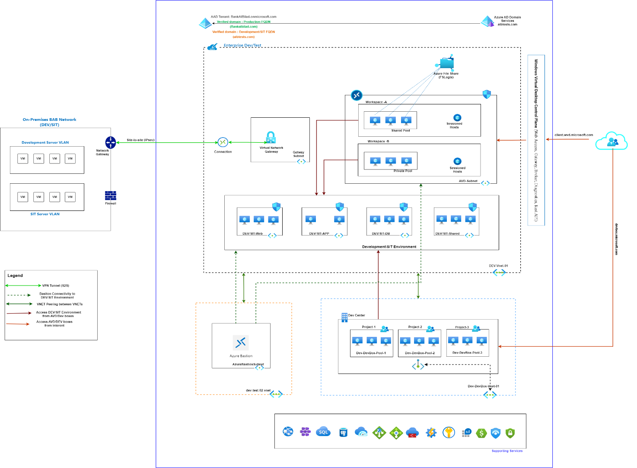

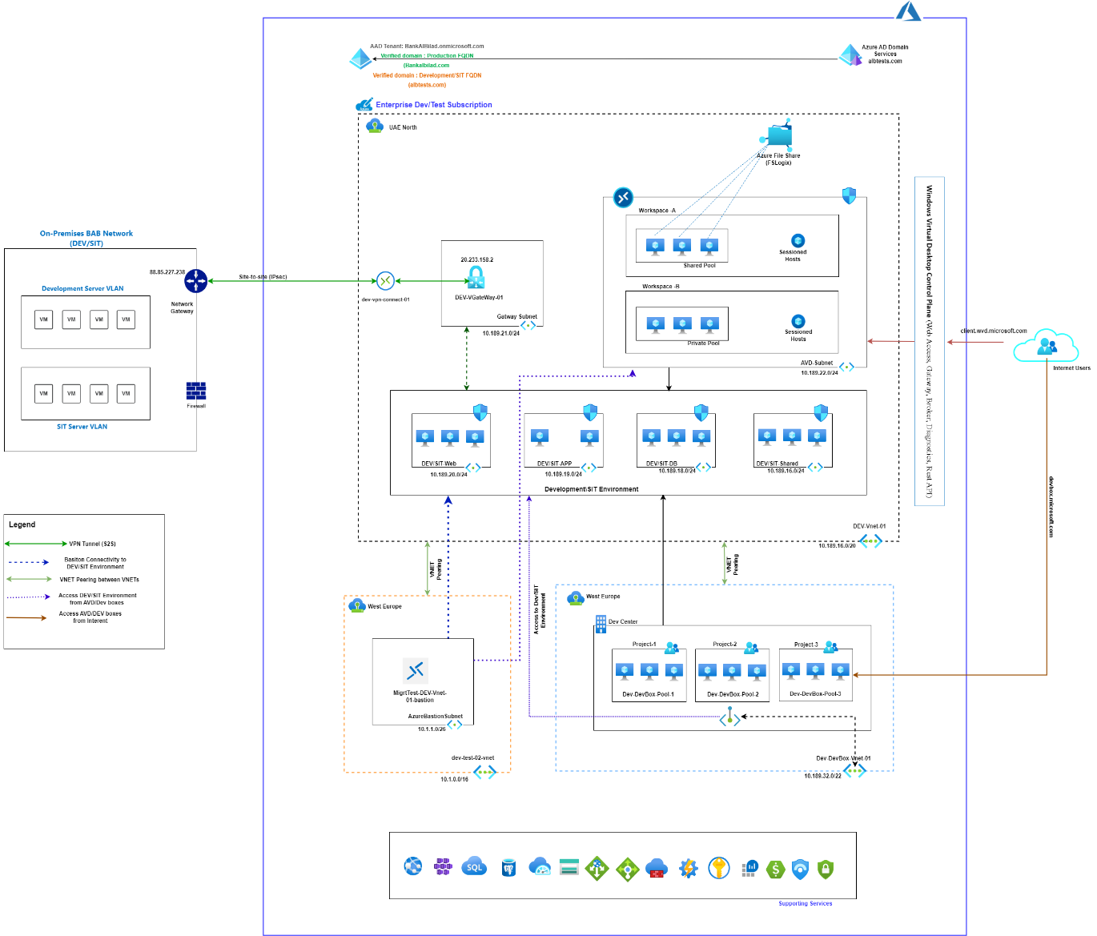

# DEV/SIT Subscription

# DEV/SIT Servers Naming Convention

**SS == DA ===**Two letter Code where asset is located

**PPP==T24 ===**Project Identification

**FF==AP/DB/WE===** Function

**XX==For sub-function==**For sub-function

**L===Environment===**D,S

**DD === Descriptor for Operating System=** WV/LV

**N=**Running Number == 1-9 then use A-Z

Use this table for naming:

|  |  |  |  |  |  |  |
| --- | --- | --- | --- | --- | --- | --- |
| SS | PPP | FF | XX | L | DD | N |
| DA | MOD | AP | TS | S | WV | 1 |

For this example:

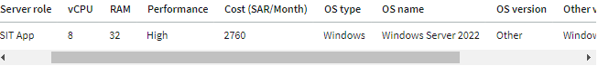

|  |  |  |  |  |  |  |
| --- | --- | --- | --- | --- | --- | --- |
| SS | PPP | FF | XX | L | DD | N |
| DA | 4LE | AP | SQ | S | WV | 1 |

# AVD Details

Azure virtual desktops have created from the custom image of Window 10 and joined in albtests.com domain.

Two types of host pool created, Personal Pool and Shared Pool. From AVD can access the DEV/SIT environment through Private network.

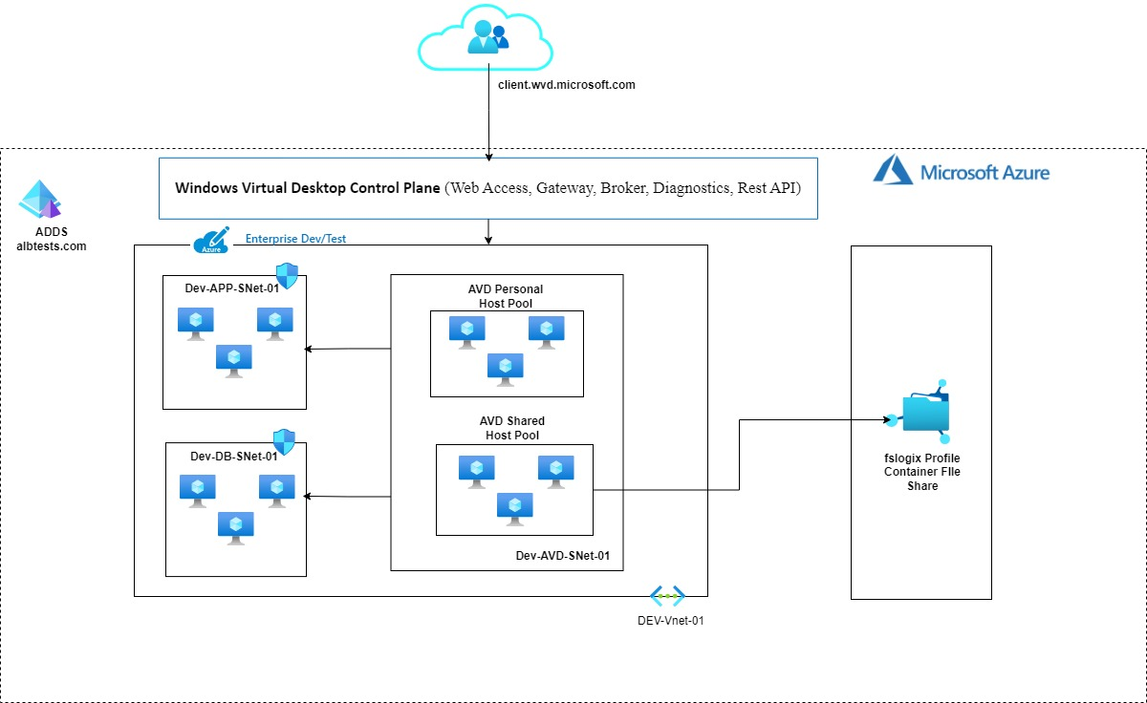

# DevBox Details

Microsoft Dev Box gives developers self-service access to ready-to-code cloud workstations called dev boxes.

Dev Box access has provided to the Developer teams like T24 Developer, Devops etc. From Dev boxes developer will be access the DEV/SIT servers in Cloud Environment.

# Appendix

1. Enterprise Dev/Test Inventory details
2. Network Topology

