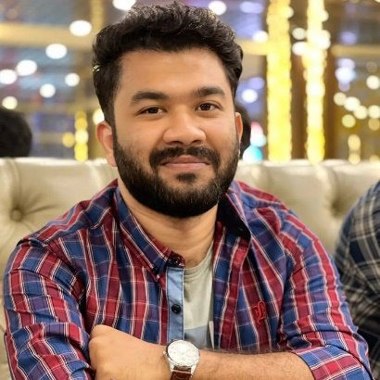

** github.com/Ankon78**

** kuril chow-Rasta, Dhaka.**

** linkedin.com/in/ankon-sarker84**

** ankonsarker17@gmail.com**

** 01767553784**

**Ankon Sarker**

I want to apply what I've learned as a fresher to launch a successful career. I enjoy a challenge and always try to do my best. Which I've demonstrated in my efforts. I want the opportunity to prove myself.

**CONTACT**

**EDUCATION**

**Bachelor of Science : BSc in Computer Science and Engineering.**

Institution **: American International University-Bangladesh.**

**Leadership, Communication Skills**

**■ ■ ■ ■ ■ (Good)**

**SOFTWARE TESTING**

**■ ■ ■ ■ ■ (Average)**

**ASP .NET MVC**

**■ ■ ■ ■ ■ (Very Good)**

**C, C++, C#, JAVA**

**■ ■ ■ ■ ■** (Good)

**HTML, CSS, PHP, MySQL**

**■ ■ ■ ■ ■** (Good)

**MS-Word, MS-Excel, MS-PowerPoint**

**■ ■ ■ ■ ■ (Very Good)**

**SKILLS**

Result : CGPA 3.54 out of 4.00

Passing Year : 2023

**Higher Secondary Certificate (HSC)**

Group : **Science**

Institution : **Cantonment Public School and Collage,Rangpur.**

Board : Dinajpur Education Board

Result : CGPA 5.00 out of 5.00

Passing Year : 2018

**REFERENCE**