PROJECT DOCUMENTATION
Student Performance Analytics System
A Python-based student performance analysis project using NumPy and Pandas

Student / Project Detail | Information
Student Name | ANKONA CHAKRABORTY
Year | 4th Year
Roll No. | ECE2023111
Department | Electronics and Communication Engineering
Project Repository | GitHub – student-performance-analytics

Project Documentation

Contents
1. Project Overview
2. Objective
3. Technologies Used
4. Dataset Description
5. System Workflow
6. Implementation
7. Key Features
8. Grading and Pass/Fail Rules
9. Output and Performance Analysis
10. Screenshots and Evidence
11. Final Outcome
12. Challenges and Learning
13. Future Scope
14. GitHub Repository
15. Conclusion

1. Project Overview
The Student Performance Analytics System is a Python-based data analysis project designed to process and analyze academic information of students. The project uses a CSV dataset as input and applies Python programming concepts together with NumPy and Pandas to generate useful academic performance statistics.
The system is designed as a simple and practical application rather than an advanced machine learning system. It focuses on fundamental programming and data-analysis concepts such as variables, conditions, loops, functions, DataFrames, numerical calculations, and CSV data handling.
The final program can calculate individual student totals and averages, assign grades, determine pass/fail status, calculate class-level statistics, compare subjects, and identify the top-performing students.

2. Objective
The main objective of the project is to develop a Student Performance Analytics System that can convert raw student marks and attendance data into meaningful academic information.
The system is intended to:
- Read student records from a CSV file.
- Store and process the data using a Pandas DataFrame.
- Use NumPy for numerical calculations such as totals and averages.
- Use reusable Python functions for repeated operations.
- Calculate total and average marks for every student.
- Assign grades according to the calculated average.
- Determine whether each student has passed or failed.
- Perform subject-wise performance analysis.
- Find the highest and lowest performing students.
- Identify the top three students in the dataset.

3. Technologies Used
Technology / Tool | Purpose
Python | Core programming language used to build the system.
NumPy | Used for numerical operations such as sum and mean.
Pandas | Used to read the CSV file, create a DataFrame, process data, and perform analysis.
CSV | Input dataset containing student information, marks, and attendance.
VS Code | Development environment used to write and run the Python program.
GitHub | Used to store, organize, and share the completed project repository.

4. Dataset Description
The input file is named students.csv and contains 20 student records. Each record contains the student's identification information, department, marks in three subjects, and attendance percentage.
Field | Description
Student_ID | Unique identification number of the student.
Name | Name of the student.
Department | Department of the student; the current dataset uses ECE.
Python | Marks obtained in Python.
Math | Marks obtained in Mathematics.
Computer_Networks | Marks obtained in Computer Networks.
Attendance | Attendance percentage.
The dataset contains realistic marks and attendance values so that the program can demonstrate different grades and both pass and fail cases.

5. System Workflow
The overall processing flow of the system is:
- Start the Python program.
- Load students.csv using Pandas.
- Calculate total marks for each student using a reusable function and NumPy.
- Calculate the average marks for each student.
- Assign a grade based on the average.
- Check the pass/fail condition using subject marks and attendance.
- Calculate overall class statistics.
- Calculate the average performance of each subject.
- Identify the best-performing subject.
- Find and display the top three students.
- Display the final analysis in the terminal.

6. Implementation

6.1 main.py
The main.py file controls the overall execution of the project. It imports Pandas and the reusable functions from functions.py. The CSV dataset is loaded with pd.read_csv(), after which new columns such as Total, Average, Grade, and Result are created.
Pandas operations are also used to calculate class averages, identify maximum and minimum averages, count passed and failed students, and compare subject averages. A loop is used to perform the subject-wise analysis and another loop displays the top three students.

6.2 functions.py
The functions.py file separates reusable calculations from the main program. This improves the organization of the project and demonstrates the use of Python functions.
Function | Purpose
calculate_total(row) | Calculates the sum of the three subject marks using NumPy.
calculate_average(row) | Calculates the mean of the three subject marks using NumPy.
calculate_grade(average) | Returns the grade based on the student's average.
check_pass_fail(row) | Checks subject marks and attendance to return Pass or Fail.
get_top_students(data, number=3) | Returns the highest-performing students based on Average.

7. Key Features
Feature | Description
CSV Data Loading | Reads the student dataset directly into a Pandas DataFrame.
Total and Average Calculation | Calculates academic totals and averages for every student.
Automatic Grading | Assigns A+, A, B, C, D, or F based on the average.
Pass/Fail Analysis | Checks minimum subject marks and attendance requirements.
Class Analysis | Finds overall class average, highest average, lowest average, and pass/fail counts.
Subject Analysis | Calculates average performance for Python, Math, and Computer Networks.
Best Subject Detection | Identifies the subject with the highest average.
Top Performers | Displays the top three students based on average marks.

8. Grading and Pass/Fail Rules
The grading system implemented in the project is:
Average Marks | Grade
90 or above | A+
80–89 | A
70–79 | B
60–69 | C
50–59 | D
Below 50 | F
A student is considered Pass only when every subject mark is at least 40 and attendance is at least 75%. If either condition is not satisfied, the student is considered Fail.

9. Output and Performance Analysis
The program was executed successfully in the VS Code terminal using the command python main.py. The output confirms that the system processes all 20 records and produces individual and class-level results.

9.1 Overall Class Results
Metric | Result
Overall Class Average | 76.68
Highest Average | 95.67 – Soham Roy
Lowest Average | 48.33 – Diya Das
Number of Passed Students | 17
Number of Failed Students | 3

9.2 Subject-wise Results
Subject | Average
Python | 76.10
Math | 76.55
Computer Networks | 77.40
Best Performing Subject: Computer Networks

9.3 Top Three Students
Rank | Student | Average | Grade
1 | Soham Roy | 95.67 | A+
2 | Aditya Bose | 93.00 | A+
3 | Priya Sharma | 91.33 | A+

10. Screenshots and Evidence
The following screenshots provide evidence of the project implementation, execution, and GitHub submission.

10.1 Project Files and main.py in VS Code
This screenshot shows the project opened in VS Code, including the project files and the main.py implementation.
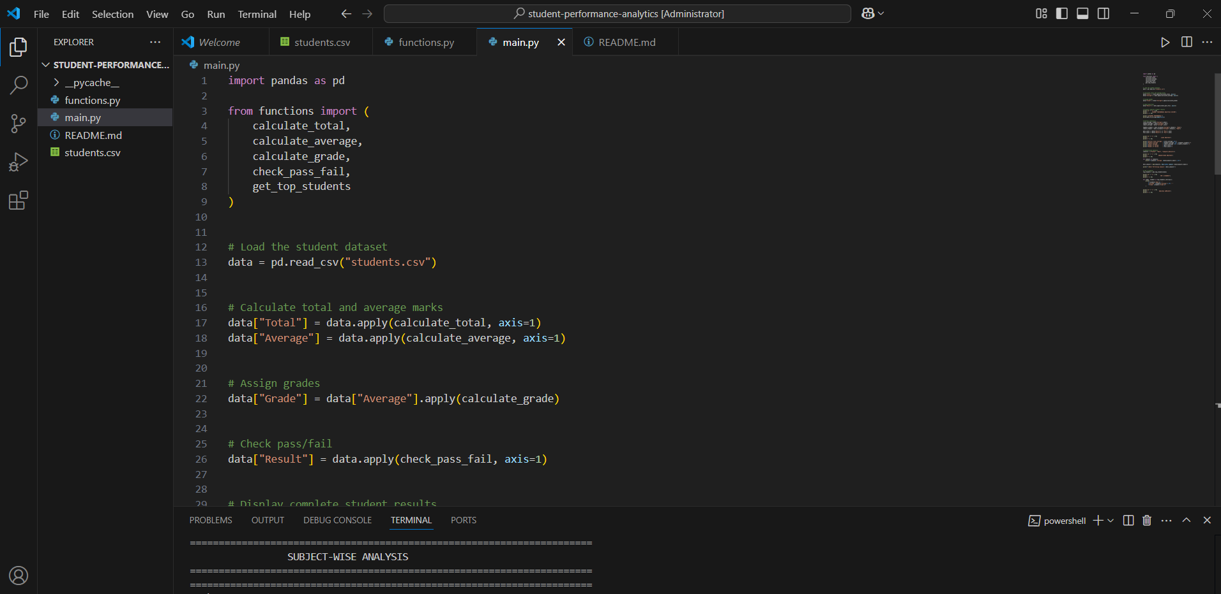
Figure 1. Project structure and main.py implementation in VS Code.

10.2 Program Execution – Student Performance Output
The first terminal screenshot shows the program execution and the generated student performance table, including subject marks, attendance, totals, averages, grades, and results.
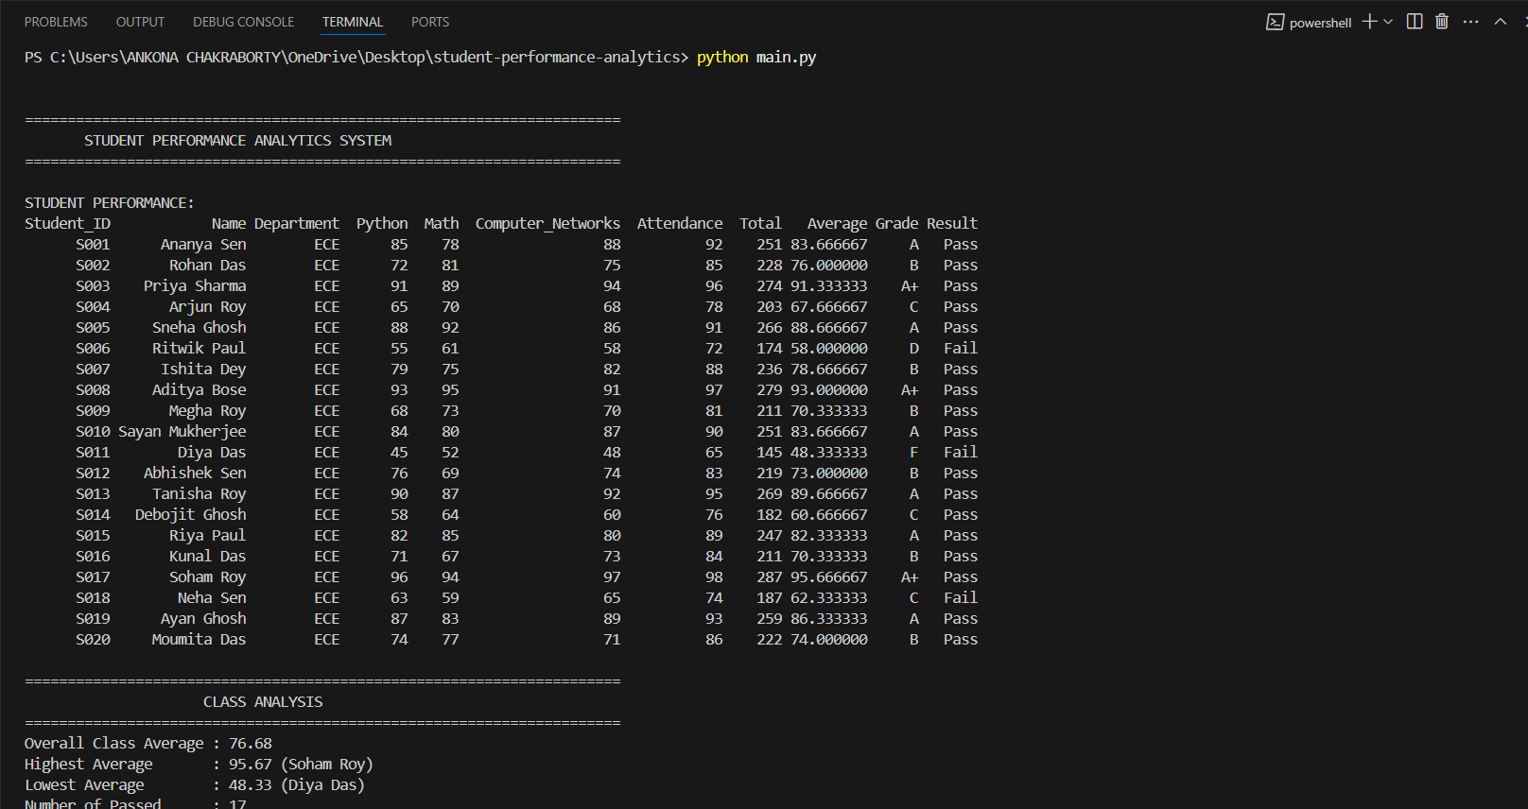
Figure 2. Program output showing student-level performance analysis.

10.3 Program Execution – Class and Subject Analysis
The second terminal screenshot shows the class-level analysis, subject-wise averages, best-performing subject, top three students, and successful completion of the analysis.
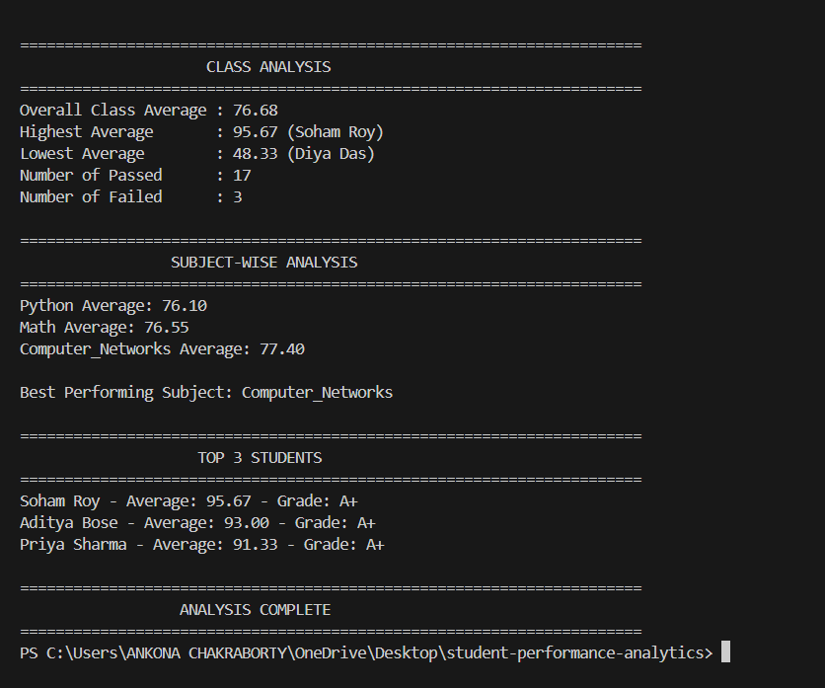
Figure 3. Class analysis, subject-wise analysis, and top-performing students.

10.4 GitHub Repository
The GitHub screenshot confirms that the completed project has been uploaded to the public repository. The repository contains README.md, functions.py, main.py, and students.csv.
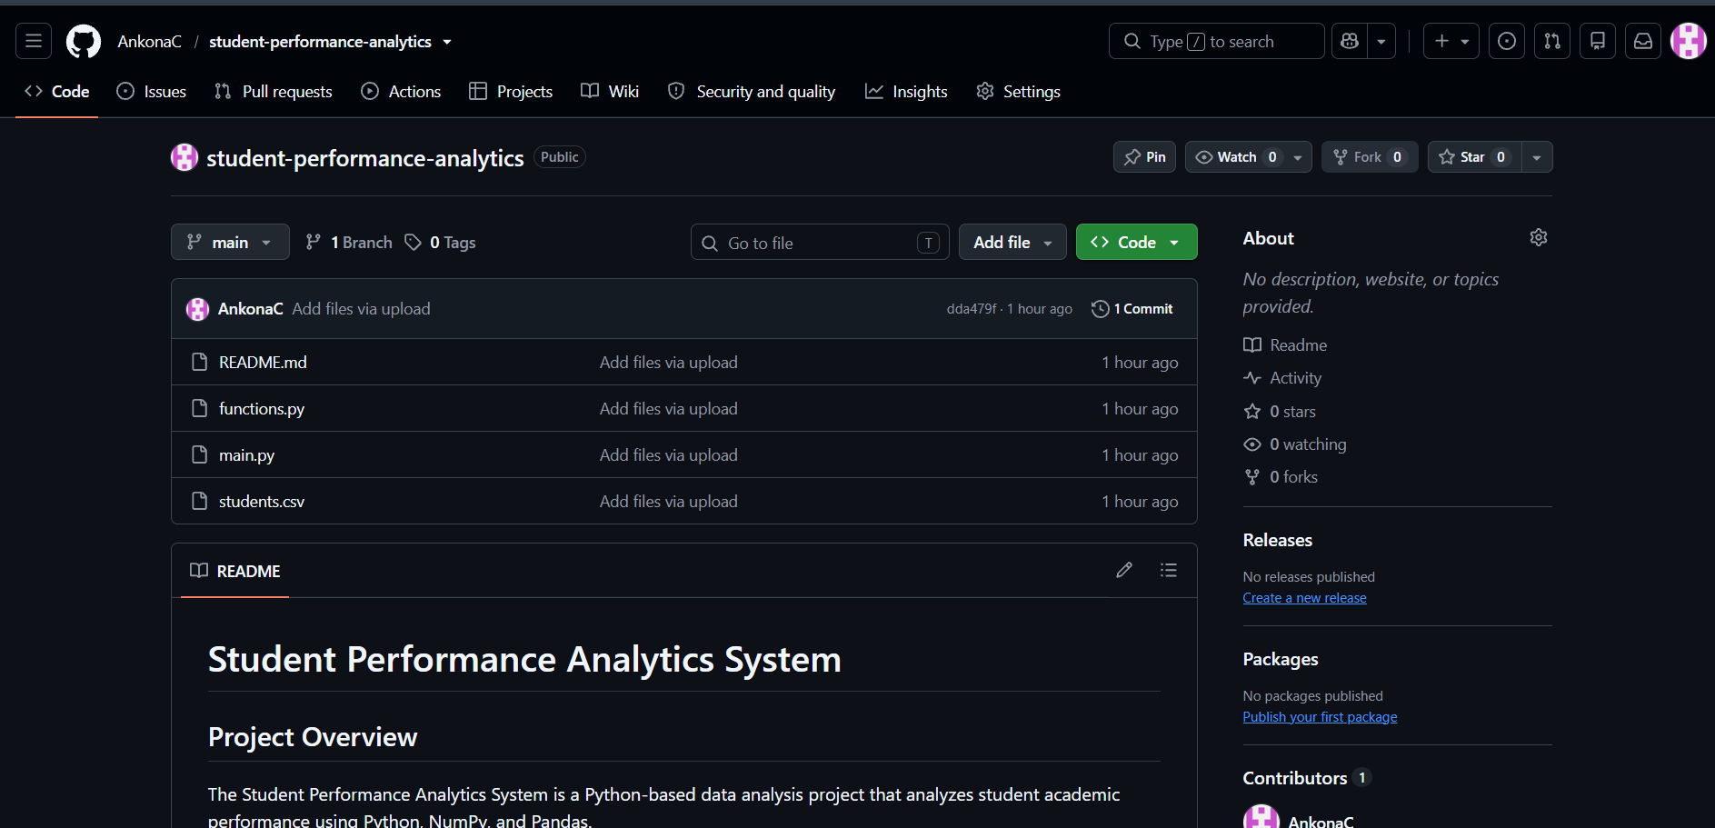
Figure 4. Public GitHub repository containing the completed project.

11. Final Outcome
The Student Performance Analytics System successfully converts raw student data into a structured performance analysis. The final program can process all 20 student records, calculate individual results, and generate summary statistics without requiring manual calculation.
The implementation demonstrates how Python can be combined with NumPy and Pandas to solve a practical data-analysis problem. The project also uses separate functions, loops, conditional statements, and DataFrame operations, satisfying the core programming concepts required for the assignment.

12. Challenges and Learning
During the development of the project, the following learning outcomes were achieved:
- Understanding how to structure a small Python project using multiple files.
- Learning how to read and process CSV data with Pandas.
- Understanding Pandas DataFrames and adding calculated columns.
- Using NumPy functions such as sum and mean for numerical calculations.
- Creating reusable functions instead of repeating the same calculations.
- Using if/elif/else conditions for grade and pass/fail decisions.
- Using loops to process multiple subjects and display top students.
- Using DataFrame operations to find maximum, minimum, averages, and counts.
- Running and testing a Python project in VS Code.
- Uploading and documenting a project using GitHub.
One of the main challenges was understanding how the different components work together: the CSV file provides the input, Pandas manages the data, NumPy performs numerical calculations, and Python functions and conditions apply the required logic. Completing the project helped connect these concepts in one practical application.

13. Future Scope
The current system is a basic academic analytics application. It can be extended in the future by adding:
- A graphical user interface for easier interaction.
- Charts and graphs for visualizing student and subject performance.
- Filtering by department or student.
- Exporting the final analysis to Excel or PDF.
- More subjects and additional academic semesters.
- Attendance and performance trend analysis.

14. GitHub Repository
The complete source code, dataset, and README have been uploaded to the following public GitHub repository:
https://github.com/AnkonaC/student-performance-analytics
Repository contents:
- main.py – main program
- functions.py – reusable calculation functions
- students.csv – student dataset
- README.md – project overview and instructions

15. Conclusion
The Student Performance Analytics System was successfully developed and tested using Python, NumPy, and Pandas. The system reads a student dataset, performs numerical and logical calculations, and presents useful academic performance information.
The project provides practical experience in Python programming, functions, loops, conditional statements, NumPy, Pandas, CSV data handling, data analysis, VS Code, and GitHub. The successful execution and repository submission demonstrate that the required project objectives have been achieved.

