TALLINNA TEHNIKAÜLIKOOL
Infotehnoloogia teaduskond
Informaatikainstituut
Infosüsteemide õppetool

Laenu Infosüsteemi projekt

Andmebaasid I IDU0220
Andmebaaside projekteerimine IDU3381

Üliõpilased:
Andrei Korsunski 061836
Andrei Andrievski 110040
Anton Vesselov 061902

Juhendaja:
Erki Eessaar

Tallinn
2011
Table of contents

1. The strategy phase 5
1.1. System overview 5
1.1.1. Organization objectives 5
1.1.2. Information system objectives 5
1.1.3. Definitions 5
1.1.4. Main objects 6
1.1.5. Main processes 6
1.1.6. Main events 6
1.1.7. Actors 7
1.1.8. Places 7
1.1.9. System division to subsystems 7
1.1.9.1. Competences 7
1.1.9.2. Functional subsystems 7
1.1.9.3. Registers 8
1.2. Loan functional subsystems 8
1.2.1. Objectives 8
1.2.2. Competences that use subsystem 8
1.2.3. Registers used by subsystem 9
1.2.4. Activity diagram of subsystem main processes 9
1.2.5. Subsystem use case diagram sketch model 10
1.2.6. Additional specifications 12
1.3. Loan register 12
1.3.1. Objectives 12
1.3.2. Competences that use register 12
1.3.3. Subsystems that serve register 12
1.3.4. Informational needs 12
1.3.5. Links to other registers 13
1.3.6. Business rules 13
1.3.7. Register conceptual sketch model 14
1.3.8. Additional requerements 14
2. Detailed analisys phase 15
2.1. Functional subsystem X detailed analisys 15
2.1.1. Use case model 15
2.2. Loan register detailed analisys 20
2.2.1. Conceptual data model 20
2.2.1.1. Entity diagramm 21
2.2.1.2. Entity type definitions 23
2.2.1.3. Atribuutide definitions 24
2.2.2. Database operations agreements 27
2.2.3. State diagrams of register’s main objects 29
2.3. CRUD matrix 30
2.4. Description of information system rolles 30
3. Logics disain 31
3.1. X register’s logics disain 31
3.1.1. Database logic schema 31
3.1.1.1. Database diagram 31

Joonised

Autorideklaratsioon

Deklareerin, et käesolev töö on meie iseseisva töö tulemus ja selle alusel ei ole varem hinnet/arvestust taotletud.

[Üliõpialase nimi]
[Allkiri]

The strategy phase

System overview
In this part we will preset overview of loan giving system.

Organization objectives
Main goal of our organization is to give clients a possibility to get loans in fast, convenient and reliable way. Loans are defined as small sum of money given for a short period of time.

Information system objectives
- To automate process of loan registration and issuing.
- To gather statistics for future planning of company policy.
- To remove the human mistakes from loan registration.
- To collect and analyze clients information.
- Give possibility to request a loan via sms or internet.
- Give possibility to add new loan offers with the means of technological advatages.

Definitions
- Client is a user
- Client in status ‘client_blacklisted’ cannot access system
- Client_blacklisted is a status of client when client didn’t pay back loan by the time loan status changes to ‘loan_sent_to_debt_collection’.
- Client should register himself for future activities.
- Loan can be taken by client.
- Client chooses a loan offer according to availibility.
- Client requests a loan.
- Client requests to postpone a loan payback.
- Client pays back a loan.
- Client can have zero or one active loan.
- Client can access his loan history when he is authenticated.
- Postpone loan is active loan.
- Unpaid loan is active loan.
- Pending loan is active loan.
- Pending loan is loan request that is not approved or canceled.
- Loan can have zero or one postpone request.
- CAM is a user
- CAM (Client account manager) checks client data.
- CAM approves client data.
- CAM approves or cancels loan request application
- CAM supervises client’s activity.
- CAM can access client loan history only during making decision on new loan request.
- Team leader analyzes client’s information.
- Team leader make decision whether to give loan to questionable client as an oral advice.
- Team leader organizes CAM work process.
- Team leader make decisions about postponed loan due date.
- Team leader can access client loan history only during making decision on loan postpone request

Main objects

- Loan
- Client
- Employee
- Loan offer
- Clients group

Main processes
- New client registration
- Loan issuance
- Loan payback
- Loan offer creation
- Client group change

Main events
- Client registers himself in the system
- Client sends loan request application.
- Client sends loan payback postpone application.
- Client sends loan payback request.
- Client status changes to client_blacklisted.
- Client is assigned to the client group.
- Loan is issued.
- Loan is paid back.
- Loan due date is changed with postpone application approvement.
- Loan is sent to debt collection.
- CAM makes decision on client registration application.
- Loan due date has come.
- Client group changed.
- Team decides to create a new loan offer.
- Team leader changes loan offer status to active.
- Decision on loan payback postpone request is made.
- Decision on loan request is made.
- Client choose connection method (sms, internet)

Actors
- Client
- Client account manager (CAM)
- Team leader

Places
- Client can make all his actions from any place that has internet connection or mobile network.
- CAM can make his actions from the office, but if it necessary everything can be done during vacation or being out of the office, using internet.
- Team leader can make his action from his office in the company or also as all other from any place where is internet connection or mobile network.

System division to subsystems
Loan issuance company info system.

Competences
Organization internal competences

- CAM competence
- Team leader competence

Organization external competences

- Client competence

Functional subsystems
Main subsystems
- Clients registration functional subsystem
- Loan functional subsystem
- Clients data validation functional subsystem
- Bank data validation subsystem
- Debt collection functional subsystem
- Messages functional subsystem

Administrative subsystems

- Employees functional subsystem
- Documents management subsystem
- Equipment subsystem
- Financial subsystem
- Contracts subsystem

Registers
Main registers

- Clients register
- Loans register
- Classificators register
- History register
- Messages register
- Users register

Administrative registers
- Employees register
- Documents register
- Contracts register
- Equipment register
- Financial register

Loan functional subsystems

Objectives

- Allow client to see current loans
- Allow client to see available loan offers
- Allow client to send request for a loan
- Allow Team Leader to overview loan offers
- Allow CAM to overview pending loan requests
- Allow CAM to make dicision on client loan requests
- Allow Team leader add, edit and remove loan offers
- Allow Team leader to make a decision on pending loan payback postopone requests

Competences that use subsystem
- Client competence
- CAM competence
- Team leader competence

Registers used by subsystem

Subsystem services loan register.
Subsystem uses.

- Clients register
- Loans register
- Employees register
- Classificators register
- History register
- Users register

Activity diagram of subsystem main processes

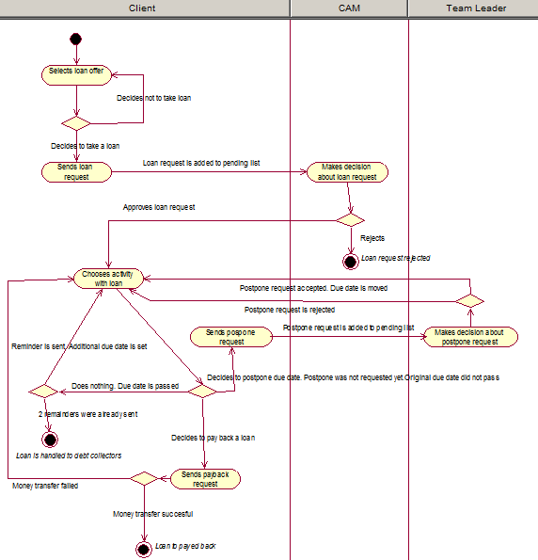

Subsystem use case diagram sketch model

Use Case: User Autentication
Actors: Client, CAM, Team Leader
Description: Own credentials input and check in database. In case of exsistance of such user, user is given acces to use the system. If user is not found the system access is not given.

Use Case: Loan Request
Actors: Client
Description: Chooses loan from the possible list of loan offers and sends a loan request.

Use Case: Remove Loan request
Actors: Client
Description: If loan request is not yet approved Client can cancel loan request.

Use Case: Loan Payback Request
Actors: Client
Description: When client is ready to pay back the loan he sends application about readiness to pay it back.

Use Case: Loan Postpone Request
Actors: Client
Description: If client wants to postpone loan pay back then he sends a request to postopone the loan.

Use Case: Remove Loan Postpone Request
Actors: Client
Description: If client wants to cancel the request to postpone loan pay back then he cancels it.

Use Case: View Client Loans
Actors: Client, CAM, Team Leader
Description: Allows to view client loans. Possible to view active, paid back, requested loans.
Note: CAM accesses the use case through use case Loan Request Decision, team leader through use case Postpone Request Decision

Use Case: View Loan Request
Actors: CAM
Description: Allows to open pending loan requests with client, loan offer, date.

Use Case: Loan Request Decision
Actors: CAM
Description: Makes a decision for the pending loan request.

Use Case: Postpone Request Decision
Actors: Team Leader
Description: Analyzes Client pay back history, and makes a decision weather to approve loan postpone request application or decline it.

Use Case: View Postpone Requests
Actors: Team Leader
Description: Allows to see pending postopone request applications.

Use Case: Add Loan Offer
Actors: Team Leader
Description: Create new Loan offer according to business requirements.

Use Case: Edit Loan Offer
Actors: Team Leader
Description: Edit an exisiting Loan offer according to business requirements.

Additional specifications

Loan register

Objectives
To hold data about loan in volume that allows completing loans subsystem objectives.

Competences that use register

- Client competence
- CAM competence
- Team leader competence

Subsystems that serve register
- Loans subsystem

Informational needs
- List of loans for concrete client.
- List of loans for specific loan status.
- Postpone request for specific loan.
- List of loans approved by specific employee.

Links to other registers
Client register - Client register is connected to loan register through entity Client. To get full information about client. Loan is given to concrete client.

Employee register - Employee register is connected to loan register through entity Employee. Loan is approved by specific employee.

History register – History register is connected to loan register through entities:
Loan Offer, Client. Loan status change is connected to certain loan. Client status change is connected with certain client which can be connected with certain loan.

Business rules
Each loan is connected to one or zero postpone requests.
Each loan is connected to one client.
Each loan has one active status.
Each loan is connected to one loan offer.

Each client has to be authenticated in the system to send loan request.
Each client can request to postpone a loan once for each loan.
Each client can have null or one loan in active status loan_requested or loan_approved.
Each postpone request can be deleted by client till the time decision for it is made by Team Leader.
Each loan request can be deleted by client till the time approval decision is made.
Each loan can be connected to zero or one employee.

Client can request to postpone loan pay back date in amount of half loan offer payback period.
Loan is handed to debt collection after it is not paid back after due date is exceeded in amount of 2 pay back periods but not longer than half a year.
Client rating is increased in case of successful payback by due date according to loan offer.
Client rating is decreased in case of loan successful payback after due date according to loan offer.
Client rating is put to ‘-1’ in case of unsuccessful payback by the time loan is handled to debt collection.
Client rating is decresead in amount corresponding to ratingdrop value for specific loan offer in case of payback after due date but before the time loan is handled to debt collection.

Register conceptual sketch model

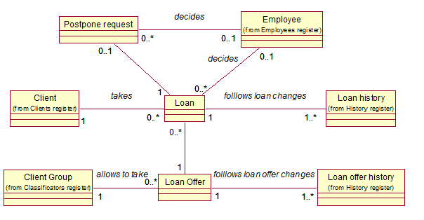

Additional requerements
Name | Discription
Software | System should have Access datebase. System should not use file storage method. Windows Server 2003 is preferred for operational system.
Language | Documentation should be in English though should be possible to translate to other languages as well to support other country markets.
Performance | Query execution and User interface refresh should not take more than 3 seconds.
User interface | System should be made using Microsoft Access due to simplicity of creation user interface forms.
Development tools | For development tools should be used CASE software Rational Rose.  For prototype creation should be used MS Access to which is integrated user interface creation tools.

Detailed analisys phase
Reliability | Loan System should work without interruptions 24 hours 7 days a week.  Interruptions in system work bring problems to the company and dissatisfaction amoung clients.
Backup | Due to the fact that data stored in system database is very important, it is necessary to do backup at least once a day.
Security | Due to the fact that system database contains bank account numbers and credit card sortcodes it is necessary to have good security mechanisms applied. Database tables and application can be accessed only after authorization. Ip filter should be applied.

Functional subsystem X detailed analisys

Use case model
Use case: User authentication
Actors: Client, CAM, Team Leader
Sides and their interests: login to user and perform actions in the responsibility scope borders
Triggering event: User wants to log in to system
Preconditions: User is registered in the system
Postconditions: Defined if the user has permission to access the system. User is authenticated and is given opportunity to use the system in his responsibility scope boarders.
Scenario:
- User wants to login into system.
- System is waiting for credentials input from User.
- User identifies himself(inputing his login and password).
- System checks if user with specified credentials exists in the database ( in case of CAM or Team Leader which objects can be accessed )
- System gives the opportunity to User use the system according responsibility scope borders.
Extensions
4a. If system doesn’t find user with specified credentials, then he doesn’t have opportunity to use the system.
4b. If client status is ‘client_blacklisted’ then then he doesn’t have opportunity to use the system.
1a. System displays notification to User, that credentials are wrong and doesn’t give opportunity to use the system.

Use case: Loan request
Actors: Client
Sides and their interests: Client wants to get a loan to cover his financial needs.
Triggering event: Client wants to get information about possible loans
Preconditions: Client is authenticated by the system and has opportunity to send loan request.
Postconditions: Sent request aplicatian is waiting for CAM’s decision, whether to aproove or cancel loan application.
Scenario:
- Client sends request for available loan offers.
- System gives a list of available loan offers (OP 1.0).
- Client chooses a loan from available loan offers.
- System asks Client to check correctness.
- Client approves correctness and sends loan request application with choosen loan offer.
- System registers new loan request in the database for the client (OP 1.1).

Extentions
2a. If client status doesn’t give him opportunity of loan request then system displays corresponding notification. None of the loan offers are available for the Client.
3a. If client doesn’t find corresponding loan offer he doesn’t choose a loan and logs out from the system.
5a. Client doesn’t approve chosen data correctness.
5b. System gives a list of available loan offers (OP 1.0).

Use case: Remove Loan Request
Actors: Client
Sides and their interests: Client wants to cancel requested loan application due to circumstances.
Triggering event: Client wants to cancel requested loan application.
Preconditions:
- Client is authenticated by the system.
- Client has not approved loan request appilication.
Postconditions: Loan request application is canceled
Scenario:
- Client sends request for pending loan requests.
- System gives a list of loan requests available for cancellation (OP 1.2).
- Client chooses a entry from loan requests available for cancellation.
- System asks Client for correctness.
- Client approves loan request cancellation.
- System cancels the loan request for the client (OP 1.3).

Extentions:
5a. Client doesn’t approve loan request cancellation.

Use case: Loan Payback Request
Actors: Client
Sides and their interests: Client wants to pay back the loan as soon as possible.
Triggering event: Client wants to pay back the loan.
Preconditions:
- Client is autheniticated in the system.
- Client has not paid back loan.
Postconditions:
- A positive answer is received from money transfer subsystem.
- Loan data is updated.
Scenario:

- Client sends request for unpaid loan.
- System displays unpaid loan information.
- Client sends a request to pay back the loan.
- System asks Client for correctness.
- Client approves loan request payback.
- System updates loan data (OP 1.4).

Extentions:
3a. Client doesn’t send request to pay back the loan.
5a. Client doesn’t approve loan payback.
6a. System receives negative answer from money transfer subsystem.

Use case: Loan Postpone Request
Actors: Client
Sides and their interests: Client wants to postpone loan pay back due to financial difficulties.
Triggering event: Client wants to postpone loan pay back.
Preconditions:
- Client is autheniticated in the system.
- Client has not paid back loan.
- Loan due date is not passed.
- No previous postpone request for this loan.
Postconditions: Loan postpone request created.
Scenario:

- Client chooses an amount of days to postpone loan payback offered by the system.
- Client approves postpone request application for unpaid loan.
- System asks client to check correctness.
- Client approves his intention to postpone loan request.
- System creates loan postpone request(OP 1.5).

Extentions:
4a. Client canceles his intention to request loan payback postpone.

Use case: Remove Loan Postpone Request
Actors: Client
Sides and their interests: Client wants to cancel loan postpone request due to financial circumstances or due to made mistake.
Triggering event: Client wants to remove loan postpone request.
Preconditions:

- Client is autheniticated in the system.
- Client has not paid back loan.
- Client has Loan postpone request registered and not approoved

Postconditions: Loan postpone request removed.
Scenario:

- Client choose to remove postone request application.
- System asks client to check correctness.
- Client approves his intention to remove postpone loan request.
- System remove loan postpone request.

Extentions:
4a. Client canceles his intention to remove request loan payback postpone.

Use case: View client loans
Actors: Client, CAM, Team Leader
Sides and their interests: Client wants to view his loans history. CAM needs to view client loans to make decision on loan request. Team Leader needs to view client loans to make decision on loan postpone request
Triggering event: Client choose to view his loans. CAM chooses to view client loan information. Team Leader chooses to view client loan information.
Preconditions:
- User is autheniticated in the system.
- Client has loans that are connected with him.
- For Team Leader: Client has Loan postpone request registered and has not been approved,
- For CAM: Client has Loan request registered and has not been approved.

Postconditions: Client loans history is shown to user

Scenario:

- User chooses to view loans history.
- System shows a filter form where user can specifiy search criteria(from, to, sum, status).
- User fills the search form and chooses to show results.
- System shows loans according to search criteria.
Extentions:

3a. No results for specified search criteria. Corresponding notification is shown to user.

Use case: Loans requests decision
Actors: CAM
Sides and their interests: CAM wants to make decision to approve or cancel client’s loan request.
Triggering event: CAM choose to approve or cancel client loan request.
Preconditions:

- CAM is authenticated in the system.
- Decision for loan request is not made.
- There are not approved loan requests from clients.

Postconditions:

- Decision for loan request is made.
Scenario:

- CAM chooses to view pending loan requests.
- System shows a list of pending loan requests and search form which allows to filter loan requests (time request made, loan payback period, loan request sum, client group).
- CAM fills search form and chooses to show results.
- System shows a list of pending loan requests according to search filter.
- CAM chooses to view loan request.
- System shows loan request details.
- CAM chooses to approve loan request decision.
- System asks to approve made decision.
- CAM approves loan request decision.
- System notifies CAM about made decision for loan request application(OP 1.7).

Extensions:
4a. No results for specified search criteria. Corresponding notification is shown to user
7.1a. CAM chooses to cancel loan request application.
7.1b. System asks to approve made decision.
7.1c. CAM approves loan request cancellation(OP 1.8).
7.1d. System notifies CAM about made decision for loan request application.
7.2a. CAM reject loan request cancellation.
7.2b. System goes to step 2.
7.3a. CAM executes ‘view client loans’ use case.
9.a CAM doesn’t accept decision approvement.
9.b System goes to step 2.

Use case: Add loan offer
Actors: Team Leader
Sides and their interests: Team leader wants to add new loan offer to extand client’s possibilities.
Triggering event: Team leader wants to add new loan offer.
Preconditions:
- Team leader is authenticated in the system.

Postconditions:
- New loan offer is created.

Scenario:
- Team Leader chooses to create new loan offer.
- System shows a form where Team leader has to specify loan details (sum, period, percent, status, client group).
- Team Leader fills the form fields.
- System checks that specified data is in accordance with business rules.
- System displays loan offer details for acceptance.
- Team Leader accepts loan offer.
Extensions:
3.1a. Team Leader cancels new loan offer registration.
3.1b. System returns Team leader to default page.
3.2a Team leader fills form fields incorrectly or some required fields are not filled.
3.2b System notifies Team leader about incorrectly filled loan offer registration form.
6.1a. Team Leader cancels loan offer.

Use case: Edit loan offer
Actors: Team Leader
Sides and their interests: Team leader wants to edit loan offer to extand client’s possibilities.
Triggering event: Team leader wants to edit loan offer.
Preconditions:
- Team leader is authenticated in the system.
- There exists a loan offer in the system database.
- Loan offer is in inactive status.
- Loan offer has no loans connected with it.
Postconditions:
- Loan offer details are changed.
Scenario:
- Team Leader chooses to change loan offer details.
- System asks to check input data correctness.
- Team Leader accepts data correction.
- System updates loan offer details(OP 1.9).

Extensions:
3a. No results for specified search criteria. Corresponding notification is shown to user.

Use case: Postpone request decision
Actors: Team Leader
Sides and their interests: Team leader wants wants to make a decision for postpone request application to take into account client’s interests and company’s interests.
Triggering event: Team leader wants to make a decision for postpone request application.
Preconditions:
- Team Leader is authenticated in the system.
- There exists not canceled loan postpone request in the database.

Postconditions:
- Decision about loan postpone request applications is made.

Scenario:
- Team Leader chooses to view postpone request applications.
- System asks to specify search criteria.
- Team Leader specify search criteria asks the system to filter results.
- System displays loan postpone applications according to applied filter.
- Team Leader choose to approve loan postpone request application.
- System asks to approve made decision.
- Team Leader approves made decision.
- System notifies Team Leader about made decision for loan postpone request application.
- System changes loan details accordingly to postpone request decision.

Extensions:
4a. No results for specified search criteria. Corresponding notification is shown to user.
5.1a Team Leader chooses to cancel loan postpone request application
5.1b System asks to approve made decision.
5.1c Team Leader approves loan postpone cancellation.
5.1d System notifies Team Leader about made decision for loan postpone request application.
5.2a Team Leader rejects loan postpone request cancellation
5.2b System goes to step 4.
5.a Team Leader doesn’t accept decision approvement
5.b System goest to step 4.

Loan register detailed analisys

Conceptual data model

Entity diagramm
This entity type marked in red is the main object of register (in this case main object of loan register).
This entity type marked in yellow is not main objects of register (in this case postpone request and loan offer register).
This entity type marked in green is objects of other registers (that are needed in loan functional subsystem).

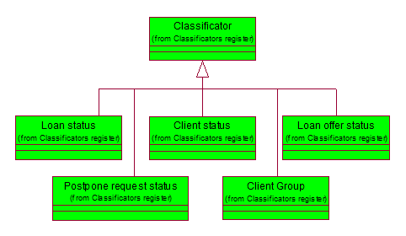
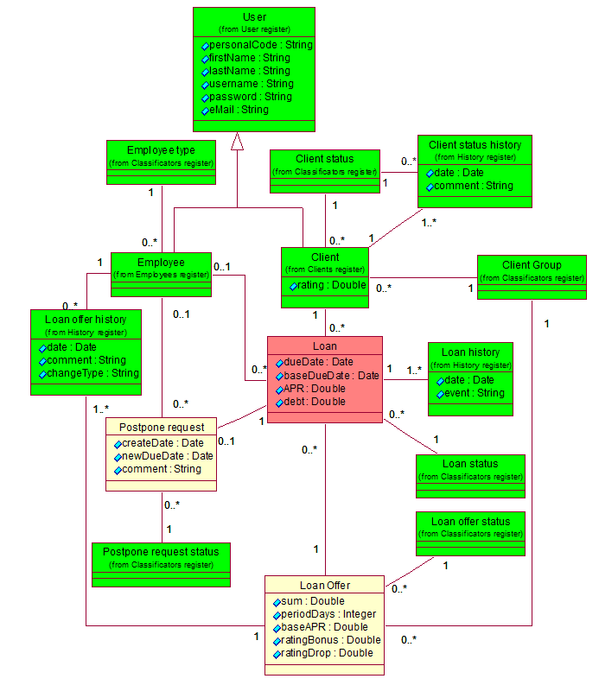

Entity type definitions
Entity type (names) | Member of register | Definitions
Loan Status | Classificator | Loan status name. Loan status contains all possible statuses for the loan.
User | User register | Person who is registered in the system, taking part in the loan infosystem processes workflow.
Employee | Employes register | Person who is working in the company, and is functioning in the system as CAM or Team Leader.
Client | Clients register | A person who takes takes and pays back the loan.
Employee type | Classificators | Classificator which describes employee functions in the system
Clients status | Classificators | Classificator which describes client opportunities in the system(e.g weather client can take a loan or cannot)
Client group | Classificators | Classificator which describes client opportunities in the system depending on the group to which it belongs.
Loan | Loan register | Entitity type which contatins data about the taken loan.
Postpone request | Loan register | Entity type which contains data about the possibility to postpone loan payback date
Postpone request status | Classificator | Classificator which contains all possible postpone request statuses
Loan offer | Loan register | Entity type which determine loan characteristics(e.g loan sum, payback date, availability for the groups)
Loan offers status | Classificators | Classificator which defines loan offer availibility
Client status history | History register | Entity type which contains data on the client status changes
Loan offer history | History register | Entity type which contains data on the loan offer statuses changes (eg creation/modification)
Loan history | History register | Entity type which contains data on the loan statuses changes(eg. When loan was issued and payed back)

Atribuutide definitions
Entity type | Attribute name | Attribute definition | Example value
User | Personal Code | Personal of the registered person | 38706260385
User | First name | Users first name | Andrei
User | Last name | Users last name | Korsunski
User | User name | Users name in the system | Ondriy
User | Password | Users password in the system | OND123
User | E-mail | Users e-mail in the system | ondrie@hotmail.com
Client | Rating | Clients rating is the numeric value that represents the dependence between taken loans and payed back loans of the client | 11
Client status history | Date | Represents the event time | 16/06/2011 15:30:02
Client status history | Comments | Comment that describes the reason the change was made. | Client accepted
Loan | Duedate | Last date when the loan is supposed to be paid back | 16/07/2011 15:30:02
Loan | Base duedate | Initial date when the loan is supposed to be paid back | 16/06/2011 15:30:02
Loan | Apr | Stands for annual percentage rate in rate for a year in percents | 60
Loan | Debt | Amount of money in euros for a client to payback including additional fees and APR | 115
Loan history | Date | Date of loan status change | 16/06/2011 15:30:02
Loan history | Event | Link to the corresponding loan status | 5
Postpone request | Create Date | Date when postpone request was created | 16/06/2011 15:30:02
Postpone request | New duedate | Changed payback date after postpone request approvement | 16/06/2011 15:30:02
Postpone request | Comment | Optional comment which describes postpone request status change | Not paid previous loan in time
Loan offer | Sum | Initial sum in euros that is to be paid back without additional fees | 100
Loan offer | Perioddays | Number of days after which loan is to be paid back initially after it has been issued | 7
Loan offer | Base apr | Initial apr rate in percents | 5
Loan offer | Raiting bonus | Number which is added to the client rating in case of successful payback in nominal period | 2
Loan offer | Raiting drop | Number which is substracted from the client rating in case of unsuccessful payback in nominal period or postponed period | 5
Loan offer history | Date | Date when loan offer status was changed | 16/06/2011 15:30:02
Loan offer history | Comment | Optional comment to describe loan offer status change | Not quite popular
Classificator | ID | Reporting the value of the classification code. This code can be used to represent the value in other table. | 1
Classificator | Name | Name of the classificatory value.This cannot be blank string or contain only whitespaces. | Pending
Classificator | Description | Discription of the classificatory value. This cannot be blank string or contain only whitespaces. | Postpone request awaiting decision

Database operations agreements
System registers new loan request in the database for the client.

OP 1.1 Registration of new loan request(client_id, loan_id, loan_history.status_id, loan_history.date, loan.baseDueDate, loan.APR, loan.debt )

- Preconditions:
  - Client sends new loan request application
  - System assures that there are no active loans connected with the client.

- Postconditions
  - New loan is created
  - New Loan History is created
  - Loan.baseDueDate, loan.debt, loan.APR are changed in accordance with loan offer.
  - Loan_History.date = time when loan request sent
  - New connection is created between Loan and Loan History and loan_history.status_id is changed to value corresponding to status ‘loan_requested’ from loan_status classificator.

Op 1.3 Loan request cancellation(client_id, status_id, date, loan_id )

- Preconditions:
  - Client has loan connected with him with loan_history.status_id = loan_requested

- Postconditions:
  - Loan is been deleted

Op 1.4 Loan Payback(client_id, loan_id, loan_history.status_id, loan_history.date, client.group_id, loan_offer.ratingBonus)

- Preconditions:
  - Client has loan with loan_status different from ‘loan_requested’
  - Positive answer about money transfer is received from money transfer subsystem

- Postconditions:
  - New connection is created between Loan and Loan History and loan_history.status_id is changed to value corresponding to status ‘loan_paid_back’ from loan_status classificator.
  - Loan_history.date is changed to date when loan is paid back.
  - Client.rating is changed according to loan_offer.ratingBonus
  - If client.rating is corresponding to new group rating then new connection is created between client and loan_group. Client.group_id = client_group.id

OP 1.5 Loan postpone request application creation(loan_id, postpone_request.status_id, loan.baseDueDate, Loan_history, Loan_status).
- Preconditions:
  - Client has loan connected with him with loan_status = loan_issued
  - Loan.baseDueDate -12 hours < Now()
- Postconditions:
  - New Postpone request object is created.
  - New connection is created between Loan and postpone_request and postpone_request.status_id is changed to value corresponding to status ‘postpone_requested’ from postpone_request_status classificator
  - Postpone_request.createDate is changed to NOW()
  - Postpone_request.comment is changed accordingly.
  - New loan_history entry, which writes that loan postpone request was created

OP 1.6 Loan postpone request removal(postpone_request_id, loan_id, postpone_request.status_id, Loan_status,Loan_history)
- Preconditions
  - Client has postpone_request with status=”waiting_for_acception”
- Postconditions
  - Postpone_request is removed for the loan. Connection between loan and postpone_request is removed.
  - New loan_history entry, which writes that loan postpone request was cancelled.

OP 1.7 Loan request decision making (loan_status, loan_history, loan_offer, loan.BaseDueDate,loan.emplyee_id)
- Preconditions
  - Loan is in status “waiting_for_approval”

- Postconditions
  - New loan_status is assigned to a loan. If loan is approved by CAM loan.loan_status=”loan_issued”. If loan is not approved loan.loan_status=”loan_canceled”
  - New connection is made between loan and loan_offer.
  - New connection is made between loan and loan_history.
  - If loan status is changed to “loan_issued” loan.BaseDueDate changed accoding to loan_offer
  - If loan status is changed to “loan_issued” loan.APR changed accoding to loan_offer
  - If loan status is changed to “loan_issued” loan.debt changed accoding to loan_offer
  - New connection is made between loan and employee, where loan.emplyee_id is changed to CAM id.

OP 1.8 Loan offer creation (loan_offer, loan_offer_history, loan_offer_status_id, loan_offer.sum, loan_offer.periodDays, Loan_offer.baseAPR, loan_offer.ratingBonus, employee,loan_offer_history.employee_id)
- Preconditions

- Postconditions
  - New loan offer is created.
  - New connection is made between loan_offer and loan_offer_history.
  - New connection is made between client_group and loan_offer.
  - New connection is made between loan_offer_status and loan_offer.
  - Loan_offer.status_id = 0(“inactive”)
  - Loan_offer.sum = chosen sum
  - Loan_offer.periodDays = chosen periodDays
  - Loan_offer.baseAPR = chosen baseAPR
  - Loan_offer.ratingBonus = chosen ratingBonus
  - New connection is made between loan_offer_history and employee, and loan_offer_history.employee_id is canged to Team Leader id.
  - If comment is added then Loan_offer_history.comment is changed accordingly

OP 1.9 Loan offer edition (Loan_offer.sum, loan_offer.periodDays, loan_offer.baseAPR, loan_offer.ratingBonus, loan_offer.status_id, loan_offer)
- Precondition

- Postcondition
  - Loan_offer.sum = chosen sum
  - Loan_offer.periodDays = chosen periodDays
  - Loan_offer.baseAPR = chosen baseAPR
  - Loan_offer.ratingBonus = chosen ratingBonus
  - If loan_offer_status is changed to “active” then new connection is created between loan_offer_status and loan_offer. Loan_offer.status_id is changed to the id which corresponds to status “active” in loan_offer_status classificator.
  - If loan_offer_status is changed to “inactive” then new connection is created between loan_offer_status and loan_offer. Loan_offer.status_id is changed to the id which corresponds to status “inactive” in loan_offer_status classificator.
  - New connection is made between loan_offer and loan_offer_history, and loan_offer_history.date is changed to date when edition was made.
  - New connection is made between loan_offer_history and employee, and loan_offer_history.emplyee_id is canged to Team Leader id.
  - If comment is added then Loan_offer_history.comment is changed accordingly

OP 2.0 Loan postpone decision making (Loan_postpone_request, Loan_postpone_request.status._id, postpone_request, postpone_request_status,loan, loan.employee_id, loan.dueDate, loan.APR, loan.debt )
- Preconditions
  - Loan_postpone_request is in status “waiting_for_approval”

- Postconditions
  - New connection is made between postpone_request and postpone_request_status
  - New connection is made between loan and employee, and loan.empolyee_id is changed to Team Leader id.
  - Loan.dueDate is changed to new value according to postpone application request.
  - Loan.APR is changed to new value according to postpone application request.
  - Loan.debt is changed to new value according to postpone application request.
  - If loan postpone application is approved then new connection is created between postpone_request_status and postpone_request. postpone_request.status_id is changed to the id which corresponds to status “approved” in postpone_request _status classificator.
  - If loan postpone application is rejected then new connection is created between postpone_request_status and postpone_request. postpone_request.status_id is changed to the id which corresponds to status “canceled” in postpone_request _status classificator.

State diagrams of register’s main objects

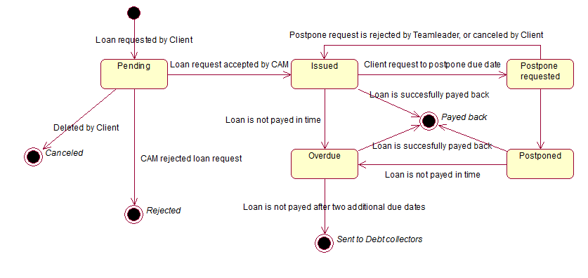

CRUD matrix

Use case | 1 | 2 | 3 | 4 | 5 | 6 | 7 | 8 | 9 | 10 | 11 | Total
Entity type
User | R |  |  |  |  |  |  |  |  |  |  | R
Client | R |  |  | U |  |  | R | R |  |  |  | RU
Client status | R |  |  |  |  |  | R | R |  |  |  | R
Client status history |  |  |  |  |  |  | R | R |  |  |  | R
Loan |  | C | D | RU | R | R | R | RU |  |  |  | CRUD
Loan status |  | R | R | R | R | R | R | R |  |  |  | R
Loan history |  | C | D | C | C | C |  | C |  |  | CR | CRD
Postpone request |  |  |  |  | C | D |  |  |  |  | U | CUD
Postpone request status |  |  |  |  | R | R |  |  |  |  | R | R
Loan offer |  | R |  |  |  |  |  |  | C | U |  | CRU
Loan offer status |  | R |  |  |  |  |  |  | R | R |  | R
Loan offer history |  |  |  |  |  |  |  |  | C | CR |  | CR
Client group |  | R |  | R |  |  |  |  |  |  |  | R
Employee | R |  |  |  |  |  |  |  |  |  |  | R
Employee type | R |  |  |  |  |  |  |  |  |  |  | R

List of use case

- User autherntication
- Loan request
- Remove Loan Request
- Loan Payback Request
- Loan Postpone Request
- Remove Loan Postpone Request
- View Client Loans
- Loans Requests Decision
- Add Loan Offer
- Edit Loan Offer
- Postpone Request Decision

Description of information system rolles
Role name | Description
Client | Client is human authernticated in the system, who is interested to request a loan.
Team Leader | Team Leader is a human authernticated in the systems, who manages loan offers and postpone requests.
Client account manager | Team Leader is a human authernticated in the systems, who take a decision to accept or reject loan request.

Logics disain

X register’s logics disain

Database logic schema

Database diagram
