# Assignment 3 Database Tie-in

In this assignment, you will take what you did in the last two assignments and move them over to using a database instead of a text file. The DBMS (Database management system) we use here on campus is Microsoft SQL Server. Specifically you will be using Microsoft SQL Server 2008 R2.

Before starting on this application read about the following topics

* SQL Management Studio - <http://msdn.microsoft.com/en-us/library/ms174173.aspx>
* Creating a table - <http://msdn.microsoft.com/en-us/library/ms188264.aspx>
* SqlConnection class - <http://msdn.microsoft.com/en-us/library/system.data.sqlclient.sqlconnection.aspx>
* SqlCommand class - <http://msdn.microsoft.com/en-us/library/system.data.sqlclient.sqlcommand.aspx>
* Sql Insert command - <http://www.w3schools.com/sql/sql_insert.asp>
* SQL Select command - <http://www.w3schools.com/sql/sql_select.asp>
* Transact SQL - <http://msdn.microsoft.com/en-us/library/ms189826%28v=sql.90%29.aspx>
* Storing connection strings in web.config (3.5 and above) - <http://www.connectionstrings.com/Articles/Show/store-connection-string-in-web-config>

### General Database Layout

When working in databases you will have a server that is running some sort of DBMS software. The server will contain databases, which contain tables. Those tables contain columns and rows. Each row will have a value for each column inside the table.

### SQL Management Studio

You have a database allocated to you on our test database server that is named your global id. You should be able to connection to this using **SQL Management Studio**. The server name is **it-sql2k8test** and you will be using **Windows Credentials**.

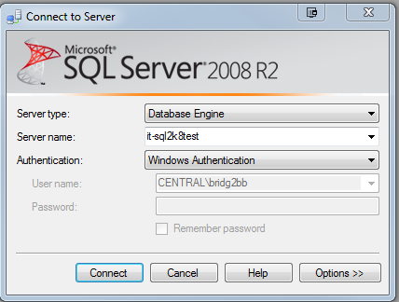

You will need to create a table to store your submissions. The table will need to have a column for each field on your form. Once connected to the server with management studio you will need to expand Databases and then find the database that is entitled your global id. Expand your database and inside there will be “Tables.” If you right-click on tables, there will be an option to create a new table. For now you can use any data type that you would like. In later assignments you will be expected to learn about the data types, but for now you just need to be able to get the table created. By default the column type will be nvarchar(50), which is a string data type. Most of your form data should fit correctly into this data type, so you may just consider leaving it. The one restriction is that all of your fields will have a maximum size of 50 characters.

Finding your database:

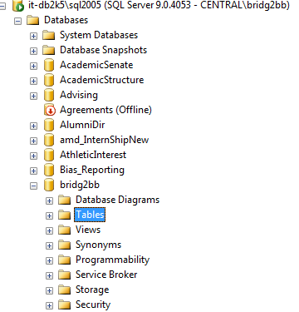

Create table dialog

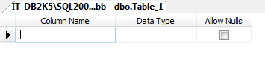

### Integrating SQL Into the Web Application

In order to use SQL inside of your web application you will need to configure a connection string inside of your web.config file. The web.config contains many runtime settings for any ASP.NET web application. In the documentation at the beginning of this assignment, there is a link that will describe how to add a connection string to your web.config.

Your specific connection string is as follows:   
**Data Source=it-sql2k8test;Initial Catalog=<YOUR_GLOBALID>;Integrated Security=SSPI;**

You will use a SQLConnection object and a SQLCommand object in order to submit your results to your newly created table in the code behind for “Default.aspx.” You will do the actual SQL inside of the button event you were previously writing the results to the text file with. You will also need to pull your results back from SQL and to supply to your data grid on the “Admin.aspx” page. You can do this entirely through the design view of “Admin.aspx”, by specifying the data source for the grid. You can do this by selecting the next to the grid inside of the design view of admin.aspx. One of the options should be data source, where you will need to select “New data source.”

Once in the new Data Source Dialog, you will need to select “Database” and follow the Wizard. If your web.config is setup correctly, you will have a connection to pick from in the “Choose Your Data Connection” section. If nothing shows up there, your web.config is not setup correctly. Please review the web.config and make sure that you have followed the correct way specified in the documentation for how to add a connection string to the web.config, including the use of **providerName**.

Finally you will be asked to configuration the select statement, you should just have to select the table your created to store your results in.

Finally, you can test your query. If the results are what you are expecting, select “Finish.”

Depending on how you were binding the data to the Grid originally, you may need to remove that code from the code behind as you are now using this SQL Data connection.

New Data Source Dialog

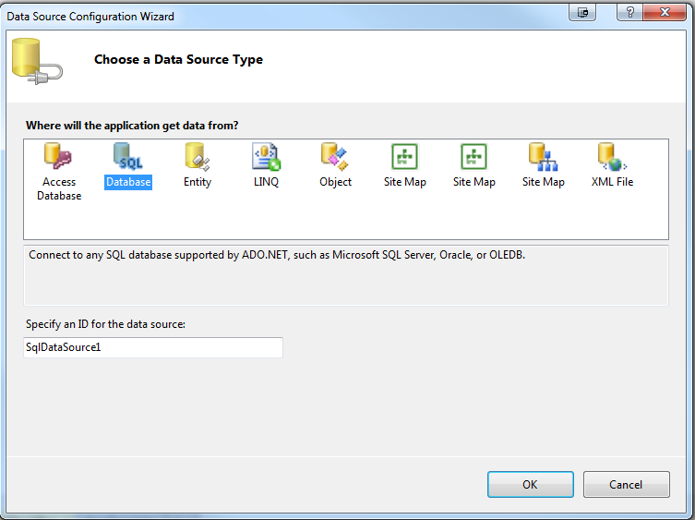

Configure the Select Statement

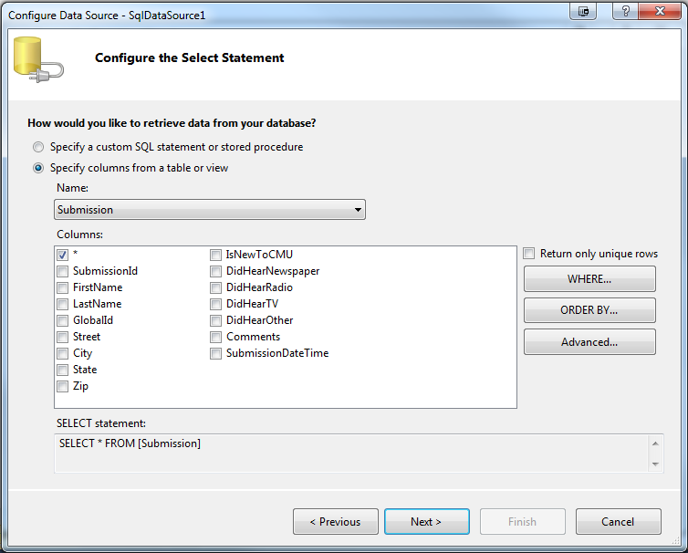

Testing Select Statement

