# Name: Shubham Sanghavi

# Net ID: SAS190003

CS 6375- Problem Set 2

Problem 1: SPAM, SPAM, HAM (50 pts)

1. Primal SVMs

## Code

spam_data= importdata('spam_train.data',',');

X_1 = spam_data(:,1:end-1);

Y = spam_data(:,end);

Y = (Y - 0.5) * 2;

spam_valid_data = importdata('spam_validation.data',',');

xv_1 = spam_valid_data(:,1:end-1);

yv = spam_valid_data(:,end);

yv = (yv - 0.5) * 2;

spam_test_data = importdata('spam_test.data',',');

xt_1 = spam_test_data(:,1:end-1);

yt = spam_test_data(:,end);

yt = (yt - 0.5) * 2;

% second degree polynomial of X

X = X_1;

N = size(X,1);

% X = X(1:15,:)

c = [1,10,10^2,10^3,10^4,10^5,10^6,10^7,10^8];

%c = [1,10,10^2];

train_acc = zeros(size(c));

val_acc = zeros(size(c));

test_acc = zeros(size(c));

O = ones(size(X,1),1);

A = [O X];

A = -Y.*A;

b = - O;

si_constraints= -1 *eye(size(X,1));

new_A = [A si_constraints];

constr_2 = zeros(size(A));

constr_2 = [constr_2 si_constraints];

new_A = [new_A; constr_2];

new_b = [b;zeros(size(b,1),1)];

f = zeros(size(A,2),1);

H = eye(size(A,2));

H(1,1) = 0;

si_rows = zeros(size(X,1),size(H,2));

new_H = [H ; si_rows];

si_cols = zeros(size(new_H ,1),size(X,1));

new_H = [new_H si_cols];

for i = 1:size(c,2)

f_lambda = c(i) * ones(size(X,1),1);

f_new = [f;f_lambda];

[w,fval,exitflag,output,lambda] = quadprog(new_H,f_new,new_A,new_b);

disp("Done with quadprog")

weights = w(2:size(X,2)+1);

bias = w(1);

pred = sign((X * weights) + bias);

diff = abs(Y - pred)/2;

accuracy = 1 - sum(diff)/size(X,1);

train_acc(i) = accuracy;

% finding the validation accuracy

pred_v = sign((xv_1 * weights) + bias);

diff_v = abs(yv - pred_v)/2;

val_accuracy = 1 - sum(diff_v)/size(xv_1,1);

val_acc(i) = val_accuracy;

% finding the test accuracy

pred_t = sign((xt_1 * weights) + bias);

diff_t = abs(yt - pred_t)/2;

test_accuracy = 1 - sum(diff_t)/size(xt_1,1);

test_acc(i) = test_accuracy;

end

## Accuracy on the training set

## Accuracy on the validation set

|  |  |  |  |  |  |  |  |  |  |
| --- | --- | --- | --- | --- | --- | --- | --- | --- | --- |
| C | 1 | 10 | 100 | 1000 | 10^4 | 10^5 | 10^6 | 10^7 | 10^8 |
| Training Accuracy | 0.9446 | 0.9473 | 0.9486 | 0.9483 | 0.9483 | 0.9486 | 0.9480 | 0.9480 | 0.9480 |
| Validation Accuracy | 0.9350 | 0.9387 | 0.9387 | 0.9375 | 0.9375 | 0.9375 | 0.9362 | 0.9362 | 0.9362 |

## Accuracy for the best C on test set

|  |  |  |  |
| --- | --- | --- | --- |
| C | 1 | 10 | 100 |
| Testing Accuracy | 0.7078 | 0.6317 | 0.6217 |

# 2. Dual

A.Code

spam_data= importdata('spam_train.data',',');

X_1 = spam_data(:,1:end-1);

Y = spam_data(:,end);

Y = (Y - 0.5) * 2;

spam_data= importdata('spam_validation.data',',');

X_V = spam_data(:,1:end-1);

Y_V = spam_data(:,end);

Y_V = (Y_V - 0.5) * 2;

% second degree polynomial of X

X = X_1;

c = 1;

N = size(X,1);

lambda_H = ones(N,N);

sigma_all = [10,100,1000];

c_all = [1,10];

store_results = []

for sig_id = 1: size(sigma_all,2)

for c_id = 1: size(c_all,2)

sigma = sigma_all(sig_id);

c = c_all(c_id);

% find guassian for the given input and sigma

trans_X = [];

for i = 1:N

gaus_col = gaussian_ss(X,X(i,:),sigma);

trans_X = [trans_X gaus_col];

end

% replace this with the guassian kernel

Y_H = Y * Y.';

H = trans_X .* Y_H .* lambda_H;

% f is just the simple lambda sum

f = -1 * ones(N,1);

% the constraints:

A = [];

b = [];

Aeq = Y.';

Beq = 0;

lb = zeros(N,1);

ub = c * ones(N,1);

[w,fval,exitflag,output,lambda] = quadprog(H,f,A,b,Aeq,Beq,lb,ub);

b_s = [];

for j = 1:size(w,1)

if w(j) > 0.01 && w(j) < c-0.001

gaus_res = gaussian_ss(X,X(j,:),sigma);

eq = gaus_res .* Y .* w;

wtx = Y(j)-sum(eq);

b_s = [b_s wtx];

end

end

b = mean(b_s);

% training predictions

train_predictions = zeros(size(X,1),1);

for i = 1:size(X,1)

gaus_col = gaussian_ss(X,X(i,:),sigma);

p_eq = gaus_col .* Y .* w;

val = sum(p_eq)+b;

train_predictions(i) = sign(val);

end

diff = abs(Y - train_predictions)/2;

accuracy = 1 - sum(diff)/size(X,1);

diff = abs(Y - train_predictions)/2;

accuracy = 1 - sum(diff)/size(X,1);

% validation predictions

val_predictions = zeros(size(X_V,1),1);

for k = 1:size(X_V,1)

gaus_col = gaussian_ss(X,X_V(k,:),sigma);

p_eq = gaus_col .* Y .* w;

val = sum(p_eq)+b;

val_predictions(k) = sign(val);

end

diff = abs(Y_V - val_predictions)/2;

val_accuracy = 1 - sum(diff)/size(X_V,1);

store_results = [store_results; c sigma accuracy val_accuracy];

end

end

function rbf = gaussian_ss(x_i,x_j,sigma)

if size(x_j,1) ~= 1

disp("Size of x_j must be 1")

end

vec = x_i - x_j;

vec = vec .^ 2;

mod_x = sum(vec,2);

rbf_in = mod_x / (2* sigma);

rbf = exp(- rbf_in);

end

## B. Results for training set

|  |  |  |  |  |  |  |  |  |  |
| --- | --- | --- | --- | --- | --- | --- | --- | --- | --- |
| **Sigma^2**  **(down)** | **C->**  **(right)** | **1** | **10** | **100** | **1000** | **10^4** | **10^5** | **10^6** | **10^7** |
| **0.1** | | 0.9997 | 0.9997 | 0.9997 | 0.9997 | 0.9997 | 0.9997 | 0.9996 | 0.9997 |
| **1** | | 0.9993 | 0.9997 | 0.9997 | 0.9997 | 0.9997 | 0.9997 | 0.9996 | 0.9997 |
| **10** | | 0.9803 | 0.9977 | 0.9997 | 0.9997 | 0.9997 | 0.9997 | 0.9996 | 0.9997 |
| **100** | | 0.8967 | 0.9770 | 0.9952 | 0.9980 | 0.9987 | 0.9997 | 0.9996 | 0.9997 |
| **1000** | | 0.8357 | 0.9267 | 0.9693 | 0.9853 | 0.9940 | 0.9963 | 0.9983 | 0.9993 |

## C. Results for the validation set

|  |  |  |  |  |  |  |  |  |  |
| --- | --- | --- | --- | --- | --- | --- | --- | --- | --- |
| **Sigma^2**  **(down)** | **C->**  **(right)** | **1** | **10** | **100** | **1000** | **10^4** | **10^5** | **10^6** | **10^7** |
| **0.1** | | 0.1963 | 0.1975 | 0.1975 | 0.1975 | 0.1975 | 0.1975 | 0.1975 | 0.1975 |
| **1** | | 0.2525 | 0.2625 | 0.2625 | 0.2625 | 0.2625 | 0.2625 | 0.2625 | 0.2625 |
| **10** | | 0.6775 | 0.6963 | 0.6912 | 0.6875 | 0.6863 | 0.6863 | 0.6862 | 0.6863 |
| **100** | | 0.7763 | 0.8375 | 0.8450 | 0.8488 | 0.8488 | 0.8375 | 0.8375 | 0.8375 |
| **1000** | | 0.7600 | 0.8500 | 0.9013 | 0.9038 | 0.8975 | 0.8950 | 0.8962 | 0.8938 |

## D. Report Test set results for the best sigma and C

Sigma^2 = 1000

C = 1000

**Test Accuracy = 0.7154**

# 3. KNN

Code:

import pandas as pd

import numpy as np

def knn_classifier(X_test,k,X_train,Y_train,distance_func):

# apply to each row

dist = np.apply_along_axis(distance_func, 1, X_train, X_test)

# pick the k-closest

idx = np.argpartition(dist, k)[:k]

# will count the number of True examples in the idx selected by the selection

pos = np.sum(Y_train[idx])

# check if more than half of the k examples selected are positive

if pos > (k/2):

Y_test = True

else:

Y_test = False

return Y_test

def euclidean(vec1,vec2):

vec = (vec1 - vec2) ** 2

ans = np.sum(vec)

return np.sqrt(ans)

def get_mean_std(in_array):

return (in_array.mean(),in_array.std())

def normalize_arr(in_array,mean,std):

return (in_array-mean)/std

if __name__ == '__main__':

df_train = pd.read_csv('spam_train.data', sep=',',header=None)

df_dev = pd.read_csv('spam_validation.data', sep=',',header=None)

df_test = pd.read_csv('spam_test.data', sep=',',header=None)

# prepare the numpy arrays for faster predictions

X_train = df_train.iloc[:,:-1].values

Y_train = df_train.iloc[:,-1].values

X_dev = df_dev.iloc[:,:-1].values

Y_dev = df_dev.iloc[:,-1].values

X_test = df_test.iloc[:,:-1].to_numpy()

Y_test = df_test.iloc[:,-1].to_numpy()

mean_std = np.apply_along_axis(get_mean_std,axis=0,arr=X_train)

X_train_norm = np.empty_like(X_train)

for col in range(np.shape(X_train)[1]):

X_train_norm[:,col] = normalize_arr(X_train[:,col],mean_std[0,col],mean_std[1,col])

X_dev_norm = np.empty_like(X_dev)

for col in range(np.shape(X_dev)[1]):

X_dev_norm[:,col] = normalize_arr(X_dev[:,col],mean_std[0,col],mean_std[1,col])

X_test_norm = np.empty_like(X_test)

for col in range(np.shape(X_test)[1]):

X_test_norm[:,col] = normalize_arr(X_test[:,col],mean_std[0,col],mean_std[1,col])

results = []

k_values = [1,5,11,15,21]

for k in k_values:

# apply to each row in our X_dev

train_pred = np.apply_along_axis(knn_classifier, 1, X_train_norm,k,X_train_norm,Y_train,euclidean)

train_acc = np.sum(train_pred==Y_train)/np.shape(Y_train)

val_pred = np.apply_along_axis(knn_classifier, 1, X_dev_norm,k,X_train_norm,Y_train,euclidean)

val_acc = np.sum(val_pred == Y_dev)/np.shape(Y_dev)

test_pred = np.apply_along_axis(knn_classifier, 1, X_test_norm,k,X_train_norm,Y_train,euclidean)

test_acc = np.sum(test_pred == Y_test)/np.shape(Y_test)

results.append([k,train_acc[0],val_acc[0],test_acc[0]])

KNN:

|  |  |  |  |
| --- | --- | --- | --- |
| **K** | **Training Accuracy** | **Validation Accuracy** | **Testing Accuracy** |
| 1 | 0.999 | 0.885 | 0.725 |
| 5 | 0.938 | 0.896 | 0.707 |
| 11 | 0.922 | 0.885 | 0.721 |
| 15 | 0.913 | 0.864 | 0.715 |
| 21 | 0.905 | 0.865 | 0.709 |

### 4. Which approach should be preferred for the classification task?

For this task we should use SVM with gaussian kernel. When we use validation set to avoid overfitting on the training data, we will get good results with the gaussian kernel as it can fit more complex functions.

Problem 2: Method of Lagrange Multipliers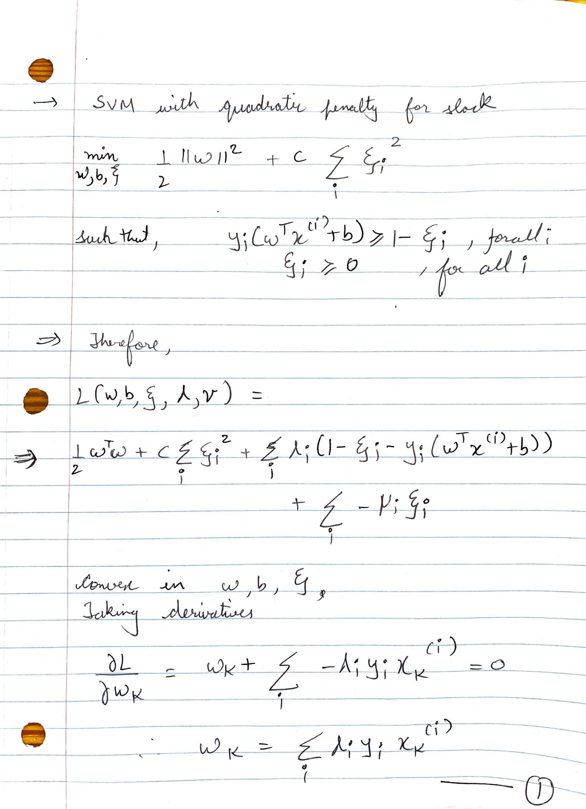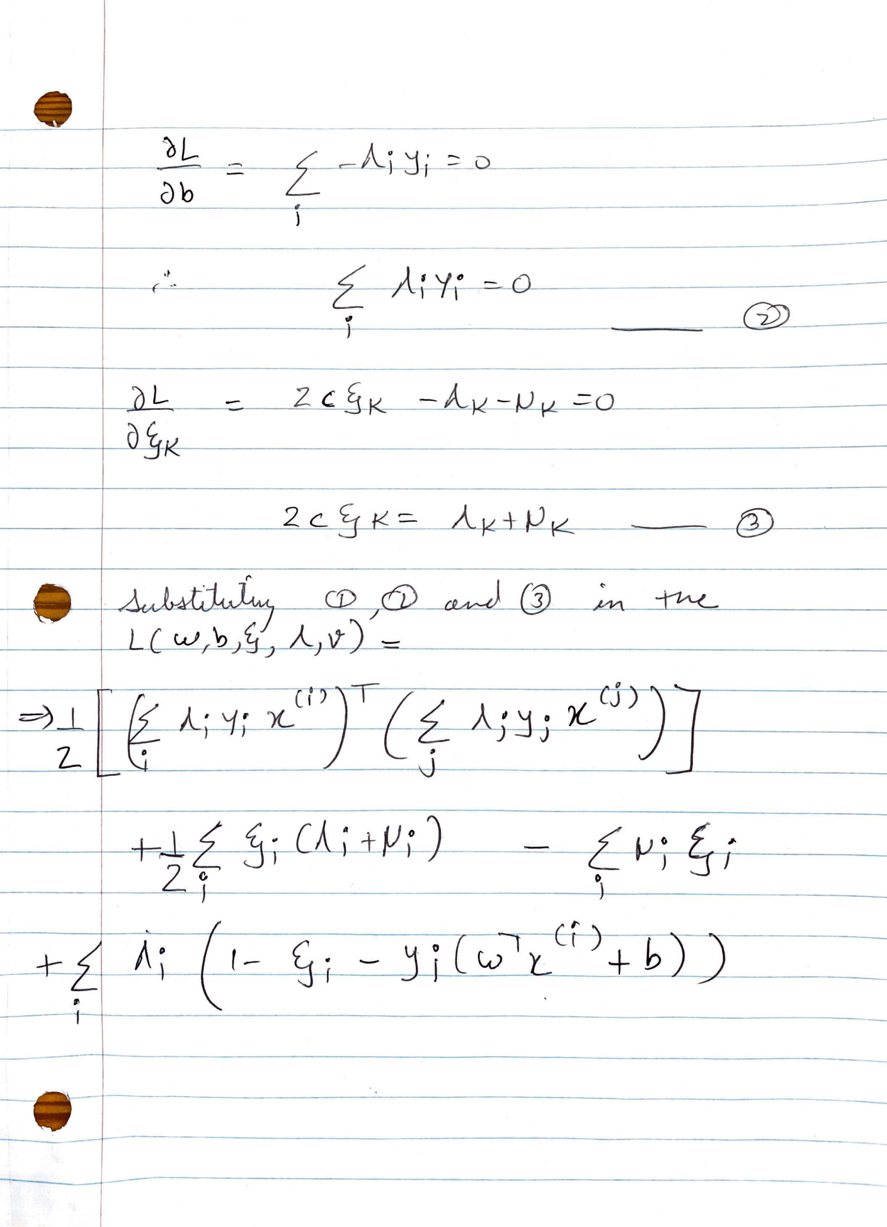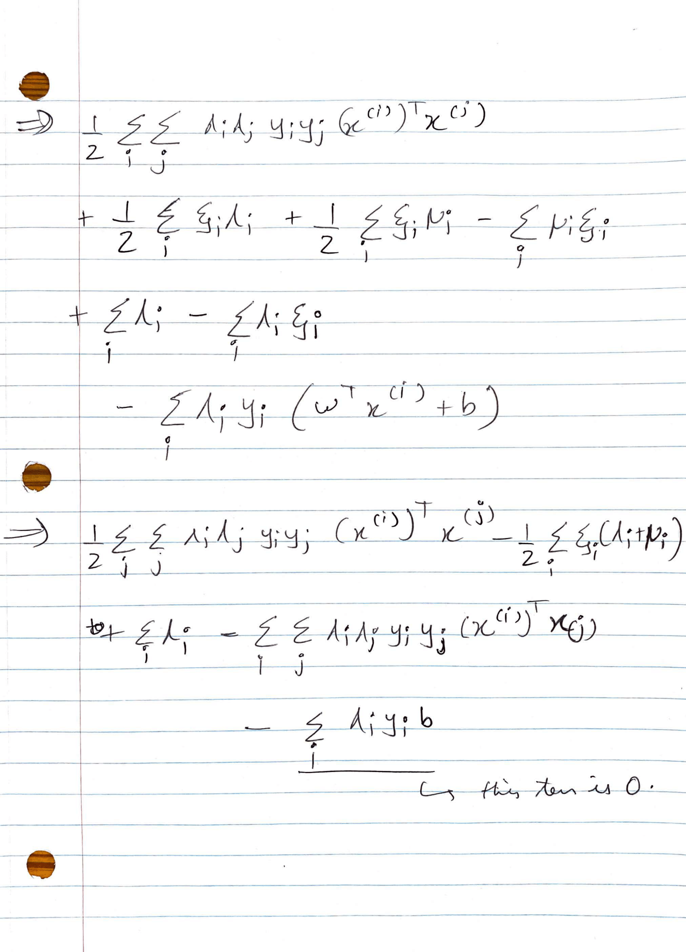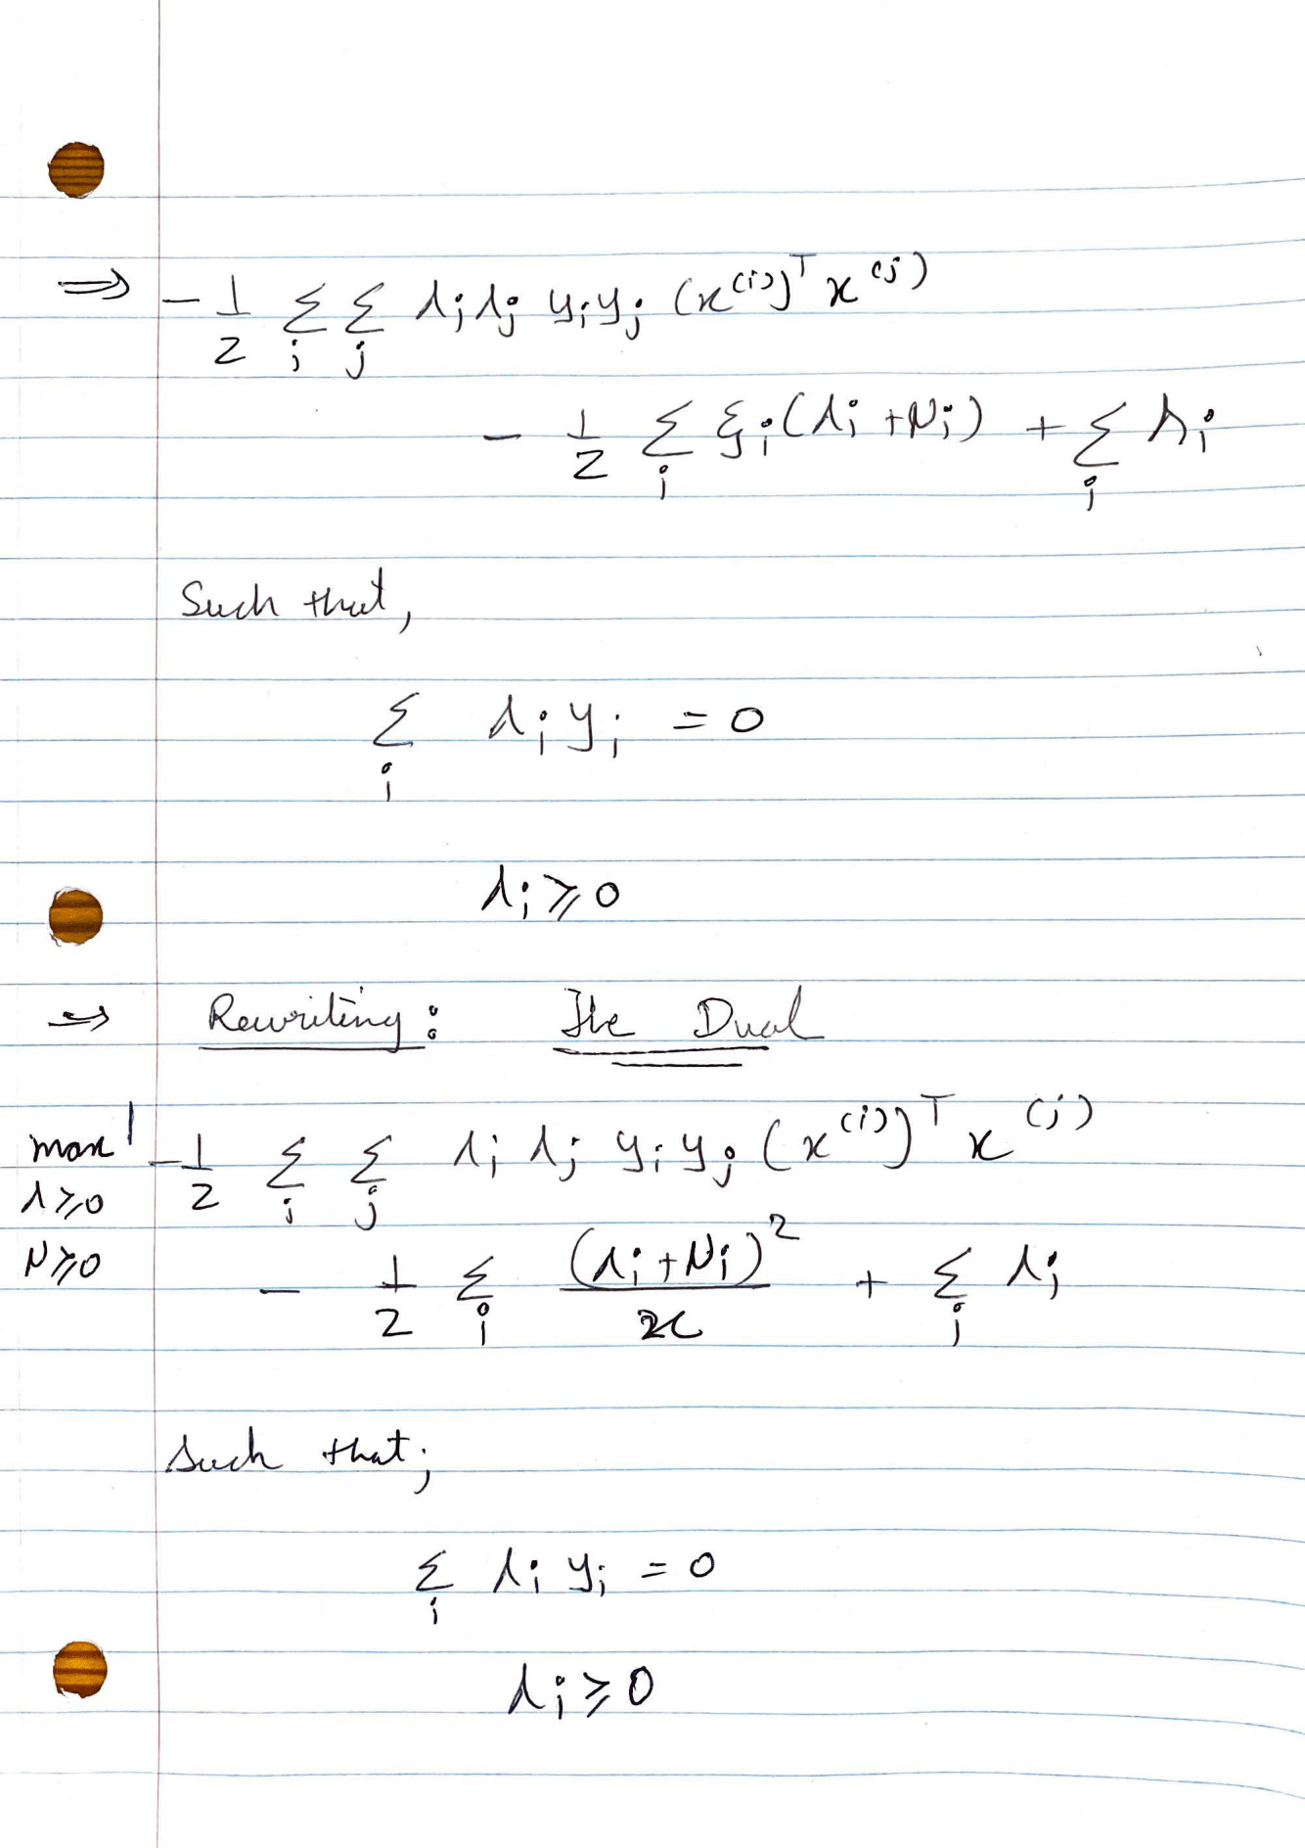

## Can this be kernelized?

Yes, this can also be kernelized as we have inner product of input data in our dual optimization function

Problem 3: Poisonous Mushrooms

1. Code

import numpy as np

import pandas as pd

import math

def getEntropy(entropy_df):

# assuming zeroth column has the variable

if entropy_df.shape[1] == 0:

#print("ERROR: Entropy function")

exit()

counts = entropy_df.iloc[:,0].value_counts()

probs = counts/sum(counts)

#print(probs)

h = 0

for p in probs:

h += p * math.log(p,2)

return -h

# question == column for the sake of this dataset

def getEntropy_question(q_entropy_df,ques):

total_h = 0

total_samples = q_entropy_df.shape[0]

weights = q_entropy_df[ques].value_counts()/total_samples

for split_label in q_entropy_df[ques].unique():

# split data for this label

df_split = q_entropy_df[q_entropy_df[ques] == split_label]

total_h += weights[split_label] * getEntropy(df_split)

#print(total_h)

return total_h

class treeNode:

def __init__(self):

# intialize a node here

self.ntype = 'internal'

self.result = None

self.question = None

self.infoGain = None

self.children = {}

def build_tree(data,entropy,parent_maxvote,level):

node = treeNode()

if data.shape[0] == 0:

# that means we dont have any samples

node.ntype = 'leaf'

node.result = parent_maxvote

elif len(train[0].unique()) == 1:

# we just have one label

node.ntype = 'leaf'

node.result = data[0].mode()

elif data.shape[1] == 1:

# we have no more columns to split on

node.ntype = 'leaf'

node.result = data[0].mode()

else:

min_entropy = entropy

new_question = None

for column in data:

if column == 0:

continue

label_entropy = getEntropy_question(data,column)

#print("Col : ",column,"\tentropy :",label_entropy)

# this will take care of ties. We are going from left to right

if label_entropy < min_entropy:

min_entropy = label_entropy

new_question = column

if new_question is not None:

print("level: ",level," split > ",new_question)

node.question = new_question

node.infoGain = entropy - min_entropy

# node.children = [None for _ in data[new_question].unique()]

node.result = data[0].mode()

new_data = data.drop(new_question,1)

print("Counts for this label:",new_question)

print(data[new_question].value_counts())

for split_label in data[new_question].unique():

print("----trying: ",new_question,',',split_label)

# split data for this label

df_split = new_data[data[new_question]== split_label]

parent_entropy = getEntropy(df_split)

child = build_tree(df_split,parent_entropy ,node.result,level+1)

if child.ntype == 'leaf':

print("-----Leaf - ",split_label)

node.children[split_label]= child

else:

node.ntype = 'leaf'

node.result = data[0].mode()

return node

def print_tree(node,level):

if not node:

return

print("\t"*level,node.ntype)

if node.ntype == 'leaf':

print("\t"*level,"Node.label:",node.result[0])

else:

print("\t"*level,"Node.I:",node.infoGain)

print("\t"*level,"Node.question,",node.question)

for child in node.children:

print("\t"*(level+1),str(child))

print_tree(node.children[child],level+1)

def make_predictions(data,node):

if node.ntype == 'leaf':

return node.result

col = node.question

# see what label do we have

if data[col] in node.children:

child = node.children[data[col]]

return make_predictions(data,child)

else:

return node.result

def check(X):

if X.iloc[0]==X.iloc[1]:

return 1

else:

return 0

# Driver Code

if __name__ == '__main__':

# read training data

train = pd.read_csv("mush_train.data",header = None)

_train = train.copy()

train.head()

unq_labels = [train[column].unique() for column in train]

lmap = []

# for each column

# transform for ease of use

for column in train:

col_map = {}

idx = 0

for label in train[column].unique():

col_map[label] = idx

idx = idx + 1

lmap.append(col_map)

train[column] = train[column].map(col_map)

max_entropy = getEntropy(train)

max_votes = train[0].mode()

tree = build_tree(train,max_entropy,max_votes,0)

print_tree(tree,0)

predictions = train.apply(make_predictions,axis=1,args=(tree,))

train = pd.concat([predictions,train],axis=1)

results = train.apply(check,axis=1)

train_accuracy = sum(results)/len(results)

test = pd.read_csv("mush_test.data",header = None)

for column in test:

test[column] = test[column].map(lmap[column])

test_pred = test.apply(make_predictions,axis=1,args=(tree,))

test_res = pd.concat([test_pred,test],axis=1)

final_results = test_res.apply(check,axis=1)

test_accuracy = sum(final_results )/len(final_results )

## Decision Tree

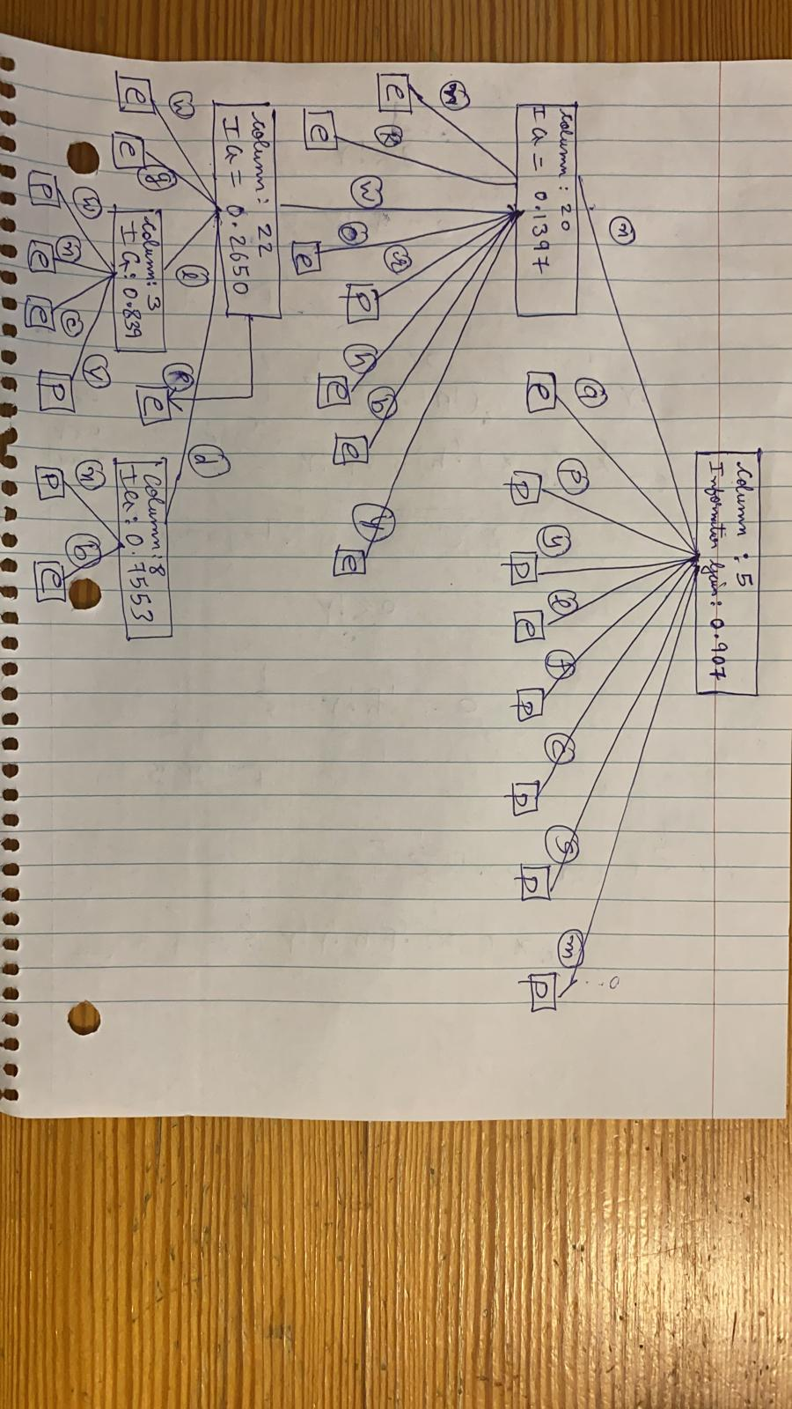

## Accuracy on the test data

We get 100% accuracy on the test data with this decision tree

## Does information gain gives best decision tree for 1-level?

Yes, for any arbitrary inut data if a 1-level decision tree is generated using information gain it will give the best training accuracy from all the possible 1-level decision trees.

The reason being that we would have selected the splits which puts similar labels together and thus when we do a majority vote, we will have maximum labels on the training set to be true.