Course No: CSE 3110

Course Name: Database Systems Laboratory

Project Name: **Banking System**

Submitted to:

**Jarin Firose Moon Md. Milon Islam**

Lecturer Lecturer

Dept of Computer Science & Engineering Dept of Computer Science & Engineering

Khulna University of Engineering & Technology Khulna University of Engineering & Technology

Submitted by:

Salim Shadman Ankur

Dept of Computer Science & Engineering

Roll: 1507014 Section: A

Khulna University of Engineering & Technology

PROJECT OVERVIEW

* The main aim of this project is it gives information about the Functioning of Databases in Banking System.
* All the Functionalities of Banking Systems are credited in this project.
* Daily Transaction
* Employee Management
* Loan System

DESCRIPTION

**Janata Bank** is a bank in Bangladesh. There are many branches of this bank throughout the country. There are a lot of transactions in a day . To store it , they need a database. This project will be on that . It includes day by day transaction, loan system, credit card system. There will be a few table. Like a **Cutomer table**, **Loan table**, **Employee table**, **Branch table.**

Mainly **Branch Table** defines the branch which we apply our database of this bank. The attributes are branch_name , city, assets. Branch_name is the primary key of this table.

Again there is another table for Customer . **Customer Table** includes all the information about customer. The attributes are account_no, name, branch_name, date_of_birth, gender, balance, phone_no, account_type. Account_no is the primary key of this table. There is M:M relationship between Customer & Branch table. One customer may have more than one account in a branch. On the basis of account_no , one can easily find a customer.

There is another table of Bank employee. **Employee Table** includes all the information about an employee of a bank . The attributes are employee_id, name, status, branch_name, salary, phone_no, gender. Employee_id is the primary key of the table. There is M:1 relationship between Employee & Branch table.

Last table is **Loan Table**. All loan transaction are included in this table. The attributes are loan_no, account_no, loan_type, amount, interest, entry_clerk_id, access_date. Loan_no is the primary key of this table. There is M:1 relationship between Loan & Customer table. Also M:1 relationship happens between Loan & Employee table.

Again transaction system, loan_repay, tax system have been included.

RULES GOVERNING THE PROJECT

* All the customers of the bank have a **unique** account number
* The account numbers are not nullable i.e., they cannot take **null** values.
* The customers must have a **minimum** account balance of Rs.**500**.
* Any customer is not allowed to withdraw amount from his account, if the withdrawal results in his account balance going below the minimum balance.
* A person is eligible to get a loan from the bank if he has an account in the bank.
* The percentage of interest imposed on the loan depends on the Company’s policies.
* The employees of the bank have **unique** identification numbers.

SCOPE

The scope of the project contains following features:

* It is a database management system aimed at computerizing and automating the working of bank managements.
* It provides a platform for comprehensive data maintenance and information access.
* It is simple and user friendly with an easy to use graphical interface.
* It is networked DBMS hence allows access to large amount of information.

DATABASE STRUCTURE

The database consists of four tables. They are branch, customer, employee and loan tables.

|  |  |
| --- | --- |
|  |  |
| **Database Tables** | **Description** |
| BRANCH | Contains all the branch information. |
| CUSTOMER | Contains information about customer. |
| EMPLOYEE | Contains information about employee. |
| LOAN | Contains details of loan. |

FUNCTIONALITY

The database system allows technicians to complete the following functions:

* Enter new customers and employees.
* Show the details of all customer and employee.
* Modify an existing one

The database is password-protected and requires a login (when we use this database in web application software).

ENTITTIES AND ATTRIBUTES

* **Branch**
* Branch_name , City, Assets
* **Customer**
* Account_no, Name, Branch_name, Date_of_birth, Gender, Balance, Phone_no, Account_type
* **Employee**
* Employee_id, Name, Status, Branch_name, Salary, Phone_no, Gender

* **Loan**
* Loan_no, Account_no, Loan_type, Amount, Interest, Entry_clerk_id, Access_date

ER Diagram

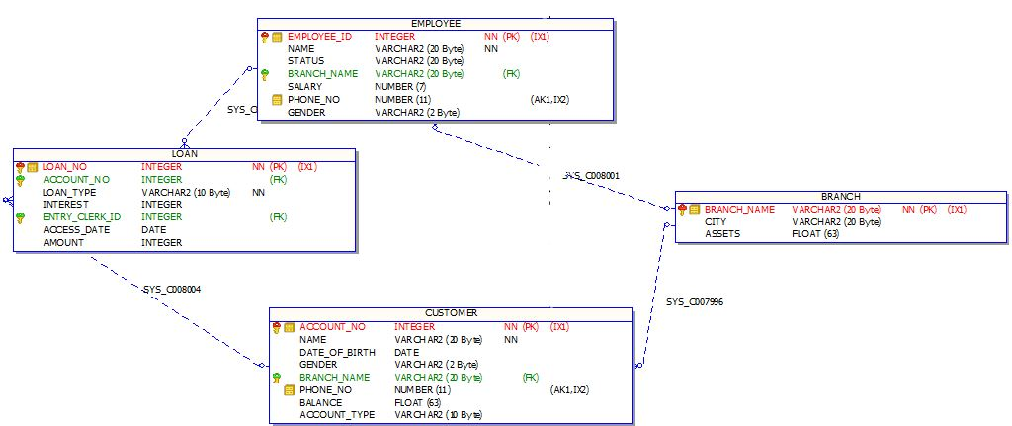

SCHEMA DIAGRAM

Branch

|  |
| --- |
| Branch_name |
| City |
| Assets |

Customer

|  |
| --- |
| Account_no |
| Name |
| Date_Of_Birth |
| Gender |
| Branch_name |
| Phone_no |
| Balance |
| Account_Type |

Employee Loan

|  |
| --- |
| Employee_ID |
| Name |
| Status |
| Branch_name |
| Salary |
| Phone_no |
| Gender |

|  |
| --- |
| Loan_no |
| Account_no |
| Loan_Type |
| Interest |
| Entry_Clerk_ID |
| Access_Date |
| Amount |

CREATE TABLE

* Firstly, drop those table if they already have been.

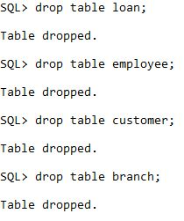

* Create Branch Table

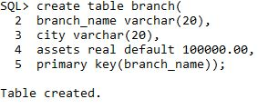

* Create Customer Table

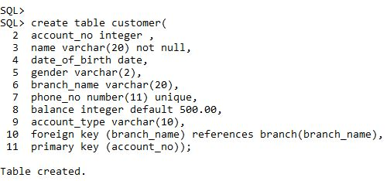

* Create Employee Table

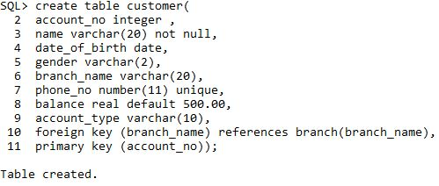

* Create Loan Table

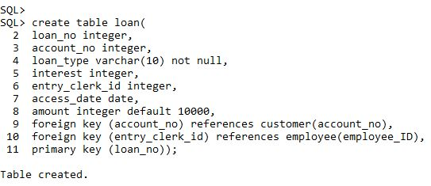

* Describe Tables

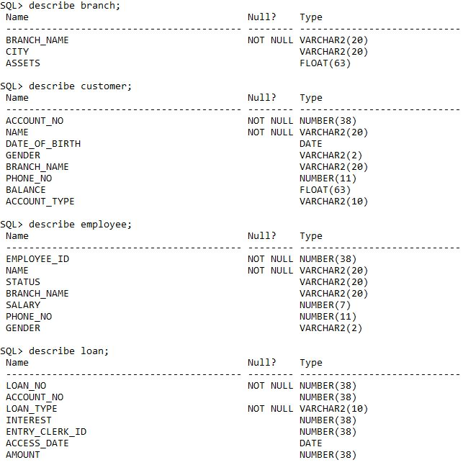

* Select * from tab;

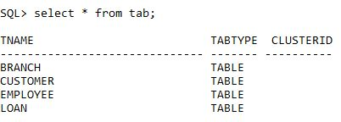

INSERT DATA INTO TABLES

* Insert data into Branch Table

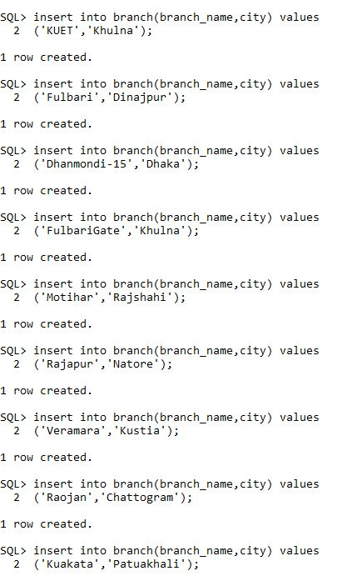

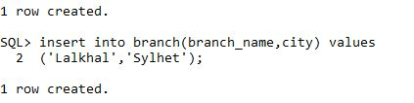

* Insert data into Customer Table

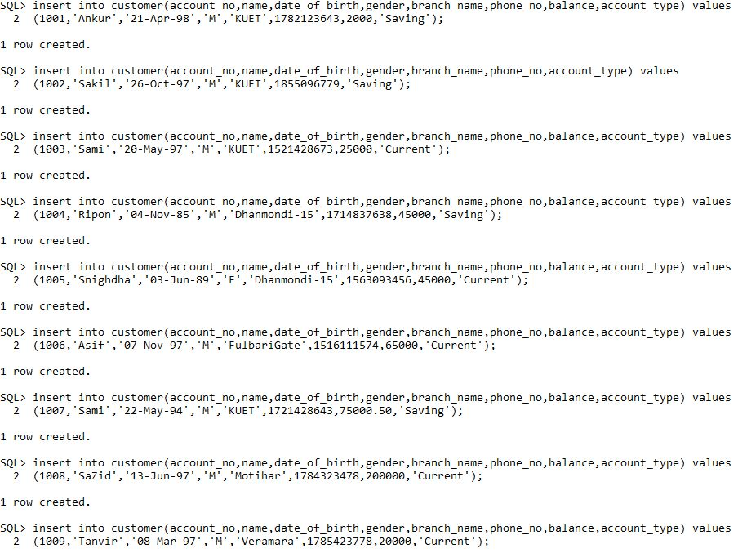

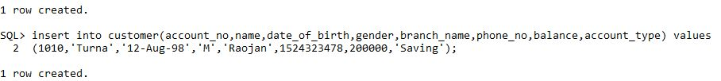

* Insert data into Employee Table

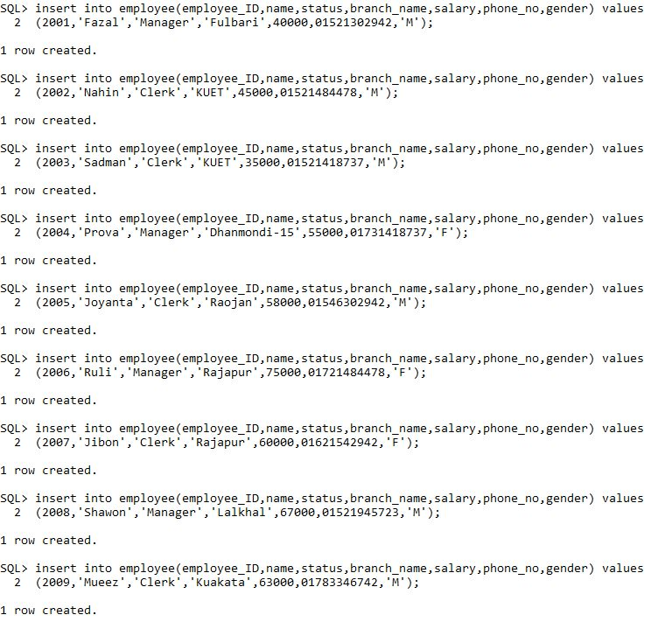



* Insert Data into Loan Table

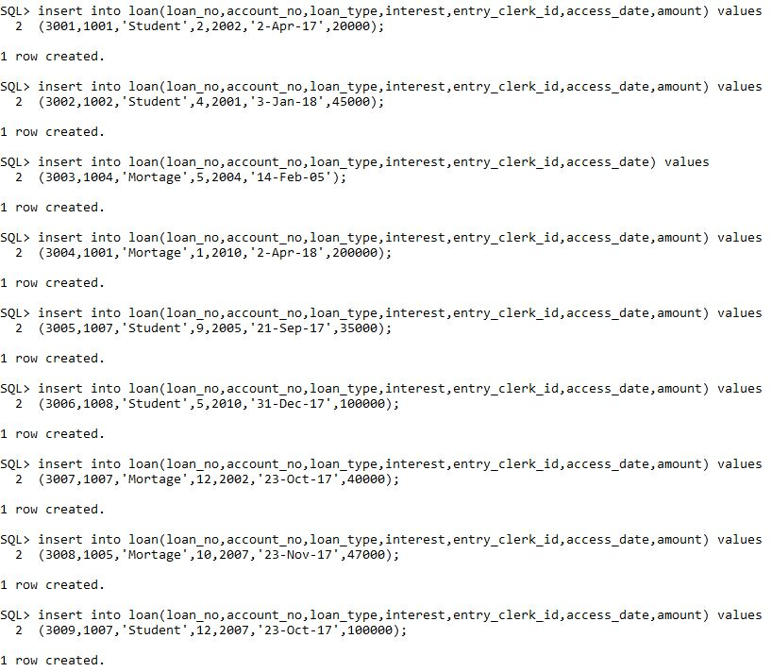



* Select * from branch;

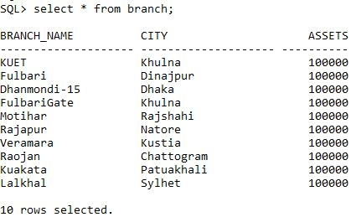

* Select * from Customer;

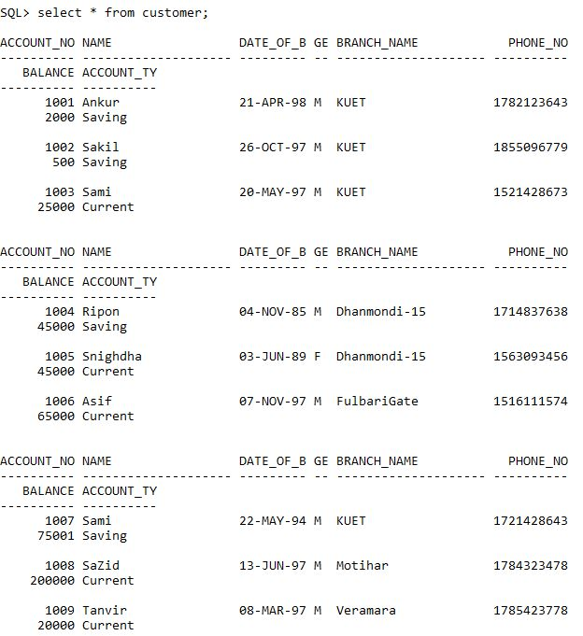

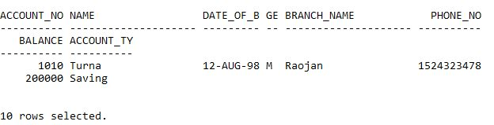

* Select * from Employee;

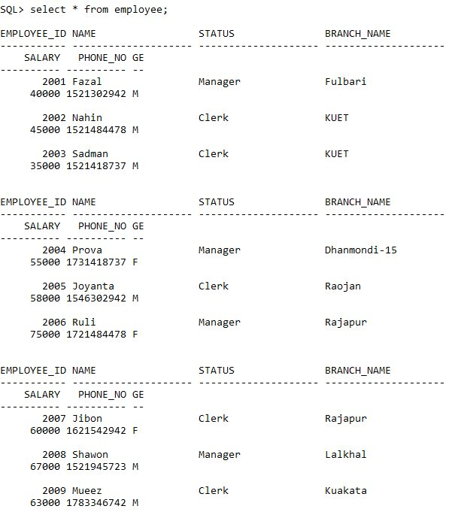

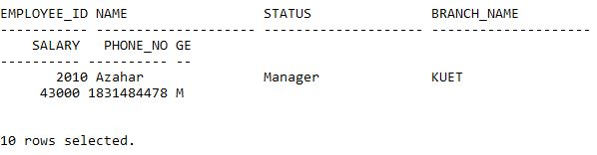

* Select * from Loan;

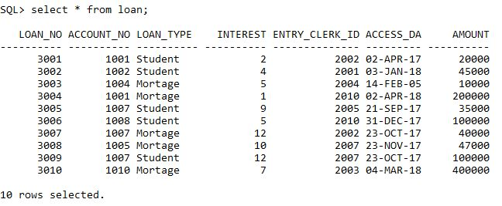

ALTER OPERATION

* Adding Column Postal_Code in Branch Table

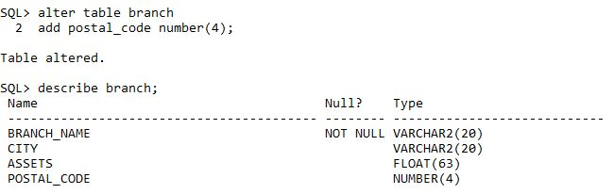

* Renaming Column Postal_Code to ZIP

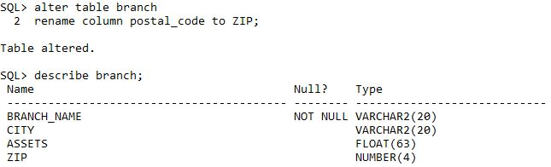

* Modifying ZIP column of Branch Table

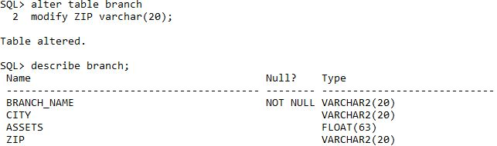

* Dropping ZIP column from Branch Table

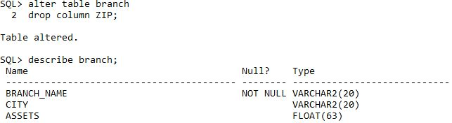

UPDATE OPERATION

* Updating Customer’s Date of Birth

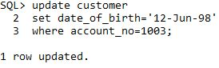

1. Before Update



1. After Update



SET MEMBERSHIP

-checks the condition which exactly matches

* Checks customers’ whose balance are 65000 & 45000

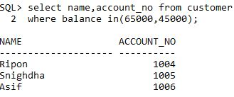

* Checks customers’ whose balance are not 65000 & 45000

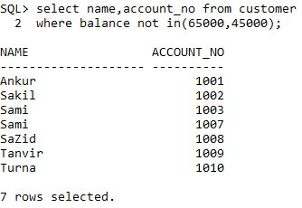

SINGLE COLUMN ORDERING

-Sorts the table based on attributes

* Sort the Employee Table based on their salary in ascending order

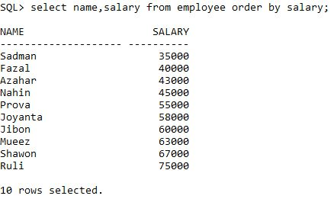

* Sort the Customer Table based on their balance in descending order

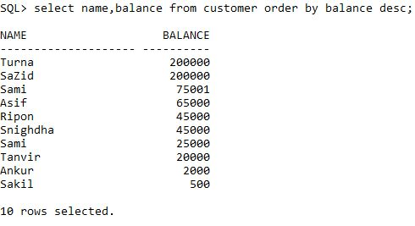

RANGE SEARCH CONDITION

-Used to concatenate two condition in sql

* Find out the Employee whose salary range is 30000 to 60000

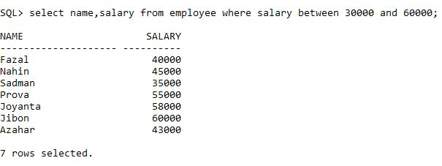

COMPOUND COMPARISON SEARCH CONDITION

-Works when one or more condition from multiple condition is true

* Find out the customer whose account type is saving or have balance > 100000

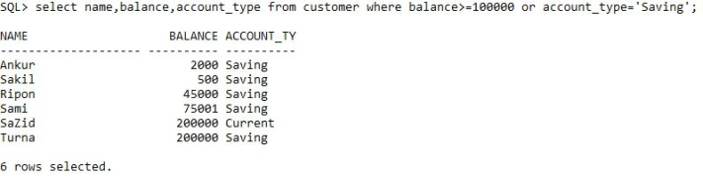

PATTERN MATCHING

- Identifies using some pattern

* Left Pattern

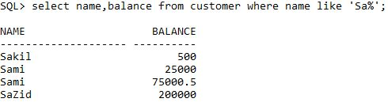

* Right Pattern

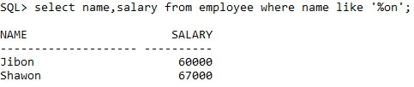

* Middle Pattern

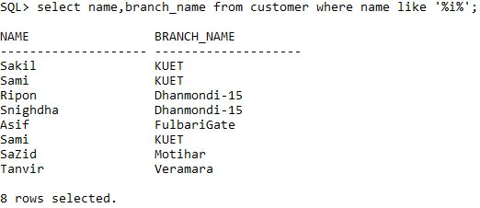

USE OF DISTINCT

* Shows the categories of status of employee

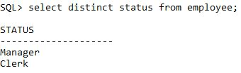

SUB-QUERY

-Used for complex transaction

* Find out the customers who have loans

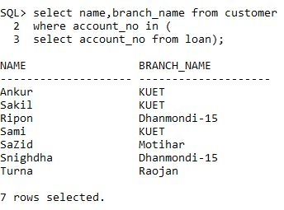

AGGREGATE FUNCTION

* **COUNT()**
* Counts the number of customer

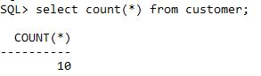

* Counts the number of clerks who entries loan . (It won’t remove duplication)

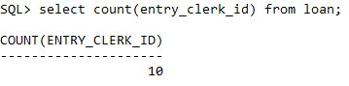

* Counts the unique number of clerks who entries loan . (Remove duplication)

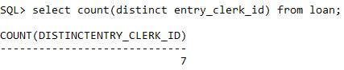

* **AVG()**
* Calculates average salary based on gender of employee

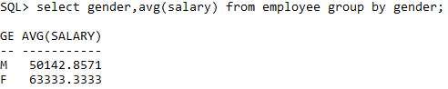

* Use of having

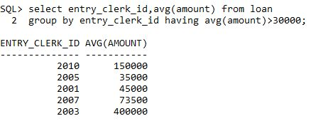

* **Max()**
* Return the maximum value

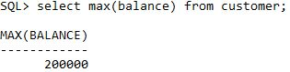

* **Min()**
* Return the minimum value

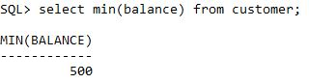

* **Sum()**
* Returns the summation

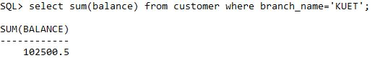

CALCULATED FIELD GIVING DIFFERENT COLUMN NAME

* Calculating average salary giving the name average_salary

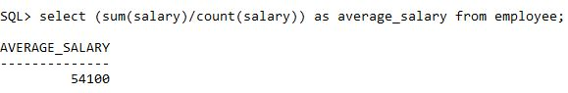

SET ORERATION

* **Union**
* Merges two branches’ sum of customer balance

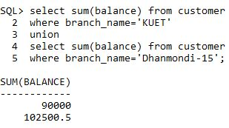

* **Intersection**
* Find out the customers who have both account of current & saving

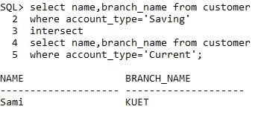

* **Minus**
* Find out the customers who have only an account

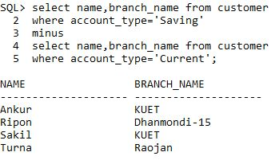

JOIN OPERATION

* Find out the customers names who have loans

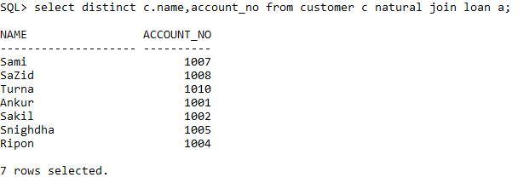

* Find out employees city

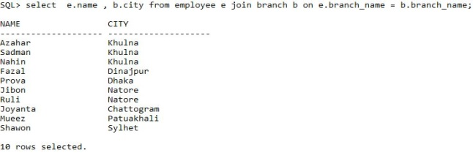

CONDITION

* Taxation System

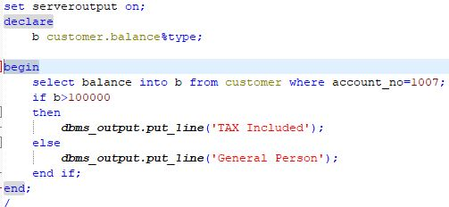



LOOP

* Loan Application

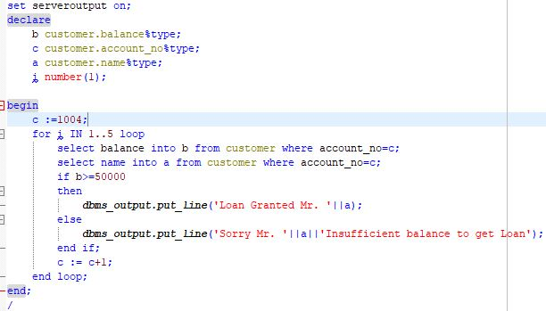

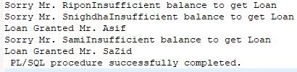

ARRAY

* Branch Customers List

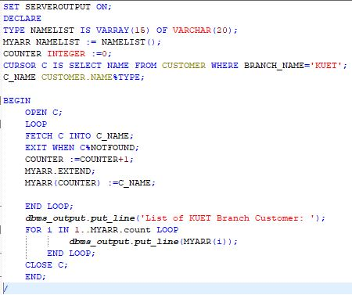

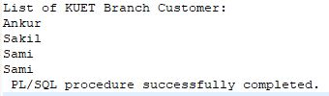

PROCEDURE/FUNCTION

* Find out the present amount of loan after some years

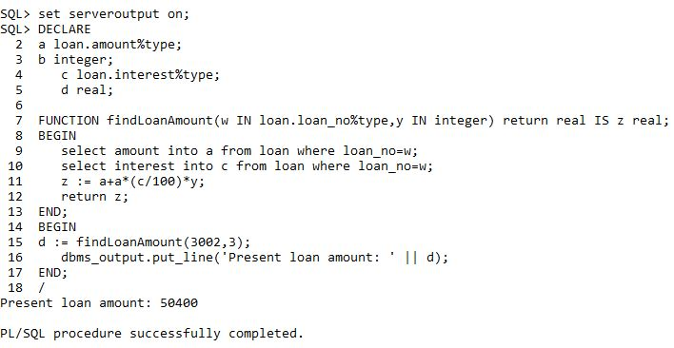

* Find out the total of a customer

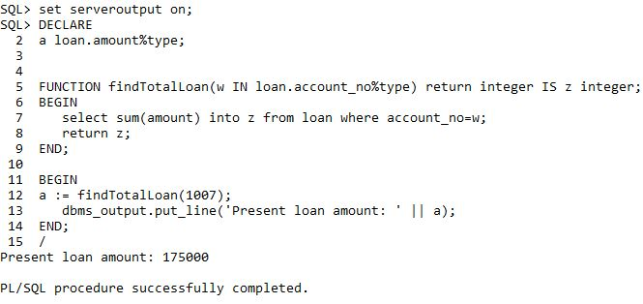

* Find interest

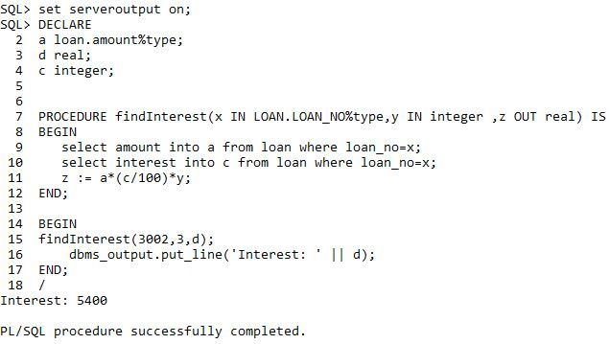

* Transaction System

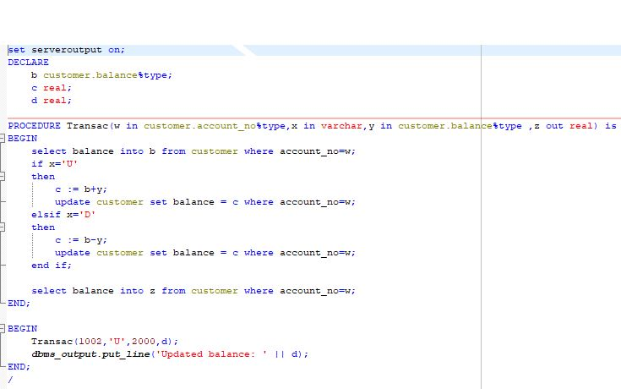



* Loan Repay System

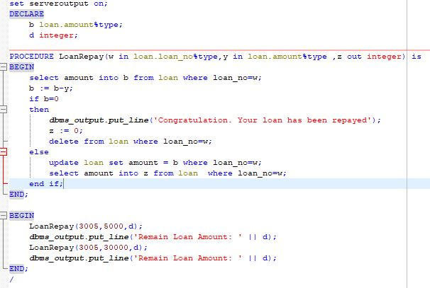

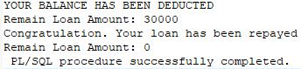

* Cheque Book

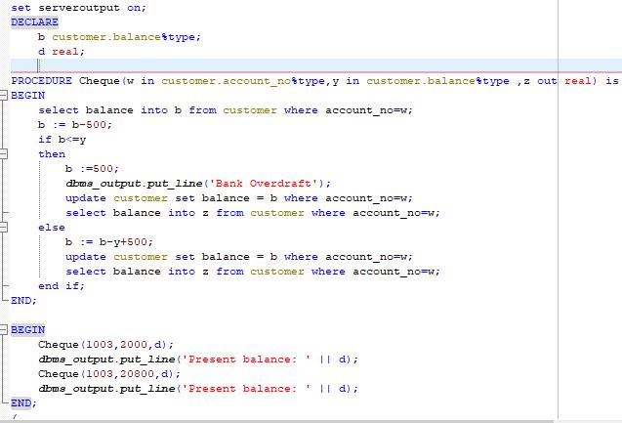

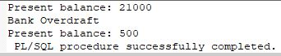

CURSOR

* Credit card system

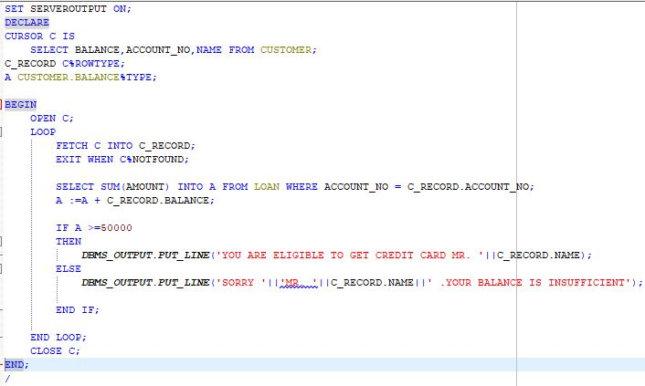

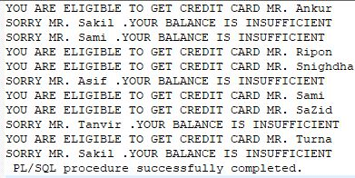

TRIGGER

* Automatically Runs when insert or delete or update
* To entry a customer

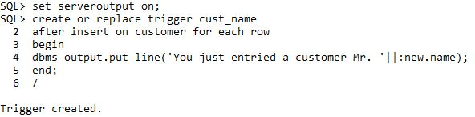

* To entry an employee

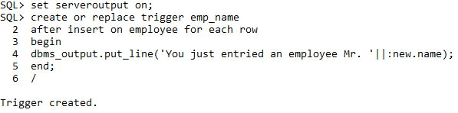

* To entry a branch

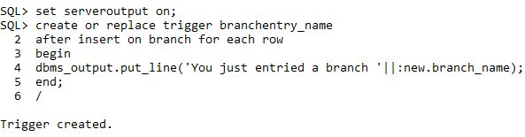

* To entry a loan

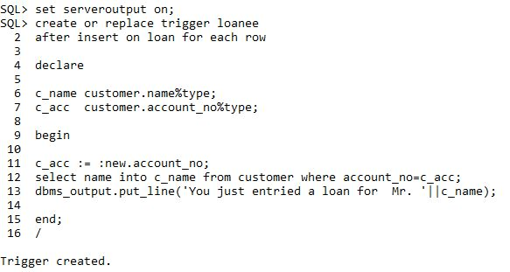

* First year interest deduction
* Will deduct the interest of first year while loan transaction occurs

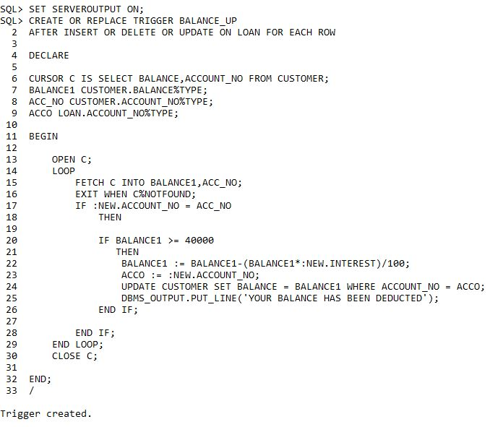

* Branch Asset Calculation
* Will update the bank asset while transaction occurs

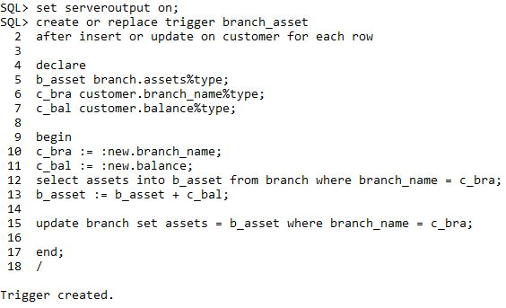

FILE SYSTEM (READ)

* Read Branch Table

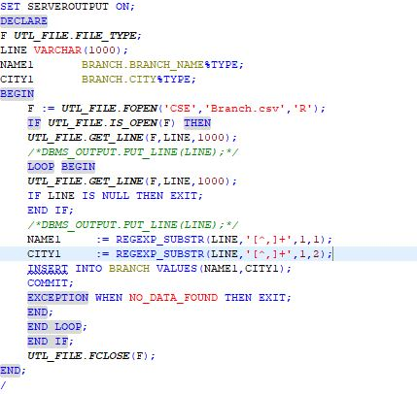

* Read Customer Table

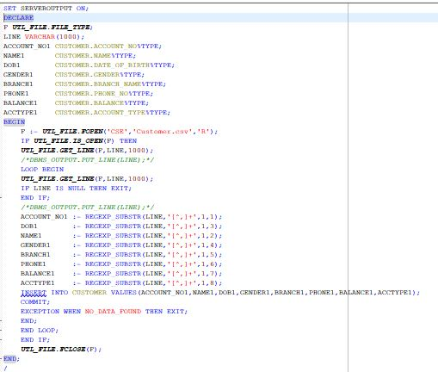

* Read Employee table

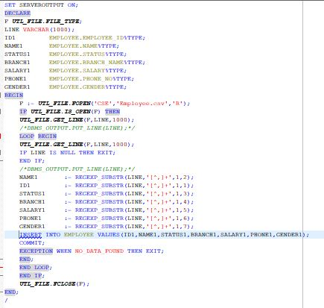

* Read Loan table

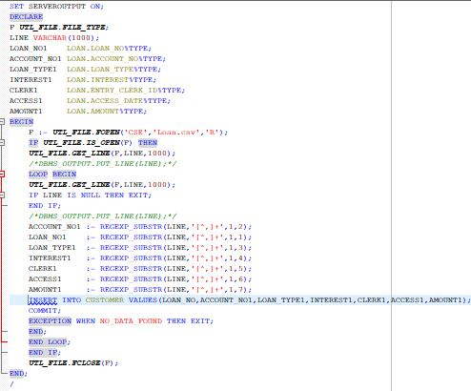

FILE SYSTEM (WRITE)

* Write individual branch information

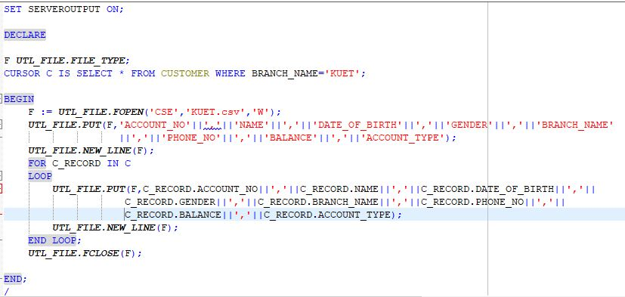

VIEW

* Customer View

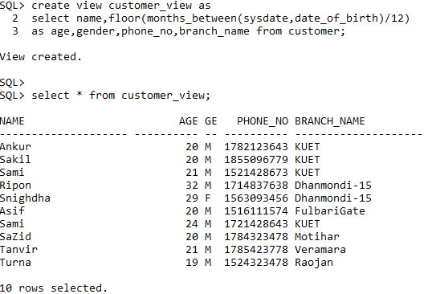

SUMMARY

The project was a learning experience for all people who have their transaction. It will help the bank employee & authorities to the transaction.