

American International University- Bangladesh

CSC 3222: Web Technologies

CO1.1 and CO2.1 Evaluation

Project Report

Summer 20-21

Project Title: STUDENT-ALUMNI HUB

Section: J

|  |  |
| --- | --- |
| Student Name | Student Id |
| SAHA, ANKUR | 18-37913-2 |
| REHAN, PULOK | 18-37907-2 |
| RAHAMAN, MD. ASIQUR | 17-34466-2 |
| AHMMAD, SAZID | 17-34121-1 |

**Introduction:**

*The purpose of the project entitled as “Student Alumni Teacher Hub” is to computerize the communication system of student, teacher and alumni to develop web application which is user friendly, simple, fast and cost-effective. It deals with the admin, student, faculty, alumni information and also to contact with different user through chatting and much more features. The main function of the system is to log in and register user and user information, to check user information, purchase or enroll course, uploading research paper through this website. Traditionally, it was done manually. Our main focus is to design a unique and interactive portal that will improve experience for students, alumni and faculties of any educational institution. The whole system will through the help of internet.*

**Background Study:**

*Various communication system of student, teacher and alumni management are present out there but there any not too many. Mostly this types of systems are available in universities of our country like the portal of our university [1]. The portal of our university does not provide any facilities for the alumni to connect with the juniors. The “Student Alumni Hub” system will be functional for any kind educational institution like school, college or university. So that connection between educational institute and students remain the same even after graduation and it will be very beneficial for students because it will help them to reach out to their faculties and alumni anytime without hassle.*

Requirement Analysis:

1. **User Category:**

There are 4-types of Users here. They are:

* Admin
* Student
* Teacher
* Alumni

1. Feature List:

**[Common Features] –**

1. Can login.
2. Can edit profile.
3. Can change password
4. Can search specific users with their info.
5. Can contact with different users through chatting.

**In this project the “Admin” has the following features**:

1. Manipulate user information.
2. Can approve new users.
3. Can delete or modify posts.

**In this project the “Students” has the following features:**

* Can register themselves.
* Can purchase & enroll into a course.
* Can submit CV’s.
* Can pin priority events.

**In this project the “Alumni” has the following features:**

1. Can register themselves.
2. Can post about jobs, internship or tutorials.
3. Can add their research papers.

**In this project the “Teacher” has the following features:**

1. Can register to the system.
2. Can upload files like research paper and more.
3. Can give notices.

**Design:**

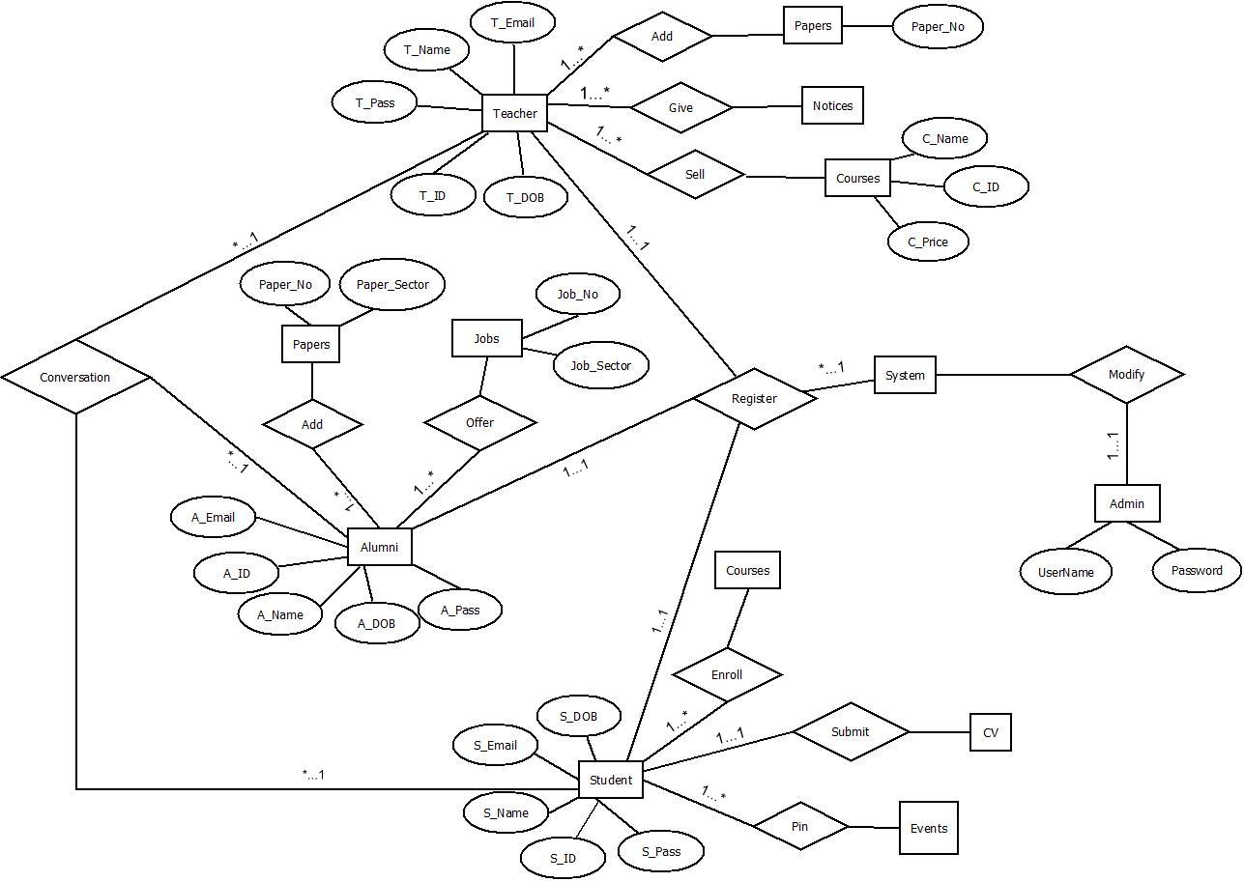

Fig: ER Diagram of Student- Alumni Hub

**Tools Used:**

To develop this project, we have used the following:

• Visual Studio Code

• Sublime Text Editor

• Xampp server

• Apache

• MySQL

• Opera, Chrome

• Windows 10

• Dia

**System Images against the Specification:**

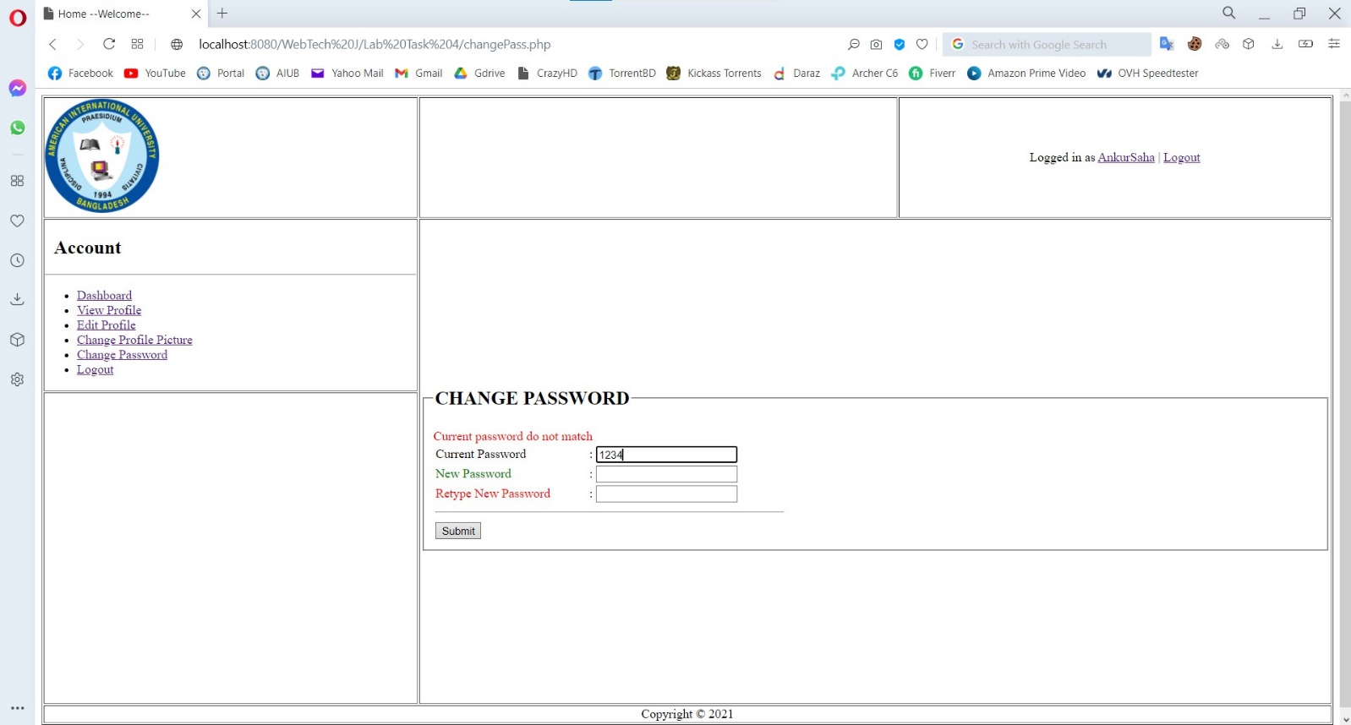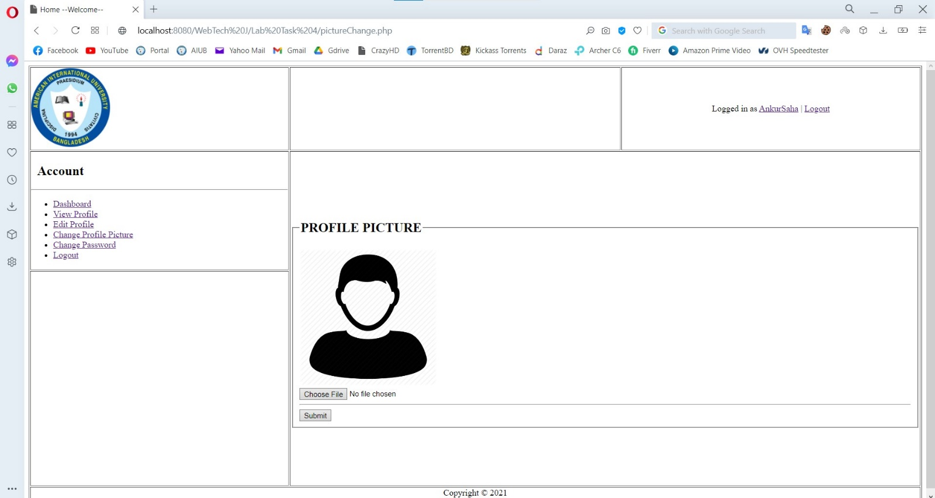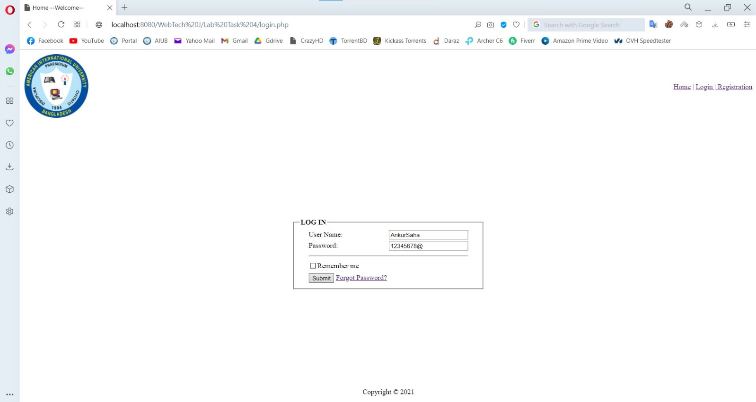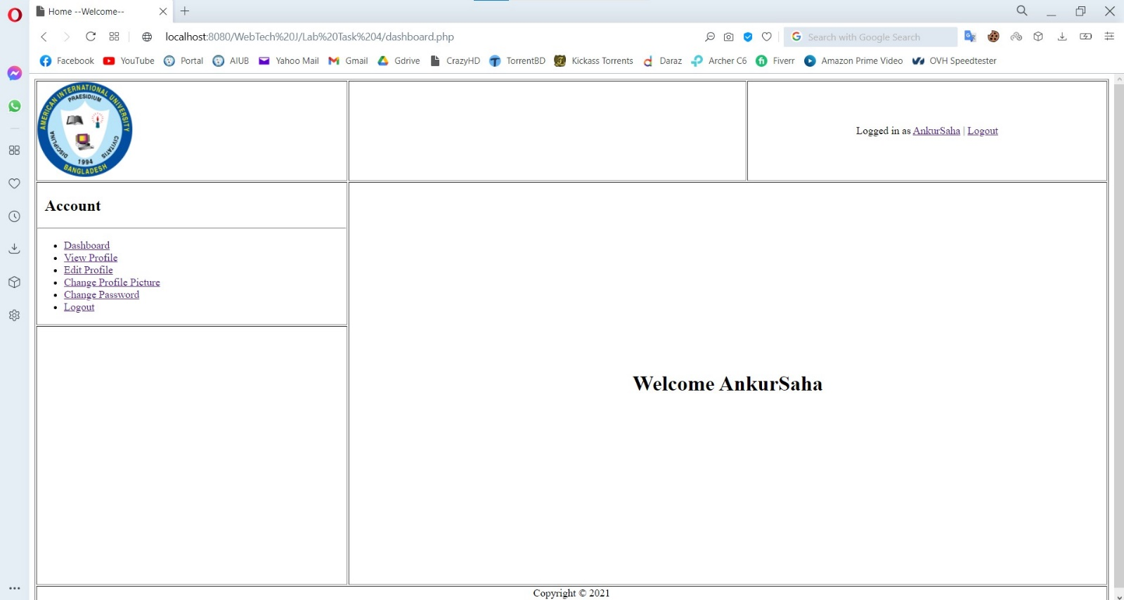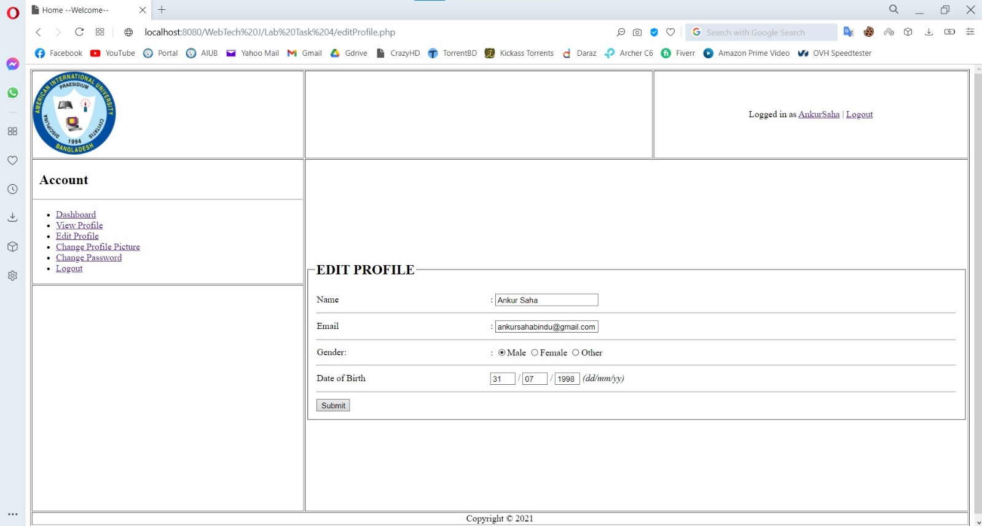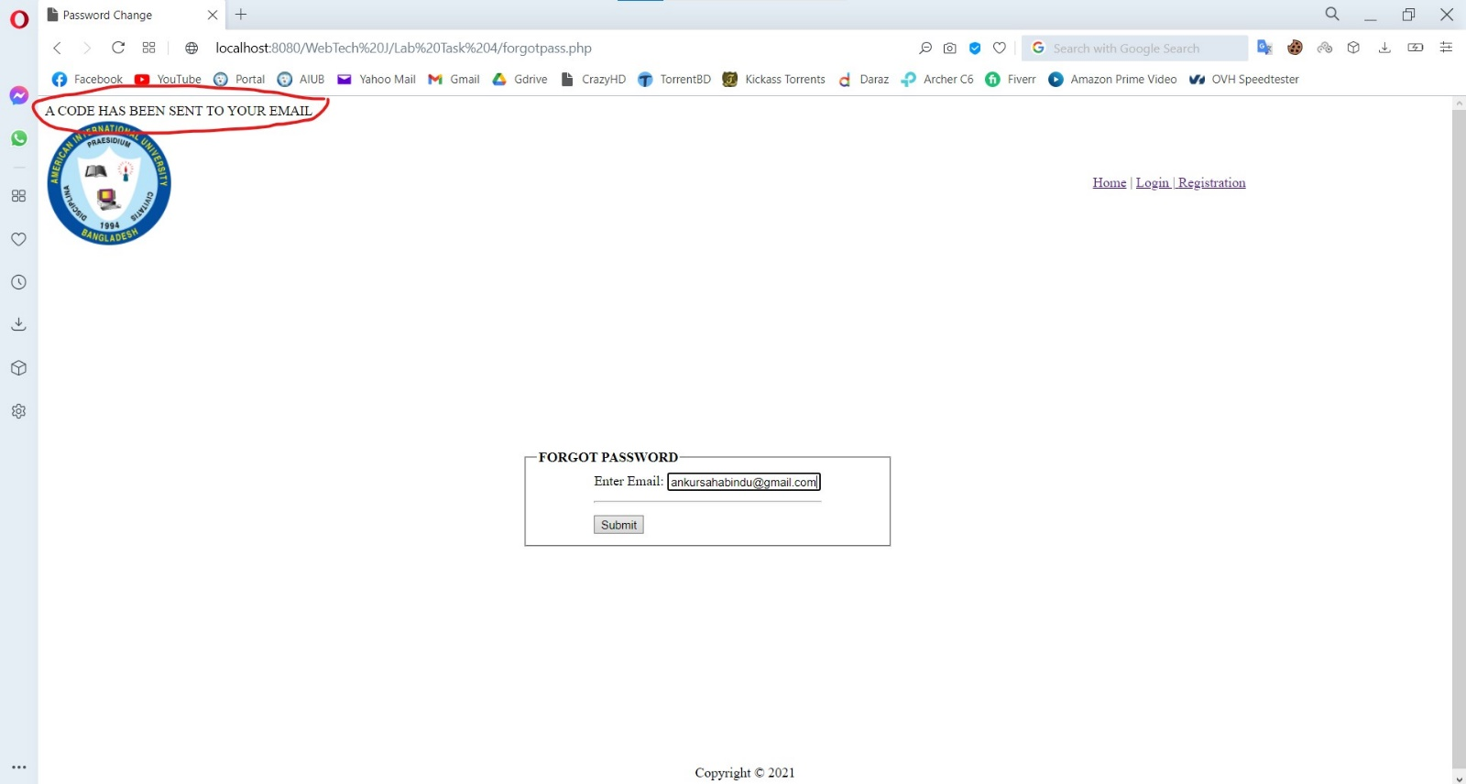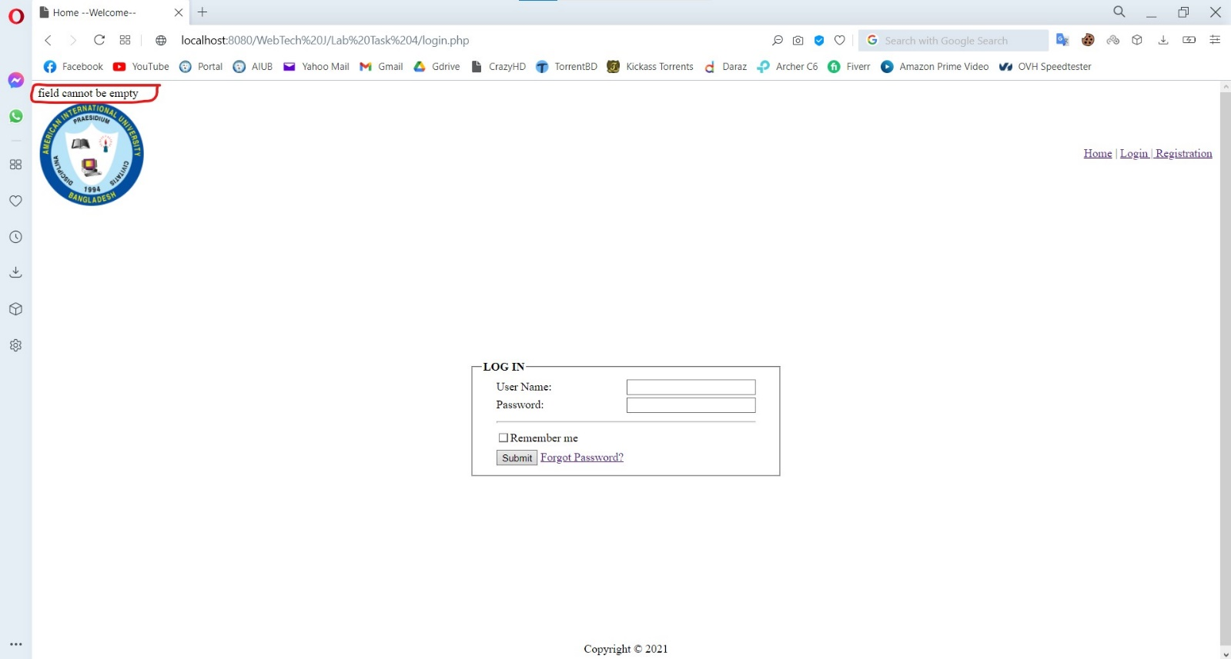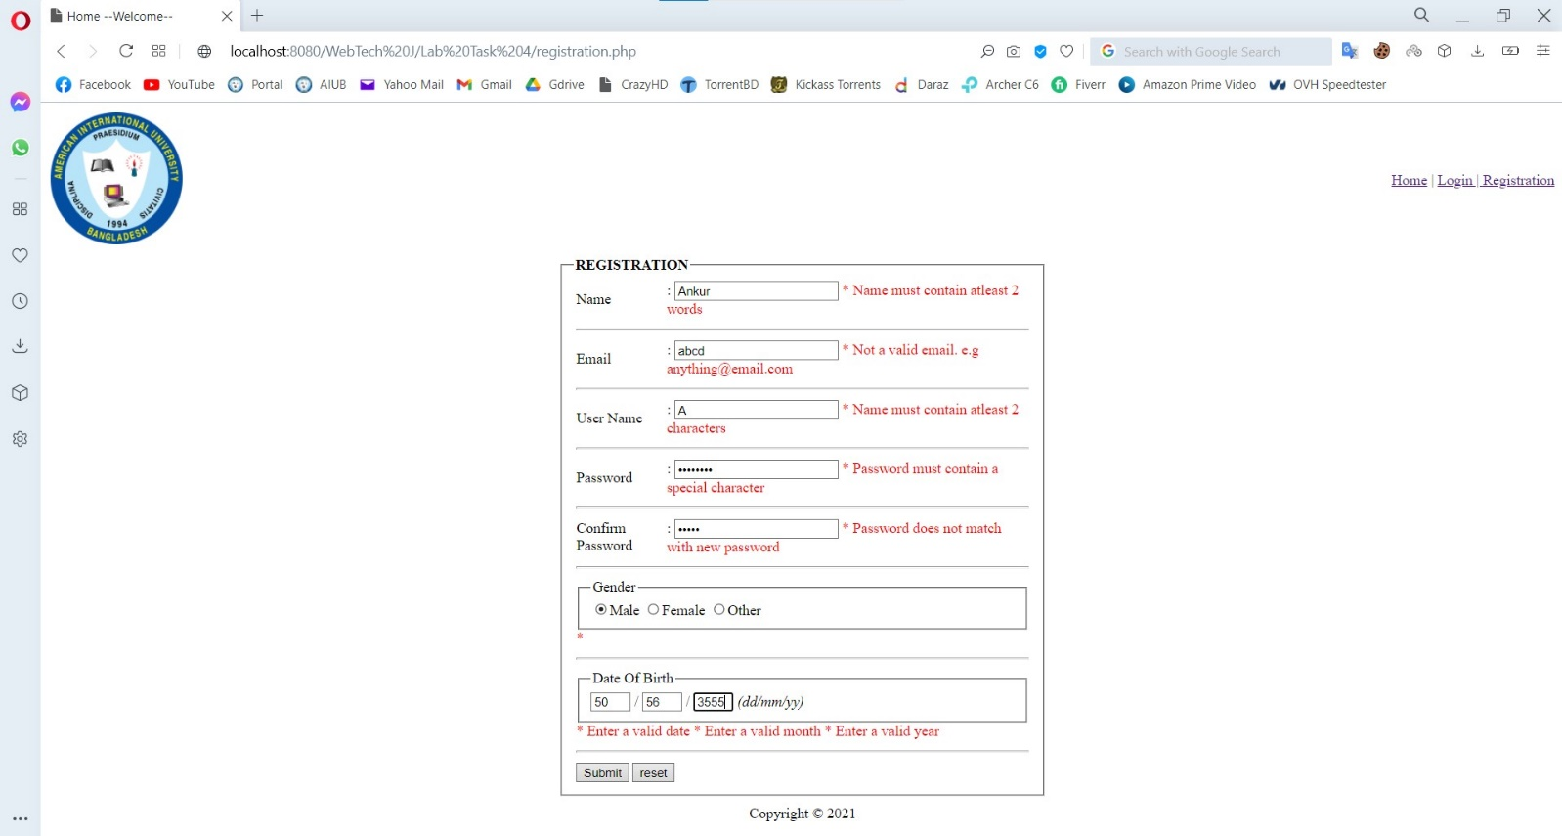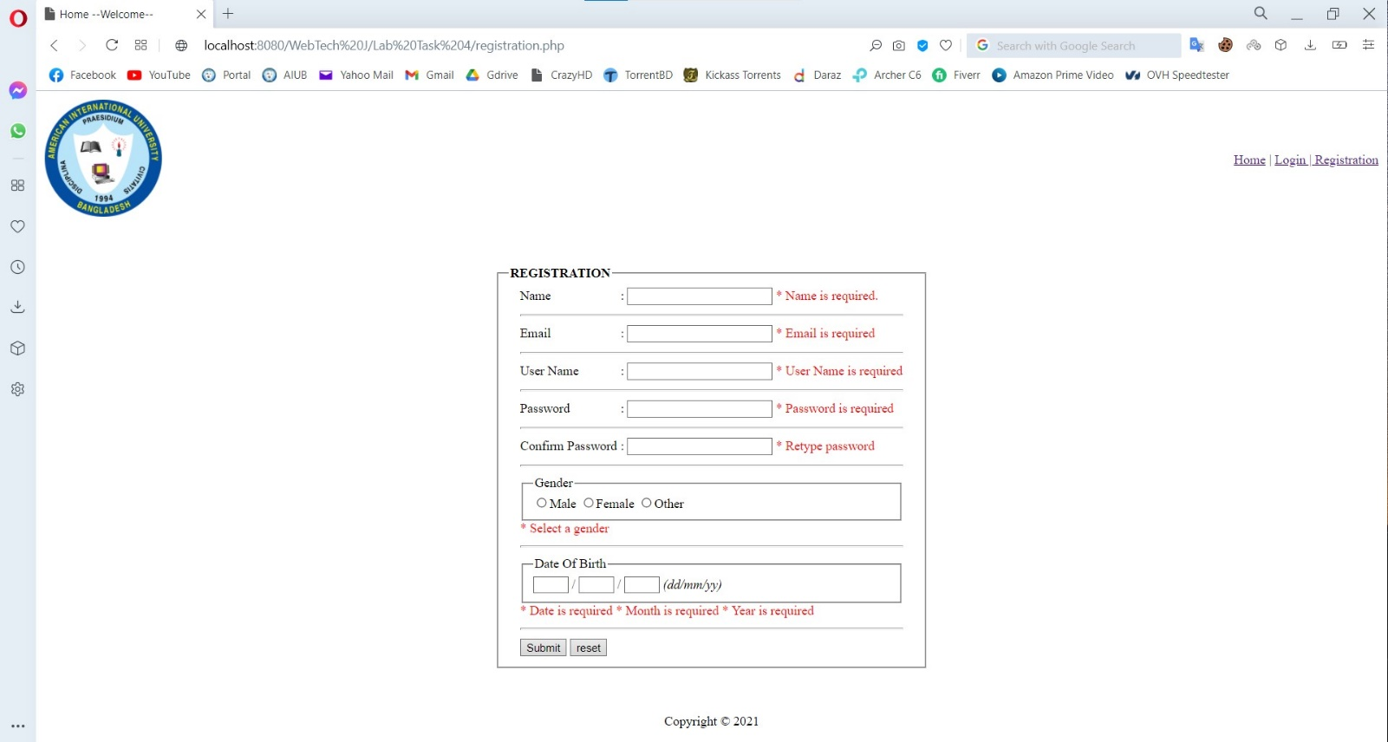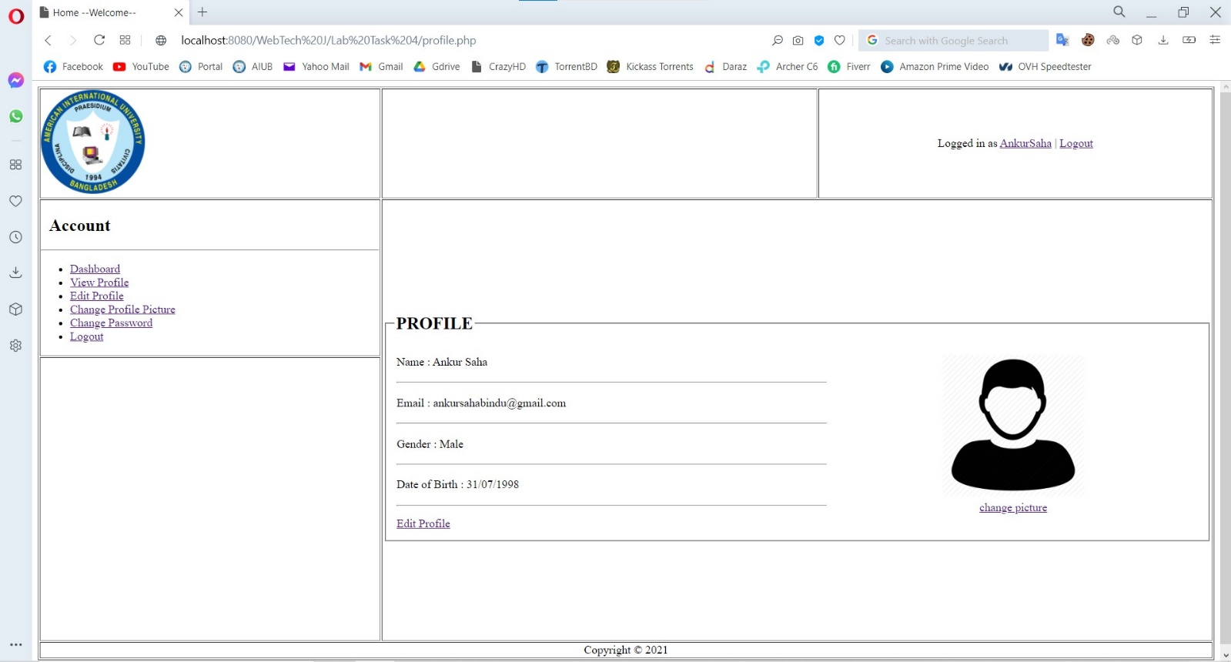

**Impact of this Project:**

Now-a-days because of the pandemic situation, it has become nearly impossible for students to keep in touch with the teachers. So, with the help of our project, students can easily contact with teachers if they don’t understand any particular topic. Besides, it is very important for students to keep in touch with the alumni’s as they can be really helpful in the job market. Students can easily contact with them also. When it comes to teachers for uploading notes or notices they can easily upload them here. So, no more lost unnoticed notices or lost lectures.

**Limitations and Possible Future Improvements:**

As we have not completed database yet, it is really difficult for us to keep the uploaded notices for a certain amount of time. We are looking forward to do that in the final. We are also looking forward to make enrolling in a course in a smart way. We also look forward to create a system where the students can send email to the recruiter of the job post that the alumni’s posted through the system

References:

[1] https://portal.aiub.edu

[2]

|  |  |  |  |  |  |
| --- | --- | --- | --- | --- | --- |
| CO1.1 and CO2.1 Evaluation: Project Report Evaluation | | | | | |
| Project Proposal  (5) | Background  Study  (5) | Requirement Analysis  (5) | Entity  Diagram  (5) | System Images  against the  Specification (5) | Total (25) |
|  |  |  |  |  |  |
|  | | | | | |