Assignment 1 : Compare various POS taggers (taking brown gold as reference) and there accuracy and confusion matrix.

Created By: Ankur Singh (111408058)

NOTE:

1. Every tagger is trained on brown corpus before tagging. Out of 57,000 sentenses 50000 where taken for training and 70000 where taken for testing. The accuracy mentioned for each tagger is what I got on testing the tagger on test set.

2. The tagger's were both tested and trained on brown tagset and then tags were mapped to universal tagset to create confusion matrix.

CRF Tagger:

Accuracy : 95.44%

confusion matrix (against brown corpus gold tags):
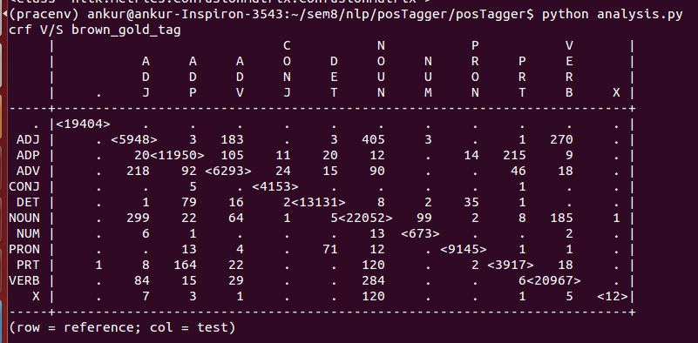

Brills Tagger:

Accuracy : 92.45%

confusion matrix (against brown corpus gold tags):

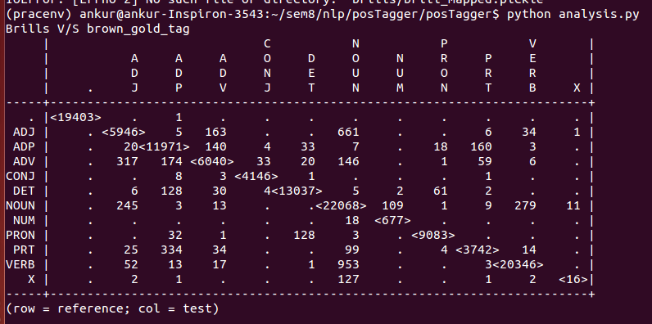

Stanford POS Tagger:

Accuracy: 99.6%

confusion matrix (against brown corpus gold tags)

