**PRESS PORTAL**

* DIPRO Department of a District plays primary role to upload the news which are relates to Block level, Town / City level, District level, State level, National level and International level of a concerned District of a State and automatically all the news will be forwarded to concerned District DC.
* After that,
  + If news is related to concerned District than, concerned DC or Department takes necessary action on that news and gives the comments / remarks / action on that news.
  + If news is related to other District than, only those news which are forwarded to other District DC only those news will be seen in dashboard with their comments / remarks / action given by Department.
* A Dashboard will be made to see all the news will be seen their remarks or category wise filter like DC of a same District of a State, DC of other District of a State, Departments of a same District of a State, Department of other District of a State.

**Work Flow:-**

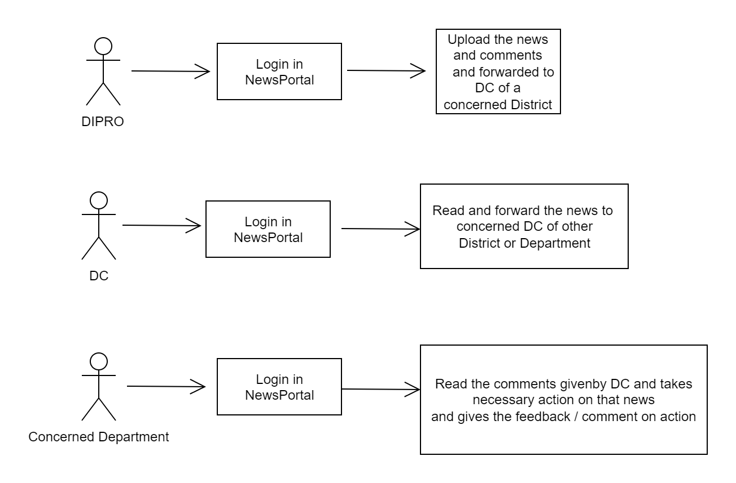

**­­Dashboard:-**

A B(A) C(E+F+G) D OTHERS

Others

10

DC forward the news to other District DC 2

DC forward the news to concerned department 8

News forwarded to DC

20

Total News

20

E(E-G) F G(E-APPROVED BY DC)

Pending action taken by concerned department of a District 6

News Filed

1

Action taken by concerned department of a District 1

**Software & Hardware Requirement:-**

* **Software:-** Any updated Web Browser
* **Hardware:-** Good speed of internet connectivity
* Printer and Scanner

**Technology used:-**

* **Front End:-** JSP using BootStrap 4
* **Back End:-** Servlet
* **Database:-** MySql 8.0
* **JDK:**- 1.8
* **Tomcat Server:**- 9
* **Dynamic Web Module:**- 3.1

**How to create war file manually:**

* jar -cvf pressportal.war *

**Query to create database:**

create database press;

**Query to use database:**

use press;

**Query to create table:**

create table dipro

(

id int(255) not null primary key,

newsdate Date not null,

filename varchar(255) not null,

filedata longblob not null,

remarks varchar(255) not null,

newspaper varchar(255) not null

);

ALTER TABLE dipro auto_increment=1;

**Query to describe the table structure:**

desc dipro;

|  |  |  |  |  |  |
| --- | --- | --- | --- | --- | --- |
| Field | Type | Null | Key | Default | Extra |
| id | int(255) | NO | PRI | NULL |  |
| newsdate | date | NO |  | NULL |  |
| filename | varchar(255) | NO |  | NULL |  |
| filedata | blob | NO |  | NULL |  |
| comment | varchar(255) | NO |  | NULL |  |
| newspaper | varchar(255) | NO |  | NULL |  |

**Query to create table:**

create table login

(

username varchar(255) not null,

password varchar(255) not null,

role varchar(255) not null,

district varchar(255) not null

);

**Query to describe the table structure:**

desc login;

|  |  |  |  |  |  |
| --- | --- | --- | --- | --- | --- |
| Field | Type | Null | Key | Default | Extra |
| username | varchar(255) | NO |  | NULL |  |
| password | varchar(255) | NO |  | NULL |  |
| role | varchar(255) | NO |  | NULL |  |
| district | varchar(255) | NO |  | NULL |  |

**Query to insert username, password, role:**

insert into login values('admin','admin','admin','palwal');

insert into login values('dc','dc','dc','palwal');

insert into login values('adc','adc','adc','palwal');

insert into login values('ctm','ctm','ctm','palwal');

insert into login values('sp','sp','sp','palwal');

insert into login values('dio','dio','dio','palwal');

insert into login values('sdm','sdm','sdm','palwal');

insert into login values('dipro', 'dipro','dipro','palwal');

**Query to create table dc as clone table:**

create table dc like dipro;

**Insert the values from one table to another:**

insert into dc select * from dipro;

**Add status column in dc table:**

alter table dc add column status varchar(255) not null;

**Update the status column values:**

update dc set status="open";

**Tomcat Server**

**Run application inside STS:**

**Port:** 7085

**Username:** root

**Password:** root

**Deploy web application manually:**

1. Install Tomcat Server in System and give the port no 8085 with username: root and password: root.
2. Make a war file of project and paste into C:\Program Files\Apache Software Foundation\Tomcat 9.0\webapps path.
3. Now run the application by giving the manual URL on browser.

**Port:** localhost:8085/PressPortal

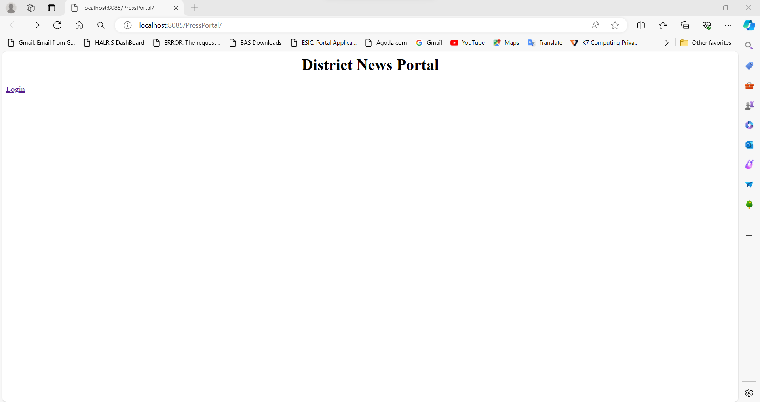

**Jenkins**

**URL:** localhost:8080/

**User Name:** Ankur

**Password:** Radha@2810

**Manage Plugin:**

**Plugin:**

Install the following plugins:

1. Deploy to Container
2. Maven

**Tools:**

Set the path of following applications:

1. JDK11
2. Maven

When u logged in, the following screen will be appeared:

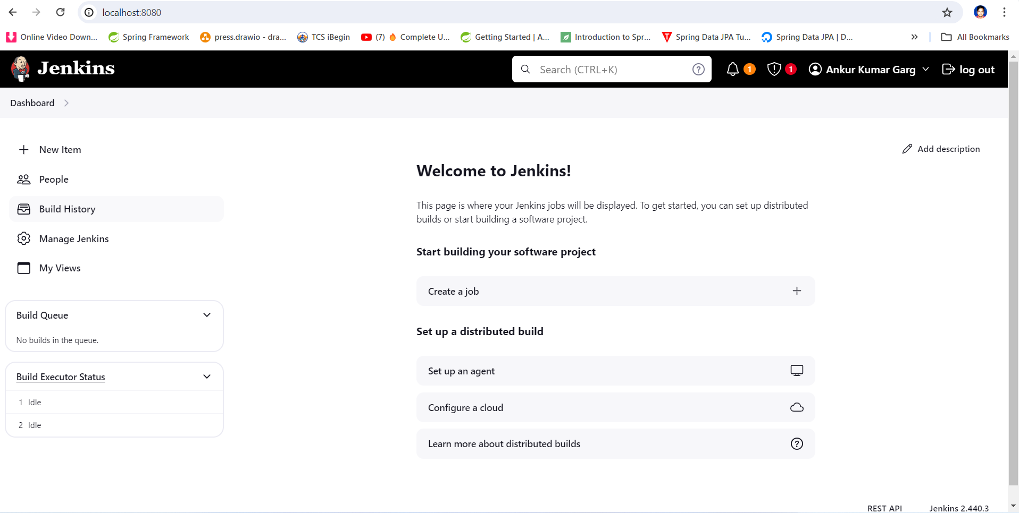

Now, click on create a job. After click, the following screen be appear.

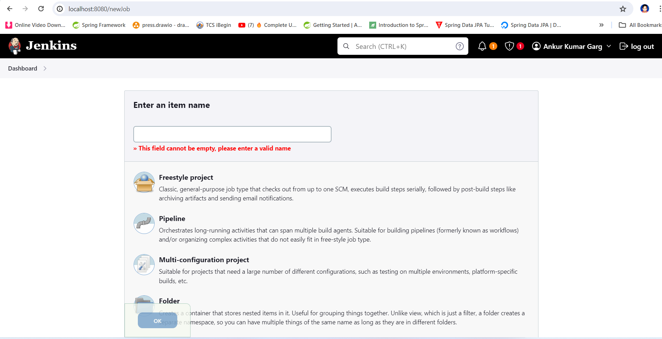

Give Item Name: Press and choose Project Type: Freestyle and click ok.

After that this page will be open.

