**Sales Performance Dashboard Using Power BI**

**Project Title: Infosys Sales Performance Dashboard**



**Table of Contents**

1. Project Statement
2. Objectives
3. Project Timeline
4. Tools and Technologies
5. Project Scope
6. Modules and Milestones
7. Key Performance Indicators (KPIs)
8. Visualizations and Insights
9. DAX Calculations and Measures
10. Future Improvements
11. Project Deliverables

**1. Project Statement**

In today’s data-driven business environment, Business Intelligence (BI) solutions are integral for enterprises to make informed decisions.

This project aims to develop a Sales Performance Dashboard for Infosys using Power BI. The goal is to utilize BI to transform raw sales data into actionable insights, enabling real-time monitoring of key performance indicators (KPIs) such as sales growth, regional distribution, and product performance. With interactive features and dynamic reporting capabilities, this dashboard will provide Infosys with essential tools to analyze their sales performance and adjust to changing market conditions effectively.

**2. Objectives**

1. **Design a Comprehensive Dashboard**: Develop a Power BI dashboard that visualizes various dimensions of Infosys’ sales performance.
2. **Enable KPI Tracking**: Facilitate tracking of KPIs such as sales growth rate, customer segmentation, product category distribution, and regional performance.
3. **Interactive Analysis**: Incorporate drill-down features and filters to allow users to explore data at different granularities and gain detailed insights.

**3. Project Timeline**

| **Weeks** | **Milestone** | **Description** |
| --- | --- | --- |
| 1–3 | **Data Preparation and Cleaning** | Import, clean, and transform data |
| 4–6 | **Basic Visualizations** | Develop initial charts and graphs |
| 7–8 | **Advanced Sales Analysis** | Implement in-depth analytics and DAX measures |
| 9–10 | **Dashboard Compilation and Presentation** | Finalize dashboard layout and create presentation |

**4. Tools and Technologies**

* **Power BI**: Primary tool for data visualization, transformation, and dashboard creation.
* **Data Sources**: Integration from Excel, CSV files, and SQL databases.
* **DAX (Data Analysis Expressions)**: For advanced calculations, custom measures, and calculated columns.  
    
  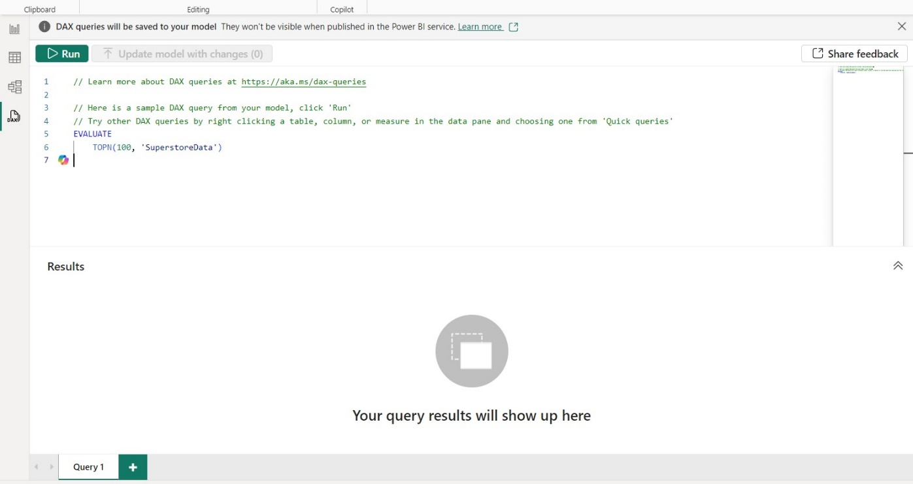

**5. Project Scope**

1. **Data Sources**: Import and integrate sales data from diverse sources including Excel, CSV files, and SQL databases.
2. **Key Metrics**: Focus on metrics like total sales revenue, regional sales performance, customer segmentation, and product distribution.
3. **Analytical Capabilities**: Enable data-driven decision-making through DAX-based calculations, interactive charts, and filters.

**6. Modules and Milestones**

**Milestone 1: Weeks 1-3**

**Module 1: Data Preparation**

Objective: Prepare raw sales data for analysis and visualization.

* **Data Import**: Load data from sources like Excel, CSV, and SQL into Power BI.
* **Data Cleaning**: Remove duplicates, handle missing values, and standardize formats.

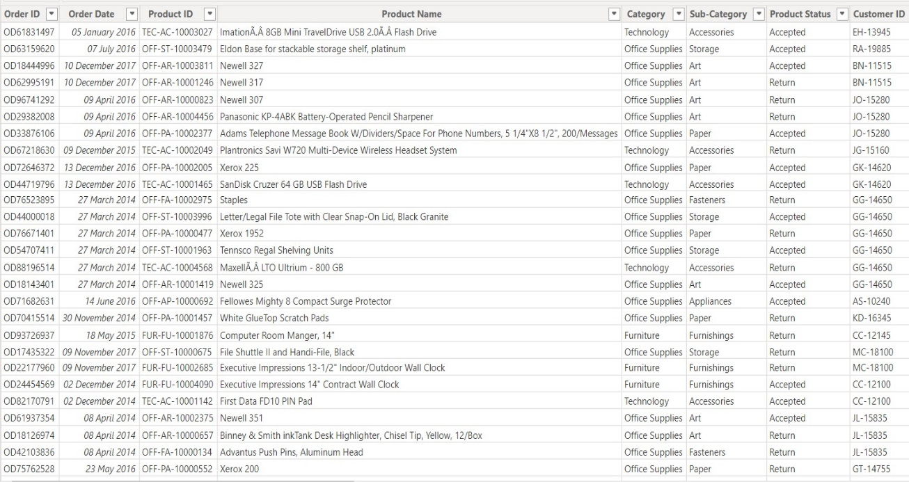

* **Data Transformation**: Utilize Power Query Editor to perform transformations, create calculated columns (e.g., Total Sales = Quantity * Price), and establish relationships between tables (e.g., linking product and customer information).

**Milestone 2: Weeks 4-6**

**Module 2: Basic Visualizations**

Objective: Develop fundamental visualizations to represent core sales metrics.

* **Clustered Column Chart**: Visualize sales performance by region.
* **Line Chart**: Illustrate trends in sales over time, enabling time-series analysis.
* **Pie Chart**: Show distribution of sales by product category, facilitating comparison among categories.

**Milestone 3: Weeks 7-8**

**Module 3: Advanced Sales Analysis**

Objective: Conduct in-depth sales analysis with advanced features in Power BI.

* **Sales Growth Rate**: Use DAX to calculate the growth rate and Year-over-Year (YoY) growth:

Sales Growth Rate = DIVIDE([Total Sales] - [Total Sales Last Year], [Total Sales Last Year], 0)

* **Waterfall Chart**: Demonstrate contributions of different regions to overall sales performance.
* **Slicers**: Add filters by region, product category, and time period for granular analysis.

**Milestone 4: Weeks 9-10**

**Module 4: Final Dashboard and Presentation**

Objective: Compile visualizations into a final dashboard and prepare an insights presentation.

* **Dashboard Layout**: Arrange visuals to provide a cohesive overview of Infosys’ sales performance.
* **Interactive Features**: Implement tooltips, bookmarks, and navigation buttons to guide users through the dashboard.
* **Presentation**: Create a PowerPoint or PDF summarizing key insights, trends, and actionable recommendations based on the dashboard analysis.

**7. Key Performance Indicators (KPIs)**

1. **Total Sales**: Represents the overall revenue from sales transactions.
2. **Sales Growth Rate**: Measures the rate of increase in sales over a specific period.
3. **Regional Sales Breakdown**: Compares sales performance across regions.
4. **Product Category Performance**: Analyzes the contribution of each product category.
5. **Customer Acquisition**: Tracks the rate of new customer acquisition.

**8. Visualizations and Insights**

* **Clustered Bar Chart**: Display sales by region for an easy side-by-side comparison.
* **Stacked Column Chart**: Analyze sales performance by both region and product category within a single chart.
* **Line and Area Chart**: Highlight trends and seasonality in sales over time.
* **Waterfall Chart**: Break down sales contribution by region.
* **Bar Chart** : Highlighting top-performing cities and products based on revenue and quantity.
* **Gauge Chart**: Show progress towards monthly or quarterly sales targets.  
    
  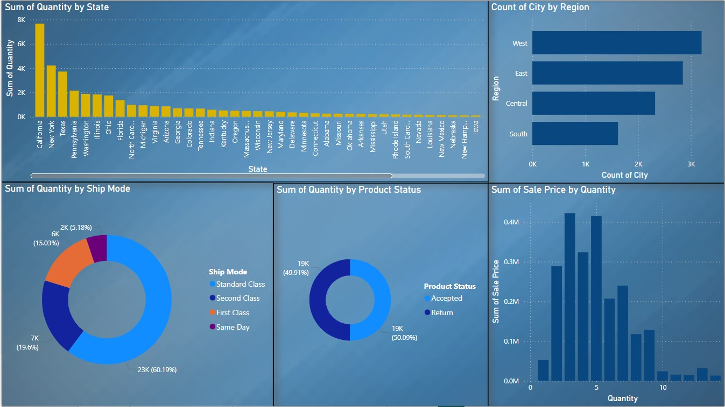

**9. DAX Calculations and Measures**

**Core DAX Formulas**

* **Total sale:**

Total Sale= SUM(Sale[SalesAmount])

* **Total cost:**

SUM(Sale[costAmount])

* **Gross profit:**

Gross profit =[Totalsale] - [Total cost]

* **Gross Profit Margin:**

DIVIDE([Grossprofit],[Total Sales])

* **AverageOrder Value:**

Average Order value=AVERAGEX(Sales,Sales[SalesAmount])

* **Sales Growth Percentage:**

Sales Growth %=DIVIDE ([Total Sales] - [Previous Year Sales] , [Previous YearSales])

* **Top 10 Customer by Sales :**

TOPN(10,VALUES(Sales[CustomerID],[TotalSales])

* **Sales by product category:**

Sales by category =SUMMARIZE(Sales,Sales[ProductCategory],"Total Sales",[Total Sales])

* **Sales By Channel:**

Sales by channel = SUMMARIZE(Sales,[SalesChannel],"Total Sales",[Total Sales])

* **Top Product Sale:**

Top Products by Sale = TOPN(10,VALUES[Sales[ProductID],[Total Sales])

* **Average Discount Given:**

Average Discount = AVERAGEX(Sales,Sales[DiscountAmount])

* **Total Units sold :**

Total Units Sold=SUM(Sales[Quantity])

* **Profit Percentage :**

Profit Percentage =DIVIDE([Gross Profit],[Total Sales])

* **Net Profit:**

Net Profit =[Gross Profit] - SUM(Sales[Total Cost])

**10. Future Improvements**

1. **Predictive Analytics**: Incorporate machine learning models to forecast sales trends based on historical data.
2. **Real-Time Data Updates**: Automate data refresh schedules in Power BI for up-to-date insights.
3. **Enhanced Customer Segmentation**: Introduce more complex segmentation based on factors such as purchase frequency, average spending, and loyalty metrics.

**11. Project Deliverables**

* **Data Preparation**: Structured, clean data ready for analysis.
* **Basic Visualizations**: Initial charts providing a foundation for analysis.
* **Advanced Analytics**: Insights from DAX formulas and specialized visuals.
* **Final Dashboard**: An interactive, user-friendly Power BI dashboard.
* **Presentation**: A detailed summary of key findings and actionable insights.  
    
  