Name: Ankur De
Roll No: BL.SC.U4AIE24105
Assignment 6

Code
"""
Multimodal Gaussian + MRF MRI lesion segmentation.

Classes:
0 = healthy / non-lesion brain tissue
1 = diseased / lesion

Input:
training/*mri_at1_t2space.nii
training/*mri_at2.nii
training/*t2_lesions.nii
testing/*mri_at1_t2space.nii
testing/*mri_at2.nii

The T1 and T2 images are combined into a 2-D feature vector per voxel.
A separate multivariate Gaussian is estimated for each class.
An MRF with a 6-connected Potts neighbourhood is then optimized using
red-black Iterated Conditional Modes (ICM).
"""

from pathlib import Path
import argparse
import re

import nibabel as nib
import numpy as np

TRAIN_DIR = "/run/media/ankur/Data/Ankur/Study/Semester 5/Probablistic Reasoning/Lab/Probablistic Reasoning/src/main/java/com/ankur/Lab_6/Data/training"
TEST_DIR = "/run/media/ankur/Data/Ankur/Study/Semester 5/Probablistic Reasoning/Lab/Probablistic Reasoning/src/main/java/com/ankur/Lab_6/Data/testing"
OUTPUT_DIR = "/run/media/ankur/Data/Ankur/Study/Semester 5/Probablistic Reasoning/Lab/Probablistic Reasoning/src/main/java/com/ankur/Lab_6/Outputs"

# Maximum number of voxels sampled from each subject/class when fitting.
# Lesion voxels are usually much fewer than healthy voxels.
MAX_SAMPLES_PER_CLASS_PER_SUBJECT = 100_000
RANDOM_SEED = 42

# Numerical regularization for the 2x2 covariance matrices.
COVARIANCE_REGULARIZATION = 1e-4

# MRF pairwise penalty. Increase it for smoother segmentations.
MRF_LAMBDA = 1000.0
MRF_ITERATIONS = 100

# Images in this dataset are scaled approximately from 0 to 100.
# Dividing by 100 keeps feature values in a convenient range.
INTENSITY_SCALE = 100.0

# A voxel is considered part of the brain if either modality has
# an intensity above this threshold after scaling.
BRAIN_THRESHOLD = 0.02

def subject_id_from_name(filename):
"""Return the subject identifier before the modality suffix."""
for suffix in (
".mri_at1_t2space.nii",
".mri_at2.nii",
".t2_lesions.nii",
):
if filename.endswith(suffix):
return filename[:-len(suffix)]
return None

def load_nifti(path):
"""
Dataset-specific NIfTI loader.

These files declare vox_offset=348 and store their voxel payload after
the 348-byte header. MRI values are already approximately [0, 100] and
lesion labels are already 0, 1, or 2. The supplied scl_slope/scl_inter
fields are inconsistent with those stored values; applying them turns
MRI intensities into a narrow range around 50 and breaks brain masking.

Repair a temporary copy: insert four padding bytes, set vox_offset=352,
and disable scaling (slope=1, intercept=0). Original files are untouched.
"""
import os
import struct
import tempfile

path = str(path)
with open(path, "rb") as f:
raw = f.read()

if len(raw) < 348:
raise ValueError(f"File is too small to be a NIfTI-1 image: {path}")

little = struct.unpack("<i", raw[:4])[0]
big = struct.unpack(">i", raw[:4])[0]
if little == 348:
endian = "<"
elif big == 348:
endian = ">"
else:
raise ValueError(f"Unsupported NIfTI-1 header: {path}")

vox_offset = struct.unpack(endian + "f", raw[108:112])[0]

if vox_offset < 352:
print(f"[FIX] Repairing NIfTI header/scaling: {os.path.basename(path)}")
repaired = bytearray(raw[:348] + b"\x00" * 4 + raw[348:])
struct.pack_into(endian + "f", repaired, 108, 352.0)
struct.pack_into(endian + "f", repaired, 112, 1.0)
struct.pack_into(endian + "f", repaired, 116, 0.0)

with tempfile.NamedTemporaryFile(suffix=".nii") as temp:
temp.write(repaired)
temp.flush()
image = nib.load(temp.name)
data = image.get_fdata(dtype=np.float32)
detached_image = nib.Nifti1Image(
data.copy(), image.affine.copy(), image.header.copy()
)
return detached_image, data

image = nib.load(path)
return image, image.get_fdata(dtype=np.float32)

def find_subject_files(directory, include_masks):
"""Pair T1, T2, and optionally lesion-mask files by subject ID."""
subjects = {}

for t1_path in directory.glob("*.mri_at1_t2space.nii"):
sid = subject_id_from_name(t1_path.name)
t2_path = directory / f"{sid}.mri_at2.nii"

if not t2_path.exists():
print(f"[WARNING] Missing T2 image for {sid}; skipping.")
continue

entry = {"t1": t1_path, "t2": t2_path}

if include_masks:
mask_path = directory / f"{sid}.t2_lesions.nii"
if not mask_path.exists():
print(f"[WARNING] Missing lesion mask for {sid}; skipping.")
continue
entry["mask"] = mask_path

subjects[sid] = entry

return subjects

def preprocess_modalities(t1, t2):
"""
Scale both modalities and construct the brain mask.

Both images are already registered to a common space in this dataset.
Their shapes must match.
"""
if t1.shape != t2.shape:
raise ValueError(f"T1/T2 shape mismatch: {t1.shape} vs {t2.shape}")

t1 = np.nan_to_num(t1 / INTENSITY_SCALE, nan=0.0,
posinf=0.0, neginf=0.0)
t2 = np.nan_to_num(t2 / INTENSITY_SCALE, nan=0.0,
posinf=0.0, neginf=0.0)

t1 = np.clip(t1, 0.0, 1.0)
t2 = np.clip(t2, 0.0, 1.0)

brain_mask = (t1 > BRAIN_THRESHOLD) | (t2 > BRAIN_THRESHOLD)

# Shape: (number_of_voxels, 2)
features = np.stack((t1, t2), axis=-1)

return features, brain_mask

def sample_class_features(features, class_mask, max_samples, rng):
"""Randomly sample feature vectors belonging to one class."""
indices = np.flatnonzero(class_mask.ravel())

if len(indices) == 0:
return np.empty((0, 2), dtype=np.float32)

if len(indices) > max_samples:
indices = rng.choice(indices, size=max_samples, replace=False)

return features.reshape(-1, 2)[indices]

def fit_gaussian(samples):
"""
Estimate a multivariate Gaussian:
p(x | class) = N(x; mean, covariance)

A small diagonal regularizer prevents singular covariance matrices.
"""
if len(samples) < 2:
raise ValueError("Not enough samples to estimate a Gaussian.")

mean = samples.mean(axis=0)
covariance = np.cov(samples, rowvar=False)
covariance = covariance + COVARIANCE_REGULARIZATION * np.eye(2)

sign, logdet = np.linalg.slogdet(covariance)
if sign <= 0:
raise ValueError("Covariance matrix is not positive definite.")

inverse_covariance = np.linalg.inv(covariance)

return {
"mean": mean,
"covariance": covariance,
"inverse_covariance": inverse_covariance,
"logdet": logdet,
}

def gaussian_negative_log_likelihood(features, model):
"""
Calculate -log p(x | class), ignoring the shared 2-D Gaussian constant.

Lower values indicate a better match to the class distribution.
"""
difference = features - model["mean"]

mahalanobis = np.einsum(
"...i,ij,...j->...",
difference,
model["inverse_covariance"],
difference,
optimize=True,
)

return 0.5 * (model["logdet"] + mahalanobis)

def train_models(training_subjects):
"""Train healthy and diseased multimodal Gaussian models."""
rng = np.random.default_rng(RANDOM_SEED)

healthy_samples = []
diseased_samples = []

print("\n========== TRAINING ==========")

for sid, files in sorted(training_subjects.items()):
print(f"\nLoading training subject: {sid}")

_, t1 = load_nifti(files["t1"])
_, t2 = load_nifti(files["t2"])
_, lesion_mask = load_nifti(files["mask"])

features, brain_mask = preprocess_modalities(t1, t2)

if lesion_mask.shape != brain_mask.shape:
raise ValueError(f"Mask shape mismatch for {sid}")

# The lesion masks use NIfTI intensity scaling, and the scaling
# factor differs between subjects. Therefore, a fixed threshold
# such as 0.5 is incorrect. The non-zero label values are encoded
# close to the mask maximum (subject 3 contains labels 1 and 2).
mask_max = float(np.nanmax(lesion_mask))
if not np.isfinite(mask_max) or mask_max <= 0:
raise RuntimeError(
f"Lesion mask for {sid} contains no positive labels. "
f"Check the mask file and NIfTI scaling."
)

# Use half the maximum to separate background (approximately zero)
# from all positive lesion labels, including labels 1 and 2.
lesion_threshold = 0.5 * mask_max
diseased_mask = (lesion_mask > lesion_threshold) &amp; brain_mask
healthy_mask = brain_mask &amp; ~diseased_mask

print(
f" Mask max: {mask_max:.8g}, "
f"lesion threshold: {lesion_threshold:.8g}"
)
print(
f" Brain voxels: {np.count_nonzero(brain_mask):,}; "
f"lesion voxels: {np.count_nonzero(diseased_mask):,}; "
f"non-lesion brain voxels: {np.count_nonzero(healthy_mask):,}"
)

h = sample_class_features(
features, healthy_mask,
MAX_SAMPLES_PER_CLASS_PER_SUBJECT, rng
)
d = sample_class_features(
features, diseased_mask,
MAX_SAMPLES_PER_CLASS_PER_SUBJECT, rng
)

healthy_samples.append(h)
diseased_samples.append(d)

print(f" Healthy voxels sampled: {len(h):,}")
print(f" Diseased voxels sampled: {len(d):,}")

healthy_samples = np.concatenate(healthy_samples, axis=0)
diseased_samples = np.concatenate(diseased_samples, axis=0)

if len(healthy_samples) == 0 or len(diseased_samples) == 0:
raise RuntimeError("One of the classes has no training samples.")

print("\nFitting healthy Gaussian...")
healthy_model = fit_gaussian(healthy_samples)

print("Fitting diseased Gaussian...")
diseased_model = fit_gaussian(diseased_samples)

print("\nHealthy Gaussian mean [T1, T2]:")
print(healthy_model["mean"])
print("Healthy covariance:")
print(healthy_model["covariance"])

print("\nDiseased Gaussian mean [T1, T2]:")
print(diseased_model["mean"])
print("Diseased covariance:")
print(diseased_model["covariance"])

return healthy_model, diseased_model

def six_neighbour_sums(array, valid_mask):
"""
Sum an array over its six axis-aligned neighbours.
Neighbours outside valid_mask are ignored.
"""
padded_values = np.pad(array, 1, mode="constant")
padded_valid = np.pad(valid_mask, 1, mode="constant")

centre = (
slice(1, -1),
slice(1, -1),
slice(1, -1),
)

total = np.zeros(array.shape, dtype=np.float32)
degree = np.zeros(array.shape, dtype=np.float32)

for axis in range(3):
for offset in (-1, 1):
neighbour = [slice(1, -1)] * 3
neighbour[axis] = (
slice(0, -2) if offset == -1 else slice(2, None)
)
neighbour = tuple(neighbour)

total += padded_values[neighbour] * padded_valid[neighbour]
degree += padded_valid[neighbour]

return total, degree

def mrf_icm(unary_healthy, unary_diseased, brain_mask,
mrf_lambda=MRF_LAMBDA, iterations=MRF_ITERATIONS):
"""
Minimize the binary MRF energy:

E(L) = sum_p D_p(L_p)
+ lambda * sum_(p,q) [L_p != L_q]

D_p is the Gaussian negative log-likelihood.
The pairwise term is a Potts penalty over six-connected neighbours.

Red-black updates allow non-adjacent voxels to be updated together.
"""
# Initial segmentation: choose the class with lower Gaussian cost.
labels = (unary_diseased < unary_healthy).astype(np.uint8)
labels[~brain_mask] = 0

# Checkerboard partition of the 3-D volume.
x, y, z = np.indices(labels.shape)
parity = (x + y + z) % 2

for iteration in range(iterations):
changes = 0

for colour in (0, 1):
diseased_neighbour_count, degree = six_neighbour_sums(
labels.astype(np.float32), brain_mask
)

# Cost of assigning healthy (0):
# pay lambda for every diseased neighbour.
cost_healthy = (
unary_healthy
+ mrf_lambda * diseased_neighbour_count
)

# Cost of assigning diseased (1):
# pay lambda for every healthy neighbour.
cost_diseased = (
unary_diseased
+ mrf_lambda * (degree - diseased_neighbour_count)
)

update_region = brain_mask &amp; (parity == colour)

new_values = (cost_diseased < cost_healthy).astype(np.uint8)
changes += np.count_nonzero(
labels[update_region] != new_values[update_region]
)

labels[update_region] = new_values[update_region]

print(
f" MRF iteration {iteration + 1}/{iterations}: "
f"{changes:,} voxel changes"
)

if changes == 0:
break

labels[~brain_mask] = 0
return labels

def segment_test_subject(files, healthy_model, diseased_model):
"""Perform multimodal Gaussian classification followed by MRF."""
sid = subject_id_from_name(files["t1"].name)

print(f"\n========== TESTING: {sid} ==========")

reference_image, t1 = load_nifti(files["t1"])
_, t2 = load_nifti(files["t2"])

features, brain_mask = preprocess_modalities(t1, t2)

print("Calculating healthy Gaussian likelihood...")
unary_healthy = gaussian_negative_log_likelihood(
features, healthy_model
)

print("Calculating diseased Gaussian likelihood...")
unary_diseased = gaussian_negative_log_likelihood(
features, diseased_model
)

# Equal class priors are used to avoid the healthy class dominating
# simply because it contains many more voxels.
print("\nApplying MRF spatial regularization...")
segmentation = mrf_icm(
unary_healthy,
unary_diseased,
brain_mask,
)

return sid, reference_image, segmentation

def main():
parser = argparse.ArgumentParser()
parser.add_argument("--train", type=Path, default=TRAIN_DIR)
parser.add_argument("--test", type=Path, default=TEST_DIR)
parser.add_argument("--output", type=Path, default=OUTPUT_DIR)
args = parser.parse_args()

args.output.mkdir(parents=True, exist_ok=True)

training_subjects = find_subject_files(args.train, include_masks=True)
testing_subjects = find_subject_files(args.test, include_masks=False)

if len(training_subjects) == 0:
raise RuntimeError(f"No complete training subjects found in {args.train}")
if len(testing_subjects) == 0:
raise RuntimeError(f"No complete testing subjects found in {args.test}")

print(f"Training subjects: {len(training_subjects)}")
print(f"Testing subjects: {len(testing_subjects)}")

healthy_model, diseased_model = train_models(training_subjects)

# Save the learned Gaussian parameters.
np.savez(
args.output / "gaussian_models.npz",
healthy_mean=healthy_model["mean"],
healthy_covariance=healthy_model["covariance"],
diseased_mean=diseased_model["mean"],
diseased_covariance=diseased_model["covariance"],
)

for files in testing_subjects.values():
sid, reference_image, segmentation = segment_test_subject(
files, healthy_model, diseased_model
)

output_path = args.output / f"{sid}_lesion_segmentation.nii.gz"

output_image = nib.Nifti1Image(
segmentation.astype(np.uint8),
reference_image.affine,
reference_image.header,
)
output_image.set_data_dtype(np.uint8)
nib.save(output_image, str(output_path))

lesion_voxels = int(np.count_nonzero(segmentation == 1))
total_brain_voxels = int(np.count_nonzero(segmentation >= 0))

print(f"\nSaved segmentation: {output_path}")
print(f"Detected lesion voxels: {lesion_voxels:,}")

print("\nProcessing completed.")
print(f"Results are available in: {args.output.resolve()}")

if __name__ == "__main__":
main()

Results
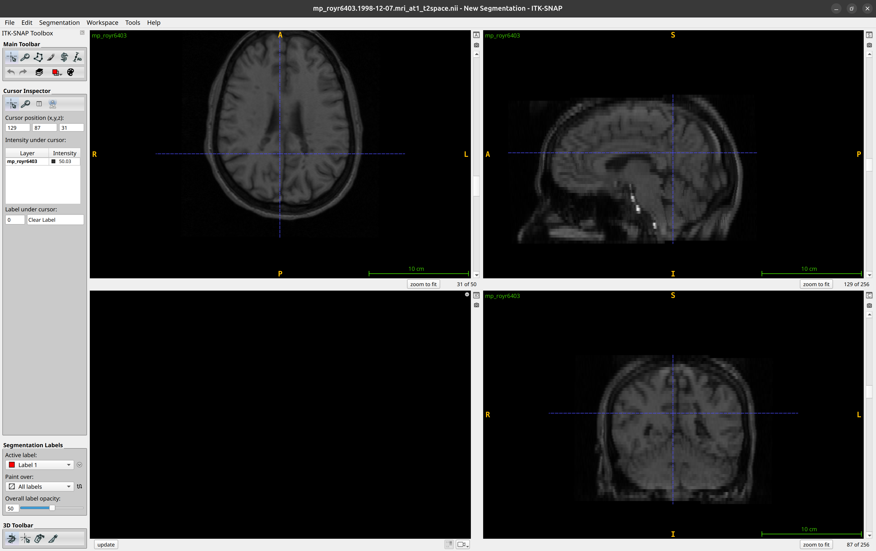
T2 Space diagram
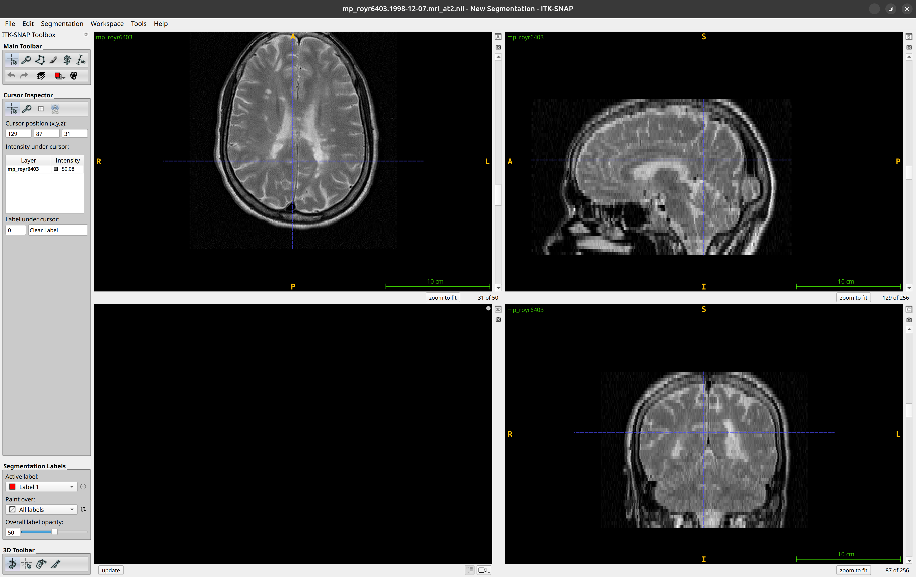
A2 Space

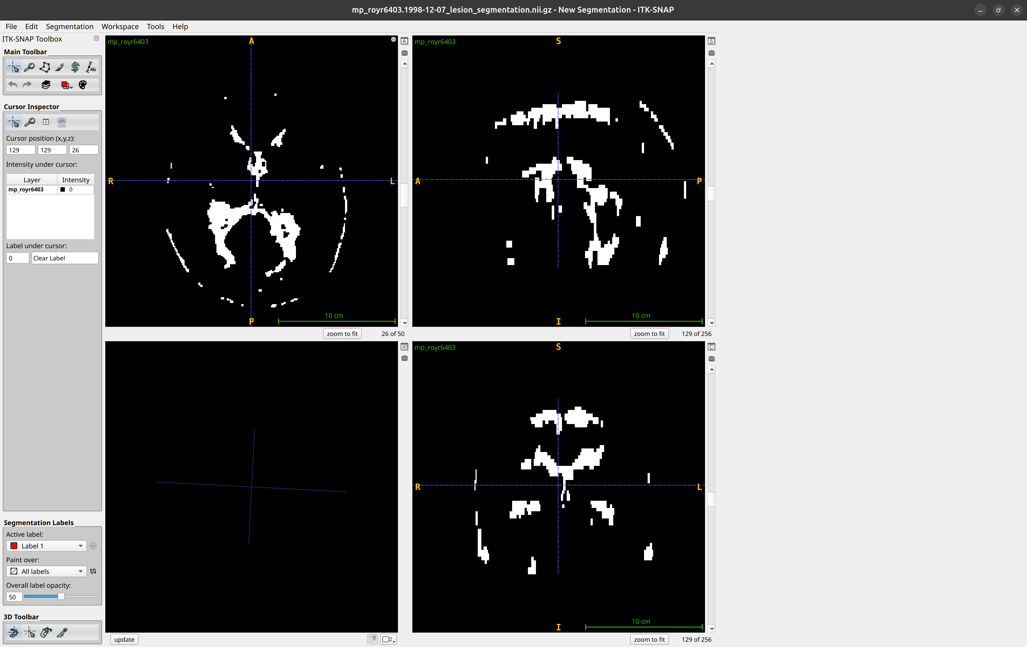
Segmentation with MRF_LAMBDA = 1000.0, MRF_ITERATIONS = 100, BRAIN_THRESHOLD = 0.02

