**NAME-ANKUR KUMAR**

**REG NO-16BIT0086**

**COLLEGE-VIT VELLORE**

**COURSE TAKEN-JAVA & DATA STRUCTURE AND ALGORITHMS**

**CODING NINJAS**

**CODE:**

**package** intern;

**import** java.util.*;

**public** **class** test {

**public** **static** **void** main(String[] args) {

Scanner sc = **new** Scanner(System.***in***);

**int** n = Integer.*valueOf*(sc.nextLine());

PriorityQueue<Event> epq = **new** PriorityQueue<Event>(**new** EventComparator());

String input;

**for**(**int** i = 0; i< n; i++){

input = sc.nextLine();

**if**(input.equals("SERVED")){

epq.poll();

}**else**{

String[] arr = input.split(" ");

**if**(arr[0].equals("ENTER"))

epq.add(**new** Event(arr[1], Double.*valueOf*(arr[2]), Integer.*valueOf*(arr[3])));

}

}

**while**(!epq.isEmpty()){

System.***out***.println(epq.poll().name);

}

}

}

**class** EventComparator **implements** Comparator<Event>{

**public** **int** compare(Event e1, Event e2){

**if**(e1.cgpa < e2.cgpa){

**return** 1;

}**else** **if**(e1.cgpa > e2.cgpa){

**return** -1;

}**else** **if**(!e1.name.equals(e2.name)){

**return** e1.name.compareTo(e2.name);

}**else**{

**return** e1.token-e2.token;

}

}

}

**class** Event{

**public** String name;

**public** **double** cgpa;

**public** **int** token;

**public** Event(String name, **double** cgpa, **int** token){

**this**.name = name;

**this**.cgpa = cgpa;

**this**.token = token;

}

}

**Output:**

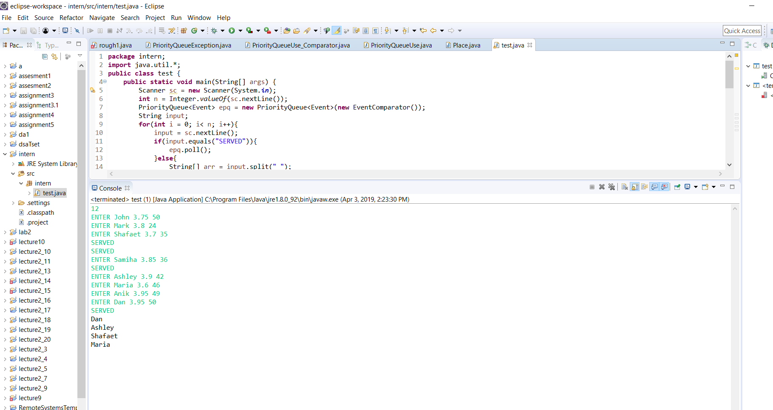

**Thanking you in advance**