Why ?
Testers setp failure/envi failure code runs in my machine scenarios
Containers every thingh necessary for that code to run is packaged you can run from there no setup required on the user end .
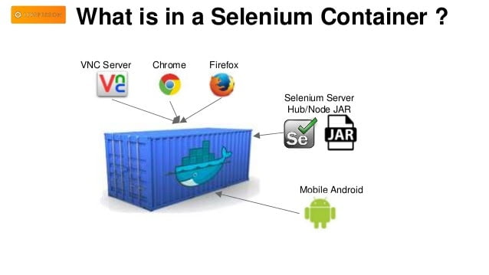 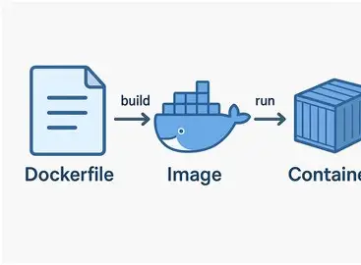
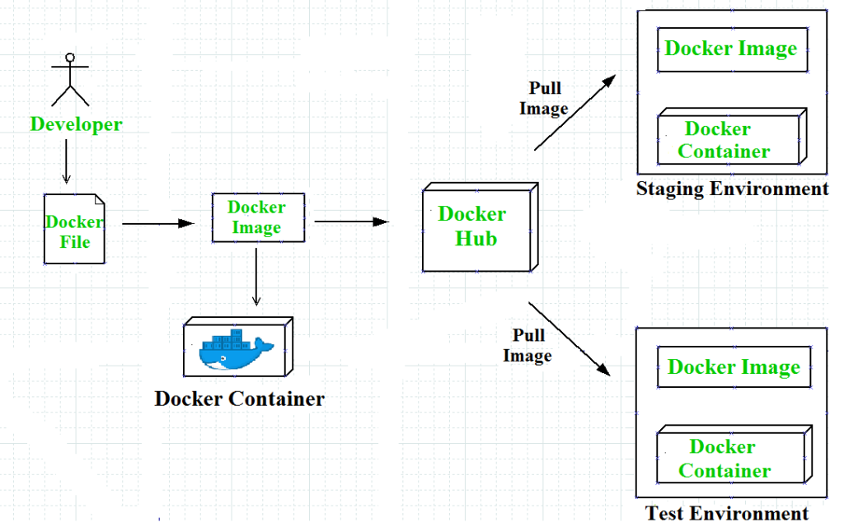

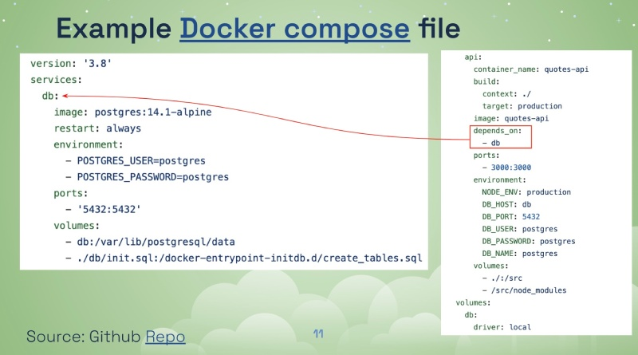
1. Basic Definitions
Docker
Docker is a platform/tool used to build, run, and manage containers.

Image
A Docker image is a read-only template that contains:
- Application code
- Dependencies
- Runtime
Think: Blueprint

Container
A container is a running instance of an image.
Think: Live application
What is a Container?
A container is a lightweight, portable unit that includes:
- Application code
- Runtime (Java, Node, etc.)
- Libraries & dependencies
hink of it as:
“A ready-to-run box that works anywhere”
Why Selenium + Docker?
- Avoid “It works on my system” issues
- Run tests in different browsers quickly
- Easy parallel execution (Grid setup)
- No manual environment setup
Install Java → Install browser → Install driver → Configure → Run test

Write Selenium Code
↓
Create Dockerfile
↓
Build Image
↓
Run Container
↓
Execute Tests
↓
View Output
↓
End
Step 1: Simple Selenium Test (Java)
Java
import org.openqa.selenium.WebDriver;
import org.openqa.selenium.chrome.ChromeDriver;

public class TestDemo {
public static void main(String[] args) {
WebDriver driver = new ChromeDriver();
driver.get("https://www.google.com");
System.out.println(driver.getTitle());
driver.quit();
}
}
Show more lines

Step 2: Dockerfile
Dockerfile
FROM openjdk:11

WORKDIR /app

COPY . /app

RUN apt-get update && apt-get install -y maven

RUN mvn clean install

CMD ["mvn", "test"]
Show more lines

Step 3: Build Docker Image
Shell
docker build -t selenium-test .
Show more lines

Step 4: Run Container
Shell
docker run selenium-test
Show more lines

6. Advanced Selenium Docker Example (Important for Real-Time)
Using Selenium Chrome Container
Shell
docker run -d -p 4444:4444 selenium/standalone-chrome
Show more lines

Remote WebDriver Code
Java
import java.net.URL;
import org.openqa.selenium.WebDriver;
import org.openqa.selenium.remote.RemoteWebDriver;
import org.openqa.selenium.chrome.ChromeOptions;

public class DockerTest {
public static void main(String[] args) throws Exception {

ChromeOptions options = new ChromeOptions();

WebDriver driver = new RemoteWebDriver(
new URL("http://localhost:4444/wd/hub"),
options
);

driver.get("https://www.google.com");
System.out.println(driver.getTitle());

driver.quit();
}
}
Show more lines

Simple Relationship
Docker → creates → Image → runs → Container

2. Complete End-to-End Flow
Write Application
↓
Create Dockerfile
↓
Build Docker Image
↓
Run Image using docker run
↓
Container is created
↓
Application runs inside container

3. Visual Explanation
[ Application Code ]
↓
[ Dockerfile ]
↓
[ Docker Image ] (Template)
↓
docker run
↓
[ Container ] (Running App)

4. Step-by-Step Algorithm
Step 1: Write application (Java/Selenium)
Step 2: Create Dockerfile
Step 3: Build image using docker build
Step 4: Store image locally / Docker Hub
Step 5: Run image using docker run
Step 6: Docker creates container
Step 7: Add writable layer
Step 8: Allocate resources (CPU, RAM)
Step 9: Execute application
Step 10: Container runs and gives output

5. Dockerfile Creation
Example Dockerfile:
FROM openjdk:11

WORKDIR /app

COPY . /app

RUN apt-get update && apt-get install -y maven

RUN mvn clean install

CMD ["mvn", "test"]

6. Build Image Command
docker build -t myapp .
Output:
- Creates an image named myapp

7. What is docker run?
Definition:
docker run is used to create and start a container from an image

8. docker run Internal Working
Step 1: Check image locally
Step 2: Pull from Docker Hub (if missing)
Step 3: Create container
Step 4: Add writable layer
Step 5: Allocate resources
Step 6: Run default command
Step 7: Start container

9. docker run Command Examples
Basic
docker run nginx

Run in background
docker run -d nginx

Port mapping
docker run -p 8080:80 nginx

Named container
docker run --name mycontainer nginx

10. Image → Container (Core Concept)
When you run:
docker run nginx
What happens?
- Image = template
- Docker adds writable layer
- Creates container
- Starts application

Diagram
Image (read-only)
↓
+ Writable Layer
↓
Container (running)

11. Selenium + Docker Flow
Start Docker Selenium container
↓
Run Selenium test
↓
RemoteWebDriver sends request
↓
Browser runs inside container
↓
Result returned

12. Start Selenium Docker Container
docker run -d -p 4444:4444 selenium/standalone-chrome
Opens Selenium Grid at:
http://localhost:4444

13. Modify Selenium Code (Important)
❌ Before (Local)
WebDriver driver = new ChromeDriver();

After (Docker)
import java.net.URL;
import org.openqa.selenium.WebDriver;
import org.openqa.selenium.remote.RemoteWebDriver;
import org.openqa.selenium.chrome.ChromeOptions;

public class DockerTest {

public static void main(String[] args) throws Exception {

ChromeOptions options = new ChromeOptions();

WebDriver driver = new RemoteWebDriver(
new URL("http://localhost:4444/wd/hub"),
options
);

driver.get("https://www.google.com");
System.out.println(driver.getTitle());

driver.quit();
}
}

14. Complete Real-Time Workflow
Write Selenium Script
↓
Create Dockerfile (optional)
↓
Start Selenium Docker Container
↓
Connect via RemoteWebDriver
↓
Execute Test
↓
Browser runs inside container
↓
View results

15. Real-Time Example Commands
# Pull image (optional)
docker pull selenium/standalone-chrome

# Run container
docker run -d -p 4444:4444 selenium/standalone-chrome

# Check running containers
docker ps

# Stop container
docker stop <container_id>

# Remove container
docker rm <container_id>

16. Key Differences Summary
Concept | Meaning
Docker | Tool/platform
Image | Template
Container | Running instance
docker run | Creates container

17. Real-Time Analogy (Teach This)
Food Example
Concept | Example
Docker | Kitchen
Image | Recipe
Container | Cooked food

18. Common Mistakes
- Forgetting port mapping
- Using ChromeDriver instead of RemoteWebDriver
- Container not running
- Wrong Grid URL

19. Practice Tasks (For Students)
Task 1
docker run -d -p 4444:4444 selenium/standalone-firefox

Task 2
- Modify local Selenium test → Docker execution

Task 3
docker run nginx
Observe container behavior

20. Final Summary
- Docker = Platform
- Image = Blueprint
- Container = Running app
- docker run = Creates container
- Selenium Docker = Run tests without local browser

Final Interview Answer
“Docker is a platform that uses images (templates) to create containers, and a container is a running instance of that image. The docker run command is used to create and start containers, and in Selenium, Docker helps execute tests in isolated environments using RemoteWebDriver.”

End session by asking:
“What happens if we run the same image 5 times?”
Answer: 5 containers will be created

