A Report
on
Project Based Learning
on
Title: Security Monitoring Tool (SSH Brute-Force Detection on Ubuntu)
Submitted by
Ankur Mondal

Table of Contents
1. Problem Statement 3
2. Abstract 3
3. Introduction 3
4. Objective(s) 3
5. Methodology 4
Step 1: Environment Setup 4
Step 2: Project Structure 4
Step 3: Data Collection (Log Source) 4
Step 4: Monitoring Script 5
Step 5: Dashboard 6
Step 6: Firewall Configuration 7
Step 7: Attack Simulation 7
Step 8: Incident Response 7
Step 9: Automation with Cron 8
Step 10: Demonstration Order 9
Step 11: Troubleshooting 9
6. Results and Discussion 9
Output screenshots, graphs, or tables 9
Observations 14
Interpretation of Results 14
7. Learning Outcomes 14
8. Conclusion 14
9. References 15

1. Problem Statement
Servers that accept remote logins over SSH are constantly targeted by automated bots that guess usernames and passwords. These failed attempts are recorded in system logs, but on a busy system nobody reads the logs line by line, so an attack can go unnoticed until an account is compromised. The challenge is to build a lightweight security monitoring tool for Ubuntu Linux that reads the authentication logs, detects repeated failed logins, raises an alert once a threshold is crossed, identifies the source of the attack, and presents the result in a form that an administrator can understand quickly.

2. Abstract
This project implements a mini security monitoring system (a small SIEM) on Ubuntu Linux for detecting SSH brute-force attacks. A Bash script, monitoring.sh, collects data from the system authentication logs and produces a nine-section security report covering failed logins, the top attacking IP addresses, logged-in users, recent logins, open ports, sudo usage, world-writable files in /etc, accounts with UID 0 and firewall status. An alert is raised when the number of failed password attempts exceeds a threshold of five. A Python web dashboard (Ubuntu Sentry) running on port 8080 shows the live threat level as a colour-coded banner, a radar of attacking addresses, a bar chart of failed logins per five minutes, the usernames being guessed, system load, memory and disk usage, and basic security checks. The UFW firewall is enabled to protect the host, and cron is used to run the script automatically every five minutes. The attack was simulated by repeatedly logging in over SSH with wrong credentials, and the tool correctly detected the attempts, changed the alert state, and recorded the source IP addresses.

3. Introduction
Log monitoring is a core task of Linux system administration and a basic building block of Security Information and Event Management (SIEM) systems. On Ubuntu, the SSH service writes every authentication event to the system log, either to /var/log/auth.log or, on newer releases, to the systemd journal. A message such as "Failed password for invalid user" followed by the source IP address is the typical signature of a brute-force attempt.
By automatically counting these events, grouping them by source address and username, and comparing them to a threshold, an administrator can detect attacks early and respond, for example by blocking the offending IP address in the firewall. This project builds such a tool using only standard Linux utilities (grep, awk, sort, uniq, journalctl, ss, ufw, cron) and a small Python script for visualisation, so it can be understood and reproduced easily on any Ubuntu machine.

4. Objective(s)
- To analyse SSH authentication logs and extract failed login attempts
- To identify the IP addresses and usernames involved in repeated login failures
- To raise an automatic alert when failed logins cross a defined threshold
- To build a live web dashboard that visualises the threat level
- To harden the system using a firewall and respond to an attacker like a real administrator
- To automate periodic monitoring using cron

5. Methodology

Step 1: Environment Setup
The project was built on an Ubuntu virtual machine (host name ubuntu, IP address 10.0.2.15). The host name was set with hostnamectl and the package index was updated. The required tools were then installed and the SSH service was enabled so that it starts automatically.
sudo hostnamectl set-hostname ubuntu
sudo apt update
sudo apt install -y openssh-server net-tools ufw python3 nano
sudo systemctl enable --now ssh
sudo systemctl status ssh
The status command showed the ssh.service as active (running), confirming that the SSH server was ready to accept and log login attempts.

Step 2: Project Structure
A project folder was created to hold the script, the dashboard and the generated reports.
mkdir -p ~/monitoring/logs
cd ~/monitoring
The final folder contains three items: monitoring.sh (the monitoring script), dashboard.py (the web dashboard) and logs (the folder where every report is saved).
The two project files, monitoring.sh and dashboard.py, were then copied into ~/monitoring/. The script was made executable and the dashboard was checked for syntax errors without running it.
chmod +x monitoring.sh
python3 -m py_compile dashboard.py && echo OK
The word OK is printed only when dashboard.py has no syntax errors, so it is safe to start.

Step 3: Data Collection (Log Source)
The script reads the authentication log through a function named getlog. If /var/log/auth.log exists, it is read directly; otherwise the script falls back to the systemd journal and filters the entries written by sshd, sshd-session and sudo. This makes the tool work on both older and newer Ubuntu releases. On the test machine the entries were read from the journal, where each failure appears as "Failed password for invalid user ... from 127.0.0.1 port ... ssh2".
Detection is done with regular expressions that match three kinds of log lines: "Failed password" (failed logins), "Accepted" (successful logins) and "sudo ... COMMAND=" (administrative commands). Every source address is then classified with Python's ipaddress module: loopback addresses are labelled Local, private and link-local ranges are labelled Private, and everything else is labelled Public.

Step 4: Monitoring Script
The script monitoring.sh gathers the log once, then writes a timestamped report into the logs folder. The core of the script is shown below.
#!/bin/bash
# Security Monitoring Tool - Ubuntu
LOGDIR=~/monitoring/logs
mkdir -p "$LOGDIR"
REPORT="$LOGDIR/report_$(date +%F_%H-%M).txt"
THRESHOLD=5

getlog() {
if [ -f /var/log/auth.log ]; then
sudo cat /var/log/auth.log
else
sudo journalctl -t sshd -t sshd-session -t sudo --no-pager
fi
}
LOG=$(getlog)

{
echo "===== SECURITY REPORT: $(hostname) - $(date) ====="
echo -e "\n[1] Failed login attempts (last 10)"
echo "$LOG" | grep "Failed password" | tail -10
echo -e "\n[2] Top IPs with failed logins"
echo "$LOG" | grep "Failed password" | awk '{print $(NF-3)}' | sort | uniq -c | sort -nr | head -5
echo -e "\n[3] Currently logged-in users"; who
echo -e "\n[4] Recent logins"; last -n 5
echo -e "\n[5] Open listening ports"; ss -tulnp
echo -e "\n[6] Recent sudo usage"
echo "$LOG" | grep "sudo:" | grep "COMMAND" | tail -5
echo -e "\n[7] World-writable files in /etc (risky)"
sudo find /etc -xdev -type f -perm -0002 2>/dev/null
echo -e "\n[8] Users with UID 0 (should only be root)"
awk -F: '$3==0 {print $1}' /etc/passwd
echo -e "\n[9] Firewall status"; sudo ufw status
} > "$REPORT"

COUNT=$(echo "$LOG" | grep -c "Failed password")
if [ "$COUNT" -gt "$THRESHOLD" ]; then
echo "ALERT: $COUNT failed login attempts detected!" | tee -a "$REPORT"
else
echo "OK: $COUNT failed login attempts. No alert." | tee -a "$REPORT"
fi
echo "Report saved: $REPORT"
The script was made executable with chmod +x monitoring.sh. The nine report sections are: failed login attempts, top attacking IPs, logged-in users, recent logins, open listening ports, recent sudo usage, world-writable files in /etc, users with UID 0 and firewall status. The alert rule is simple: if the total number of failed password attempts is greater than the threshold of 5, an ALERT is printed; otherwise an OK message is shown.
Running the script and viewing the report
cd ~/monitoring
./monitoring.sh
Every run ends with one of two messages: "OK: 0 failed login attempts. No alert." when nothing was found, or "ALERT: N failed login attempts detected!" when the count crosses the threshold. The newest saved report can be displayed at any time with the command below.
cat "$(ls -t ~/monitoring/logs/report_*.txt | head -1)"

Step 5: Dashboard
The Python program dashboard.py (named Ubuntu Sentry) runs a small web server on port 8080 and reads the same authentication log. It needs sudo to read the log. It refreshes every 5 seconds and shows:
- A colour-coded banner (green for no threats, amber or red when failed logins are detected)
- The number of failed logins in the last 10 minutes, the last hour and in the whole log
- A radar in which every attacking IP is a blip; the closer to the centre, the more attempts
- A bar chart of failed logins per five minutes over the last hour
- A list of the addresses failed logins come from and the usernames being guessed
- System load, memory and disk usage, and simple security checks such as "Only root has UID 0"
cd ~/monitoring
sudo python3 dashboard.py
# open http://localhost:8080 in the browser
The dashboard page refreshes itself every 5 seconds. It is served by a small Python http.server that returns one HTML page and a JSON endpoint (/api/…) that the page reads. Sudo is needed so that the program can read /var/log/auth.log and see which program owns each open port. The behaviour can be changed with three optional command-line options.
Table 1: Dashboard command-line options
Option | Description
--port 9000 | Change the port (default 8080)
--host 0.0.0.0 | Allow other devices on the network to open the dashboard
--log FILE | Read a different log file (useful for testing)

The colour of the banner tells the administrator the current threat level at a glance.
Table 2: Dashboard status levels
Banner | Meaning
Green: No threats detected | No recent failed logins
Amber: Suspicious activity | 1 to 5 failed logins in 10 minutes, or a failed critical system check
Red: THREAT DETECTED | More than 5 failed logins in 10 minutes (names the top source IP)

Step 6: Firewall Configuration
The Uncomplicated Firewall (UFW) was enabled with SSH allowed, so that legitimate remote access still works while all other incoming connections are blocked by default.
sudo ufw allow ssh
sudo ufw enable
sudo ufw status
The status showed Status: active with the rules 22/tcp ALLOW Anywhere and 22/tcp (v6) ALLOW Anywhere (v6).

Step 7: Attack Simulation
To test the tool, failed logins were generated by connecting to the machine over SSH with a user that does not exist and entering wrong passwords repeatedly. The attempts were made both from the local machine and using the VM address 10.0.2.15. Only the project's own machine was used for testing.
ssh fakeuser@localhost
ssh fakeuser@10.0.2.15
Attack test (wrong passwords)
In a second terminal, ssh fakeuser@localhost was run and a wrong password was entered at least 6 times, reconnecting each time. Within about 5 seconds the dashboard banner turned red, the attacker IP table filled in and a blip appeared on the radar. When the attack is made against localhost the address is shown as 127.0.0.1 (Local); to see a LAN address, the attack is made against the server IP shown in the dashboard header.
ssh fakeuser@192.168.x.x
Real login test (correct password)
A normal login with the correct password was also tested. The dashboard showed a Login event, a Sudo event and the user under Logged-in users. The session was closed with exit.
ssh YOUR_USERNAME@localhost
sudo ls /etc
exit
Confirmation with the script
Running ./monitoring.sh again confirmed the attack: the expected output is "ALERT: 6 failed login attempts detected!" or a higher number.

Step 8: Incident Response
After an alert, the administrator reads the report, finds the attacker's IP in the Top IPs section, and blocks it in the firewall. Blocking the loopback address 127.0.0.1 must be avoided because it is the machine itself; this step is meaningful only for an external address.
sudo ufw deny from ATTACKER_IP
sudo ufw status

Step 9: Automation with Cron
The script was scheduled in the root crontab to run every five minutes, so that a new report is generated automatically without manual effort.
sudo crontab -e
*/5 * * * * /home/ubuntu/monitoring/monitoring.sh
sudo crontab -l

In the crontab line, YOUR_USERNAME is replaced with the real user name, and the entry is verified afterwards with sudo crontab -l.

Step 10: Demonstration Order
For the live demonstration the tool is shown in the following order:
1. hostname shows ubuntu.
2. ./monitoring.sh prints the nine-section report.
3. sudo python3 dashboard.py is started and the browser shows the green banner.
4. ssh fakeuser@localhost with wrong passwords turns the dashboard red with the attacker IP and radar blip.
5. ssh YOUR_USERNAME@localhost with the correct password shows the Login event.
6. ./monitoring.sh is run again and shows the ALERT.
7. sudo crontab -l shows the automation, and ls ~/monitoring/logs shows the saved reports.

Step 11: Troubleshooting
The problems met most often during setup and testing, together with their fixes, are listed below.
Table 3: Troubleshooting guide
Problem | Fix
Permission denied running the script | chmod +x monitoring.sh
Dashboard stays green after attacks | sudo tail /var/log/auth.log to confirm that failures are logged
SSH connection refused | sudo systemctl enable --now ssh
Dashboard says it cannot read the log | Start it with sudo
No Login row after a real login | sudo tail /var/log/auth.log | grep Accepted, and check grep PasswordAuthentication /etc/ssh/sshd_config
Port 8080 already in use | sudo python3 dashboard.py --port 9000

6. Results and Discussion

Output screenshots, graphs, or tables
The results are shown through terminal outputs and the dashboard.
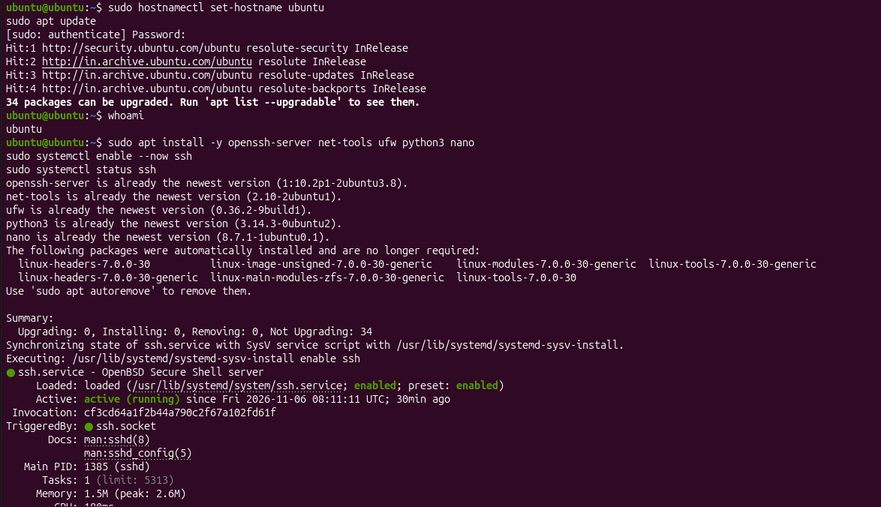
Fig 1: Host name, package installation and SSH service
The host name was set to ubuntu and whoami confirmed the user ubuntu. The apt update step reached the Ubuntu repositories and reported 34 upgradable packages. openssh-server, net-tools, ufw, python3 and nano were all already the newest version, and ssh.service was enabled and active (running).
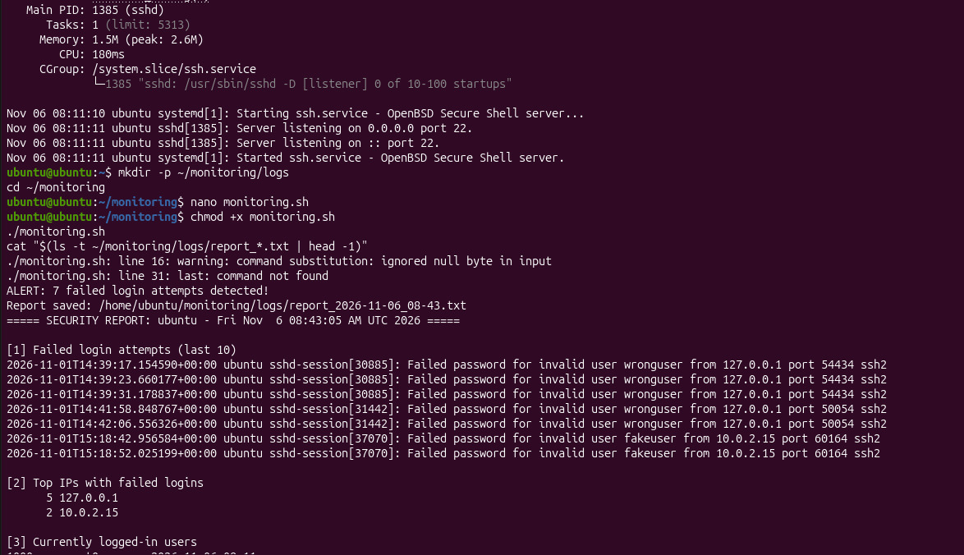
Fig 2: Project folder and first run of the monitoring script
The journal shows sshd listening on port 22 for both IPv4 and IPv6. The monitoring folder and logs folder were created, monitoring.sh was made executable with chmod +x and then run. It printed "ALERT: 7 failed login attempts detected!" and saved the report under the logs folder. Section 1 of the report lists the failed passwords for wronguser from 127.0.0.1 and fakeuser from 10.0.2.15, and section 2 counts 5 attempts from 127.0.0.1 and 2 from 10.0.2.15. The script also printed "last: command not found", which only affects the recent logins section.
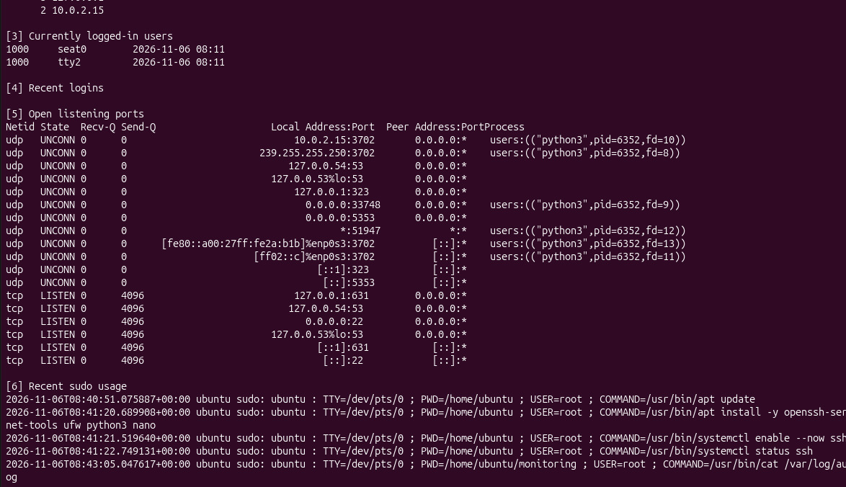
Fig 3: Report sections for logged-in users, open ports and sudo usage
Section 3 lists the logged-in sessions, section 5 lists the listening ports with SSH on port 22 for both IPv4 and IPv6, and section 6 lists recent sudo commands such as apt update, apt install, systemctl enable --now ssh and systemctl status ssh. These sections show what the machine is exposing and which administrative commands were run.
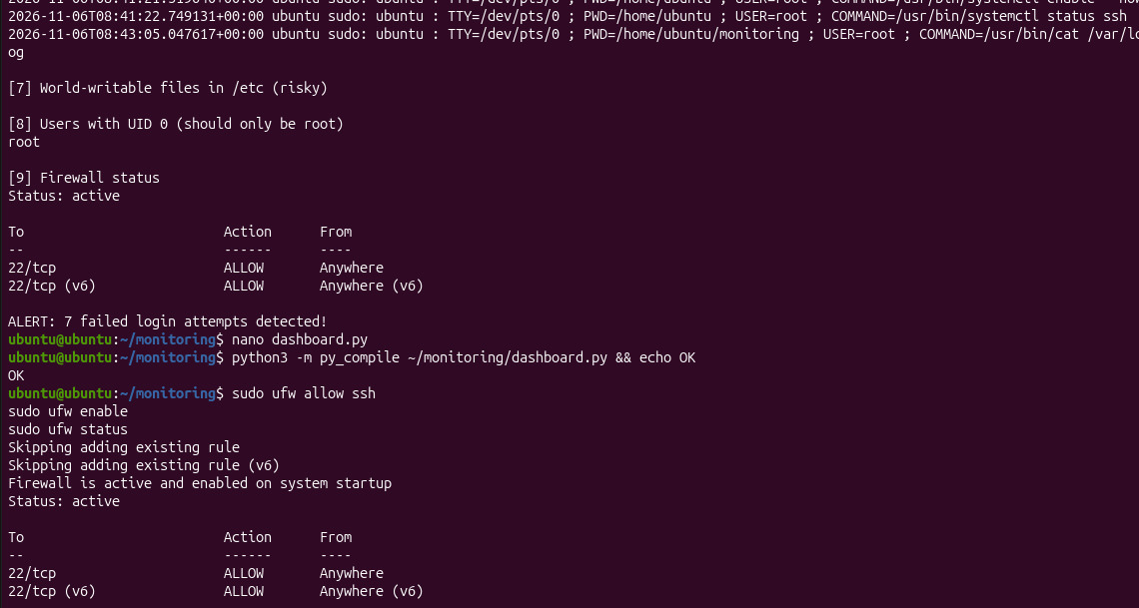
Fig 4: Security checks and ALERT at the end of the report
No world-writable files were found in /etc and root was the only user with UID 0. The firewall section shows Status: active with 22/tcp allowed for IPv4 and IPv6. The report ends with "ALERT: 7 failed login attempts detected!" because 7 is above the threshold of 5. The dashboard.py file was then checked with py_compile, which printed OK.
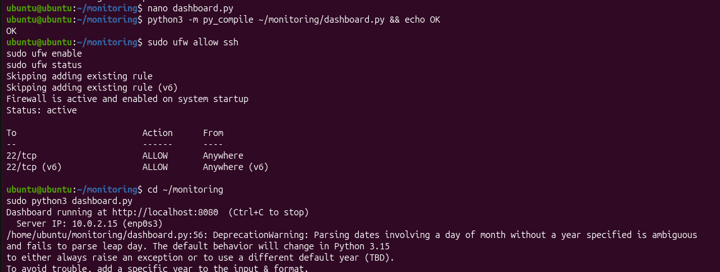
Fig 5: Enabling the firewall and starting the dashboard
sudo ufw allow ssh skipped the rules that already existed, and the firewall was reported active and enabled on system startup. Running sudo python3 dashboard.py printed "Dashboard running at http://localhost:8080" and the detected server IP address 10.0.2.15 on interface enp0s3. The date-parsing DeprecationWarning is only a Python notice and does not stop the dashboard from working.
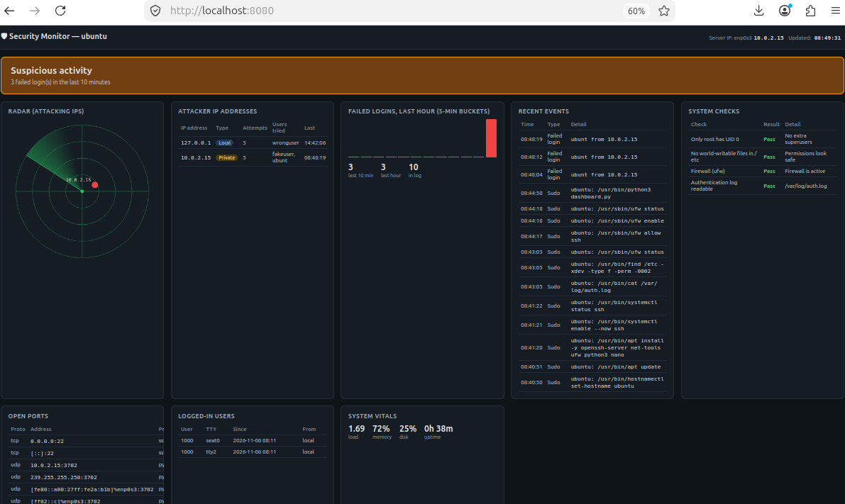
Fig 6: Security Monitor dashboard with IP address detection
The dashboard at http://localhost:8080 showed an amber "Suspicious activity" banner with 3 failed logins in the last 10 minutes and 10 in the log. The attacker IP table lists 127.0.0.1 (Local) and 10.0.2.15 (Private) with their attempt counts and usernames, and 10.0.2.15 appears as a labelled blip on the radar. All four system checks passed, and the system vitals showed a load of 1.69, 72% memory and 25% disk use. This screenshot was taken after further wrong-password attempts, so its counts are higher than in the script report.
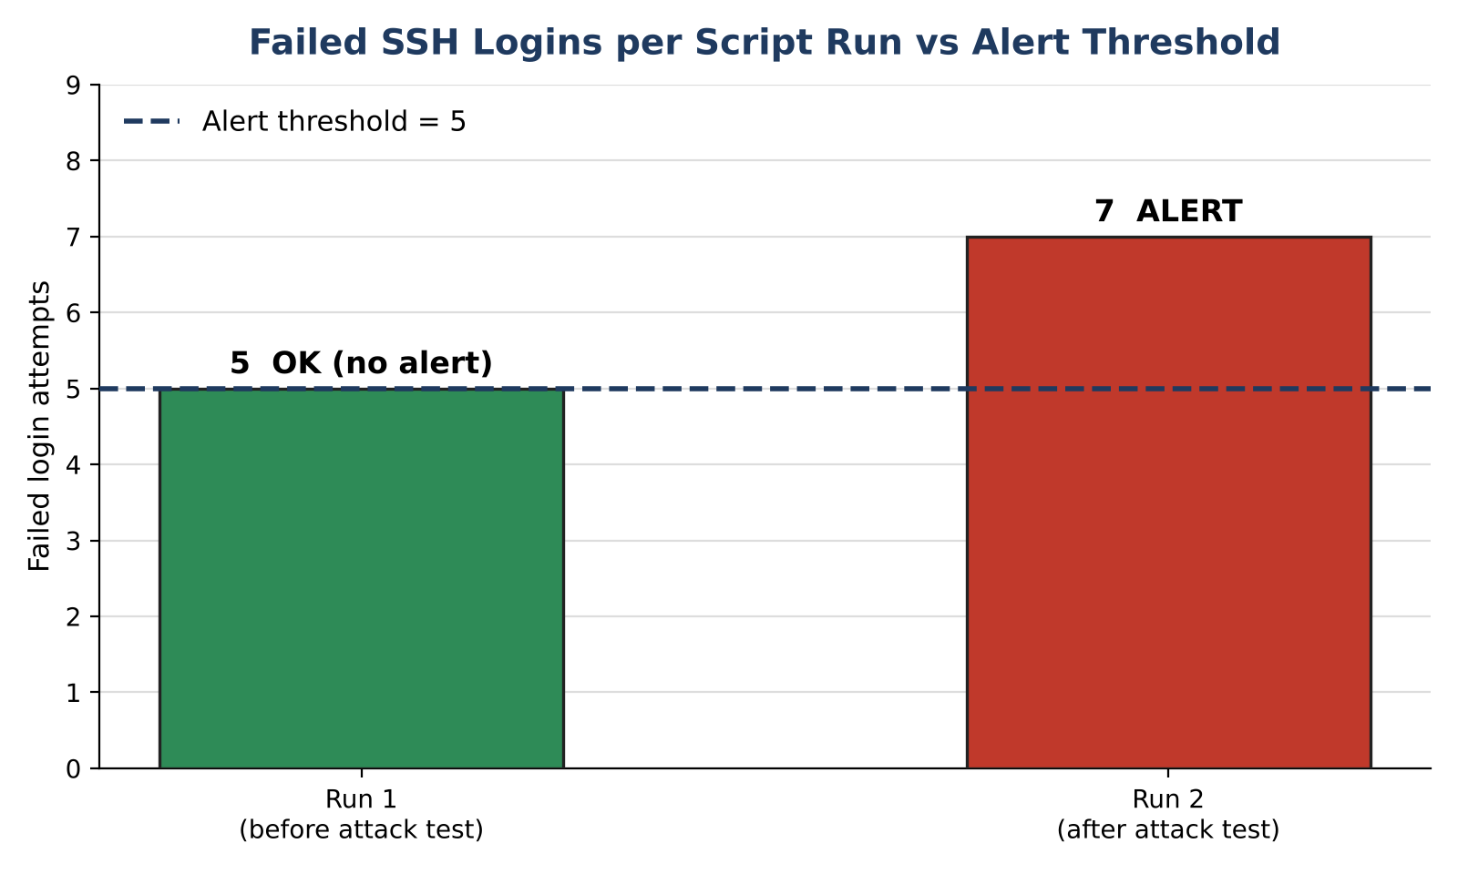
Fig 7: Bar chart - failed logins per script run
The bar chart compares the two script runs with the alert threshold of 5. Run 1 found 5 failed logins, which is not above the threshold, so no alert was raised. After the further attack test, Run 2 found 7, which crossed the threshold and produced the ALERT.
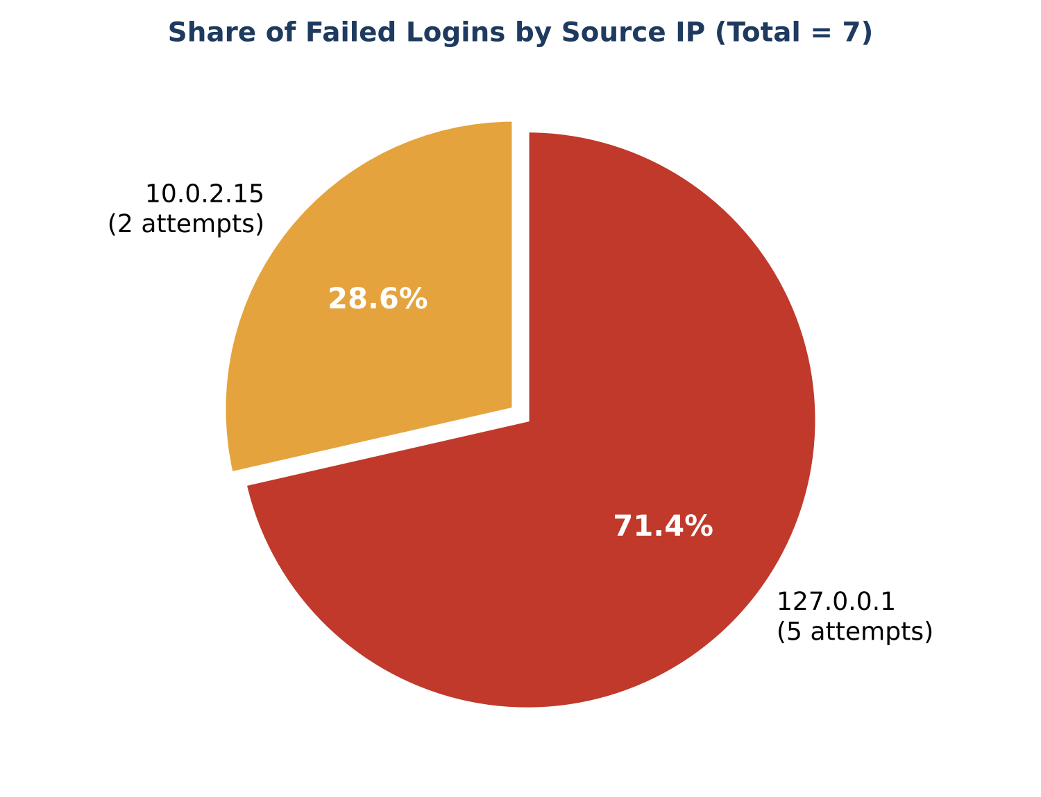
Fig 8: Pie chart - failed logins by source IP address
Of the 7 failed logins, 5 (71.4%) came from 127.0.0.1 and 2 (28.6%) from 10.0.2.15, matching the "Where failed logins come from" panel of the dashboard.
Table 4: Summary of detected failed logins
Source address | Failed attempts | Username guessed
127.0.0.1 | 5 | wronguser
10.0.2.15 | 2 | fakeuser
Total | 7 | -

Observations
The tool detected every failed SSH login that was written to the log and counted them correctly: the total of 7 in the script output matches the 5 + 2 shown on the dashboard. The attack was grouped by source address, so the repeated guessing from one address is immediately visible, and the usernames being tried (wronguser, fakeuser) were listed. The alert changed from OK to ALERT only after the count went above the threshold. The bar chart showed bursts of failures at the times the tests were performed. It was also observed that the line in the script that runs the last command printed "last: command not found" on the test system, which means the Recent logins section could not be filled; the rest of the report and the alert logic were not affected.

Interpretation of Results
The results show that simple command-line tools are enough to build an effective early-warning system for SSH brute-force attacks. A threshold-based rule is easy to understand and works well for a demonstration, although in a real deployment the threshold should be applied per source address and per time window to avoid false alarms from a single user mistyping a password. Combining the text report with the live dashboard gives both a permanent record (the saved reports) and an at-a-glance view for the administrator. The firewall and the cron job complete the loop of detection, response and automation. Limitations of the current version are that it only monitors SSH, it reads the log on every run instead of streaming it, and it does not block attackers automatically.

7. Learning Outcomes
- Understanding of Linux authentication logs and the systemd journal
- Practical use of grep, awk, sort, uniq, ss and journalctl for log analysis
- Writing and running Bash scripts with functions, conditions and file output
- Configuring SSH and the UFW firewall on Ubuntu
- Scheduling automated tasks with cron
- Building a simple web dashboard using Python
- Understanding how brute-force attacks are detected and handled in real systems

8. Conclusion
The project successfully demonstrates a working security monitoring tool on Ubuntu Linux. It detects SSH brute-force attempts, identifies the source addresses and usernames, raises an alert above a threshold, and presents the information through both a saved report and a live dashboard. The tool can be improved by adding automatic blocking of repeated offenders with fail2ban or UFW rules, e-mail or messaging notifications, monitoring of additional services, and storing events in a database for long-term analysis. The project highlights the importance of continuous log monitoring in keeping Linux servers secure.

9. References
- Ubuntu Documentation. OpenSSH Server. https://ubuntu.com/server/docs
- Ubuntu Documentation. Uncomplicated Firewall (UFW). https://help.ubuntu.com/community/UFW
- The Linux man-pages: journalctl(1), ss(8), crontab(5), grep(1), awk(1).
- OpenBSD. OpenSSH manual pages: sshd(8), sshd_config(5). https://www.openssh.com/
- Python Software Foundation. Python 3 Documentation. https://docs.python.org/3/
- Nemeth, E., Snyder, G., Hein, T., Whaley, B., & Mackin, D. UNIX and Linux System Administration Handbook. Pearson.
- GNU Bash Reference Manual. https://www.gnu.org/software/bash/manual/

