Step 1. Download MobaXterm_Personal_21.2 software in PC.
Step 2. Open Mobaxterm
Step 3. Click on new session
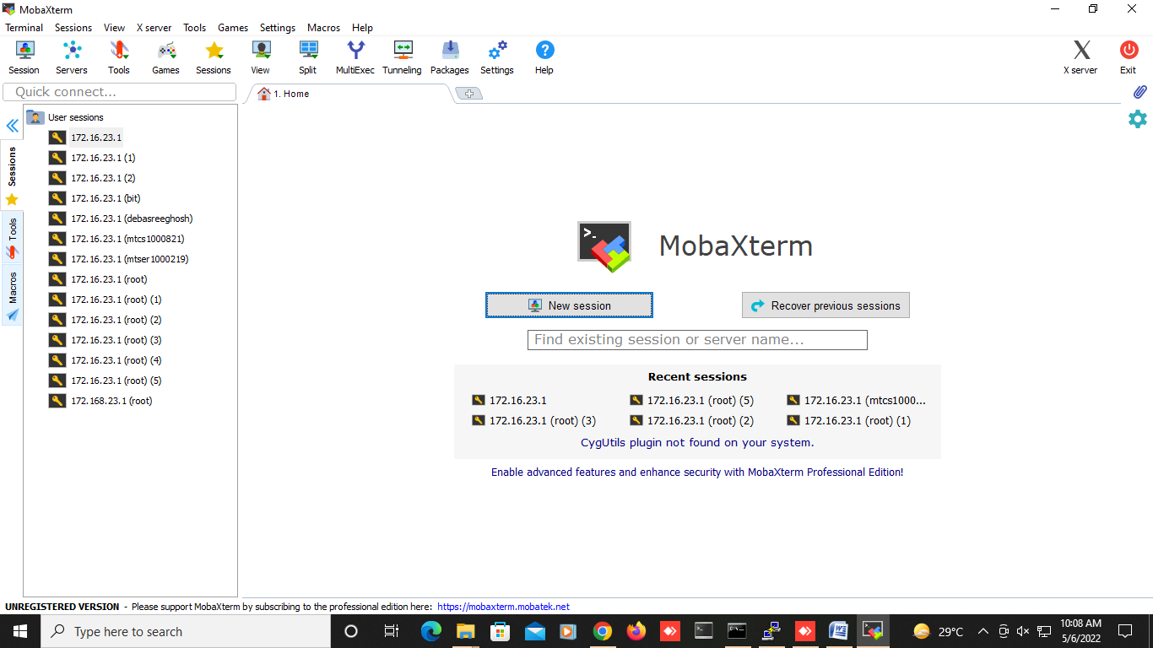
Step 4. Enter the IP of the Master node and user name.

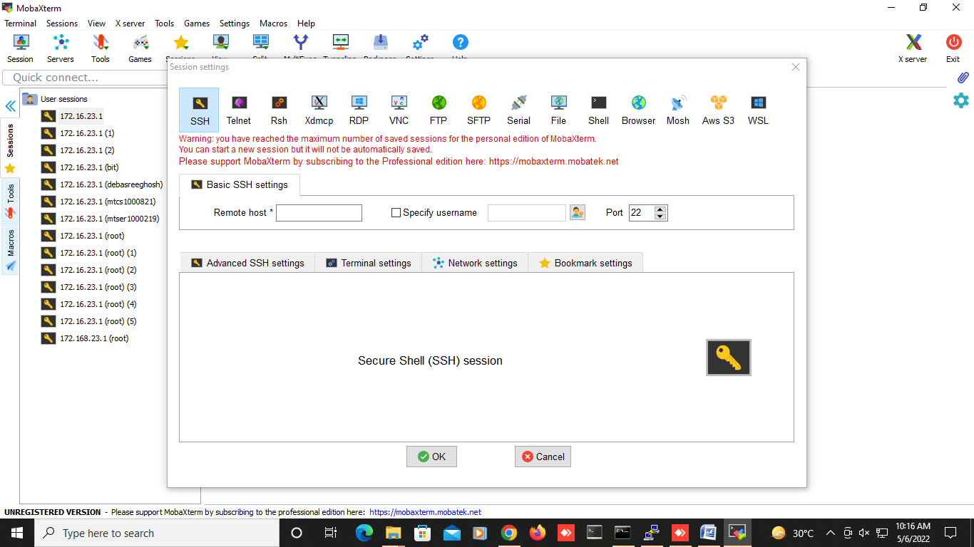
Put ip here(172.16.220.100)
Put your user name
Check it
Step 5. Click ok.
Step 6. Enter your password and press Enter.(default password is : password)
command | description | Usage | Effect
qsub | Submit a job | qsub myjob | Submits the job "myjob" for the execution.
qstat | Show status of batch jobs | qstat -u bellj  qstat -a | Show the status of all the jobs submitted by the user bellj (Jason Bell).  Display all jobs in alternative format
qdel | Delete a job | qdel 3221.pbsserver | Deletes the job with job id 3221.
qhold | Place a hold on a job to keep it from being scheduled for running | qhold 54.pbsserver | Puts the user hold on job 54.
qrls | Remove a hold from a job | qrls -h u 54.pbsserver | Releases the user type hold from the job 54.

Submitting a serial Job:

[hpcmpcl@RACHEL~]# vim submit.sh
#!/bin/bash
#These commands set up the Grid Environment for your job:
#PBS -N ExampleJob
#PBS -l select=1,
#PBS -q select queue (i.e. run, short,long)
#print the time and date
date
#wait 10 seconds
sleep 10
#print the time and date again
Date

Submitting Parallel Job

#!/bin/bash
#PBS -N "Job Name"
#PBS -q workq
#PBS -o $PBS_JOBID.out
#PBS -e $PBS_JOBID.err
#PBS -l select=2:ncpus=32
#PBS -S /bin/bash -V
#print the time and date
date
#wait 10 seconds
sleep 10
#print the time and date again
Date

Name of CPU job submission script is : cpujobsubmit.sh
Name of GPU job submission script is : gpujobsubmit.sh

