**DEPARTMENT OF COMPUTING TECHNOLOGIES**

**MINI PROJECT REPORT**

**ACADEMIC YEAR: 2021-22 EVEN SEMESTER**

**Programme (UG/PG)** **: UG**

**Semester :VI**

**Course Code** **: 18CSC303J**

**Course Title** **: Database Management System**

**Section : H2**

**Year : Third**

***Submitted by***

Udain Srivastava (RA1911003011012)

Ankur Soni (RA1911003011015)

Chaitanya Shrivastava (RA1911003011018)

**FACULTY OF ENGINEERING AND TECHNOLOGY**

**SRM UNIVERSITY**

(Under section 3 of UGC Act, 1956) SRM Nagar, Kattankulathur- 603203 Kancheepuram District

**Bonafide certificate**

**Course Code: 18CSC303J**

**Name of the Course: Database Management System**

**Programme: B. Tech**

It is certified that this is a Bonafide record of the work carried out by _____________________(**RA_________________)** of ____ class during the year 2021 -2022

Faculty In-Charge______________ HoD______________

Internal Examiner _____________

Date of the Examination___________________

**TABLE OF CONTENTS**

|  |  |  |  |
| --- | --- | --- | --- |
| **S.NO** | **CONTENT** | **PAGE NO.** | **SIGNATURE** |
| 1 | List of figures | 4 |  |
| 2 | Abstract | 5 |  |
| 3 | Schema Diagram | 6 |  |
| 4 | ER Diagram | 7 |  |
| 5 | List of modules | 8 |  |
| 6 | Screenshots | 10 |  |
| 7 | Conclusions | 18 |  |
| 8 | Refrences | 19 |  |

**LIST OF FIGURES**

|  |  |  |
| --- | --- | --- |
| S. NO. | FIGURE NAME | PAGE NO |
| 1 | Schema Diagram | 6 |
| 2 | ER Diagram | 7 |

**ABSTRACT**

Abstract: The project which we have selected is Farm Management system. The ‘Farm Management System’ has been developed to override the problems prevailing in the practicing manual system. The purpose of Farm Management System is to automate the existing manual system by the help of computerized equipment. It lead to error free, secure, reliable and fast management system. Here in our project, you have to log in to the system. If the user is visiting fir time then user have to signup. You can either log in as a farmer or a buyer. After logging the user can go to My Profile, My Cart, Digital Market and Blog section from the Nav Bar. In the Digital Market the user can see all the products and then add it to cart. The user can also give feedback.

Design of this project is pretty simple so that the user won’t find any difficulties while working on it. In our project we have used PHP HTML CSS SQL BOOTSTRAP XAMPP.

**SCHEMA DIAGRAM**

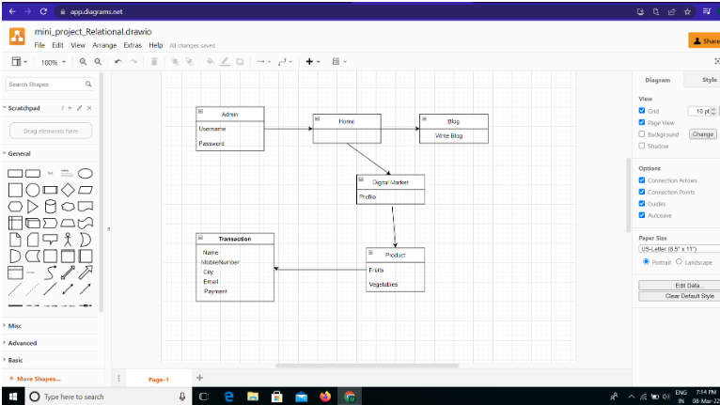

**ER Diagram**

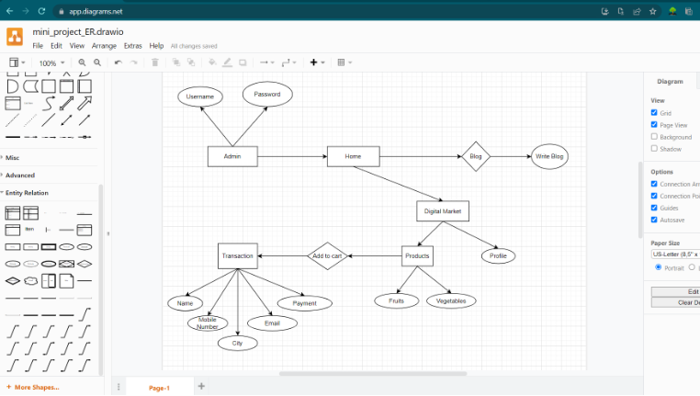

**LIST OF MODULES**

In our project “FARM MANAGEMENT SYSTEM” we identified these following modules:

1. The main page
2. The toggle bar
3. The sign up page
4. The login page
5. My profile
6. Digital market
7. Product range
8. My cart page
9. Transaction
10. Order confirmation
11. Review page
12. Blog page
13. Logout

The purpose of Farm Management System is to automate the existing manual system by the help of computerized equipment. We first begin with the main page where we are asked to login or signup. The login can be either from the farmer’s side or the buyer’s side. The login entered are saved in our database. These credentials can be used later for future use. On the main page we have a toggle bar which gives the privilege to our users to navigate on our website to various other pages, some of them being my cart, my profile, digital market and blog writing.

After logging , the user can create his personal profile with personal details like mobile number, email id and address. Another module “digital market” gives our user wide range of grocery products including fruits, vegetables and grains. The products page lists the various products available with the farmers we have tied up with.

After selecting the product and the amount required by the user, the user is taken to the products buy page. There he can finalize whether the products selected by him are correct or not. The products selected are also listed in the my cart page. After finalizing all the products the user can make the payment.

For payment the user is taken to the transaction page. Upon entering the transaction page, the user has to enter personal details like name, mobile number, city etc. After successful payment the order is placed and order successful message is prompted on the screen. Then we get the products information which the user had bought on our database along with the amount and the address to which the products need to be delivered.

Some add-on features like review writing and blog writing are also available on the website where the users can give their feedback so that other customers can also benefit from them. Finally after placing the order, the user can logout.

**Screenshots**

Main Page



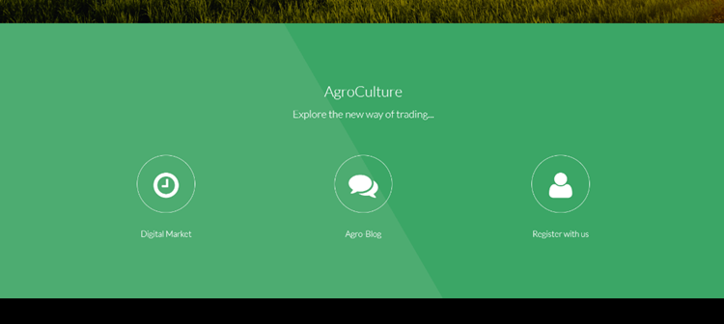



Toggle Bar

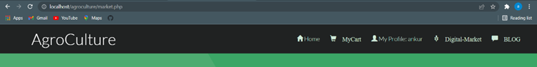

Signup Page

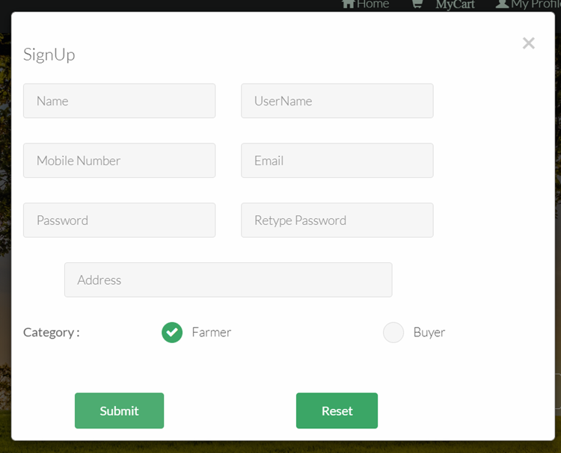

Login Page

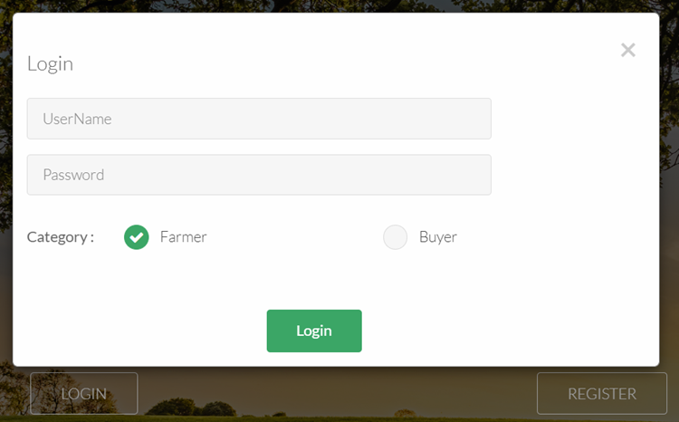

After Login Page



My Profile Page

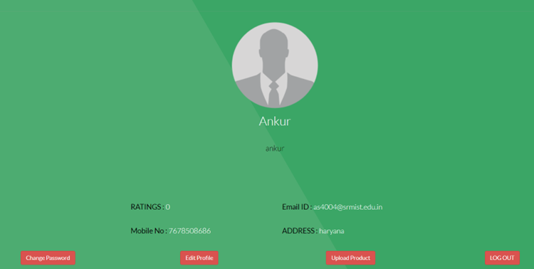

Digital Market Page

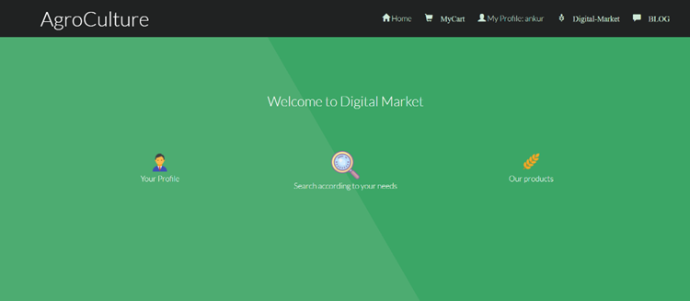

Products Page

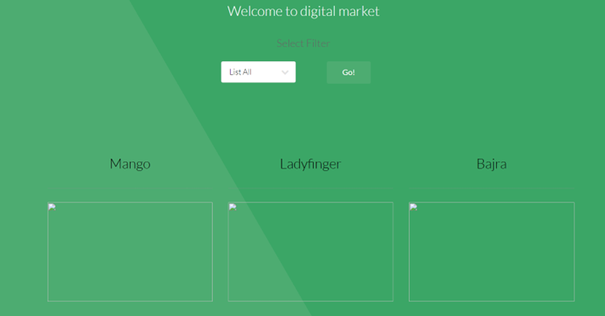

Product Buy Page



My Cart Page

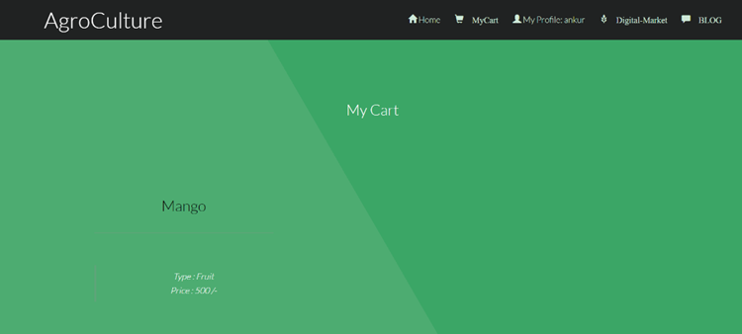

Transaction Page

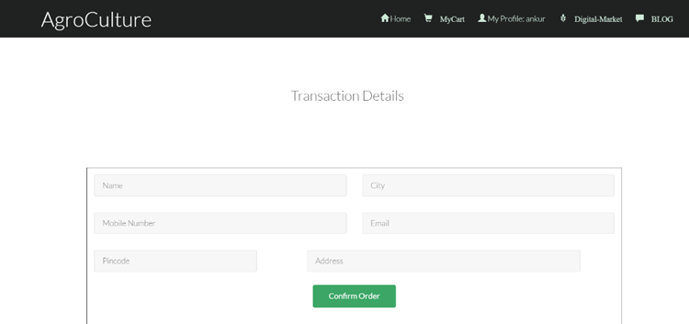

Order Confirmation Page



Review Page

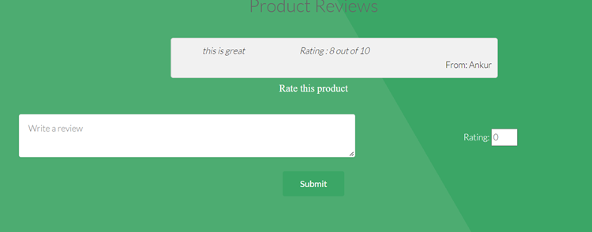

Blog Page

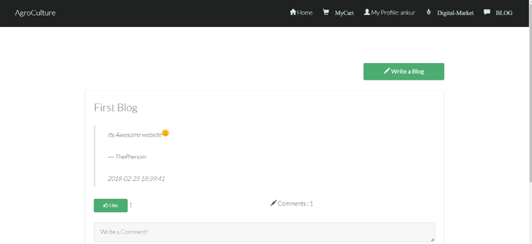

Logout Page



**CONCLUSIONS**

The project based on Farm Management System has been developed to override the problems prevailing in the practicing manual system. The purpose of Farm Management System is to automate the existing manual system by the help of computerized equipment. It lead to error free, secure, reliable and fast management system.

The conclusions drawn from our project was that the previously used manual system for farm management were pretty much incapable and were less sufficient than modern era techniques. So to deal with these prevailing problems we developed a project based on Farm management system to automate these activities with the help of a real time database.

**REFRENCES**

1. [www.wikipedia.org](http://www.wikipedia.org)
2. Book ‘Modern Era Farm Techniques’
3. YouTube