**Project: Clustering Location/places from Uber Trip Analysis   
  
 -Ankur Srivastava  
 -2201029  
  
1. Introduction**

This project involved the analysis of Uber trip data to predict and cluster places or locations based on attributes like pickup start date, end date time etc. The main objective of this project was to explore clustering techniques in machine learning and apply them to a real-world dataset to make meaningful predictions.

I was introduced to this project by Mam, who encouraged me to work on clustering techniques and their applications in real-world datasets, specifically in the context of Uber trips. I was excited about the project because it combined machine learning with real-world data, which I believed would give me a solid understanding of both domains.

**2. Project Concept and Motivation**

The main idea was to predict location clusters based on the Uber trip data. The dataset consisted of various attributes, but the most important ones for clustering were:

* **Miles**
* **Duration**
* **Timestamp of the trip**

I had to take extra steps to preprocess the data, ensuring it included these key features. This project was an excellent opportunity to practice and learn data wrangling, clustering, and dimensionality reduction techniques.

**3. Learning Process**

This project was a huge learning curve for me. I started by studying different clustering algorithms and techniques to identify which one would be most appropriate for this task. I initially worked for about 30 minutes each day, gradually expanding my time as I understood the intricacies of the project.

* **Learning New Libraries**: As I worked on the project, I came across several new libraries and tools that I had not worked with before. Libraries like **Pandas**, **Scikit-learn**, and **Seaborn** were crucial for handling data, applying machine learning models, and creating visualizations. Additionally, **Matplotlib** was used for basic plotting, while **KMeans** clustering from **Scikit-learn** became my go-to algorithm for segmenting the data.
* **Exploring Different Models**: I explored various clustering models such as **KMeans**, **DBSCAN**, and **Hierarchical Clustering**. After testing each model, I found that KMeans provided the best results for this dataset because it efficiently partitioned the data into distinct clusters based on location.
* **Model Tuning**: I spent considerable time experimenting with different numbers of clusters (K) for the KMeans algorithm, using techniques like the **Elbow Method** and **Silhouette Score** to determine the optimal number of clusters. This was an important learning experience as I gained deeper insights into the workings of clustering algorithms and how to tune them effectively.

**4. Why I Chose KMeans Clustering**

KMeans was chosen for this project due to its simplicity and efficiency. Some of the key reasons include:

* **Scalability**: KMeans is highly efficient for larger datasets, which was critical given that Uber trip data can be extensive.
* **Interpretability**: The results of KMeans clustering are easy to interpret. The output consists of cluster centroids, which provide a clear view of the centers of each cluster.
* **Suitability for Spatial Data**: Since the data was related to geographical locations (latitude and longitude), KMeans worked well by grouping nearby locations together into clusters.

While other clustering methods such as DBSCAN might have been useful for more complex spatial data, KMeans offered a good balance between simplicity and effectiveness for my project.

**5. Data Preprocessing and Cleaning**

One of the key challenges in the project was the **data preprocessing** phase. The dataset initially lacked the **latitude and longitude** fields, which were essential for clustering the locations. I had to perform the following steps:

* **Handling Missing Values**: I ensured that all missing data was properly handled, either by filling in with default values or removing incomplete rows.
* **Feature Engineering**: I created new features where necessary, such as calculating the **distance** between different trip points to enrich the dataset.
* **Normalization**: I standardized the features (particularly latitude and longitude) to ensure that all the data points were on the same scale, as KMeans is sensitive to scale differences.

**6. Clustering and Model Building**

After preparing the data, I applied the **KMeans clustering algorithm**. The steps involved were:

1. **Choosing the Right K Value**: I used the **Elbow Method** to determine the optimal number of clusters for the data.
2. **Fitting the Model**: I applied KMeans clustering to the dataset with the selected K value.
3. **Cluster Visualization**: I visualized the clusters in both 2D and 3D plots, which helped me understand the distribution of the clusters and their relative positions.

**7. Visualization Techniques**

To make the project more analytical and visually appealing, I incorporated several types of visualizations:

* **2D Scatter Plots**: The most straightforward visualization was a 2D scatter plot, where I plotted the latitude and longitude of each Uber trip, color-coded by the predicted cluster.
* **PCA (Principal Component Analysis)**: To reduce the dimensionality of the dataset (especially for visualization purposes), I used PCA to project the data onto a 1D or 2D space. This helped in visualizing the clusters more clearly.
* **Heatmaps and Correlation Plots**: I used heatmaps to visualize the correlation between various features in the dataset, which gave insights into how different attributes were related and influenced clustering.

**8. Results and Observations**

After running the KMeans algorithm, I obtained the following observations:

* The dataset was grouped into distinct clusters, representing different geographical areas in the Uber trip dataset.
* The clusters seemed to correspond well with well-known regions within the city or locality, demonstrating the power of clustering to identify natural groupings in geographic data.
* The 3D visualizations helped me understand how the clusters were spatially distributed across different areas.

**9. Predicting New Data**

One of the final steps in this project was to use the trained KMeans model to predict which cluster a new data point (new Uber trip) would belong to. This was done by using the predict() function on the model, which returned the predicted cluster based on the features of the new trip. Also A GUI has been implemented by me for better understanding.  
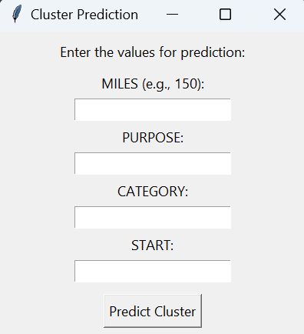

**10 . Visualizations**

**Below are some visualizations that represent the project’s outcomes:**

**1. Clustering Output**

***This plot shows the clustering of data points based on the MILES feature. Each color represents a cluster, and the groups highlight similarities between trips.***

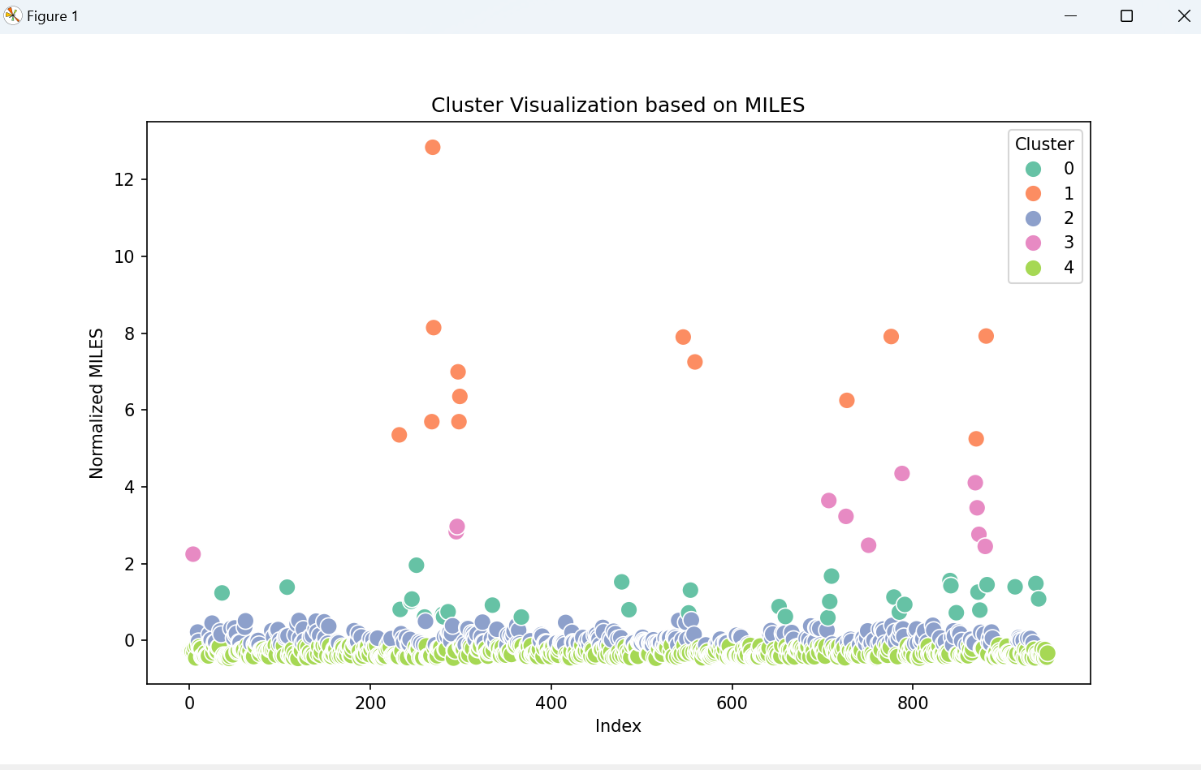

**2. Elbow Method**

***The Elbow Method plot was used to find the optimal number of clusters. The "elbow point" was chosen, indicating the balance between model performance and computational efficiency.***

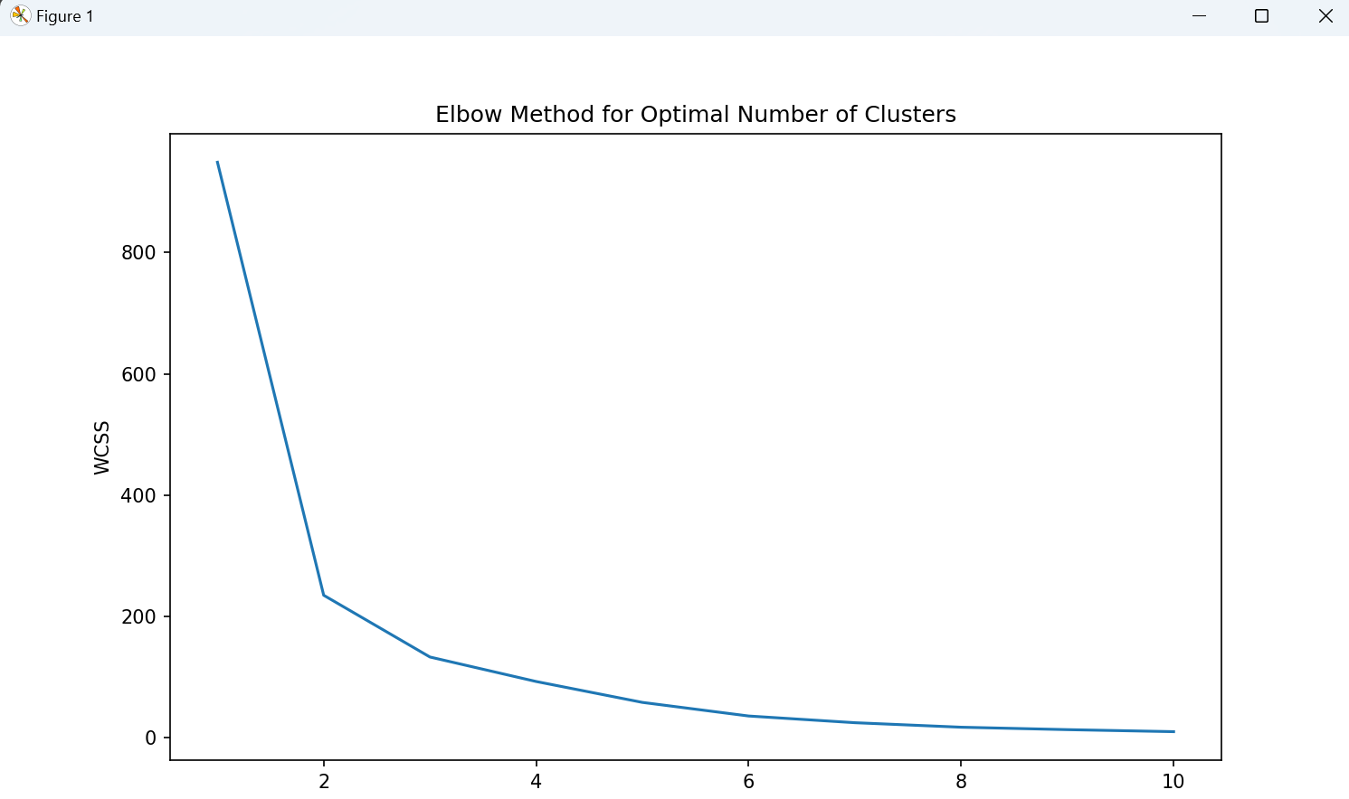

**3. Cluster Distribution**

***This bar chart shows the number of data points in each cluster. It helps visualize how the trips are distributed across different clusters, providing insights into the density of trips.***

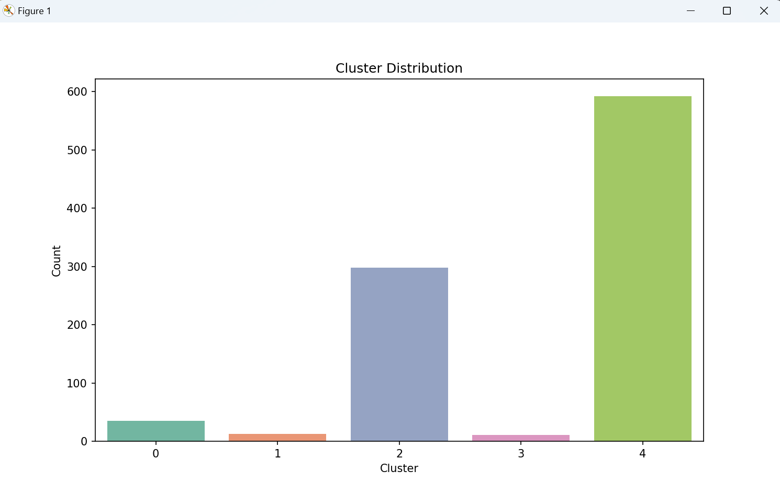

**11. Conclusion**

This project has been a valuable learning experience. I started with very little knowledge about clustering techniques and machine learning in general, but through consistent effort and learning, I was able to build a working model that successfully predicted clusters of Uber trip locations.

* **Key Takeaways**: I have gained a deeper understanding of data preprocessing, feature engineering, clustering algorithms (especially KMeans), and how to effectively visualize data to make informed decisions.
* **Future Work**: There are several ways to improve the model, such as experimenting with different clustering algorithms, including additional features like time of day, or incorporating external datasets for further analysis.

I would like to sincerely thank my professor for providing me with this project opportunity. It has been a fantastic learning experience, and I am grateful for the guidance and support throughout this journey.

**Thank You!**