**ASSINGMENT NO-03**

Q1.Program to write the first 10 numbers.

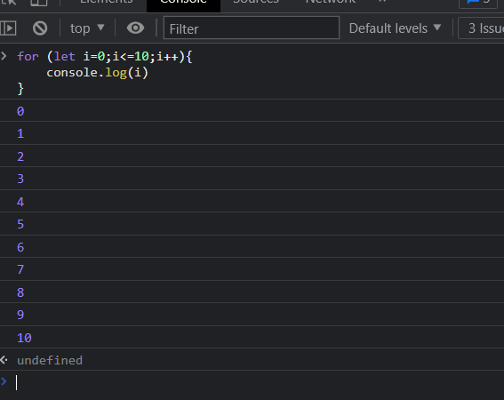

Q2.Program to calculate the sum of first 10 numbers

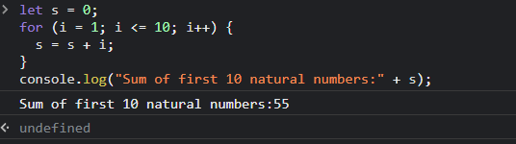

Q3.Make the loop stop when i is 5.

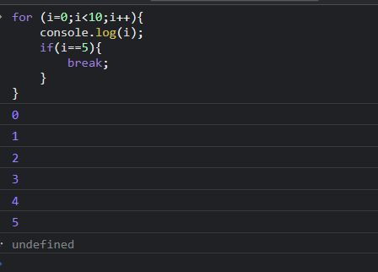

Q4.Write a program to print day of week name using switch case.

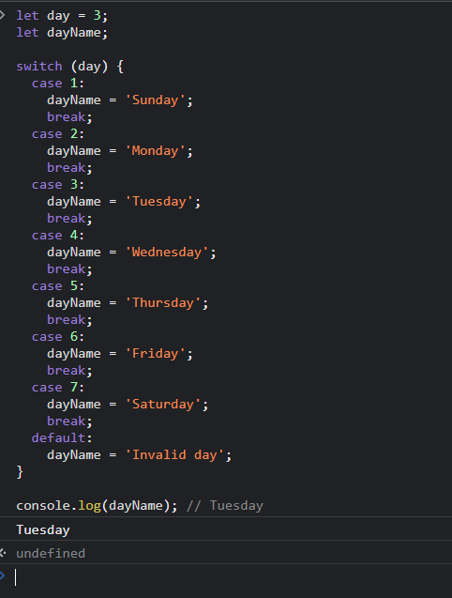

Q5.Write a program print total number of days in a month using switch case.

