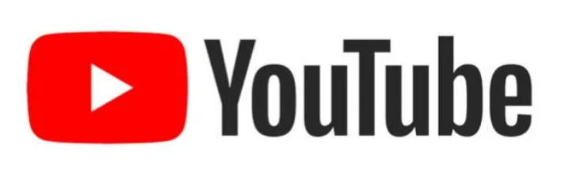
Product Dissection for YouTube

Company Overview:
YouTube is a popular online video-sharing platform where users can watch, upload, share, and interact with videos. It was launched in 2005 and later acquired by Google. Today, YouTube provides a platform for entertainment, education, news, music, and content creation. Users can create channels, upload videos, subscribe to other channels, like and comment on videos, create playlists, and discover new content through search and recommendations. YouTube connects content creators and viewers on a single platform and uses features such as search, recommendations, subscriptions, and engagement to help users find and interact with relevant content.

Product Dissection and Real-World Problems Solved by YouTube:
YouTube provides several features that solve common problems for both viewers and content creators.

1. Video Sharing
Users can upload and share videos with a large audience.
Problem solved: People need an easy way to share their knowledge, skills, experiences, and entertainment with others.

2. Video Search
Users can search for videos using keywords.
Problem solved: Finding specific information or content on the internet can be difficult. YouTube helps users quickly find relevant videos.

3. Recommendations
YouTube recommends videos based on a user's interests and activity.
Problem solved: There is a huge amount of video content available, making it difficult to decide what to watch. Recommendations help users discover relevant content.

4. Subscriptions
Users can subscribe to channels they like and receive updates about their content.
Problem solved: Users may miss new videos from their favourite creators. Subscriptions help them stay connected with channels they follow.
5. Likes and Comments
Users can like videos and share their opinions through comments.
Problem solved: Creators need feedback from viewers, while viewers need a way to interact with content and other users.

6. Playlists
Users can organize videos into playlists.
Problem solved: Managing and finding frequently watched or related videos can be difficult. Playlists help users organize content in one place.

7. YouTube Channels
Creators can create their own channels to publish and manage videos.
Problem solved: Creators need a dedicated space to build an audience and share their content.

In Conclusion, YouTube combines content sharing, search, discovery, communication, and creator tools in one platform. These features help users find useful content and help creators reach and interact with their audience.

Case Study: Real-World Problems and YouTube's Innovative Solutions
YouTube addresses several common problems faced by people who want to watch, learn, share, and create content online.

Problem 1: Difficulty Finding Useful Information
Real-World Challenge:
People often have difficulty finding specific information, tutorials, or educational content.
YouTube's Solution:
YouTube provides search functionality that allows users to find videos using keywords. Users can search for tutorials, educational videos, news, entertainment, and many other types of content.

Problem 2: Too Much Content to Choose From
Real-World Challenge:
There are millions of videos available, so users may not know what to watch next.
YouTube's Solution:
YouTube uses video recommendations to show users content related to their interests and viewing activity. This helps users discover new videos more easily.

Problem 3: Creators Need a Platform to Reach an Audience
Real-World Challenge:
People who create educational, entertainment, or informative content need a way to share it with a large audience.
YouTube's Solution:
YouTube allows creators to create channels and upload videos. Creators can build an audience through subscribers, views, likes, comments, and shares.

Problem 4: Users Want to Stay Connected with Their Favourite Creators
Real-World Challenge:
Users may miss new videos from creators they regularly watch.
YouTube's Solution:
The Subscribe feature allows users to follow channels and receive updates about new content.

Conclusion
YouTube solves these problems by combining search, recommendations, video sharing, channels, subscriptions, and user interactions in one platform. These features make it easier for users to discover content and for creators to reach their audience.

Top Features of YouTube:

1. User Accounts
YouTube allows users to create accounts and manage their personal information and activities.

2. YouTube Channels
Creators can create channels to upload and organize their videos and build an audience.

3. Videos
Videos are the main content of YouTube. Users can upload, watch, share, and interact with videos.

4. Likes and Comments
Users can like videos and post comments. These features allow viewers to interact with content and provide feedback.

5. Subscriptions
Users can subscribe to channels they are interested in and keep track of new content from those channels.

6. Search
Users can search for videos, channels, and other content using keywords.

7. Recommendations
YouTube recommends videos based on user activity and interests, helping users discover new content.

8. Playlists
Users can create playlists to organize multiple videos in one place.
These features will form the basis for our database schema and ER diagram in the next steps.

Schema Description:
Based on YouTube's main features, we can design a database using several important entities. Each entity stores specific information and connects with other entities to support the platform's functionality.

1. User Entity
Stores information about YouTube users.
- UserID – Primary Key
- Username – User's name
- Email – User's email address
- Registration_Date – Date the user joined

2. Channel Entity
Stores information about creator channels.
- ChannelID – Primary Key
- UserID – Foreign Key
- Channel_Name – Name of the channel
- Description – Channel description
- Created_Date – Channel creation date

3. Video Entity
Stores information about uploaded videos.
- VideoID – Primary Key
- ChannelID – Foreign Key
- Title – Video title
- Description – Video description
- Video_URL – Location of the video
- Upload_Date – Date the video was uploaded

4. Comment Entity
Stores comments made on videos.
- CommentID – Primary Key
- VideoID – Foreign Key
- UserID – Foreign Key
- Comment_Text – Comment content
- Comment_Date – Date of the comment

5. Like Entity
Stores likes given by users.
- LikeID – Primary Key
- VideoID – Foreign Key
- UserID – Foreign Key
- Like_Date – Date the video was liked

6. Subscription Entity
Stores relationships between users and channels.
- SubscriptionID – Primary Key
- UserID – Foreign Key
- ChannelID – Foreign Key
- Subscription_Date – Date of subscription

7. Playlist Entity
Stores playlists created by users.
- PlaylistID – Primary Key
- UserID – Foreign Key
- Playlist_Name – Name of the playlist
- Created_Date – Date the playlist was created

8. PlaylistVideo Entity
Connects videos with playlists.
- PlaylistVideoID – Primary Key
- PlaylistID – Foreign Key
- VideoID – Foreign Key

Main Relationships
- Users create Channels
- Channels contain Videos
- Users comment on Videos
- Users like Videos
- Users subscribe to Channels
- Users create Playlists
- Playlists contain Videos

Rationale Behind the Schema Design
The schema is designed to represent YouTube's main features in a simple and organized way. Each entity has a specific purpose and is connected to other entities through relationships.

1. User and Channel
A User can create and manage a Channel. Keeping them as separate entities makes it easier to store user information and channel information independently.

2. Channel and Video
A Channel can contain multiple Videos. The ChannelID in the Video entity connects each video to its creator's channel.

3. User and Video Interaction
Users can like and comment on videos. Separate Like and Comment entities allow us to record which user interacted with which video and when.

4. User and Channel Subscription
Users can subscribe to multiple channels. The Subscription entity stores this relationship between users and channels.

5. Playlist and Video
A playlist can contain multiple videos, and the same video can be added to multiple playlists. Therefore, the PlaylistVideo entity is used to connect playlists and videos.

6. Use of Primary and Foreign Keys
Primary keys uniquely identify each record, while foreign keys connect related entities. This helps maintain relationships between different parts of the database.

Conclusion
The schema separates different types of data into individual entities while connecting them through relationships. This makes the database organized, easier to manage, and suitable for supporting YouTube's core features.

ER Diagram:

Let's construct an ER diagram that clearly represents the relationships and attributes of the entities within the YouTube schema. This diagram will provide a visual representation of YouTube's data model, helping us understand how users, channels, videos, comments, likes, subscriptions, and playlists are connected and how these relationships support the platform's core features.

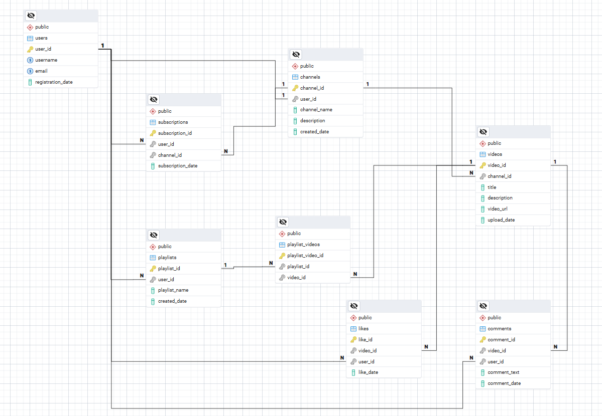

Conclusion

In this case study, we explored YouTube's core features and the real-world problems they solve. We then designed a conceptual database schema based on these features.
The schema includes important entities such as Users, Channels, Videos, Comments, Likes, Subscriptions, and Playlists. The relationships between these entities help represent how users create content, interact with videos, subscribe to channels, and organize videos.
The ER diagram provides a clear visual representation of these relationships and helps us understand how the different parts of the YouTube data model work together.
Overall, this case study helped us understand how product features can be translated into database entities, relationships, and a structured schema.

