**Advance Numerical Technique**  *Ankush Chatterjee 13MA20008*

**Q.1 Solve using Crank Nicolson Method**

du/dt = k * d2u/dx2

u(x,0) = cos pi*x/2

u(-1,t) = 0, u(1,t) = 0, t = 1

dt = 1/27

dx = 1/3

**Solution** :-

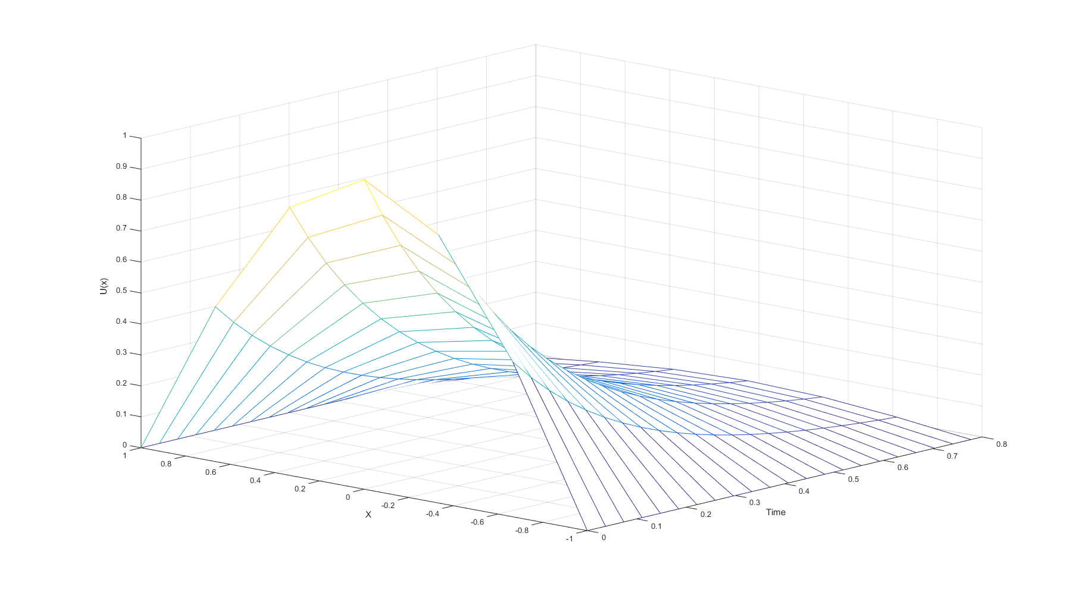

**Q.2 Solve using Crank Nicolson Method and Fictitious Method**

du/dt = k * d2u/dx2

u(x,0) = 1, 0 < x < 1

u(0,t) = u'(0,t), u(1,t) = -u'(1,t), t = 1

dt = 0.04;

dx = 0.2;

r = 1

**Solution:-**

