**Clean Tabular Data**

AIM – To find out how Different open source OCR perform text detection.

RAW IMAGE

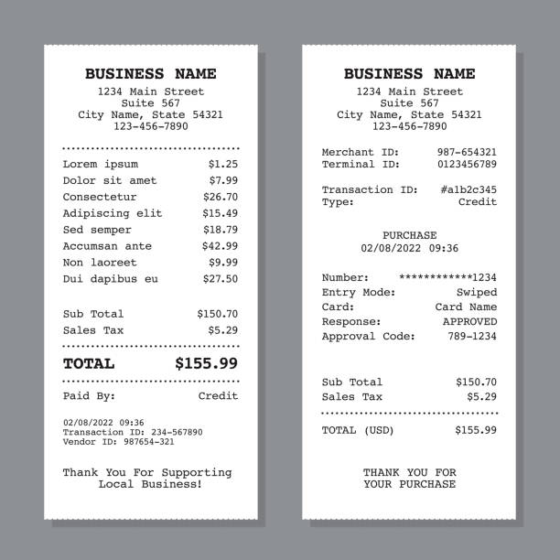

**TESEERACT OCR**

Extraction –

BUSINESS NAME 1234 Main Street suite 567 City Name, State 54321 123-456-7890 Lorem ipsum $1.25 Dolor sit amet $7.99 consectetur $26.70 Adipiscing elit $15.49 Sed semper $18.79 Accumsan ante $42.99 Non laoreet $9.99 Dui dapibus eu $27.50 Sub Total $150.70 Sales Tax $5.29 TOTAL $155.99 Paid By: credit 02/08/2022 09:36 ‘Peangact ion 10: 234-567090 Vendor 1Dr 987654-201 ‘Thank You For Supporting ‘Local Business! BUSINESS NAME 1234 Main Street ‘suite 567 City Name, State 54321 123-456-7890 Merchant ID: 987~654321 ‘Terminal 1D: 0123456789 ‘Transaction ID: #alb2c345 Type! credit PURCHASE 02/08/2022 09:36 seeeveeeeeei234 Swiped card Name Response: APPROVED Approval Code: 789-1234 Sub Total $150.70 Sales Tax $5.29 TOTAL (USD) $155.99 THANK YOU FOR YOUR PURCHASE

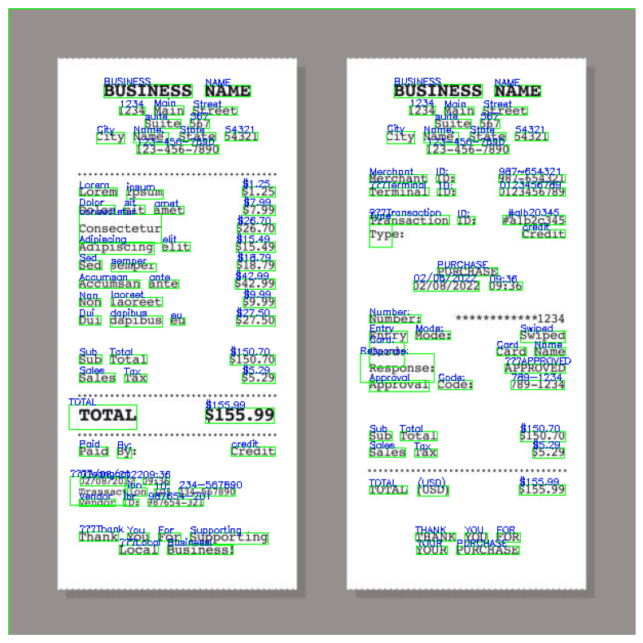

**KERAS OCR**

**Extraction –**

business business name name 1234 main 1234 main street street suite 567 suite 567 city 54421 city nameo stale names slate 54821 1238 45617890 123 4567890 merchant 987654321 ids ipsum 5125 0127156769 lorem terminal ide dolor sit 5799 ame transaction ralb2c3a5 ids s264 70 consecletur credit types adipiscing elit s1549 sed s18179 semper purchase s4279 accumsan ante 0210812022 09436 laoreet s999 non t11234 dui numbers dapibus s274 50 eu entry modes swiped cards card name sub total 515070 responser approved sales s5129 tax 7891274 approval codes s15599 total s15070 sub total paid credit sales s529 bys tax 0210812022 ogba6 total usdy s15599 transaction 23a56769d ids vendor 967654921 ids thank supporting you for thank you for local businessl your purchase

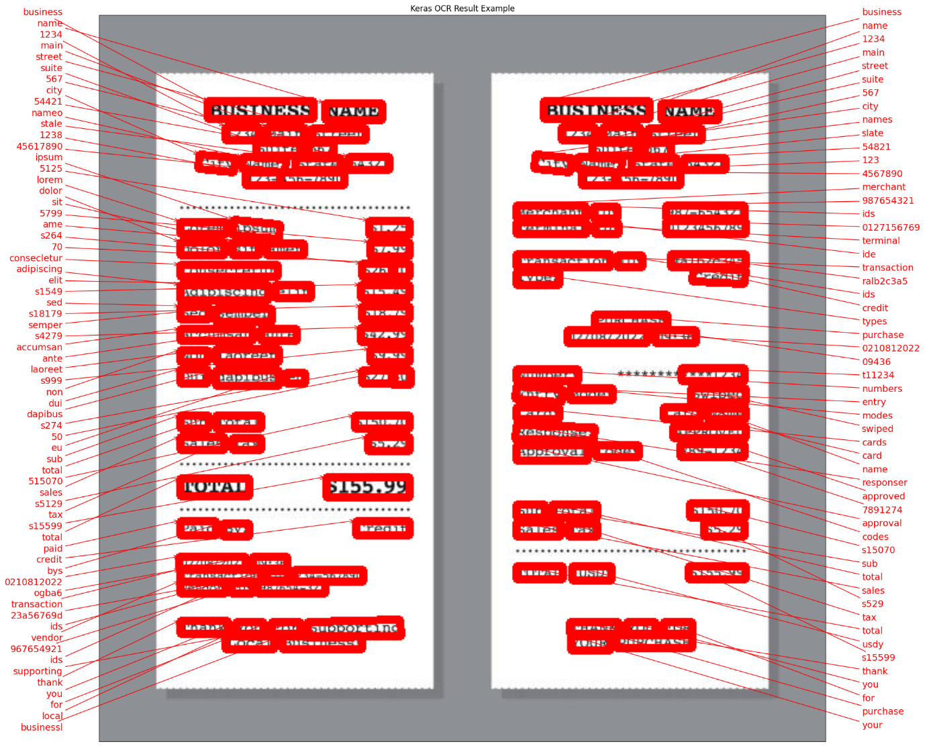

**EASY OCR**

**Extraction-**

BUSINESS NAME BUSINESS NAME 1234 Kain Street 1234 Kain Street Suite Suite 567 City Namc state 54321 City Namc state 54321 123-456-7890 123-456-7890 Merchant ID: 987-654321 Lorem ipsun 51.25 Terminal ID: 0123456789 Dolor sit amet 57.99 Transaction ID #alb2c345 Consectetur 526.70 Type: Credit Adipiscing elit 415.49 Sed semper 518.79 PURCHASE Accumsan ante 542.99 02/08/2022 09:36 Non laoreet $9.99 Dui dapibus 527.50 Number: ***1*****+1234 Entry Mode: Swiped Card: Card Namc Sub Total 5150.70 Response: APPROVED Sales Tax 55.29 Approval Code: 789-1234 TOTAL $155.99 Sub Total 5150.70 Paid By: Credit Sales Tax 55.29 02/08/2022 09:36 Transaction 234-567890 TOTAL (USD) $155.99 vendor 987654-321 Thank You For Supporting THANK YOU FOR Local Business! YOUR PURCHASE

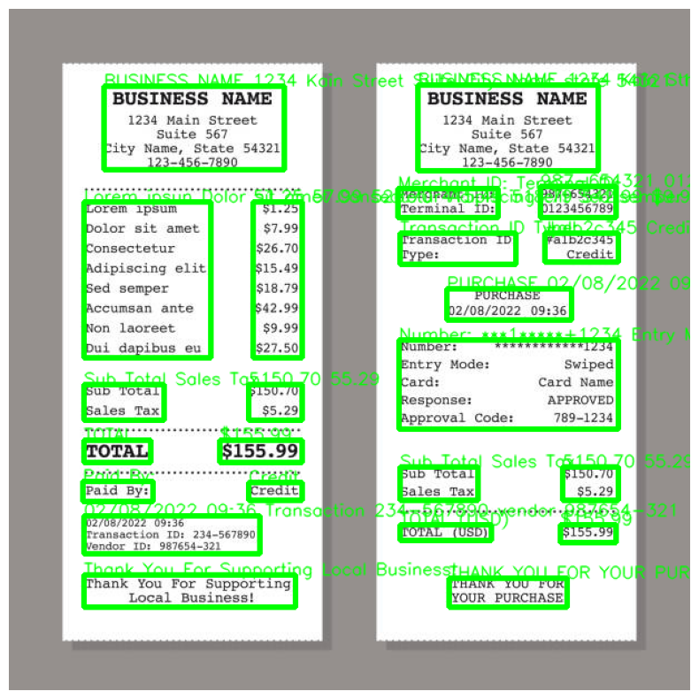

**Paddle OCR**

**Extraction –**

BUSINESS NAME BUSINESS NAME 1234 Main Street 1234 Main Street Suite 567 Suite 567 City Name, State 54321 City Name, State 54321 123-456-7890 123-456-7890 Merchant ID: 987-654321 Lorem ipsum $1.25 Terminal ID: 0123456789 Dolor sit amet $7.99 Consectetur $26.70 Transaction ID: #alb2c345 Type: Credit Adipiscing elit $15.49 Sed semper $18.79 PURCHASE Accumsan ante $42.99 02/08/202209:36 Non laoreet $9.99 Dui dapibus eu $27.50 Number: Entry Mode: Swiped Sub Total $150.70 Card: Card Name Response: $5.29 APPROVED Sales Tax Approval Code: 789-1234 TOTAL $155.99 Sub Total $150.70 Paid By: Credit Sales Tax $5.29 02/08/2022 09:36 Transaction ID:234-567890 TOTAL USD $155.99 Vendor ID:987654-321 Thank You For Supporting THANK YOU FOR Local Business! YOUR PURCHASE

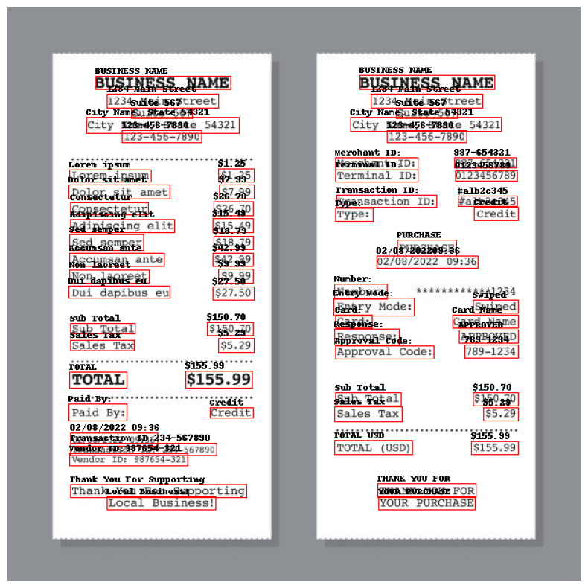

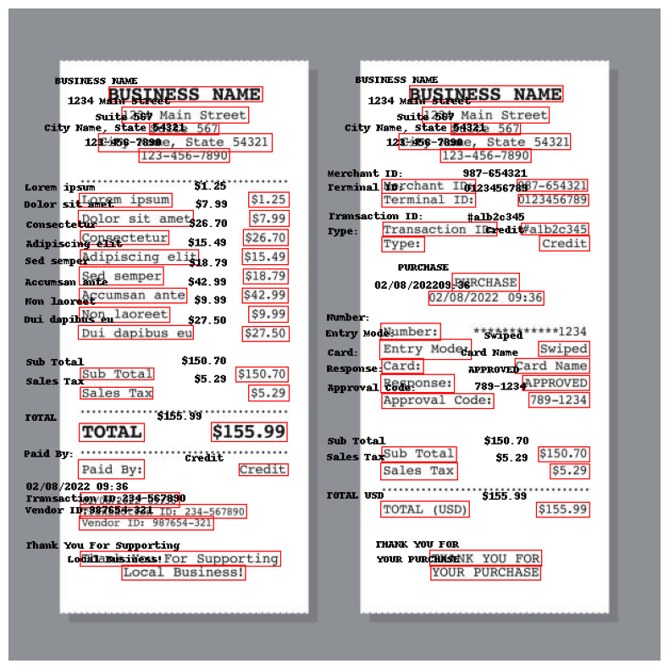

**DONUT OCR**

**Extraction –**

<s_cord-v2><s_menu><s_nm> BUSINESS NAME</s_nm><s_price> NAME</s_price><sep/><s_nm> 1234 Main Street</s_nm><s_price> 1234 Main Street</s_nm><s_price> 1234</s_price><sep/><s_nm> Suite 567</s_nm><s_price> Suite 567</s_price><sep/><s_nm> City Name, State 54321</s_nm><s_price> 123-456-7890</s_price><sep/><s_nm> 123-454</s_nm><s_price> 123-21</s_price></s_menu><s_sub_total><s_subtotal_price> 987-654321</s_subtotal_price><s_discount_price> 0123456789</s_discount_price><s_tax_price> $7.99</s_tax_price><s_etc> #alb2345<sep/><s_nm> Adipiscing elit $15.49</s_nm><s_price> Credit</s_price><sep/><s_nm> sed semper</s_nm><s_price> $18.79</s_price><sep/><s_nm> Accumsan ante $42.99</s_nm><s_price> 02/08/2022</s_price><sep/><s_nm> Non laoreet</s_nm><s_price> 09:36</s_price><sep/><s_nm> $9.99</s_nm><s_price> Dui dapibus eu</s_nm><s_price> $27.50</s_price></s_menu><s_sub_total><s_subtotal_price> Number:</s_nm><s_price> Swiped</s_nm><s_price> Swided</s_price></s_menu><s_sub_total><s_subtotal_price> $150.70</s_subtotal_price><s_discount_price> 789-1234</s_discount_price><s_service_price> $5.29</s_service_price><s_tax_price> $150.70</s_tax_price><s_etc> 85.29</s_etc></s_sub_total><s_total><s_total_price> $155.99</s_total_price><s_total_etc> THANK YOU FOR</s_total_etc><s_changeprice> Local Business!</s_nm><s_price> YOUR PURCHASE</s_changeprice></s_total></s>

After Cleaning

BUSINESS NAME NAME 1234 Main Street 1234 Main Street 1234 Suite 567 Suite 567 City Name, State 54321 123-456-7890 123-454 123-21 987-654321 0123456789 $7.99 #alb2345 Adipiscing elit $15.49 Credit sed semper $18.79 Accumsan ante $42.99 02/08/2022 Non laoreet 09:36 $9.99 Dui dapibus eu $27.50 Number: Swiped Swided $150.70 789-1234 $5.29 $150.70 85.29 $155.99 THANK YOU FOR Local Business! YOUR PURCHASE