|  |  |
| --- | --- |
|  | **Mobile Phone Repairing Center**  **Technical Design Document** |
| |  |  |  |  | | --- | --- | --- | --- | |  | **Prepared By / Last Updated By** | **Reviewed By** | **Approved By** | | **Name** | Ankush Darade  Pankaj Darade |  |  | | **Role** |  |  |  | | **Signature** |  |  |  | | **Date** | 14/08/2023 |  |  | |
|  |

Table of Contents

1.0 Introduction 3

1.1 Purpose of this document 3

1.2 Project overview 3

2.0 Solution Summary 3

2.1 Scope 3

2.2 Assumptions 4

2.3 Dependencies 4

2.4 Risks 5

3.0 Schematic Diagram 6

4.0 System Design 6

4.1 Proposed design 6

4.2 Component inventory 8

5.0 Database Design 8

5.1 Data Model 8

5.2 Tables Structure 9

6.0 Appendices 9

6.1 Glossary 9

6.2 Other 10

7.0 Terms & Conditions 10

8.0 Change Log 10

# Introduction

## Purpose of this document

The purpose of this document is to document the technical design, component details and Database design. This will also capture the scope, assumptions, risk, dependencies of this project.

## Project overview

The Mobile Phone Repairing Center Application is designed to provide a convenient and efficient solution for customers who need mobile repairs or testing. In this digital world, most people use mobile phones, which may sometimes get damaged or have operating issues. Previously, customers had to physically visit a mobile service Center for repair services. However, with the Mobile Phone Repairing Center Application, customers can easily file a mobile problem online and get a technician to solve their mobile problem without the need to visit any shop physically. The Mobile Phone Repairing Center Application is a user-friendly digital application that makes life easier for its users. With this application, customers can raise a ticket for mobile problems at anytime and anywhere, and they can get the help of a technician to solve their mobile problem.

# Solution Summary

## Scope

The purpose of this document is to provide a detailed description of the scope of a proposed application. The application aims to provide a convenient platform for users to raise tickets for their mobile problems and receive assistance from technicians. The application will be designed with user accounts, technicians, and an admin panel to manage the system. Additionally, the application will be built with security features to ensure user data safety, and a ticket searching service to enable users to retrieve information easily.

**User Account:**

The application will provide users with the ability to create their accounts to access the system. Upon account creation, users will be able to raise tickets and receive assistance from technicians. The application will store user account details and ticket details in a secure database.

**Technicians:**

The application will have a section for technicians to view and respond to tickets raised by users. The technicians will be able to provide assistance to users by responding to their tickets, and update the ticket status. The technician section of the application will be secure and require authentication before access is granted.

**Admin:**

The application will have an admin panel to manage the system. The admin panel will allow the admin to add and remove technicians, view and delete tickets, and monitor the system's overall performance. Additionally, the admin will be able to access and manage the user account details.

**Security Service:**

The system will also store the encoded format password of every user for security purposes.

**Ticket Searching Service:**

The application will have a search functionality that allows users to retrieve tickets based on specific criteria such as date, ID, or technician. The search functionality will help users to easily find their tickets and get quick assistance from technicians. The ticket searching service will be accessible to both technicians and the admin.

In summary, the proposed application will provide users with a convenient platform to raise tickets for their mobile problems and receive assistance from technicians. The application will have a user account section, technician section, admin panel, and search functionality to enable easy navigation and access to the system's services. The application will be designed with security features to ensure user data safety. Overall, the application aims to reduce customer waiting times and provide valuable services to the users.

## Assumptions

Some Assumptions are:

* The application will be built as a web-based system accessible via desktop and mobile devices.
* The application will require an internet connection to function correctly.
* Users will have basic knowledge of using a computer and accessing web-based applications.
* Technicians will have the required technical knowledge to provide assistance to users.
* The admin will have the necessary knowledge to manage the system and its resources.
* The application will be tested thoroughly to ensure it meets the requirements and is bug-free.
* The system will store user data and tickets in a secure database to ensure user privacy.
* The application will use an encryption mechanism to store user passwords.
* The system will be scalable and able to handle a large number of users and tickets.
* Users will be responsible for providing accurate and complete information when raising a ticket.
* The technicians will respond to tickets in a timely and professional manner.
* The admin will monitor the system's performance and take action to resolve any issues that may arise.
* Users will be able to view the status of their tickets and receive notifications when there is an update.

Top of Form

## Dependencies

The proposed application requires a set of dependencies for its successful implementation. These dependencies are crucial for the app's functionality and performance, and they need to be carefully considered and integrated.

Data Sources: The application will store ticket data, user data, and technician data in a MySQL database. The database will be managed using JPA to ensure efficient data storage and management.

Web Server: The application requires a web server to host it and to make it accessible via web browsers. A reliable and secure web server is necessary to ensure uninterrupted service to users.

User Interface: To provide users with a seamless experience, the application will need a user-friendly interface. The UI should be easy to use, visually appealing, and accessible on various screen sizes.

Backend Infrastructure: The application will depend on Java language and Spring Framework for its backend infrastructure. The framework will provide the necessary components for building robust, scalable, and reliable applications.

Password Encryption: The application will use an encryption mechanism to store user passwords. This will ensure that user passwords are not accessible in plain text and will prevent unauthorized access to user accounts.

Overall, the dependencies outlined above are crucial for the successful implementation of the proposed application. They need to be carefully considered and integrated to provide a seamless user experience.

## Risks

However, there are certain risks associated with implementing this project, which include:

Data Security: The application will store sensitive user data, including personal and device information. If the data is not secured correctly, it could be vulnerable to cyber attacks and data breaches.

User Authentication: The application will require user authentication to access the system. If the authentication process is not robust, it could lead to unauthorized access to user accounts, which could compromise the security of the application.

Technical Issues: The application will be reliant on the web server, database, and other technical infrastructure. Any technical issues with the infrastructure could result in system downtime, which could impact user experience and result in loss of revenue.

User Acceptance: The success of the application depends on user acceptance. If users do not find the application useful, they may not use it, which could result in loss of revenue and reputation damage.

Competition: There may be other similar applications in the market, which could pose a threat to the success of this project. The application needs to have unique features and a robust marketing strategy to stand out in the market.

In conclusion, the proposed application has several benefits, but it also comes with certain risks. The risks need to be carefully considered and mitigated to ensure the successful implementation and adoption of the application.

# **Schematic** **Diagram**

# **System Design**

## Proposed design

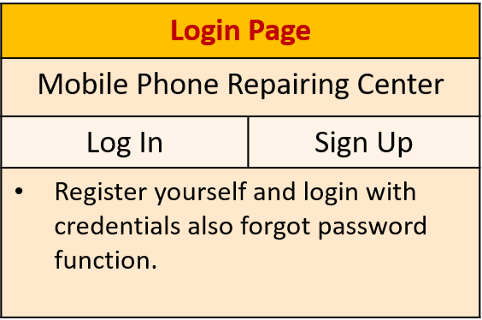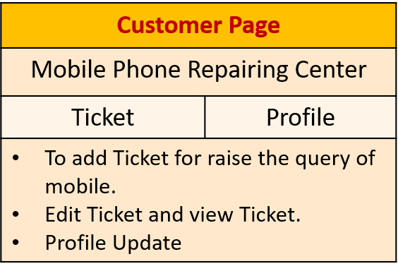

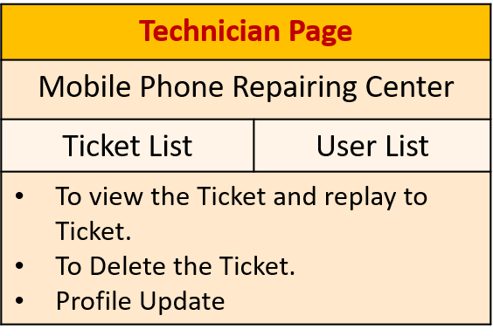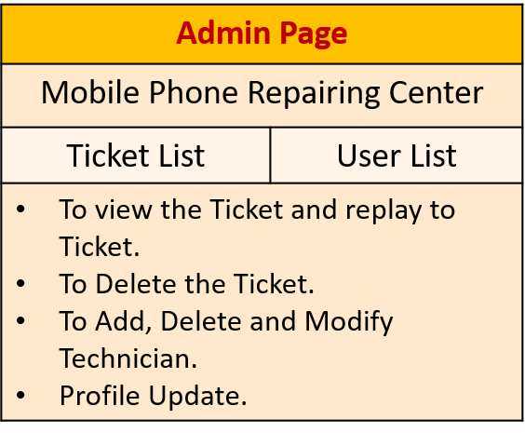

* Home Page:
* Logo for the app.
* About the app
* Instructions to use the app
* Login/ Register Button
* Registration Page:
* Asks Basic Information of User:
* Name
* Email
* Mobile
* Address
* Username
* Password
* Login page:
* Username
* Password
* User Dashboard:
* Option for to Raise the Ticket
* To View the Ticket
* Delete the Ticket
* Profile Update
* Technician Dashboard:
* View the Ticket
* Give Reply to Ticket
* Ticket view by Id/ Date Functions
* Delete Ticket
* Add Intimation Price
* Add Actual Price
* Profile Update
* Admin Dashboard:
* View the Tickets
* View the Technicians
* Add the Technicians
* Remove/Modify Technicians
* Ticket view by Id/ Date Functions
* Profile Update

## Component inventory

The component inventory for the proposed app can include:

Database: The database component will be responsible for storing user account details, ticket details, and technician details. MySQL and JPA will be used for data storage and management.

Web server: The web server component will host the application and enable users to access the system through their web browsers.

APIs: The application will use APIs to communicate with external services such as email gateways to notify users and technicians about ticket updates.

Third-party libraries: The project may use third-party libraries such as Spring Security for authentication and authorization, and Bootstrap for UI design.

Hardware requirements: The application will require hardware components such as servers, storage devices, and network equipment to run the system. These components will need to meet the system's performance and capacity requirements.

Software requirements: The application will require software components such as an operating system, web server software, and database management software to run the system. The software components will need to meet the system's performance and compatibility requirements.

# Database Design

## Database Tables

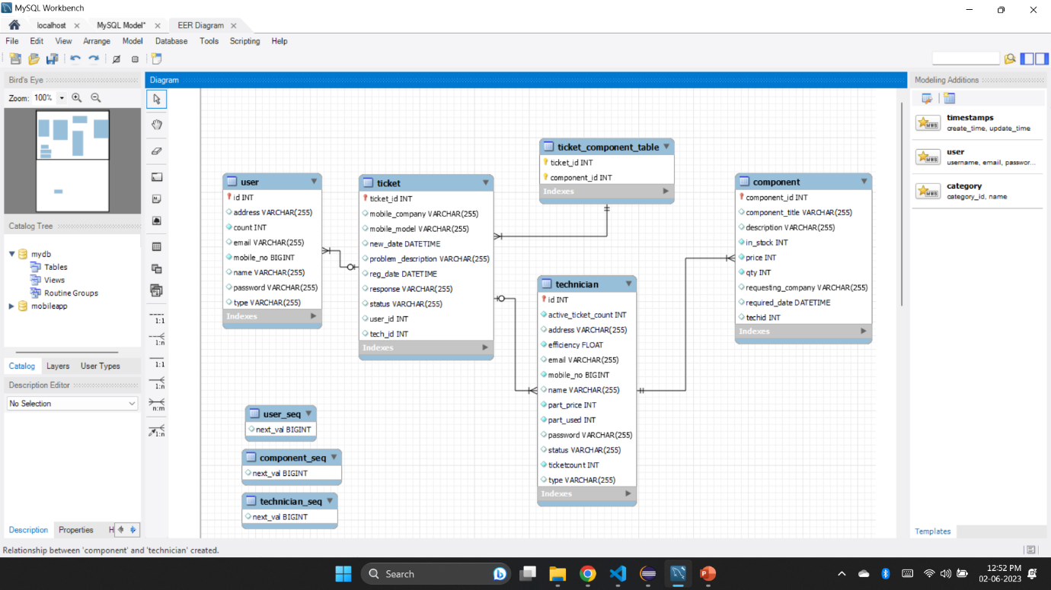

# Appendices

## Glossary

|  |  |
| --- | --- |
| **Acronyms** | **Definitions** |
|  |  |

## Other

# Change Log

*Please note that this table needs to be maintained even if a Configuration Management tool is used.*

|  |  |  |  |  |
| --- | --- | --- | --- | --- |
| Version Number | Changes made | | | |
| V<n.n> | *<If the change details are not explicitly documented in the table below, reference should be provided here>* | | | |
| Page no | Changed by | Effective date | Changes effected |
|  |  |  |  |
|  |  |  |  |
|  |  |  |  |