**Problem**: How to delete modify, change Default route for Internet access?

**Solution**: First of all, check the default route by using command

$ ip route

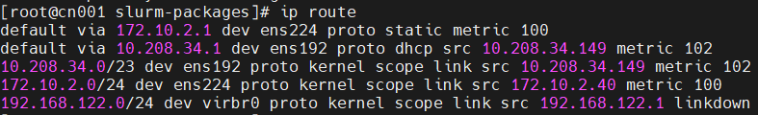

Then delete the additional route by using the following command

$ route del default

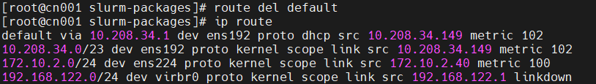

Now there is only one entry for default, Internet access start working.

**Some additional command**:

$ route add default 1.2.3.4

Where 1.2.3.4 is the new gateway

**Useful Link**:

https://unix.stackexchange.com/questions/87543/how-can-i-change-the-default-gateway