Technical Unit Testing
Settlement Details — SAP GUI vs. RAP Fiori Application Output Comparison
RAP Name | Settlement Details
Application Name | ccbji.otc.stlmnt
GUI Name | /CCBJI/RDSDFSVG_STLMNT_DETAILS
Transaction Name | /CCEJ/RDOVM_STLMNTDT
Date | 24-08-2026 | System | Q4R

PURPOSE & SCOPE
Purpose: To compare the output of the existing SAP GUI Settlement Details report with the output of the newly developed RAP-based Fiori application, and to confirm that both give the same data for the same selection in every report mode.
Scope: Covers all report modes of the Settlement Details report - Tour Details, Visit Details, Sales / Replenishment Info., Payment Details, Check Out / Check In, Money Differences, Quantity Differences, FSR Documents and Route Summary. For each report mode, the GUI screen captures are placed first, followed by the corresponding RAP screen captures, so that the selection and the resulting output can be compared side by side.
VALIDATION RESULT
Validation Point | Previous | Current | Result
Tour Details | 1 record | 1 record | Match
Visit details | 2 records | 2 records | Match
Sales/Replenishment info. | 8 records | 8 records | Match
Payment Details | 6 records | 6 records | Match
Check out/Check in | 2 records | 2 records | Match
Money Differences | 2 records | 2 records | Match
Quantity Differences | 5 records | 5 records | Match
FSR Documents | 6 records | 6 records | Match
Route Summary | 2 records | 2 records | Match
Final Output | Output Data | Output Data | Match

The number of records and the output data are identical and matched in both the GUI and RAP reports.
SCREEN CAPTURE

Tour Details
GUI
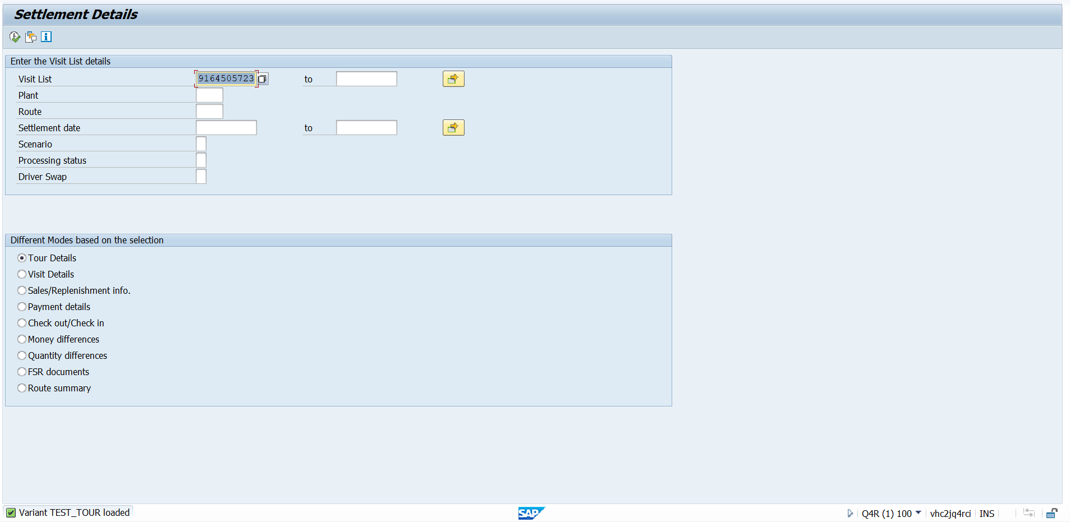

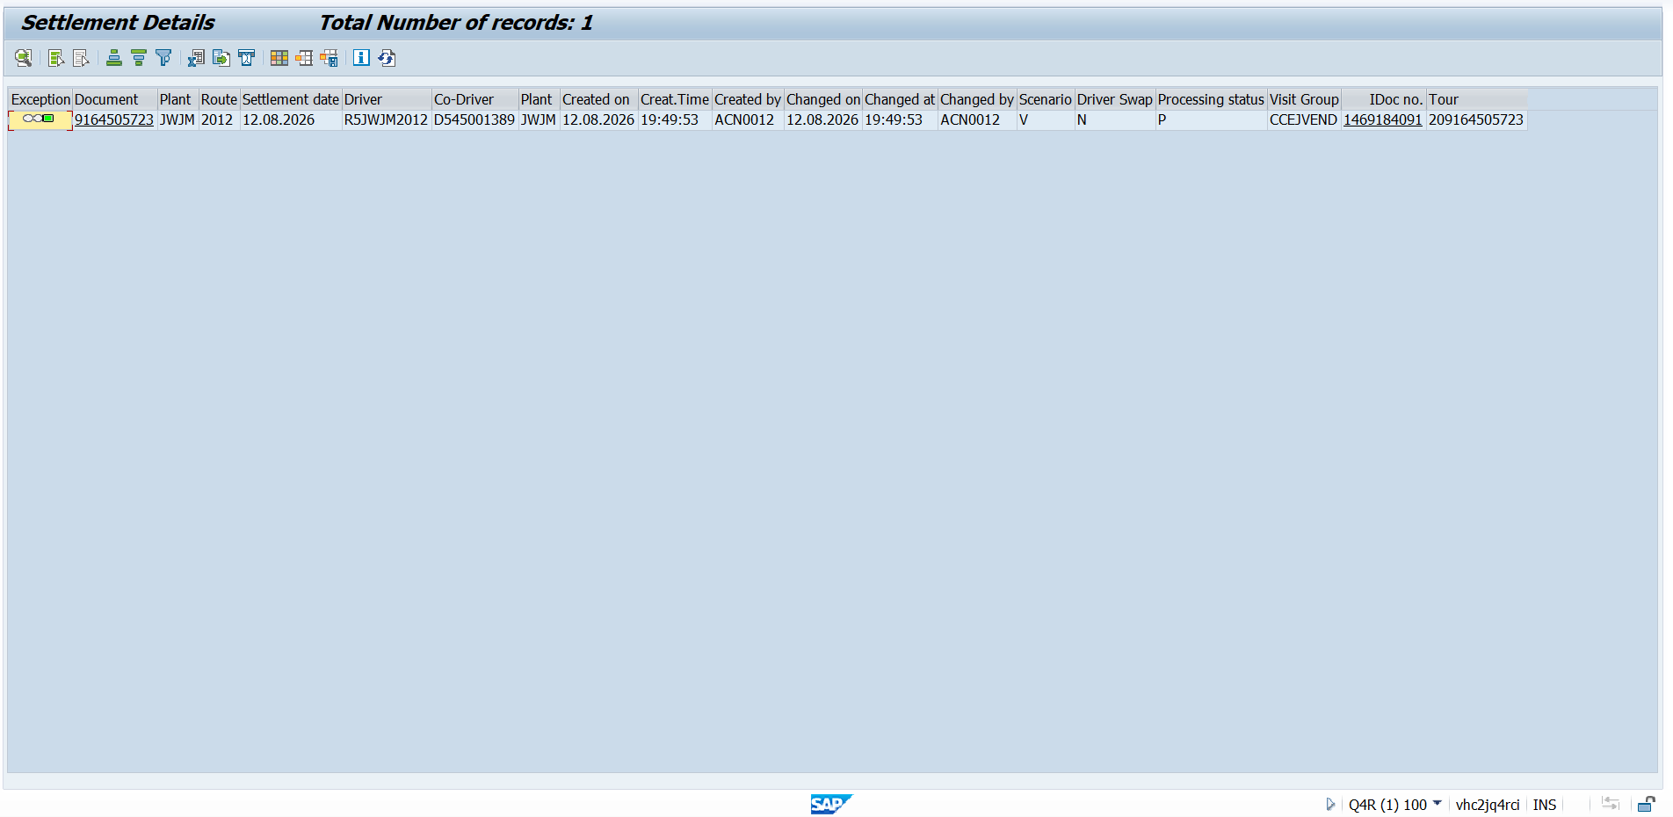

Tour Details
RAP
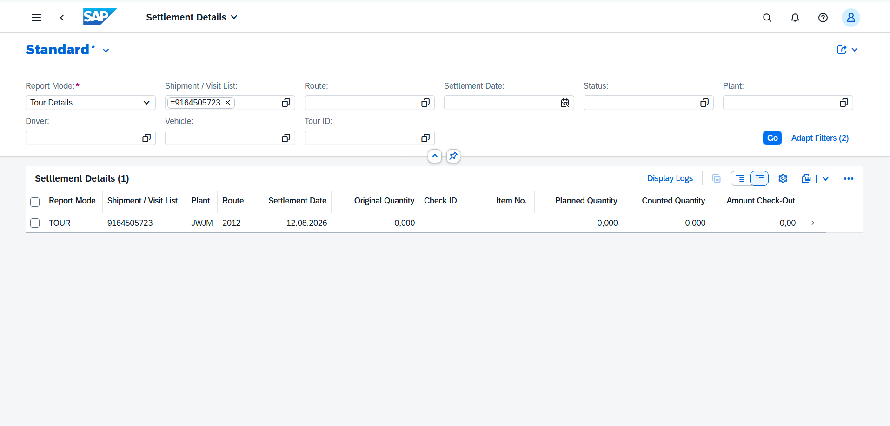

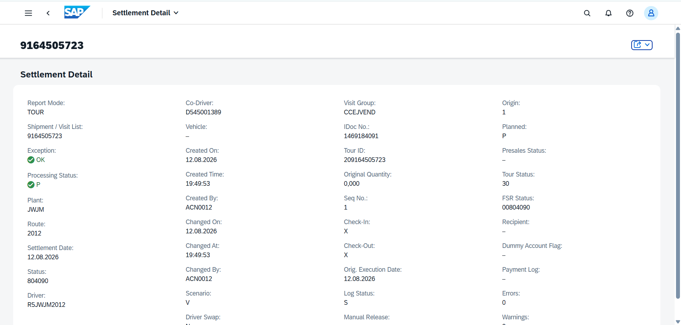

Visit Details
GUI
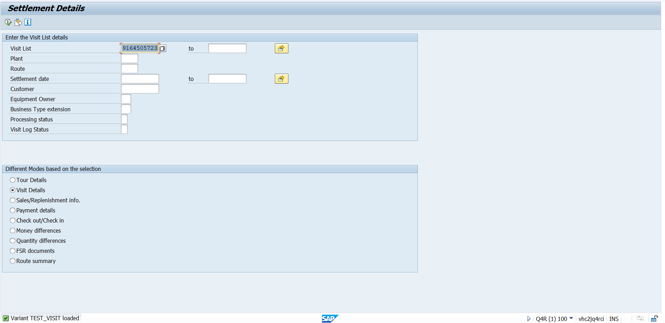

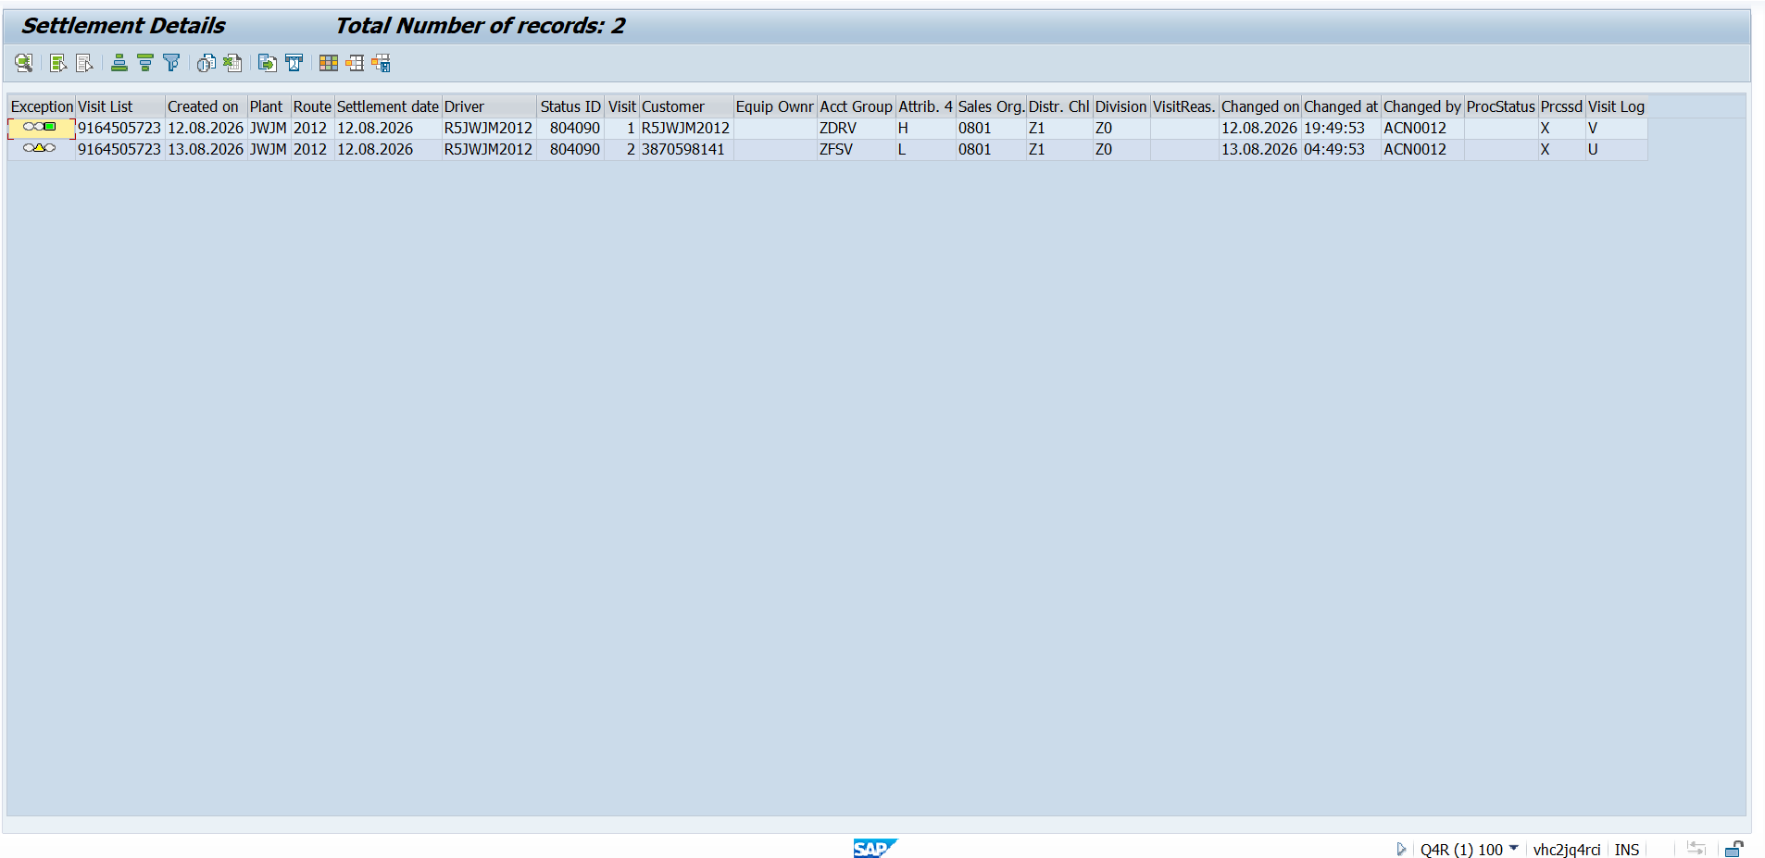

Visit Details
RAP
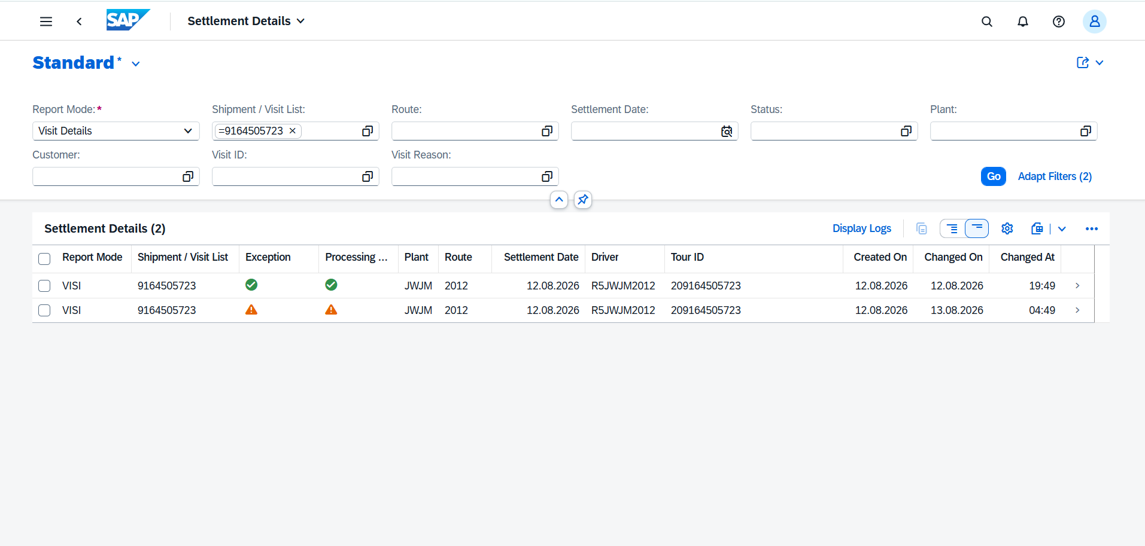

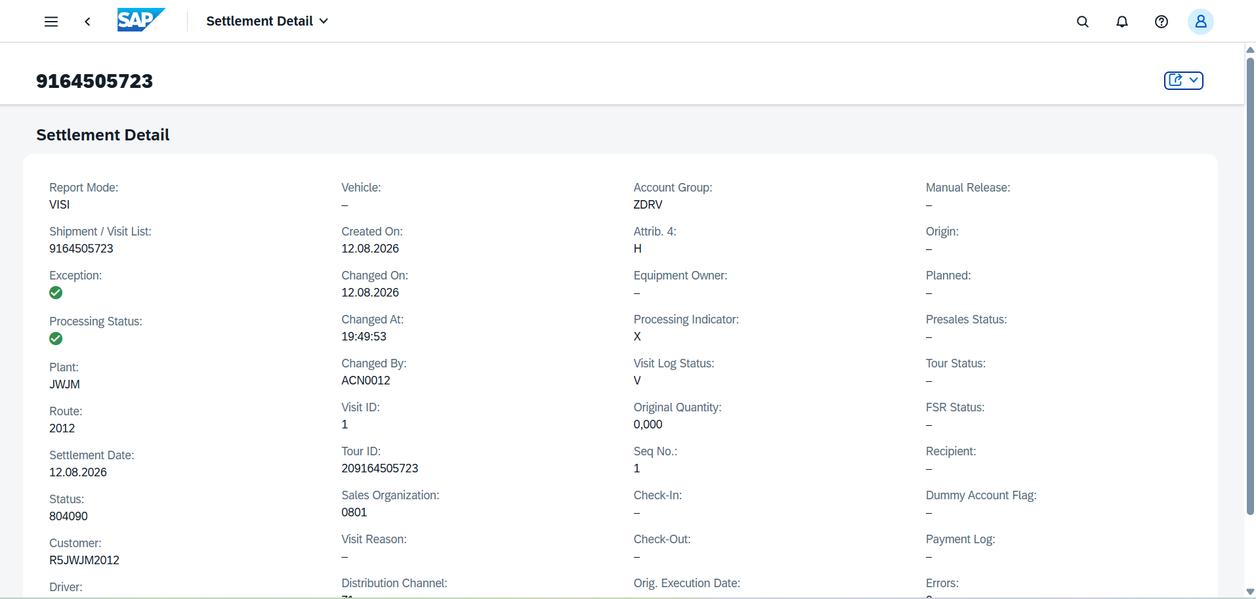

Sales / Replenishment Info.
GUI
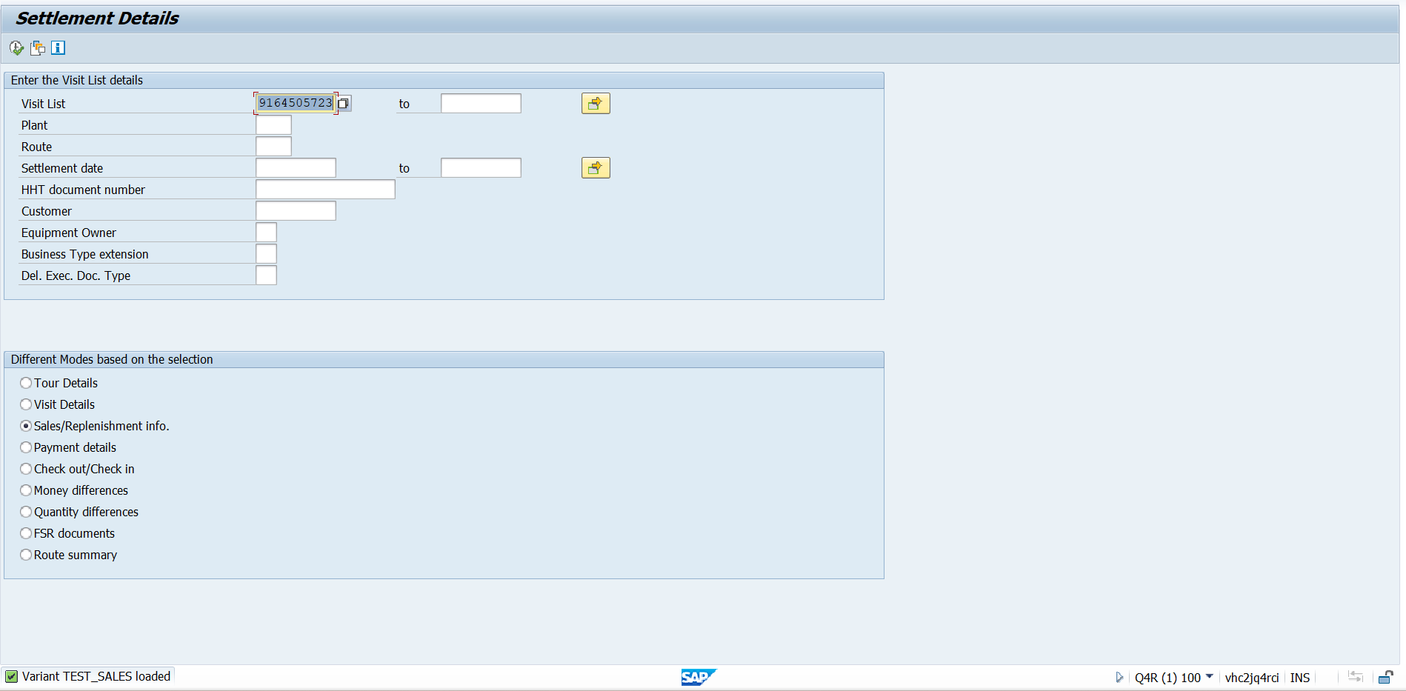

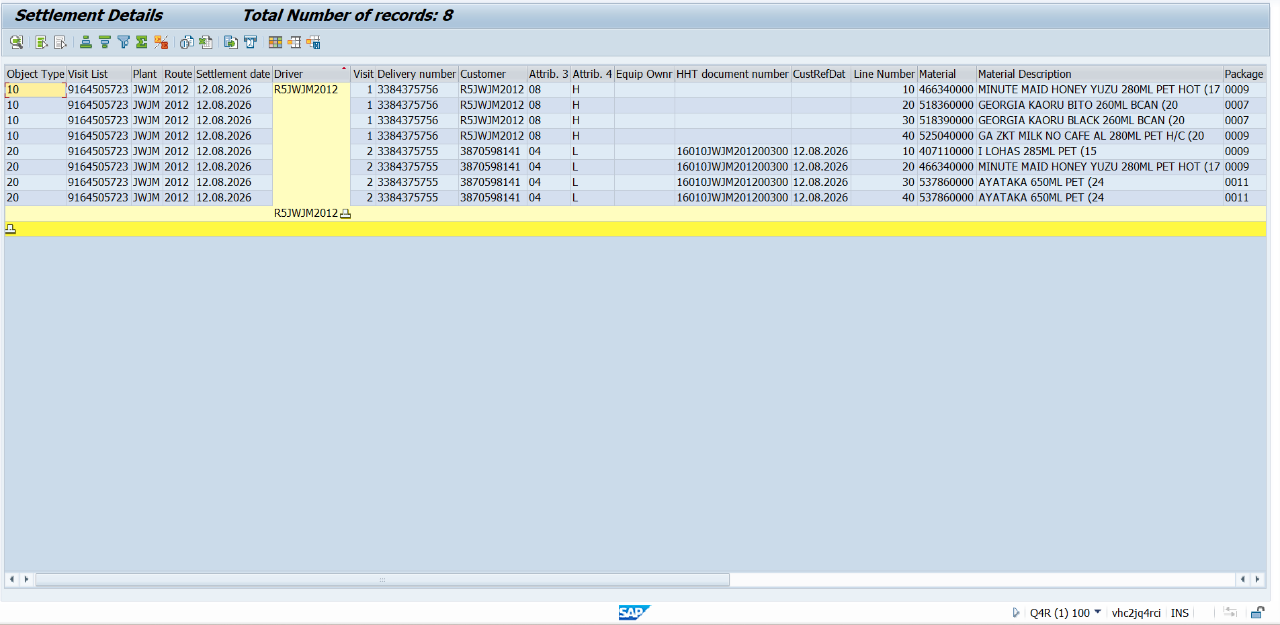

Sales / Replenishment Info.
RAP
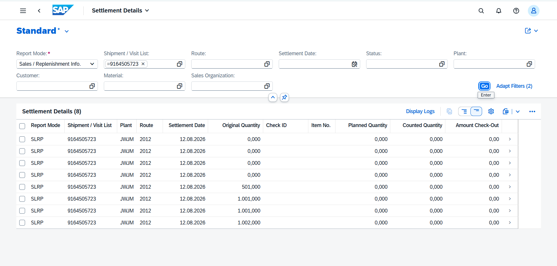

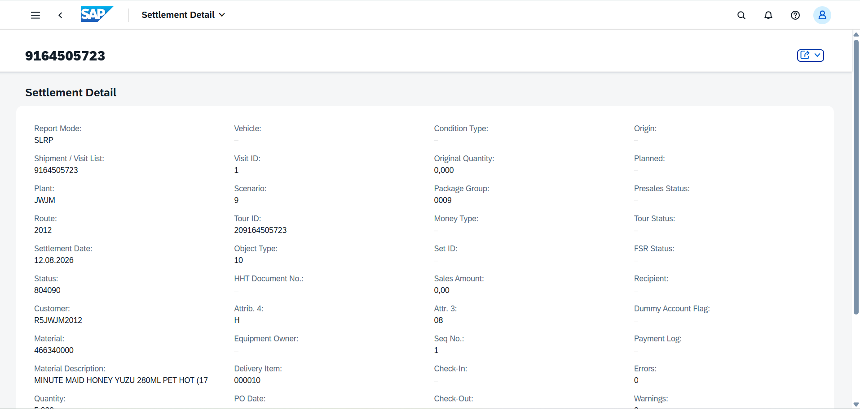

Payment Details
GUI
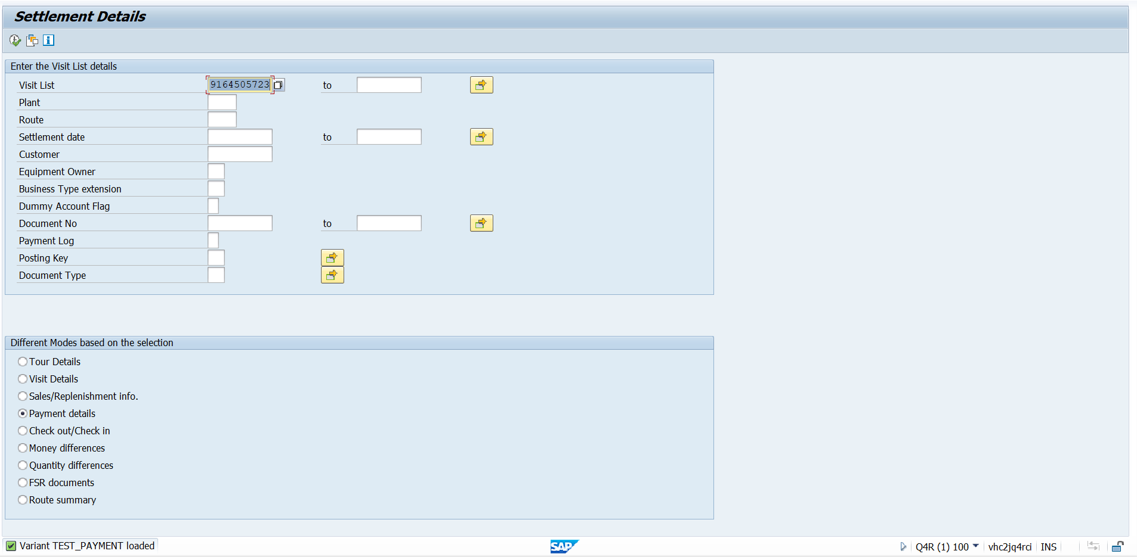

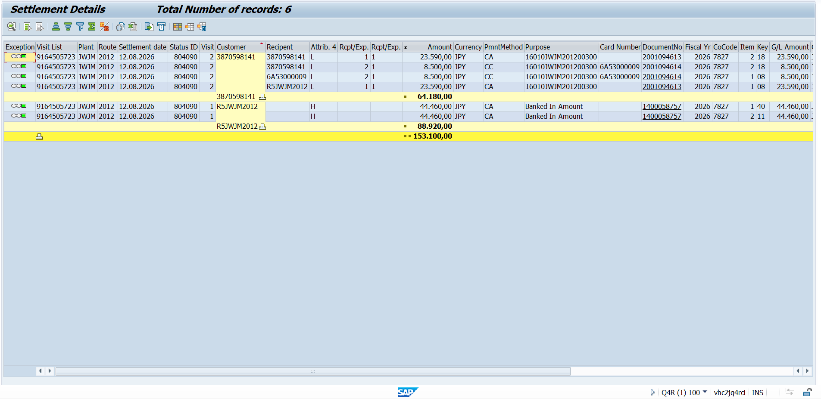

Payment Details
RAP
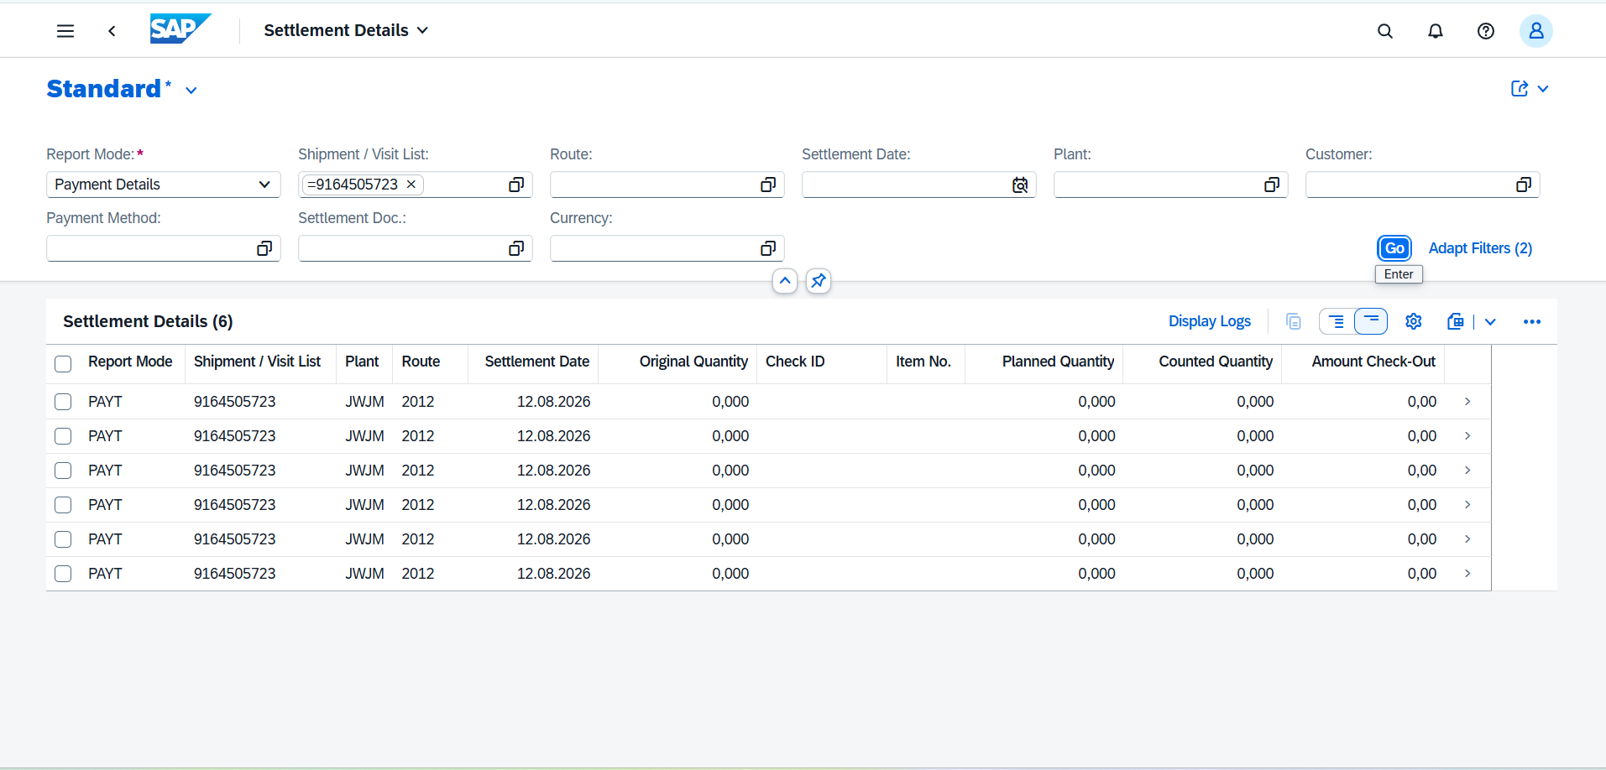

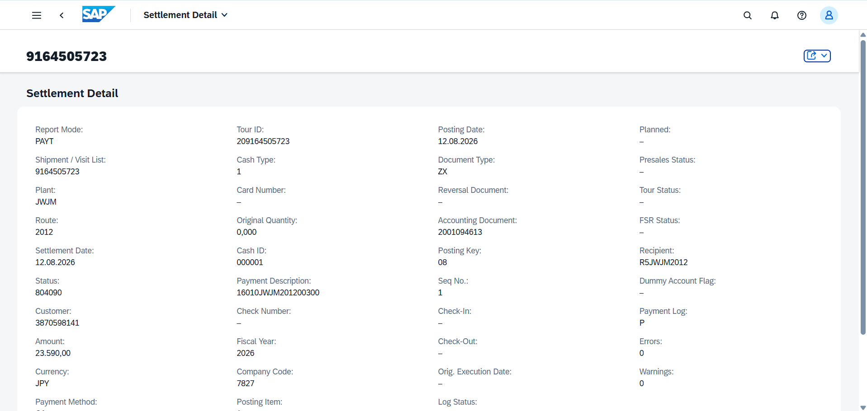

Check Out / Check In
GUI
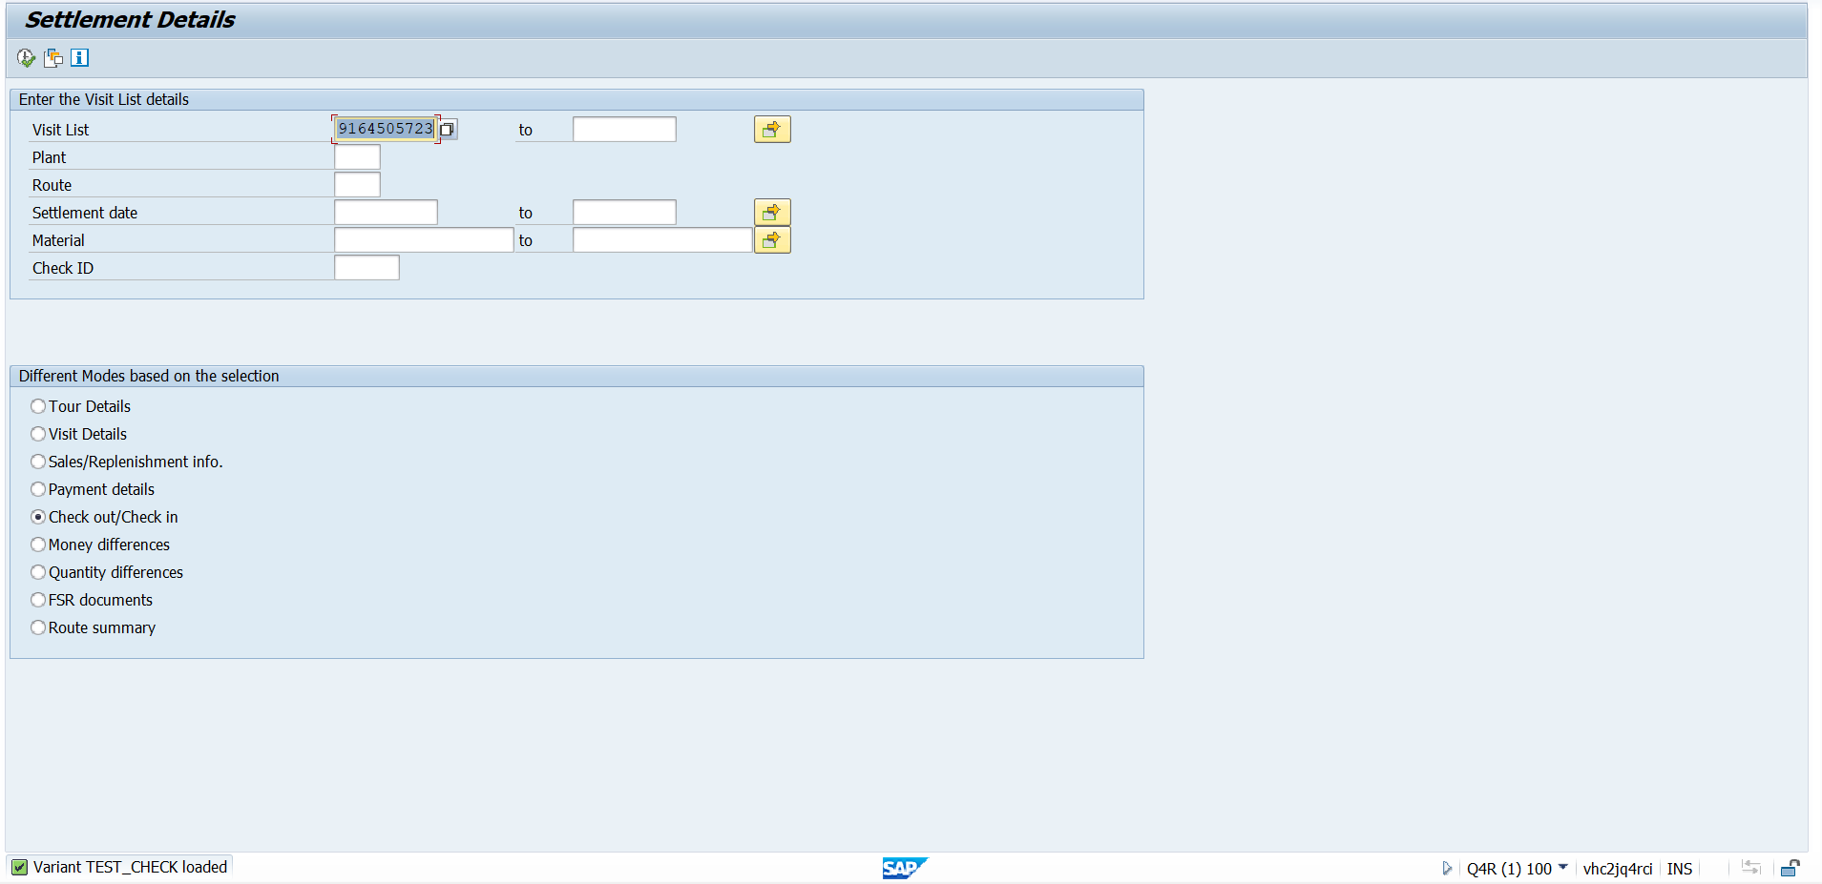

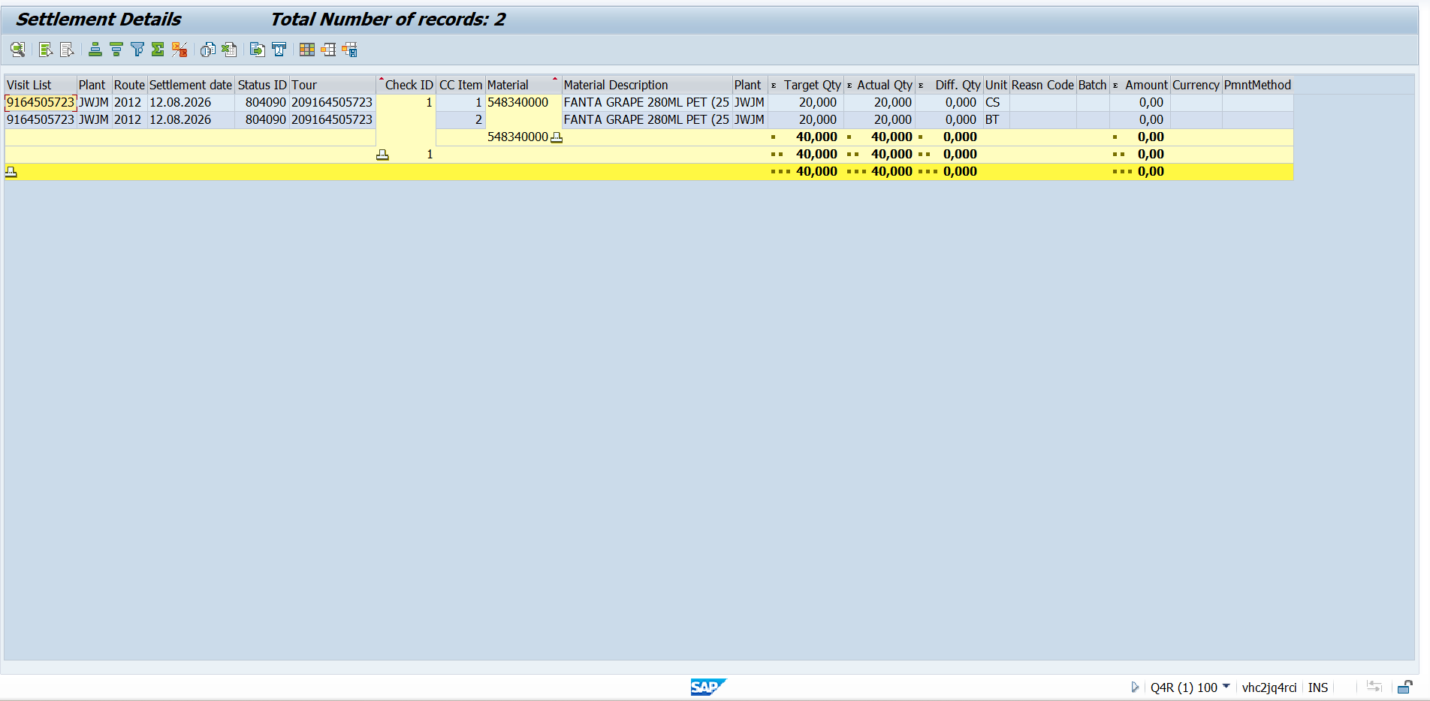

Check Out / Check In
RAP
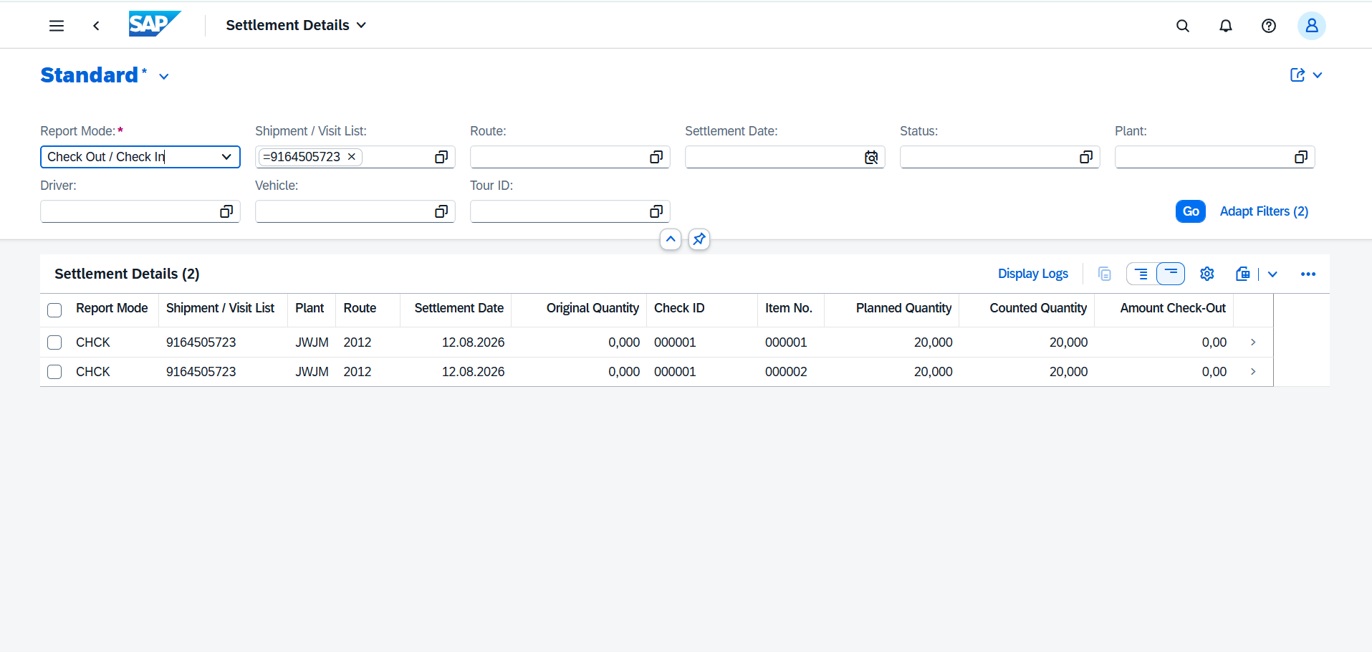

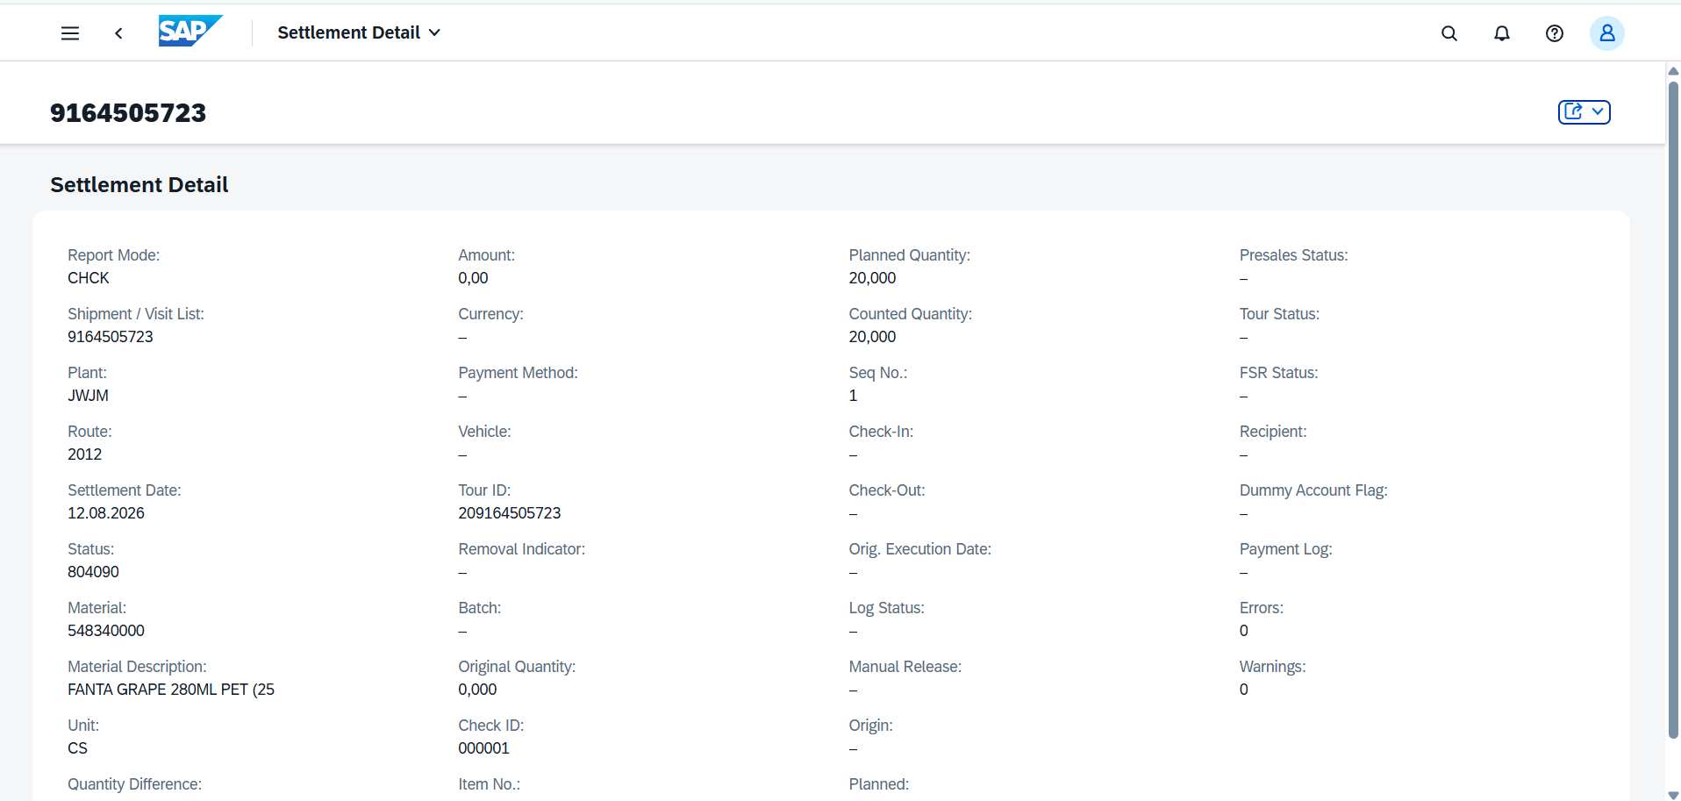

Money Differences
GUI
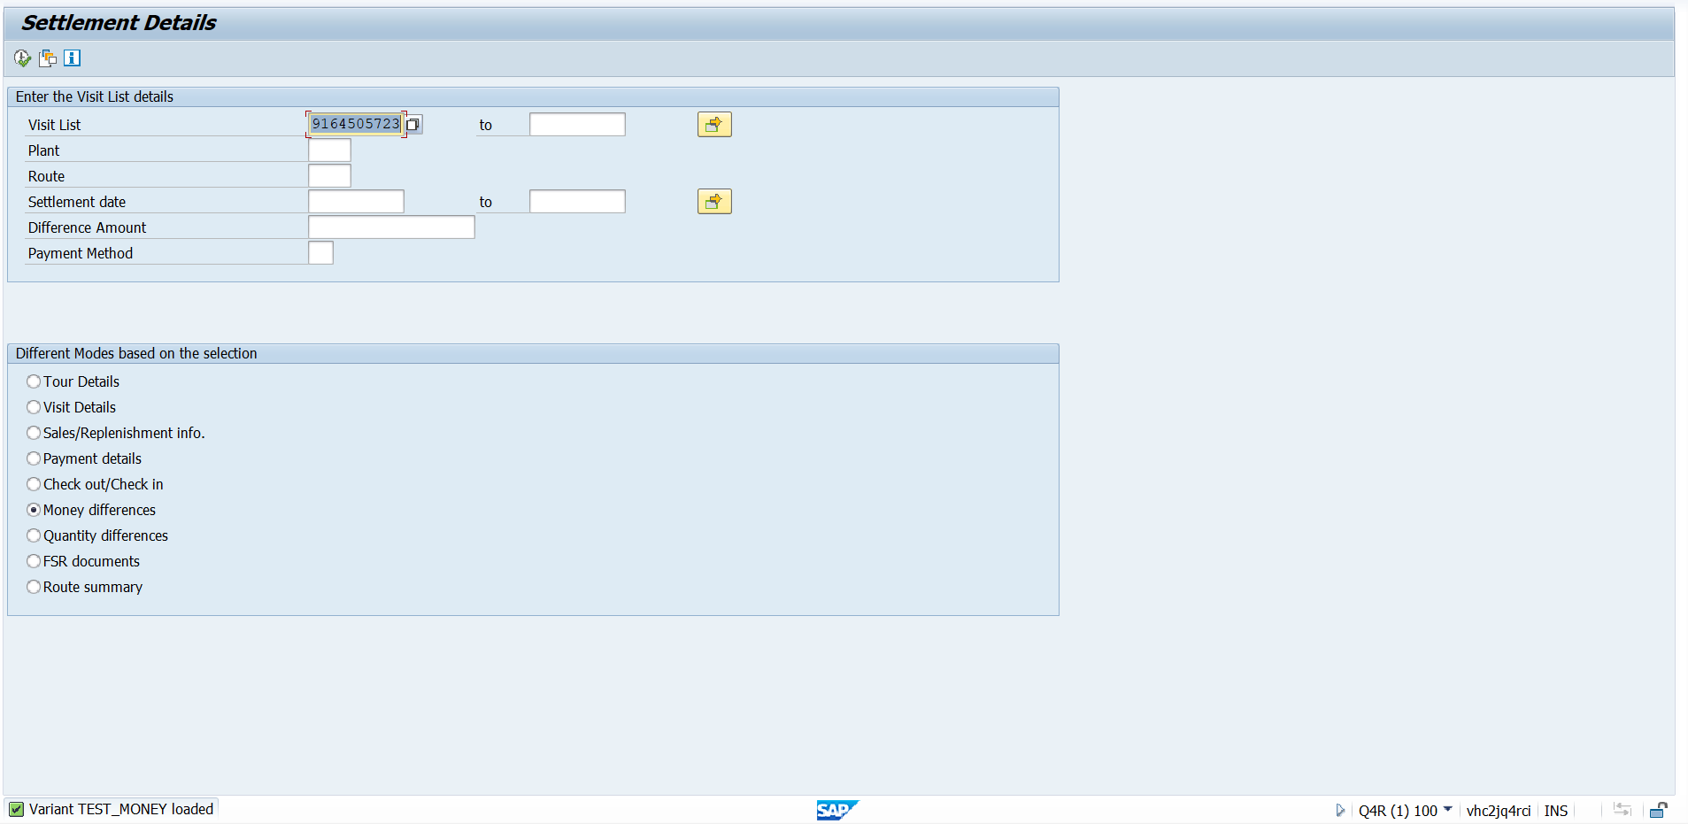

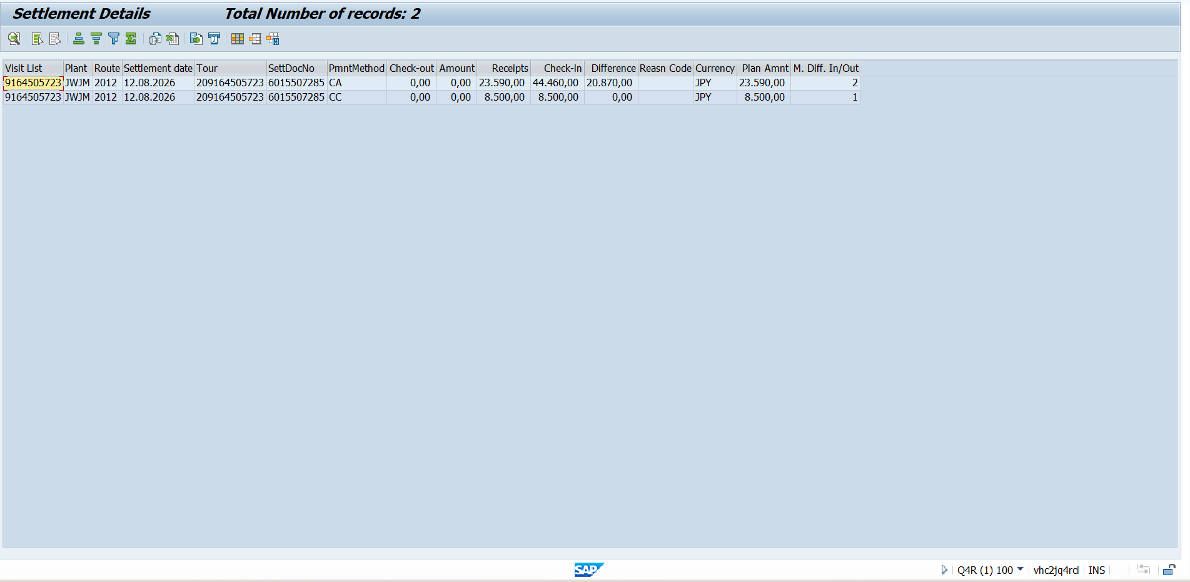

Money Differences
RAP
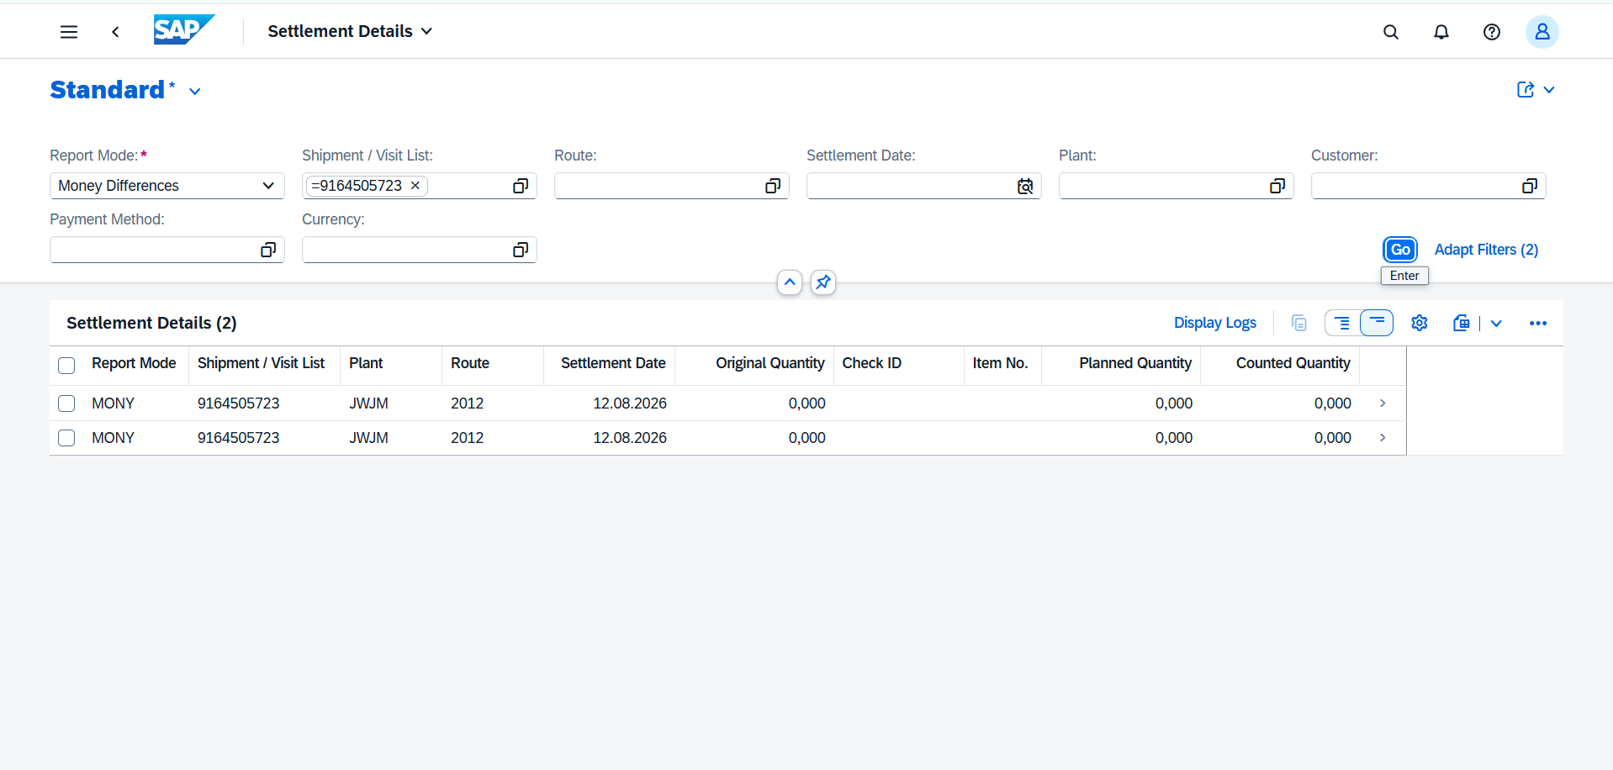

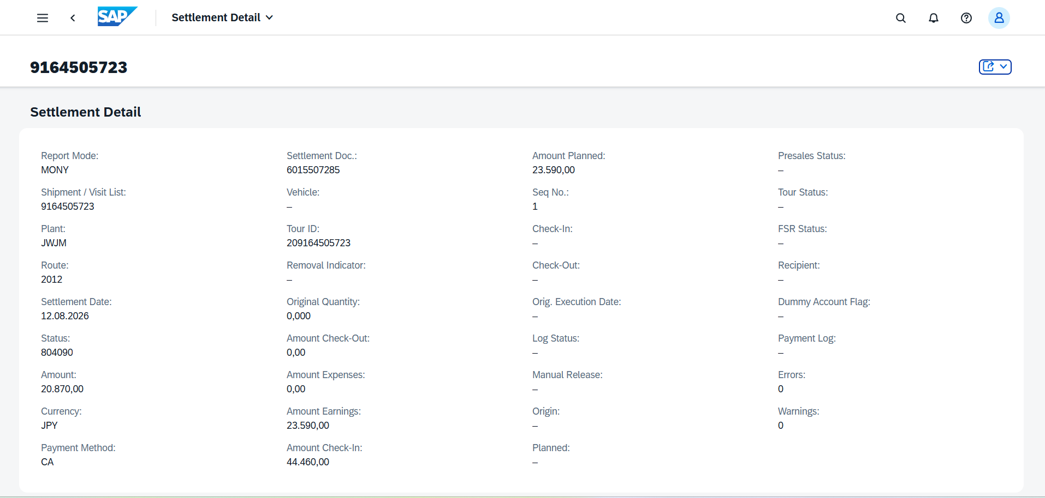

Quantity Differences
GUI
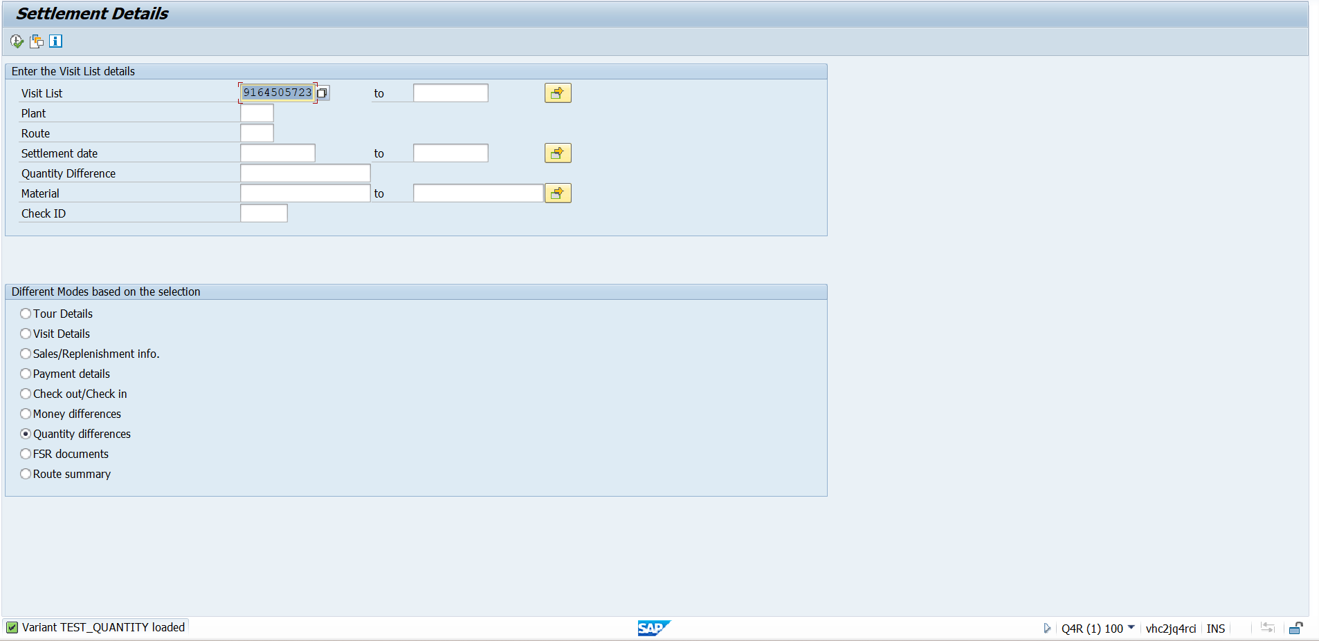

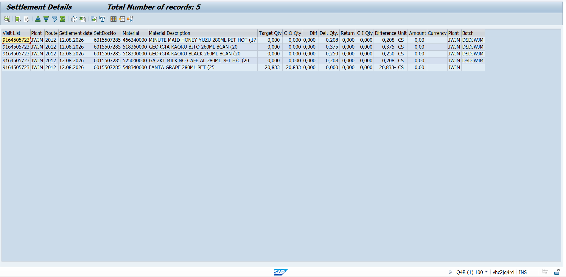

Quantity Differences
RAP
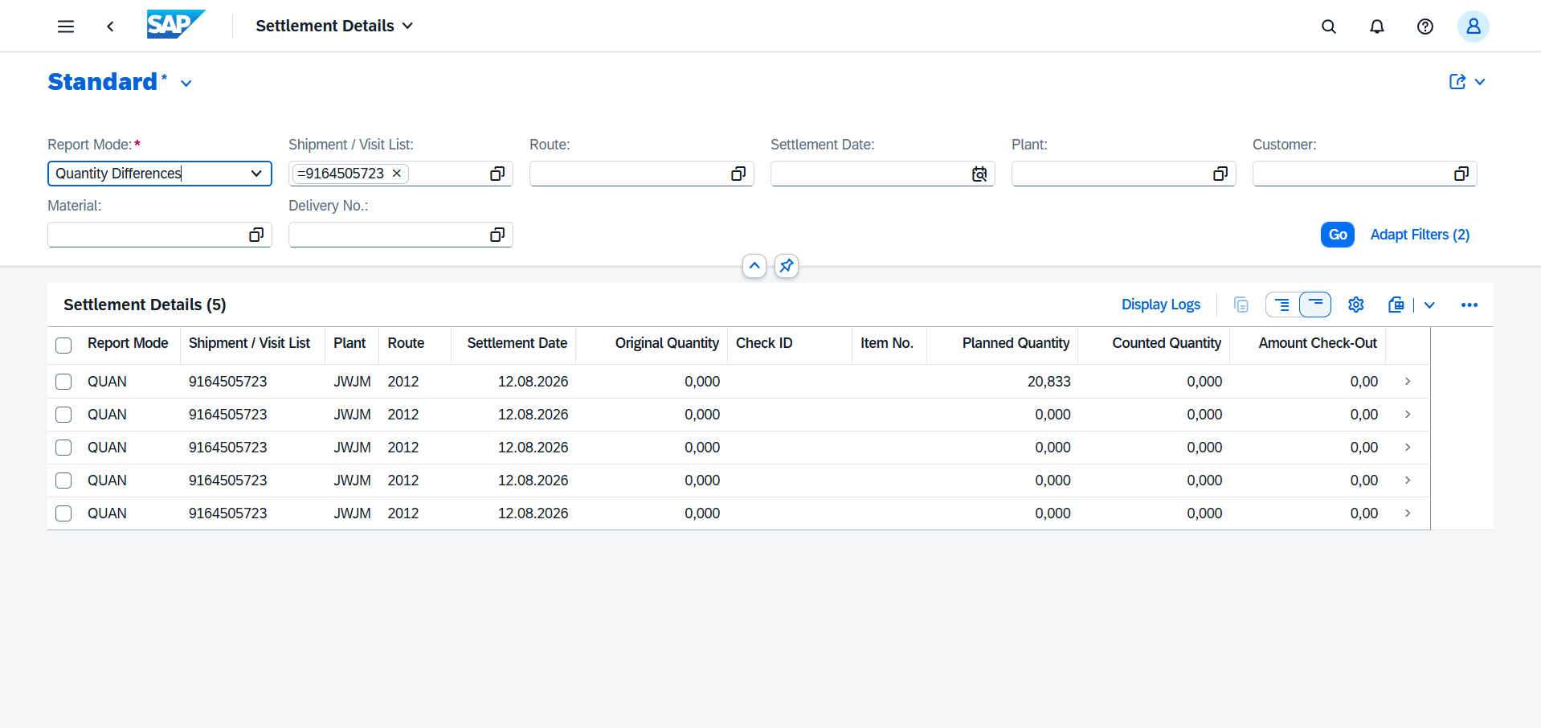

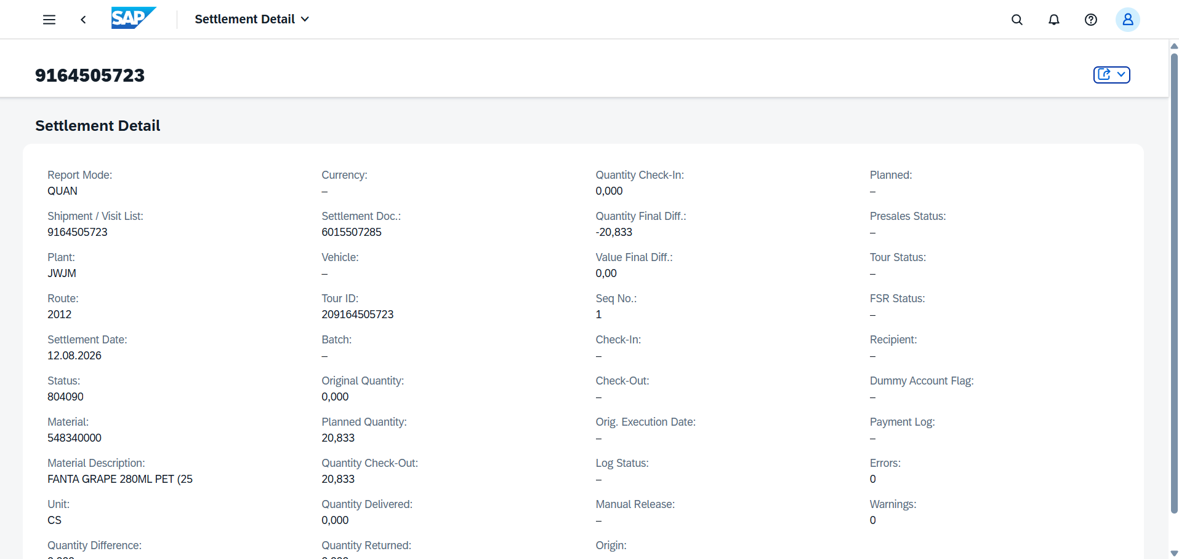

FSR Documents
GUI
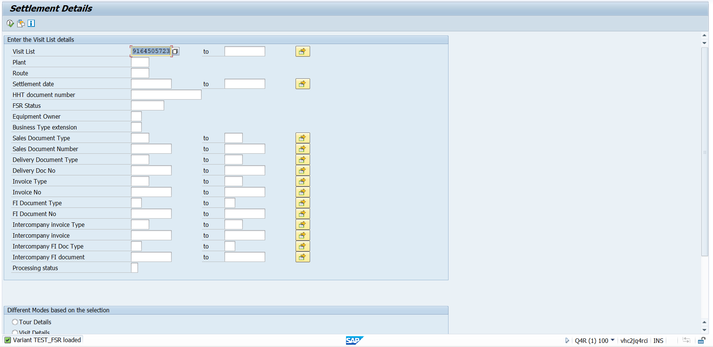

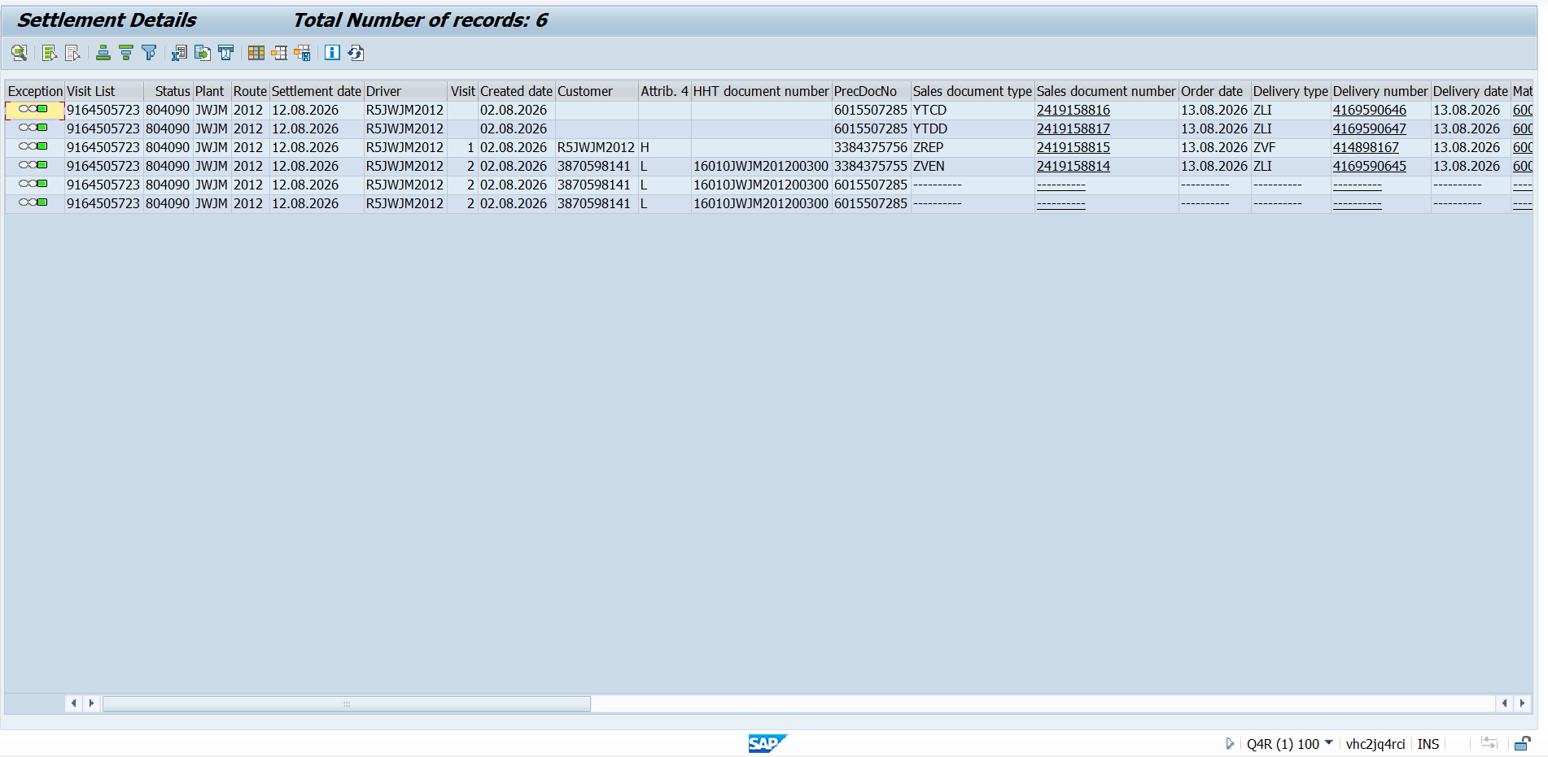

FSR Documents
RAP
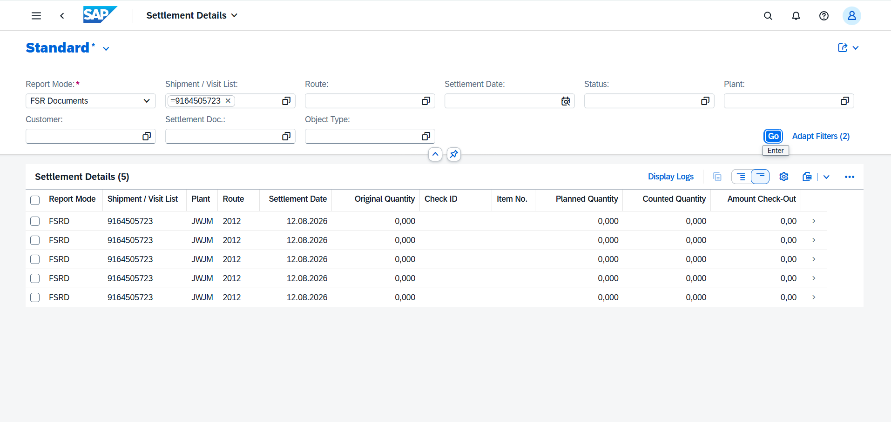

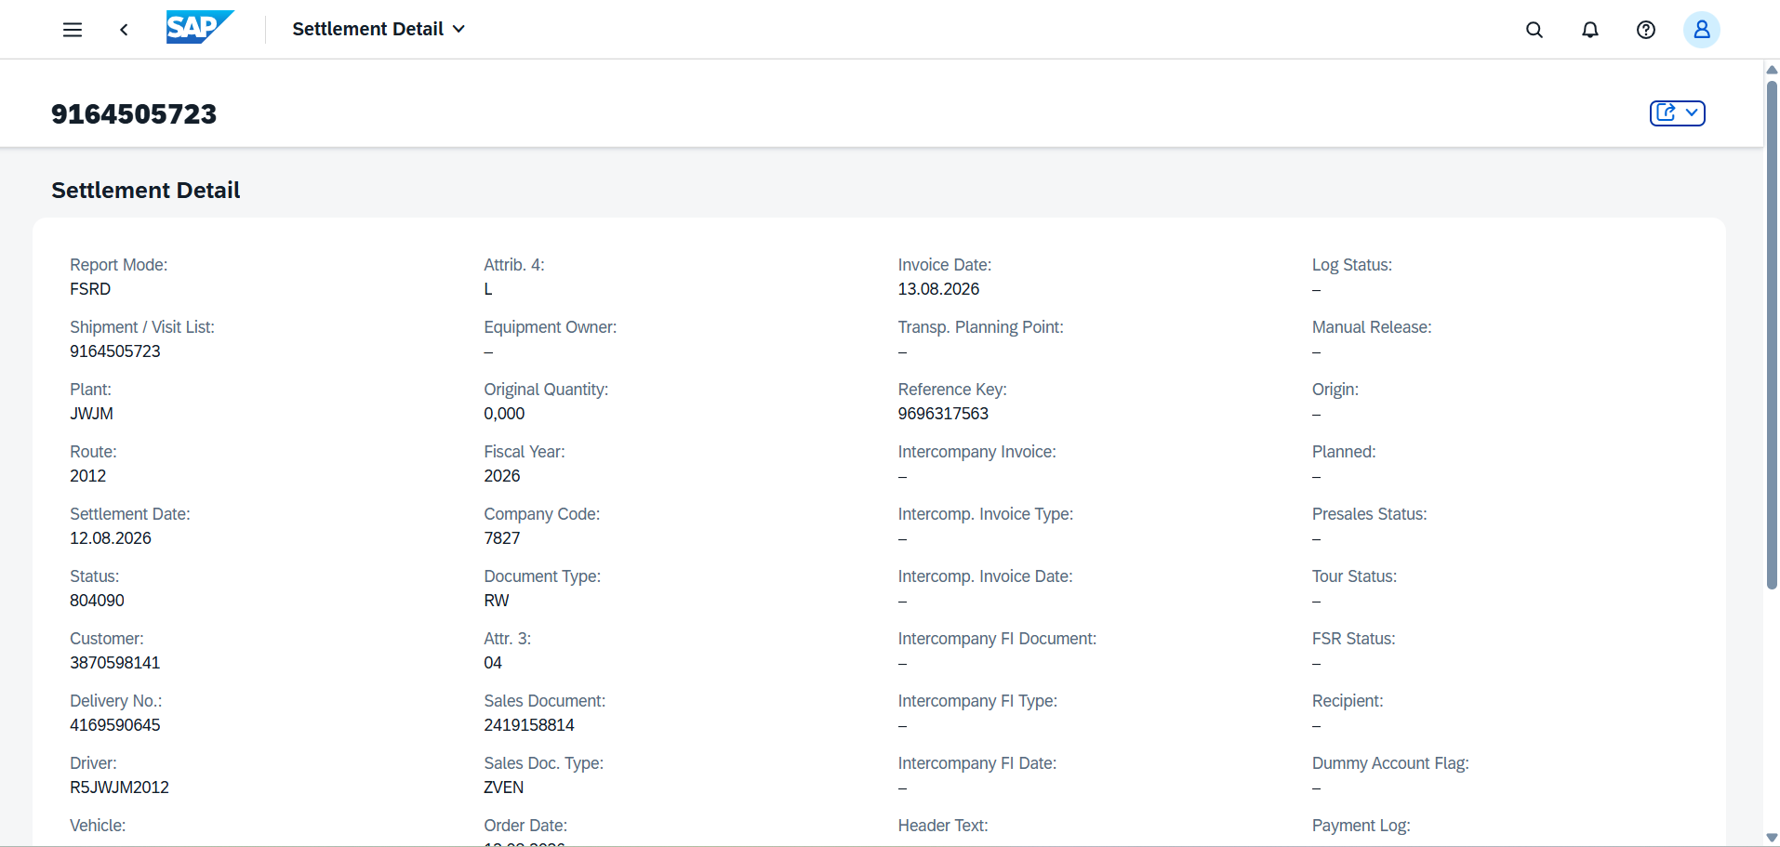

Route Summary
GUI
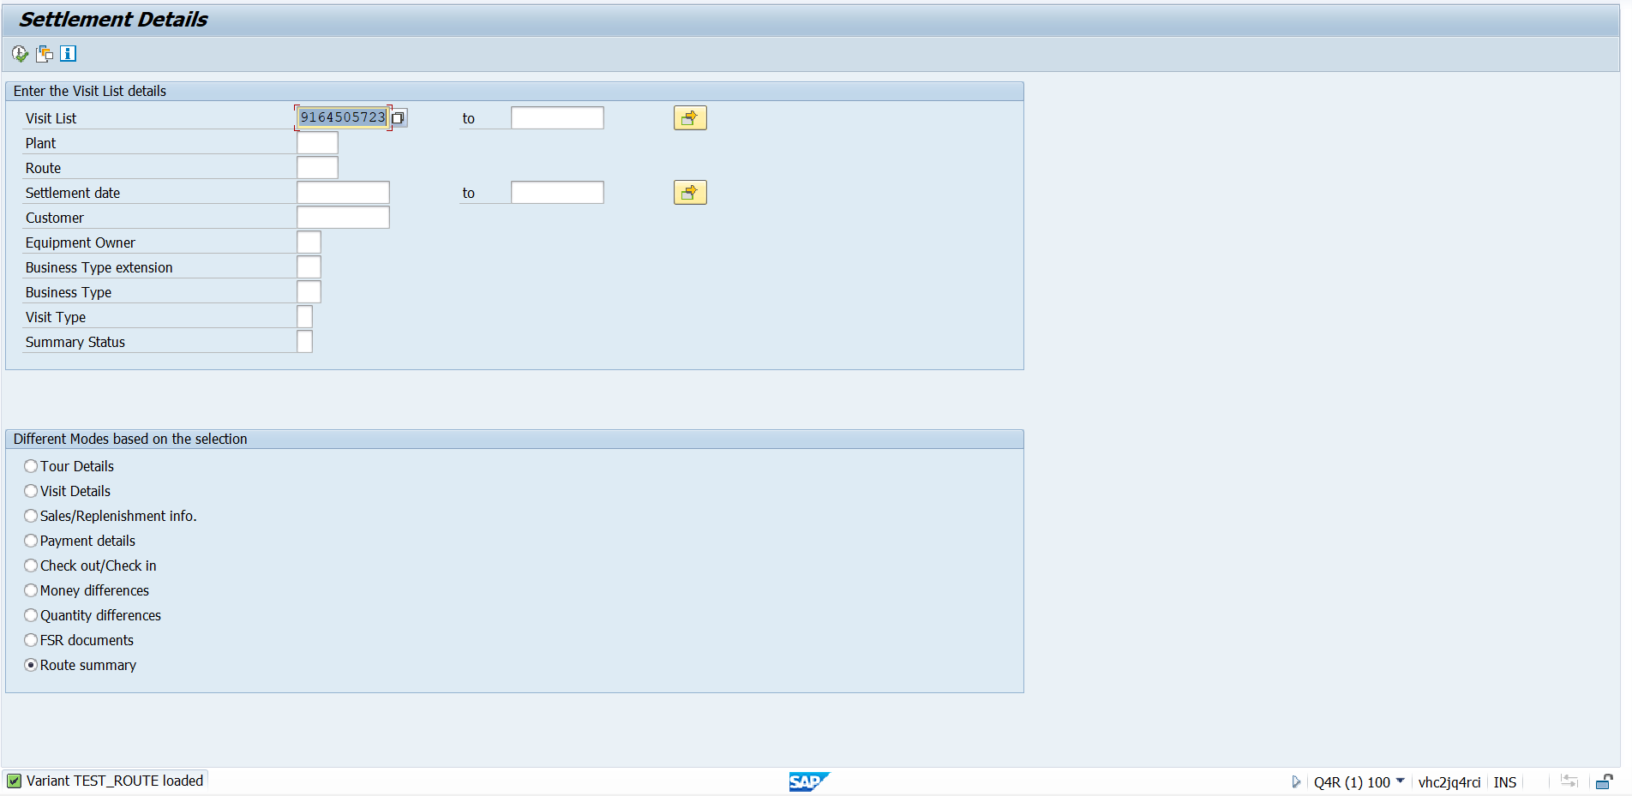

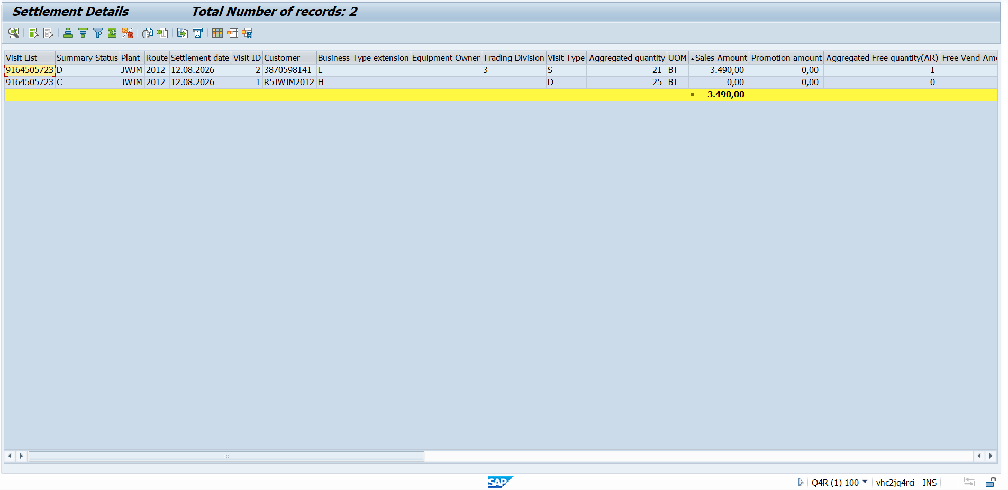

Route Summary
RAP
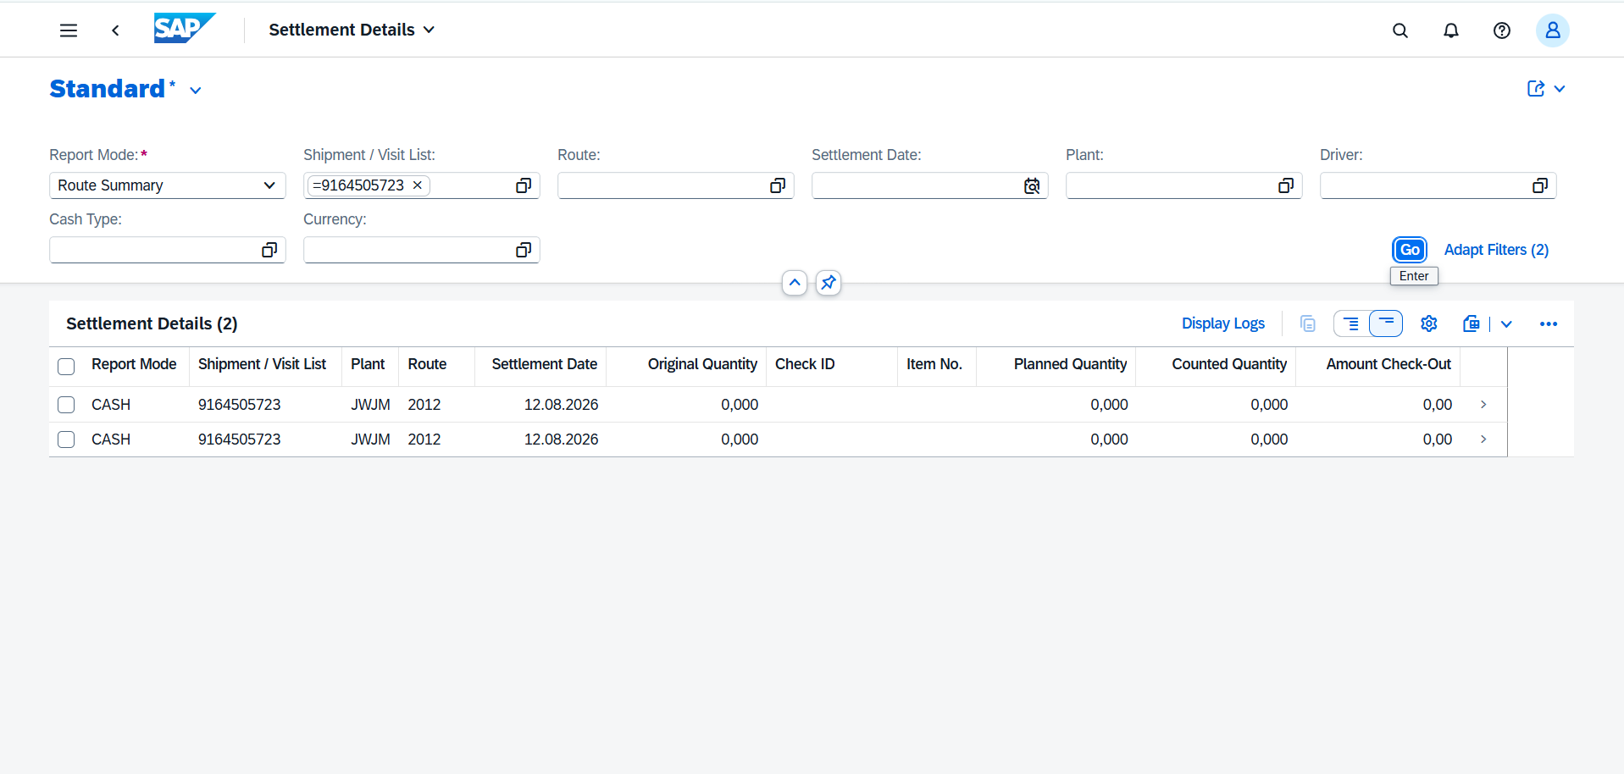

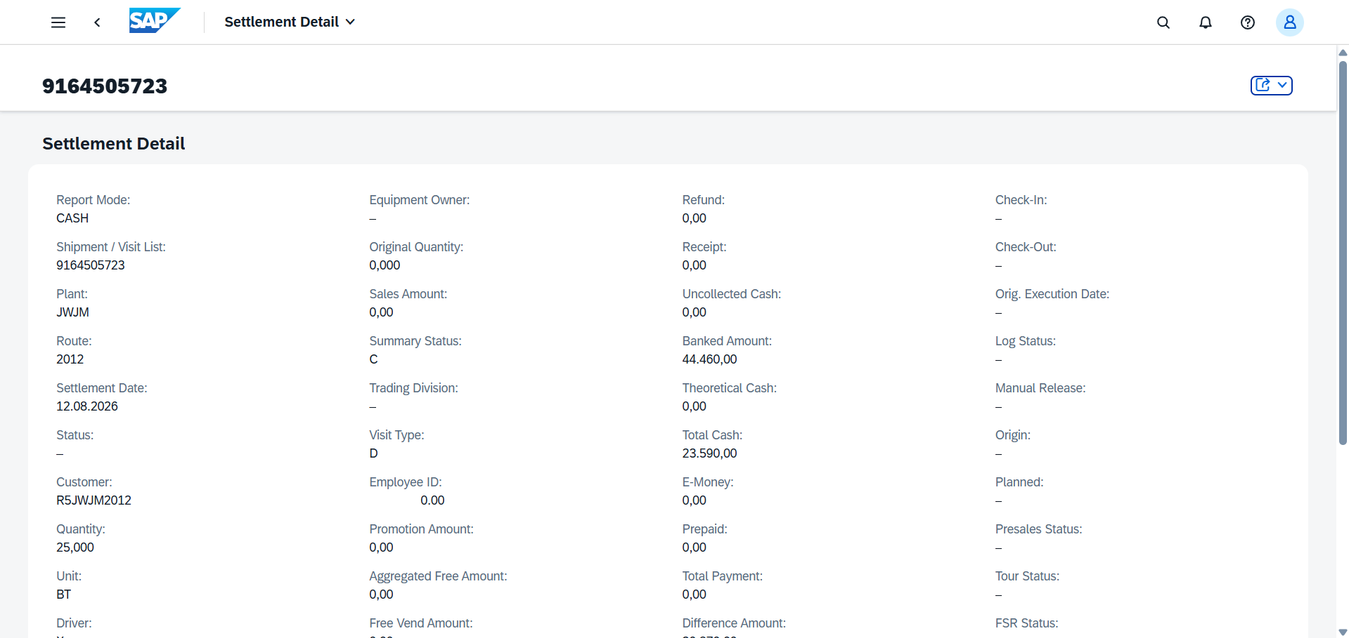

CONCLUSION
The new RAP-based Settlement Details application produces the same output as the existing SAP GUI report for all report modes, and the screen captures above confirm the comparison for the same selection input.

