# Paul, Ankush  
# 1001-830-258  
# 2021-09-11  
# Assignment-00-02

Have you taken and passed the CSE-5301 Data Analysis and Modeling Techniques course? Yes

If yes, specify the university, department, year, and the semester that you took CSE 5301:

University: University of Texas at Arlington

Department: Computer Science

Year: 2021

Semester: Spring

I, Ankush Paul have fully read and understood the syllabus".

# Syllabus

# CSE 5368 Neural Networks

# Fall 2021

## Instructor Information

### Instructor

Farhad Kamangar

### Office Number

ERB 524

### Office Telephone Number

817-272-3605

### Email Address

kamangar@cse.uta.edu

### Faculty Profile

https://mentis.uta.edu/explore/profile/farhad-kamangar

### Office Hours

Tuesdays  & Thursdays 5:30-6:45 PM (Virtual using Microsoft Teams)

## Course Information

### Section Information

CSE 5368-001. NEURAL NETWORKS

### Time and Place of Class Meetings

TuTh 7:00-8:20 PM Room TBD. This is a hybrid class. Microsoft Teams will be used for the online portion of this class.

### Description of Course Content:

CSE 5368. NEURAL NETWORKS (3-0) Theoretical principles of neurocomputing. Learning algorithms, information capacity, and mapping properties of feedforward and recurrent networks. Different neural network models will be implemented and their practical applications discussed. Prerequisite: CSE 5301 and calculus II, knowledge of a high level programming language, or consent of instructor.

### Student Learning Outcomes:

This course focuses both on the theoretical and practical aspects of neural networks. Major neural networks paradigms and concepts such as Perceptrons, Hebbian learning, performance surfaces, optimization, multi-layer networks, backpropagation, self-organizing maps, stochastic networks, Adaptive Resonance Theory, and Hopfield networks will be integrated into this course. After completing this course, students will be able to:

* Understand the concepts, and representation of the common neural network models and the most essential deep learning models and algorithms.
* Understand the mathematical foundations of deep learning and the concepts of the performance surfaces and different methods for optimizations.
* Reason about the performance of neural networks and implement neural network models for particular applications.
* Learn to implement neural networks (from scratch)
* Learn to use popular neural network libraries such as Tensorflow and Keras.
* Equip students with the skills to read papers and implement their own ideas to real world problems to do research.

### Requirements:

* Prerequisite: CSE 5301 and calculus II, working knowledge of a high level programming language, or consent of instructor.
* Be advised that this course is intended for graduate students in computer science and engineering. It is assumed that all students are comfortable with math (calculus, linear algebra, vectors, and matrices) and are proficient in high level programming languages, particularly Python.
* This class is heavy on math and programming. Please be prepared.

### Textbook:

Neural Network Design (2nd Edition),Martin T. Hagan, Howard B. Demuth, Mark H. Beale, Orlando De Jesus, ISBN-10: 0-9717321-1-6, ISBN-13: 978-0-9717321-1-7

### Supplemental Books (Recommended):

* [Deep Learning](http://www.deeplearningbook.org/) (Free online)
* [Neural Networks and Deep Learning](http://neuralnetworksanddeeplearning.com/index.html) (Free online book)
* [Deep Learning Tutorial](http://deeplearning.net/tutorial/deeplearning.pdf) (Free online)
* [Neural Networks and Learning Machines](https://cours.etsmtl.ca/sys843/REFS/Books/ebook_Haykin09.pdf) (3rd edition)
* Deep Learning Step by Step with Python: A Very Gentle Introduction to Deep Neural Networks for Practical Data Science, [N D Lewis](https://www.amazon.com/s/ref=dp_byline_sr_book_1?ie=UTF8&text=N+D+Lewis&search-alias=books&field-author=N+D+Lewis&sort=relevancerank), 2016, ISBN-10: 1535410264, ISBN-13: 978-1535410267
* Make Your Own Neural Network, [Tariq Rashid](https://www.amazon.com/s/ref=dp_byline_sr_book_1?ie=UTF8&text=Tariq+Rashid&search-alias=books&field-author=Tariq+Rashid&sort=relevancerank), 2016, ISBN-10: 1530826608, ISBN-13: 978-1530826605
* Artificial Intelligence for Humans, Volume 3: Deep Learning and Neural Networks, [Jeff Heaton](https://www.amazon.com/Jeff-Heaton/e/B001IZRB9E/ref=dp_byline_cont_book_1), 2015, ISBN-10: 1505714346, ISBN-13: 978-1505714340

### Course Schedule and Important Dates

* First day of class: Aug. 26, 2021
* Census day: Sept. 10, 2021
* Exam 1: Oct. 14, 2021. 7:00-8:30 PM. This is a Face-to-Face exam (unless UTA policies change).
* Last day to drop classes: Nov. 5, 2021
* Thanksgiving Holidays: Nov. 24-26, 2021
* Exam 2: Nov. 30, 2021 7:00-8:30 PM. This is a Face-to-Face exam (unless UTA policies change).

### Descriptions of major assignments and examinations:

This course includes online and face-to-face lectures, face-to-face exams, online and face-to-face quizzes, online and face-to-face polls, and programming assignments.

* Exams and quizzes will include theoretical and programming questions.
* Exams and quizzes will be comprehensive and shall include information from the textbook as well as information from class lectures.
* Quizzes consist of occasional, unannounced, written questions and they will be based on the assigned advance readings and class lectures.  A quiz may be given at any time during any class period. There will be no make-up quizzes. Quizzes will be given only to those students who are present at the time of the quiz.
* The lowest quiz score will be dropped (The two exams are absolutely required).
* There will be no makeup exams or quizzes. If, and only if, you have an approved written medical or university excuse for being absent from an exam or a quiz, the next scheduled exam, or quiz, shall count twice.
* All assignments will be assigned well in advance of the due date. All assignments are due at 11:59 PM on the specified date. There is a 24-hour grace period after the due date with no penalty. The purpose of the grace period is to compensate for the unforeseen events such as network or server problems. No assignment will be accepted after the grace period.
* Assignments must be submitted electronically using Canvas.
* The programming language for this class will be Python. The examples and demos in the lectures will also use the Python language. However, you may use any other programming language that you choose for submitting your assignments.
* Each assignment must be self-contained (unless it is explicitly stated otherwise), i.e. it must include all the required components to run. The teaching assistant will only use the submitted files. No additional or supplemental files may be used at the run time. In other words, your assignments must run as submitted.
* Programs that do not run will receive no credit (No partial credits).
* Programs that implement some, but not all, of the requirements may receive partial credit. However, these programs must still run without errors.
* It is each student's responsibility to completely test their program PRIOR to submission and make sure that it executes without error(s) as submitted.
* All assignments are graded as submitted. Once the submission deadline is passed no changes or modification can be made to the submitted files. Note that you may submit your assignments as many times as you want before the deadline.

### Technology Requirements:

Canvas will be an important resource throughout the semester, so you will need to be proficient in the use of Canvas to perform well. Your assignments, grades, and other multimedia files will be posted through Canvas. Make sure you have access to Canvas. Canvas support is available 24/7 by calling 1-855-597-3401 or by clicking on the “?” icon on your Canvas Dashboard.

Microsoft Teams will be used for lectures and office hours. Microsoft Teams is available to all employees and students at The University of Texas at Arlington.  [Download Teams](https://teams.microsoft.com/downloads) to your device.

Your computer must have a webcam, internet access, a word processor, and a microphone.

## General Policies:

* **Your opinion matters.**All constructive suggestions will be seriously considered. However, your suggestions should be applicable to all students in the class and not to a particular group or individual. **Please do not ask for any exception.**
* All announcements will be communicated via email. You are responsible for checking your email.

## Grading Information

Grades will be calculated based on the following percentages:

|  |  |
| --- | --- |
| Assignments | 10% |
| Quizzes and polls | 30% |
| Exam 1 | 30% |
| Exam 2 | 30% |

Letter grades are assigned as follows:

|  |  |
| --- | --- |
| 87%–100% | A |
| 75%–87% | B |
| 65%–75% | C |
| 55%–65% | D |
| 0%–55% | F |

* There will be **no curves** and the letter grades will be absolutely based on the table shown above. Multiple studies have shown that grading on a curve discourages studying. The problem with grading curves is that they are not applied until the end of a semester. This uncertainty may lead to high stress levels and leaves students with no idea where they stand in a course or what it will take to get a certain grade.
* All the grades and assignment will be posted on Canvas and students are expected to keep track of their performance throughout the semester and seek guidance from the instructor if their performance drops below satisfactory levels.

### Make-up Exams

There are no make-up exams. If, and only if, you have an approved written medical or university excuse for being absent from an exam or a quiz, the next scheduled exam, or quiz, shall count twice.

### Expectations for Out-of-Class Study:

Beyond the time required to attend each class meeting, students enrolled in this course should expect to spend at least an additional 12 hours per week of their own time in course-related activities, including reading required materials, completing assignments, preparing for exams, etc.

### Grade Grievances:

Any appeal of a grade in this course must follow the procedures and deadlines for grade-related grievances as published in the current University Catalog.

[Undergraduate Grading Policies](http://catalog.uta.edu/academicregulations/grades/#undergraduatetext)

[Graduate Grading Policies](http://catalog.uta.edu/academicregulations/grades/#graduatetext)

[Student Complaints](http://www.uta.edu/deanofstudents/complaints/index.php)

### Incomplete Grades

No incomplete shall be given in this course, except if you miss the last exam with a university approved letter.

No special make-up work will be accepted after the end of the semester. In the event of a documented major medical problem, with a university approved letter, a grade of Incomplete will be given pending the submission of complete work. However, make-up work “to improve one’s grade” will not be accepted.

### Drops

Students may drop or swap (adding and dropping a class concurrently) classes through self-service in MyMav from the beginning of the registration period through the late registration period. After the late registration period, students must see their academic advisor to drop a class or withdraw. Undeclared students must see an advisor in the University Advising Center. Drops can continue through a point two-thirds of the way through the term or session. It is the student's responsibility to officially withdraw if they do not plan to attend after registering. **Students will not be automatically dropped for non-attendance**. Repayment of certain types of financial aid administered through the University may be required as the result of dropping classes or withdrawing. For more information, contact the Office of Financial Aid and Scholarships (<http://wweb.uta.edu/aao/fao/>).

## Institution Information

UTA students are encouraged to review the below institutional policies and informational sections and reach out to the specific office with any questions. To view this institutional information, please visit the [Institutional Information](https://resources.uta.edu/provost/course-related-info/institutional-policies.php) page which includes the following policies among others:

* Drop Policy
* Disability Accommodations
* Title IX Policy
* Academic Integrity
* Student Feedback Survey

## Additional Information

### Face Covering Policy

While the use of face coverings on campus is no longer mandatory, all students and instructional staff are strongly encouraged to wear face coverings while they are on campus. This is particularly true inside buildings and within classrooms and labs where social distancing is not possible due to limited space. If a student needs accommodations to ensure social distancing in the classroom due to being at high risk they are encouraged to work directly with the Student Access and Resource Center to assist in these accommodations. If students need masks, they may obtain them at the Central Library, the E.H. Hereford University Center’s front desk or in their department.

### Attendance:

At The University of Texas at Arlington, taking attendance is not required but attendance is a critical indicator in student success. Each faculty member is free to develop his or her own methods of evaluating students’ academic performance, which includes establishing course-specific policies on attendance. As the instructor of this section, I will not take attendance. However, while UT Arlington does not require instructors to take attendance in their courses, the U.S. Department of Education requires that the University have a mechanism in place to mark when Federal Student Aid recipients “begin attendance in a course.” UT Arlington instructors will report when students begin attendance in a course as part of the final grading process. Specifically, when assigning a student a grade of F, faculty report the last date a student attended their class based on evidence such as a test, participation in a class project or presentation, or an engagement online via Canvas. This date is reported to the Department of Education for federal financial aid recipients.

This is a Tuesday/Thursday hybrid course that rotates students through the face-to-face sessions (Unless UTA policy changes). For the face-to-face part of the class, half the class meets on Tuesday face-to-face, and the other half meets online. On Thursday, students switch.

### Emergency Exit Procedures:

Should we experience an emergency event that requires evacuation of the building, students should exit the room and move toward the nearest exit. When exiting the building during an emergency, do not take an elevator but use the stairwells instead. Faculty members and instructional staff will assist students in selecting the safest route for evacuation and will make arrangements to assist individuals with disabilities.

[Evacuation Route Maps (Buildings)](http://www.uta.edu/campus-ops/ehs/fire/Evac_Maps_Buildings.php).

[Emergency/Fire Evacuation Procedures](http://www.uta.edu/police/Evacuation%20Procedures.pdf).

[Emergency Communication System](https://www.uta.edu/uta/emergency.php)

### Emergency Phone Numbers:

In case of an on-campus emergency, call the UT Arlington Police Department at 817-272-3003 (non-campus phone), 2-3003 (campus phone). You may also dial 911. Non-emergency number 817-272-3381

### Disability Accommodations:

UTArlington is on record as being committed to both the spirit and letter of all federal equal opportunity legislation, including *The Americans with Disabilities Act (ADA), The Americans with Disabilities Amendments Act (ADAAA),* and *Section 504 of the Rehabilitation Act.* All instructors at UT Arlington are required by law to provide “reasonable accommodations” to students with disabilities, so as not to discriminate on the basis of disability. Students are responsible for providing the instructor with official notification in the form of **a letter certified** by the Office for Students with Disabilities (OSD).Only those students who have officially documented a need for an accommodation will have their request honored. Students experiencing a range of conditions (Physical, Learning, Chronic Health, Mental Health, and Sensory) that may cause diminished academic performance or other barriers to learning may seek services and/or accommodations by contacting: **The Office for Students with Disabilities, (OSD)** [www.uta.edu/disability](http://www.uta.edu/disability) or calling 817-272-3364. Information regarding diagnostic criteria and policies for obtaining disability-based academic accommodations can be found at [www.uta.edu/disability](http://www.uta.edu/disability). Counseling and Psychological Services, (CAPS) or calling 817-272-3671 is also available to all students to help increase their understanding of personal issues, address mental and behavioral health problems and make positive changes in their lives.

Counseling and Psychological Services (CAPS):

[www.uta.edu/caps/](http://www.uta.edu/caps/) or calling 817-272-3671 is also available to all students to help increase their understanding of personal issues, address mental and behavioral health problems and make positive changes in their lives.

### Non-Discrimination Policy:

The University of Texas at Arlington does not discriminate on the basis of race, color, national origin, religion, age, gender, sexual orientation, disabilities, genetic information, and/or veteran status in its educational programs or activities it operates. For more information, visit [uta.edu/eos](http://www.uta.edu/hr/eos/index.php).

### Title IX Policy:

The University of Texas at Arlington (“University”) is committed to maintaining a learning and working environment that is free from discrimination based on sex in accordance with Title IX of the Higher Education Amendments of 1972 (Title IX), which prohibits discrimination on the basis of sex in educational programs or activities; Title VII of the Civil Rights Act of 1964 (Title VII), which prohibits sex discrimination in employment; and the Campus Sexual Violence Elimination Act (SaVE Act). Sexual misconduct is a form of sex discrimination and will not be tolerated.*For information regarding Title IX, visit* or contact Ms. Jean Hood, Vice President and Title IX Coordinator at (817) 272-7091 or jmhood@uta.edu.

### Academic Integrity:

All students enrolled in this course are expected to adhere to the UT Arlington Honor Code:

I pledge, on my honor, to uphold UT Arlington’s tradition of academic integrity, a tradition that values hard work and honest effort in the pursuit of academic excellence.

I promise that I will submit only work that I personally create or contribute to group collaborations, and I will appropriately reference any work from other sources. I will follow the highest standards of integrity and uphold the spirit of the Honor Code.

UT Arlington faculty members may employ the Honor Code in their courses by having students acknowledge the honor code as part of an examination or requiring students to incorporate the honor code into any work submitted. Per UT System *Regents’ Rule* 50101, §2.2, suspected violations of university’s standards for academic integrity (including the Honor Code) will be referred to the Office of Student Conduct. Violators will be disciplined in accordance with University policy, which may result in the student’s suspension or expulsion from the University. Additional information is available at <https://www.uta.edu/conduct/>.

All students are expected to pursue their academic careers with honesty and integrity. “Scholastic dishonesty includes, but is not limited to, cheating, plagiarism, collusion, the submission for credit of any work or materials that are attributable in whole or in part to another person, taking an examination for another person, any act designed to give unfair advantage to a student or the attempt to commit such acts” (Regents’ Rules and Regulations, Part One, Chapter VI, Section 3, Subsection 3.2, Subdivision 3.22.). Students found guilty of dishonesty in their academic pursuits are subject to penalties that may include suspension from the university. **Any student found guilty of academic dishonesty will receive a -100% for that work (exams, assignments, project, etc.) as well as having the course grade lowered one full letter grade - in addition to any other penalties assessed (suspension, expulsion, probation).** These and other applying UTA rules, will be strictly enforced. Any case of academic dishonesty will be treated in accordance with the UTA Handbook of Operating Procedures or the Judicial Affairs. If you do not understand this policy, it is your responsibility to obtain clarification or any additional information you may require. Students are not allowed to:

* Collaborate with others on the code they write
* Copy any part of someone else's program, even if they have permission and/or have modified the code
* Share or give their code, or even a subset of the code to, another student
* Review another student’s solution (including from past semesters)
* All work turned in for grading must be the student's own work.

### Electronic Communication:

UT Arlington has adopted MavMail as its official means to communicate with students about important deadlines and events, as well as to transact university-related business regarding financial aid, tuition, grades, graduation, etc. All students are assigned a MavMail account and are responsible for checking the inbox regularly. There is no additional charge to students for using this account, which remains active even after graduation. Information about activating and using MavMail is available at <http://www.uta.edu/oit/cs/email/mavmail.php>.

### Campus Carry:

Effective August 1, 2016, the Campus Carry law (Senate Bill 11) allows those licensed individuals to carry a concealed handgun in buildings on public university campuses, except in locations the University establishes as prohibited. Under the new law, openly carrying handguns is not allowed on college campuses. For more information, visit <http://www.uta.edu/news/info/campus-carry/>

### Student Feedback Survey:

At the end of each term, students enrolled in face-to-face and online classes categorized as “lecture,” “seminar,” or “laboratory” are directed to complete an online Student Feedback Survey (SFS). Instructions on how to access the SFS for this course will be sent directly to each student through MavMail approximately 10 days before the end of the term. Each student’s feedback via the SFS database is aggregated with that of other students enrolled in the course. Students’ anonymity will be protected to the extent that the law allows. UT Arlington’s effort to solicit, gather, tabulate, and publish student feedback is required by state law and aggregate results are posted online. Data from SFS is also used for faculty and program evaluations. For more information, visit <http://www.uta.edu/sfs>.

## Course Overview

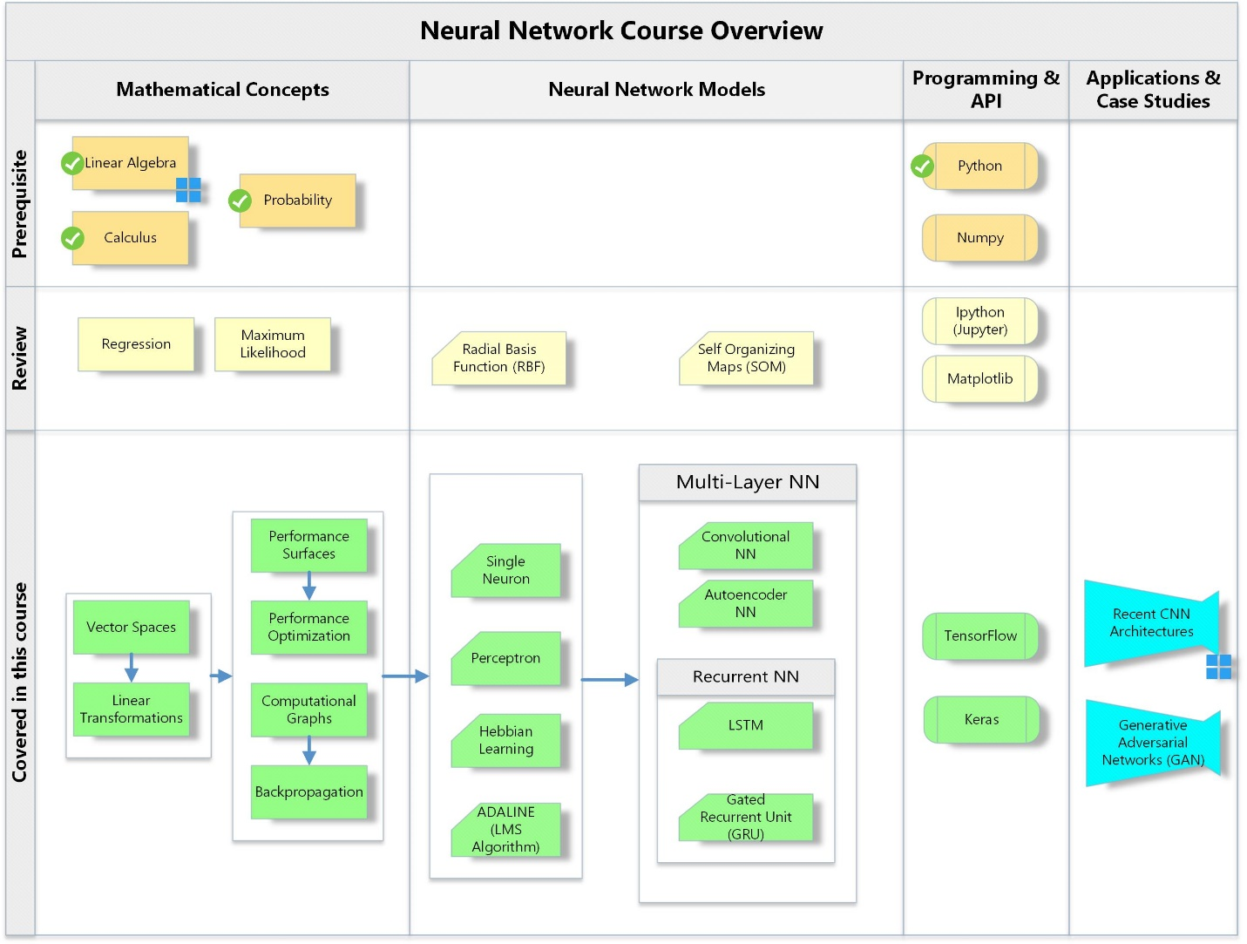

## Course Schedule:

|  |  |
| --- | --- |
| Introduction  * Introduction to Python, Numpy, Matplotlib * Definitions * Historical background * Theoretical background * Matrix operations * Relationship to biological networks * Anatomy of a single neuron | Week 1 |
| Neuron Model and Network Architectures  * Artificial Neural Networks * Single neuron and single layer of neurons. * Inside an artificial neuron * Transfer functions * Multiple neurons * Topology of neural network architectures * Recurrent neural networks | Week 2 |
| Regression (Linear & Logistic)Perceptrons  * Definition * Learning rules * Convergence * Applications | Week 3 |
| Computational GraphsVector Spaces and Linear Transformations  * Vectors * Linear transformations * Matrix operations * Eigenvalues and Eigenvectors * Orthogonalization and diagnolization | Week 4 |
| Introduction to TensorFlow and KerasHebbian Learning  * Linear associator * The Hebb rule * Variations of Hebbian learning | Week 5 |
| Performance Surface and Optimization  * Tyler series * Directional Derivatives * Performance / cost functions * Quadratic functions (Eigensystem, Hessian) * MSE, Softmax, … * Steepest descent * Conjugate gradient | Week 6 |
| Multi-Layer Networks  * Backpropagation * Convolutional Neural Networks * Recurrent Neural Networks * Self-Organizing map * Raidal Basis Functions (RBF) | Week 7-10 |
| Applications of neural networks  * Pattern recognition & computer vision * Practical Considerations * Generative Adversarial Networks (GAN) * LSTM * GRU * AlexNet, GoogleNet, and ResNet * Visualization * Time series forecasting | Week 11-.. |

As the instructor for this course, I reserve the right to adjust this schedule in any way that serves the educational needs of the students enrolled in this course. –Farhad Kamangar.