

**Python Laboratory**

**(BTCS 513-18)**

**B.Tech CSE 5th**

**2022 Odd**

**CT GROUP OF INSTITUTIONS,**

**Maqsudan**

**Prepared by:**

**Name: Ankush Kumar**

**Class: Btech CSE**

**Roll no: 2021963**

**College: Ct group of institutions, Maqsudan**

|  |  |  |
| --- | --- | --- |
| http://www.ctgroup.in/images/audi/cell/CT%20Logo%20Final.png | **CT Group of Institutions, Maqsudan** | **Department: B.TECH CSE** |
| **Subject Name: Python Lab** | **Subject Code:**  **BTCS 513-18** |
| **Course-Semester: B.TECH CSE 5th** | **Faculty Name/Lab Instructor: Mrs. Priyanka Gotter**  **Mr. Prince Verma** |

**INDEX**

|  |  |  |  |  |
| --- | --- | --- | --- | --- |
| **S. No.** | **Experiment Description** | **Experiment Number**  **CT-Subject-Number**  **(ct-mp-01)** | **Page No** | **Remarks** |
| **1** | **Write a program to demonstrate different number data types in Python**. | **cT-Python LAB-01** |  |  |
| **2** | **Write a program to perform different Arithmetic Operations on numbers in Python**. | **cT-Python Lab-02** |  |  |
| **3** | **Write a program to create, concatenate and print a string and accessing sub-string from a given string.** | **cT-Python Lab-03** |  |  |
| **4** | **Write a python script to print the current date in the following format “Sun May 29 02:26:23 IST 2017”** | **cT-Python Lab-04** |  |  |
| **5** | **Write a program to create, append, and remove lists in python.** | **cT-Python Lab-05** |  |  |
| **6** | **Write a program to demonstrate working with tuples in python.** | **cT-Python Lab-06** |  |  |
| **7** | **Write a program to demonstrate working with dictionaries in python.** | **cT-Python Lab-07** |  |  |
| **8** | **Write a python program to find largest of three numbers.** | **cT-Python Lab-08** |  |  |
| **9** | **Write a Python program to convert temperatures to and from Celsius, Fahrenheit. [ Formula: c/5 = f-32/9]** | **cT-Python Lab-09** |  |  |
| **10** | **Write a Python program to construct the following pattern of *, using a nested for loop** | **cT-Python Lab-10** |  |  |
| **11** | **Write a Python script that prints prime numbers less than 20.** | **cT-Python Lab-11** |  |  |
| **12** | **Write a python program to find factorial of a number using Recursion** | **cT-Python Lab-12** |  |  |
| **13** | **Write a program that accepts the lengths of three sides of a triangle as inputs. The program output should indicate whether or not the triangle is a right triangle (Recall from the Pythagorean Theorem that in a right triangle, the square of one side equals the sum of the squares of the other two sides).** | **cT-Python LAB-13** |  |  |
| **14** | **Write a python program to define a module to find Fibonacci Numbers and import the module to another program.** | **cT-Python LAB-14** |  |  |
| **15** | **Write a python program to define a module and import a specific function in that module to another program.** | **cT-Python LAB-15** |  |  |
| **16** | **Write a script named copyfile.py. This script should prompt the user for the names of two text files. The contents of the first file should be input and written to the second file.** | **cT-Python LAB-16** |  |  |
| **17** | **Write a program that inputs a text file. The program should print all of the unique words in the file in alphabetical order.** | **cT-Python LAB-17** |  |  |
| **18** | **Write a Python class to convert an integer to a roman numeral.** | **cT-Python LAB-18** |  |  |
| **19** | **Write a Python class to implement pow(x, n).** | **cT-Python LAB-19** |  |  |
| **20** | **Write a Python class to reverse a string word by word.** | **cT-Python LAB-20** |  |  |

|  |  |  |
| --- | --- | --- |
| http://www.ctgroup.in/images/audi/cell/CT%20Logo%20Final.png | **CT Group of Institutions, Maqsudan** | |
| **Experiment Title:**  **Write a program to demonstrate different number data types in Python**. | |
| **Laboratory: Python Lab ( BTCS 513-18 )** | **Department: B.TECH CSE** |
| **Experiment No: 1** | **Semester: 5th** | **Page:** 01 |

**Program:**

#Number data types

#1

a=5

print(f"type of {a} is ",type(a))

#2

a=3.2

print(f"type of {a} is ",type(a))

#3

c=4+6j

print(f"type of {c} is",type(c))

**Screenshot:**

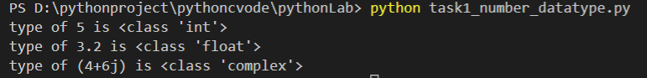

**Program:**

#Taking two inputs from user

first_number=int(input("enter first number:"))

second_number=int(input("enter second number:"))

#Addition

sum=first_number+second_number

print(f"sum of {first_number} and {second_number} is ",sum)

#Substarction

sub=first_number-second_number

print(f"substraction of {first_number} and {second_number} is",sub)

#Multiplication

mul=first_number*second_number

print(f"multiplication of {first_number} and {second_number} is",mul)

#Division

division = first_number/second_number

print(f"division of {first_number} and {second_number} is", division)

#Floor division

fdivision=first_number//second_number

print(f"floor division of {first_number} and {second_number} is ",fdivision)

#Power

power=first_number**second_number

print(f"power of {first_number} of {second_number} is ",power)

**Screenshot:**

|  |  |  |
| --- | --- | --- |
| http://www.ctgroup.in/images/audi/cell/CT%20Logo%20Final.png | **CT Group of Institutions, Maqsudan** | |
| **Experiment Title: Write a program to perform different Arithmetic Operations on numbers in Python.** | |
| **Laboratory: Python Lab ( BTCS 513-18 )** | **Department: B.TECH CSE** |
| **Experiment No: 2** | **Semester: 5th** | **Page: 01** |

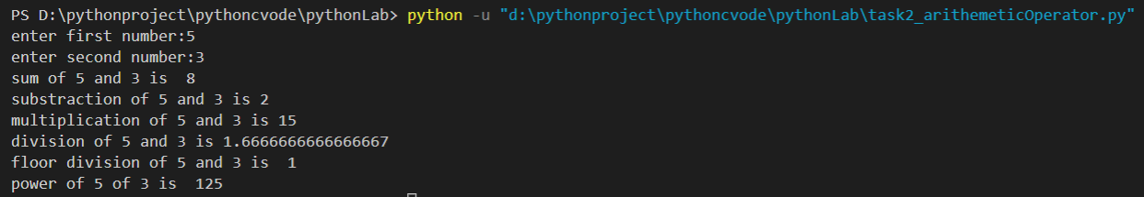

|  |  |  |
| --- | --- | --- |
| http://www.ctgroup.in/images/audi/cell/CT%20Logo%20Final.png | **CT Group of Institutions, Maqsudan** | |
| **Experiment Title: Write a program to create, concatenate and print a string and accessing sub-string from a given string**. | |
| **Laboratory: Python Lab ( BTCS 513-18 )** | **Department: B.TECH CSE** |
| **Experiment No: 3** | **Semester: 5th** | **Page: 01** |

**Program:**

**#**string creating

first_name="Ankush"

last_name="Kumar"

#concatenation strings

full_name=first_name+" "+last_name

#print after concatenation strings

print(full_name)

#Accesing sub string from strings

college_name="ct group of institutions"

print(college_name[0:4])

print(college_name[0:5:2])

print(college_name[0::2])

print(college_name[:5:-1])

**Screenshot:**

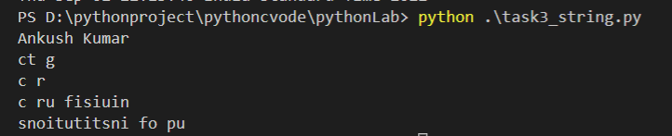

|  |  |  |
| --- | --- | --- |
| http://www.ctgroup.in/images/audi/cell/CT%20Logo%20Final.png | **CT Group of Institutions, Maqsudan** | |
| **Experiment Title: Write a python script to print the current date in the following format “Sun May 29 02:26:23 IST 2017”**. | |
| **Laboratory: Python Lab ( BTCS 513-18 )** | **Department: B.TECH CSE** |
| **Experiment No: 4** | **Semester: 5th** | **Page: 01** |

**Program:**

import time

current_time=time.localtime()

print(time.strftime("%a %b %d %H:%M:%S %Z %Y",current_time))

**Screenshot:**



|  |  |  |
| --- | --- | --- |
| http://www.ctgroup.in/images/audi/cell/CT%20Logo%20Final.png | **CT Group of Institutions, Maqsudan** | |
| **Experiment Title: Write a program to create, append, and remove lists in python.** | |
| **Laboratory: Python Lab ( BTCS 513-18 )** | **Department: B.TECH CSE** |
| **Experiment No: 5** | **Semester: 5th** | **Page: 01** |

**Program:**

#create list of number type

number=[1,5,7.5,11]

# a list of string type

words=['os','python','dbms','flat']

#a list of mixed type

mixed=['mathe',1,"datastructure",2]

#append method

subjects=["Flat","Software Engineering","Math","Computer Network"]

subjects.append("Python")

subjects.append("DBMS")

print("after appending ",subjects)

#remove method

subjects.remove("Math")

print("after romoving math from sujects:\n", subjects)

#append a list into new empty list

new_subject = []

print("Initial element in new subject",new_subject)

for suject in subjects:

    new_subject.append(suject)

print("after appending subjects into new subject list:\n",new_subject)

**Screenshot:**

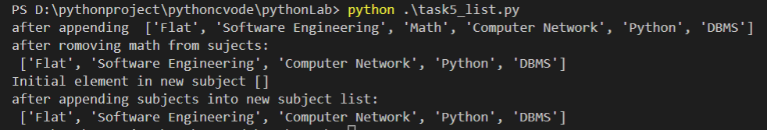

|  |  |  |
| --- | --- | --- |
| http://www.ctgroup.in/images/audi/cell/CT%20Logo%20Final.png | **CT Group of Institutions, Maqsudan** | |
| **Experiment Title: Write a program to demonstrate working with tuples in python.** | |
| **Laboratory: Python Lab ( BTCS 513-18 )** | **Department: B.TECH CSE** |
| **Experiment No: 6** | **Semester: 5th** | **Page: 01** |

**Program:**

days=('sunday','monday','tuesday','wednesday','thrusday','friday','saturday')

#tuple unpacking -->we need same amout of variables as tuples have

day1,day2,day3,day4,day5,day6,day7=(days)

print("day one is",day1)

#tuple slicing

print(days[:2])

#tuple with one element

names=('karina',)

print(type(names))

#tuples without parenthesis

nums='one','two','three'

print("type of nums is",type(nums))

#min,max and sum method in tuples

grades=(2,5.6,7.5,4,8)

print("minimum gade is",min(grades))

print("maximum grade is",max(grades))

print("total grades are",sum(grades))

#loop in tuple

for i in grades:

    if i>7:

        break

    print(i)

**Screenshot:**

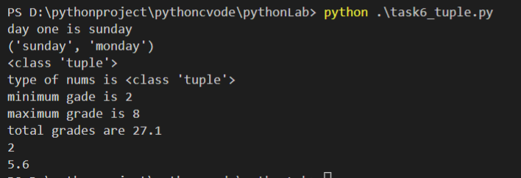

|  |  |  |
| --- | --- | --- |
| http://www.ctgroup.in/images/audi/cell/CT%20Logo%20Final.png | **CT Group of Institutions, Maqsudan** | |
| **Experiment Title: Write a program to demonstrate working with dictionaries in python.** | |
| **Laboratory: Python Lab ( BTCS 513-18 )** | **Department: B.TECH CSE** |
| **Experiment No: 7** | **Semester: 5th** | **Page: 01** |

**Program:**

**student_detail={ "name":"karina", "age":20,  "rollno":2021,  "hobie":"study", "favperson":"ankush","favbook":"os"**

**}**

**#Accessing value**

**print("fav person is",student_detail["favperson"]**

**#displaying all key value pair**

**for i in student_detail:**

**print(i)**

**#add new key value pair in dictonary**

**student_detail['contact']=7973742809**

**print(student_detail)**

**#update dictionary**

**student_detail["age"]=19**

**print(student_detail)**

**#remove key value pair from dictionary**

**student_detail.pop("favbook")**

**print(student_detail)**

**#length of dictionary**

**print("length of dictionary is",len(student_detail))**

**#copy a dictionay**

**karina_detail=student_detail.copy()**

**print("karina's detail",karina_detail)**

**#delete dictonary**

**student_detail.clear()**

**print(student_detail)**

**Screenshot:**

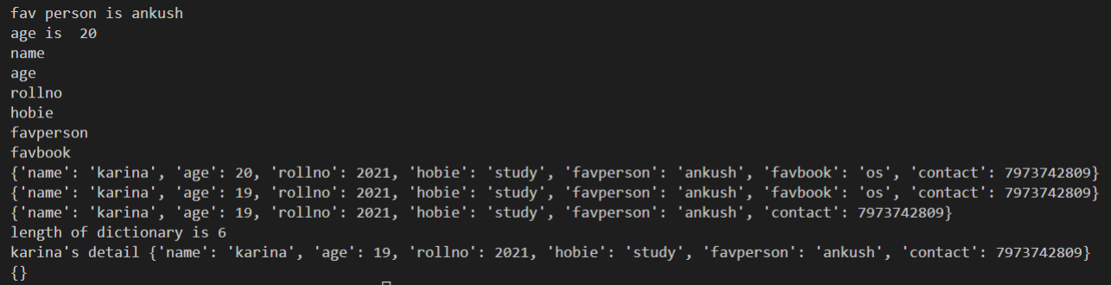

|  |  |  |
| --- | --- | --- |
| http://www.ctgroup.in/images/audi/cell/CT%20Logo%20Final.png | **CT Group of Institutions, Maqsudan** | |
| **Experiment Title: Write a python program to find largest of three numbers**. | |
| **Laboratory: Python Lab ( BTCS 513-18 )** | **Department: B.TECH CSE** |
| **Experiment No: 8** | **Semester: 5th** | **Page: 01** |

**Program:**

a=int(input("enter 1st number"))

b=int(input("enter 2nd number"))

c=int(input("enter 3rd number"))

max=a

if b>max:

    max=b

if c>max:

    max=c

print(max)

**Screenshot:**

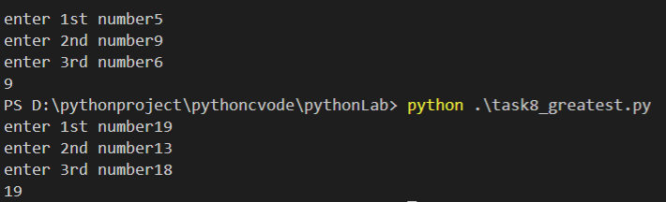

|  |  |  |
| --- | --- | --- |
| http://www.ctgroup.in/images/audi/cell/CT%20Logo%20Final.png | **CT Group of Institutions, Maqsudan** | |
| **Experiment Title: Write a Python program to convert temperatures to and from Celsius, Fahrenheit.** | |
| **Laboratory: Python Lab ( BTCS 513-18 )** | **Department: B.TECH CSE** |
| **Experiment No: 9** | **Semester: 5th** | **Page: 01** |

**Program:**

print("enter 1 for Celsius to f and 2 for fehrenheit to celsius")

over=False

#celsius to fahrenheit

while(over!=True):

    temp = input("enter your choice:")

#Celsius to Fahernheit

    if temp=="1":

        cel=int(input("enter tempreture in celsius:"))

        fah=(cel*9/5)+32

        print("tempretures in fahernheit is",fah)

        over=True

    #fahrenheit to celsius

    elif temp=="2":

        fah =int(input("enter temperature in fahrenheit:"))

        cel=(fah-32)*5/9

        print("Tempretures in celsius is",cel)

        over = True

    else:

        print("Please,enter valid choice")

        over = False

**Screenshot:**

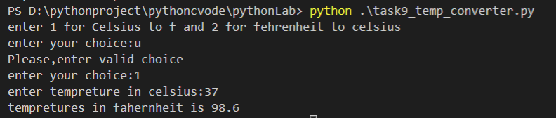

|  |  |  |
| --- | --- | --- |
| http://www.ctgroup.in/images/audi/cell/CT%20Logo%20Final.png | **CT Group of Institutions, Maqsudan** | |
| **Experiment Title: Write a Python program to construct the following pattern, using a nested for loop** | |
| **Laboratory: Python Lab ( BTCS 513-18 )** | **Department: B.TECH CSE** |
| **Experiment No: 10** | **Semester: 5th** | **Page: 01** |

**Program:**

n=5

#print first 5 * in increasing order

for i in range(n+1):

    print(i*"*")

#print * 6 to 10 in decreasing order

for i in range(n,0,-1):

    print(i*"*")

**Screenshot:**

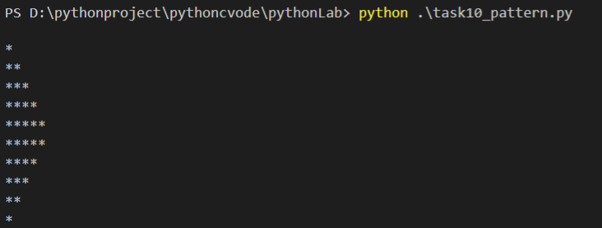

|  |  |  |
| --- | --- | --- |
| http://www.ctgroup.in/images/audi/cell/CT%20Logo%20Final.png | **CT Group of Institutions, Maqsudan** | |
| **Experiment Title: Write a Python script that prints prime numbers less than 20.** | |
| **Laboratory: Python Lab ( BTCS 513-18 )** | **Department: B.TECH CSE** |
| **Experiment No: 11** | **Semester: 5th** | **Page: 01** |

**Program:**

rang=20

print("primes number less than 20 are:")

for num in range(rang):

    if num>1:

        for i in range(2,num):

            if(num%i)==0:

                break

        else:

            print(num)

**Screenshot:**

