**Problem Statement**

- This program is a simple implementation of a customer management system with three types of customers: Regular, Premium, and an abstract base class Customer.

- The program generates and assigns unique customer IDs, calculates and applies discounts for Regular customers, and calculates loyalty points for Premium customers.

**Class Diagram**

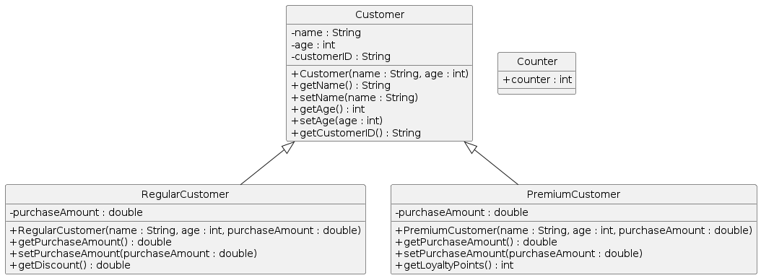

<Insert Class Diagram Image>

**Model Class Documentation**

**Class Name: Customer**

**generateCustomerID()**

- This method automatically generates and sets the customerID for each instance of Customer.

- It does this by taking the first character of the customer's name, concatenating it with the customer's age, and then finally with the counter value from the Counter class.

- This way, each customer gets a unique ID.

**Class Name: RegularCustomer**

**getDiscount()**

- This method calculates and returns the discount for the Regular customer based on their purchase amount.

- If the purchase amount is greater than the DISCOUNT\_THRESHOLD, the discount is equal to the DISCOUNT\_RATE multiplied by the purchase amount. Otherwise, the method returns a discount of 0.

**Class Name: Counter**

**counter**

- This is a static variable used to generate unique customer IDs for each customer.

- It increments each time a new customer is created, ensuring the uniqueness of the customer ID.

**Main Class Documentation**

**main()**

- The main method creates instances of RegularCustomer and PremiumCustomer, initializes them with required attributes, and outputs the following:

- The customer's name, age, ID, and purchase amount.

- The discount for the Regular customer or the loyalty points for the Premium customer.

- This method demonstrates the functionality of the RegularCustomer and PremiumCustomer classes, specifically the calculateDiscount() and calculateLoyaltyPoints() methods.