**CAR RENTAL SYSTEM**

Through this project I’m trying to solve the problem for those who wants to buy their new car but due to certain reasons they are unable to do this or they are travelling and want to drive their own car. In this project we have a login form through which the details of the customers will be stored in a database. Then after this according to their comfort the customer can choose the which ever car he wants to drive. The prices of the rented car may vary. Once the person have booked the car he have to book it for a particular period of time like 2 hrs or for a day and after that he have to return it within a fixed amount of time. Through this the one’s who travelled from state to state can get their own car in a reasonable rate.

Home Page

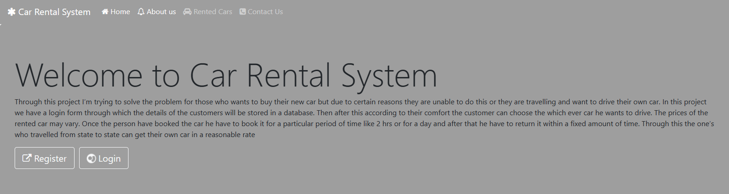

Register

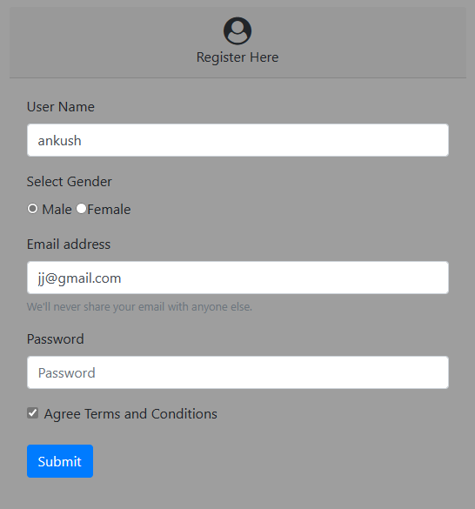

Login

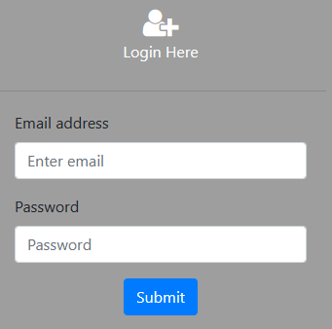

Main page

