AIVORA
Language Model
A 101.7M-parameter DeepSeek-V3-architecture model trained from scratch for financial text
Model Technical Documentation
Version 1.0 · 5 October 2026 · Companion to Aivora_Technical_Documentation.docx

This document reports what the model does, including where it fails. Every number is measured on a frozen held-out set the model was never trained on and never selected against. Capability is never reported from training loss.

1. Overview
The Aivora model is a decoder-only transformer of 101.7M parameters, written from scratch in this repository and following the DeepSeek-V3 architecture: a Mixture-of-Experts feed-forward network, Multi-head Latent Attention, and a Multi-Token Prediction auxiliary head. It was pre-trained on financial text and then supervised fine-tuned for extraction and question answering.
It is a research model. Within the Aivora application it is used for generation only; it is never trusted with arithmetic, and no figure it produces is shown to a user without validation against the source document. Section 7 reports the measurements that led to that decision.

1.1 Specification
Property | Value
Architecture | DeepSeek-V3 style decoder-only transformer
Total parameters | 101.72M
Layers | 8
Hidden size | 512
Attention heads | 8
Context length | 1,024 tokens
Vocabulary | 50,257 (GPT-2 BPE via tiktoken)
Experts | 8 routed, top-2 per token, plus 1 always-active shared expert
Expert intermediate size | 512 (routed), 768 (shared)
KV LoRA rank | 128
Query LoRA rank | 192
RoPE dimensions | 32
MTP heads | 1, auxiliary loss weight 0.3
Dropout | 0.1
Precision | float32, CPU and CUDA

1.2 Parameter Distribution
Component | Parameters | Share
Transformer blocks (8) | 66.61M | 65.5%
Token embeddings | 25.73M | 25.3%
Multi-Token Prediction head | 8.85M | 8.7%
Position embeddings | 0.52M | 0.5%
Final layer norm | < 0.01M | ~0%
Total | 101.72M | 100%

A quarter of the model is its vocabulary embedding. At this scale the 50,257-token GPT-2 vocabulary is a substantial fixed cost, and the MTP head is a further 8.7% that serves training rather than inference. (measured)

2. Architecture
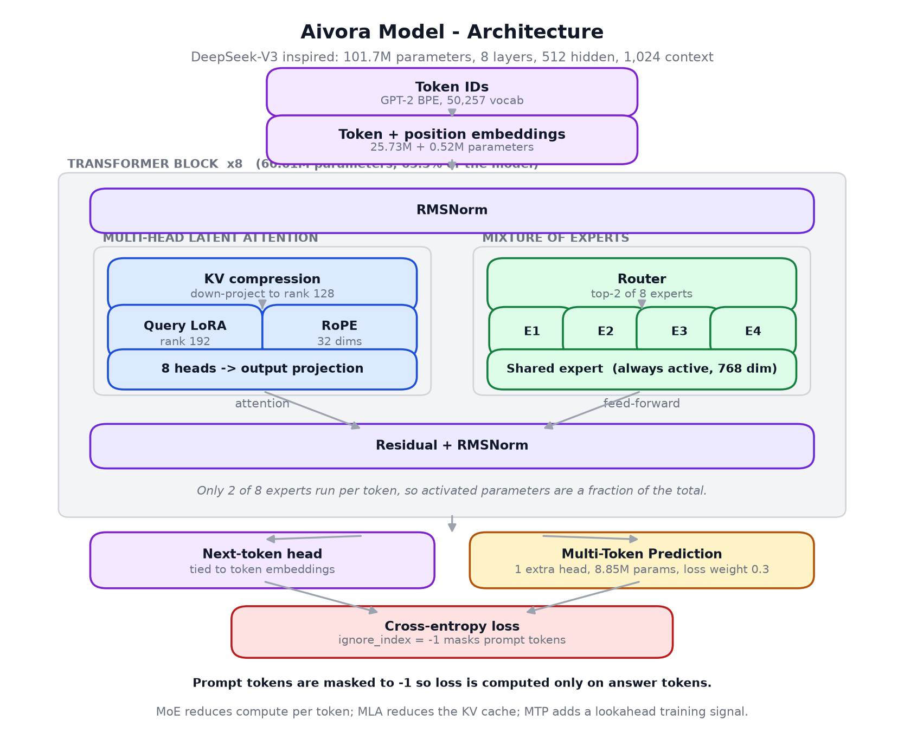
Figure 1. Model architecture. Attention and feed-forward paths within one of eight transformer blocks.

2.1 Multi-head Latent Attention
Standard attention caches a key and value vector per head per token. MLA instead projects keys and values into a shared low-rank latent space - rank 128 here - and caches that, reconstructing per-head keys and values on use. Queries carry their own low-rank projection at rank 192, and 32 dimensions carry rotary position encoding separately from the compressed path. The purpose is a smaller KV cache at long context for a small accuracy cost.

2.2 Mixture of Experts
Each block's feed-forward network is eight expert networks plus one shared expert. A router scores the experts per token and the top two run; the shared expert always runs, giving every token a common pathway so the routed experts can specialise. Total parameters therefore exceed activated parameters: most of the feed-forward capacity is idle for any given token.
Auxiliary load-balancing loss weight is set to 0.0 in this configuration, so expert balance is not actively encouraged. Whether routing collapsed onto a subset of experts has not been measured. (unverified)

2.3 Multi-Token Prediction
One additional head predicts a second future token, contributing to the loss at weight 0.3. The intent is a denser training signal per position. The head is 8.85M parameters and is used in training only.

2.4 Objective and Prompt Masking
Loss is cross-entropy over answer tokens only. Prompt tokens are set to the ignore index so the model is not rewarded for reproducing the question. The ignore index is -1, matching the value passed to the loss function; a mismatch here silently trains on prompt tokens and is not visible in the loss curve.
IGNORE_INDEX = -1
PROMPT_TEMPLATE = "Question: {prompt}\nAnswer:"
loss = F.cross_entropy(logits, targets, ignore_index=-1)

3. Training Data
Pre-training used financial text - filings, financial QA sets, instruction data and general web text - tokenised with the GPT-2 BPE vocabulary and packed into 1,024-token sequences with document separators so unrelated documents do not bleed across a boundary.
Property | Value
Unique training tokens | 120,857,129
Epochs | 16.3
Total tokens processed | ~1.97B (unique tokens x epochs)
Token / parameter ratio | 1.19
Compute-optimal ratio (Chinchilla) | ~20
Fraction of compute-optimal data | ~6%

This is the single most important fact about the model. It saw about 6% of the data a 101.7M-parameter model needs, repeated 16 times. Repetition is not a substitute for breadth, and no amount of fine-tuning recovers pre-training the model never had.

4. Training Pipeline
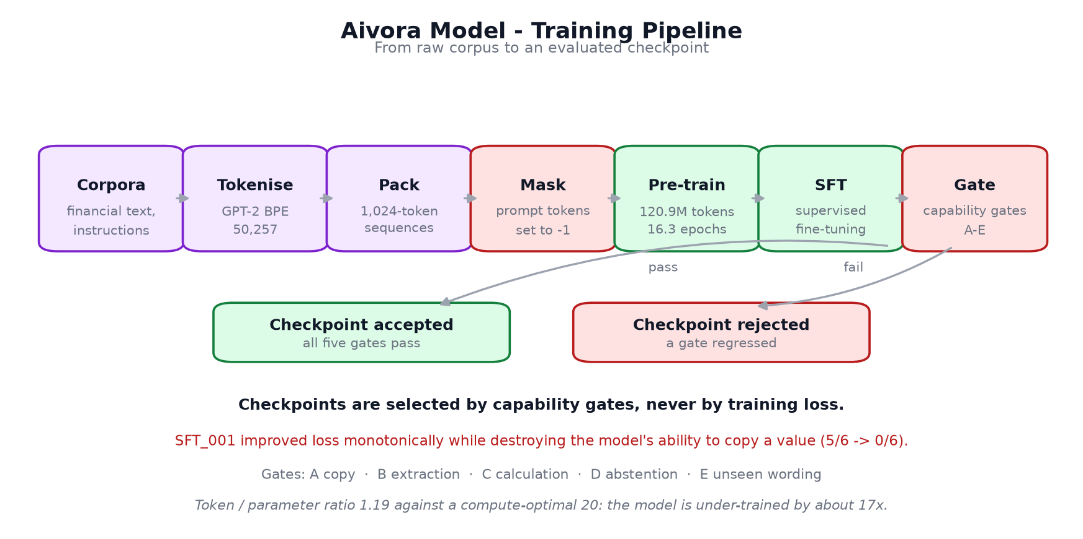
Figure 2. Training pipeline, from corpus to an accepted checkpoint.

4.1 Checkpoint Selection by Capability Gate
Checkpoints are accepted on measured capability, never on training loss. Five gates run against probes the model has not been trained on:
Gate | Tests
A - Copy | Reproducing a literal value present in the prompt
B - Extraction | Returning the value for a named field
C - Calculation | Producing a correct arithmetic result
D - Abstention | Refusing when the information is absent
E - Unseen wording | Extraction under labels not seen in training

4.2 SFT_001 - A Documented Failure
The first supervised fine-tuning run improved training loss monotonically and destroyed the model's ability to copy: gate A fell from 5/6 to 0/6. Loss would have accepted this checkpoint. The causes were measured, not guessed:
- Extraction examples were 30% of rows but only 10% of answer tokens, so the objective barely saw them.
- 956 rows shared just 13 distinct answer strings, teaching the model to emit a small set of fixed replies.
- Early stopping was driven by loss rather than by capability.
SFT_002 was built to correct exactly these defects - answer-token balancing, a distinct-answer entropy floor, and gate-based stopping - and passed all five gates. The dataset builder now refuses to write a dataset that repeats the SFT_001 defect.
A loss curve is not a capability measurement. This was the most expensive lesson in the project and the reason gates exist.

5. Evaluation Methodology
The model is measured against a frozen held-out set that it was never trained on and never selected against. The rules were pre-registered before any system was scored.
Property | Value
Frozen set size | 313 items
Hand-written items | 125
Generated items | 188
Copy / Extraction / Wording | 69 / 69 / 75
Calculation / Abstention | 48 / 52
Selection split | 61 items, used only to choose a configuration
Contamination control | Exact match plus 8-gram overlap removal against 5 training files
Seed | 424242
Integrity check | Content hash over parsed items in canonical order, verified on every scored run

- One shared scorer for every system, so no system is judged by its own standard.
- Identical prompts and decoding across systems; the only variable is the system.
- The frozen set is scored once per configuration, and raw outputs are preserved so a scorer correction can be applied without re-running a model.
- Wilson intervals for single scores; the exact McNemar test for two systems on identical items.
- Over-refusal is reported separately from abstention accuracy, because abstention alone would reward a system that refuses everything.

6. Measured Results
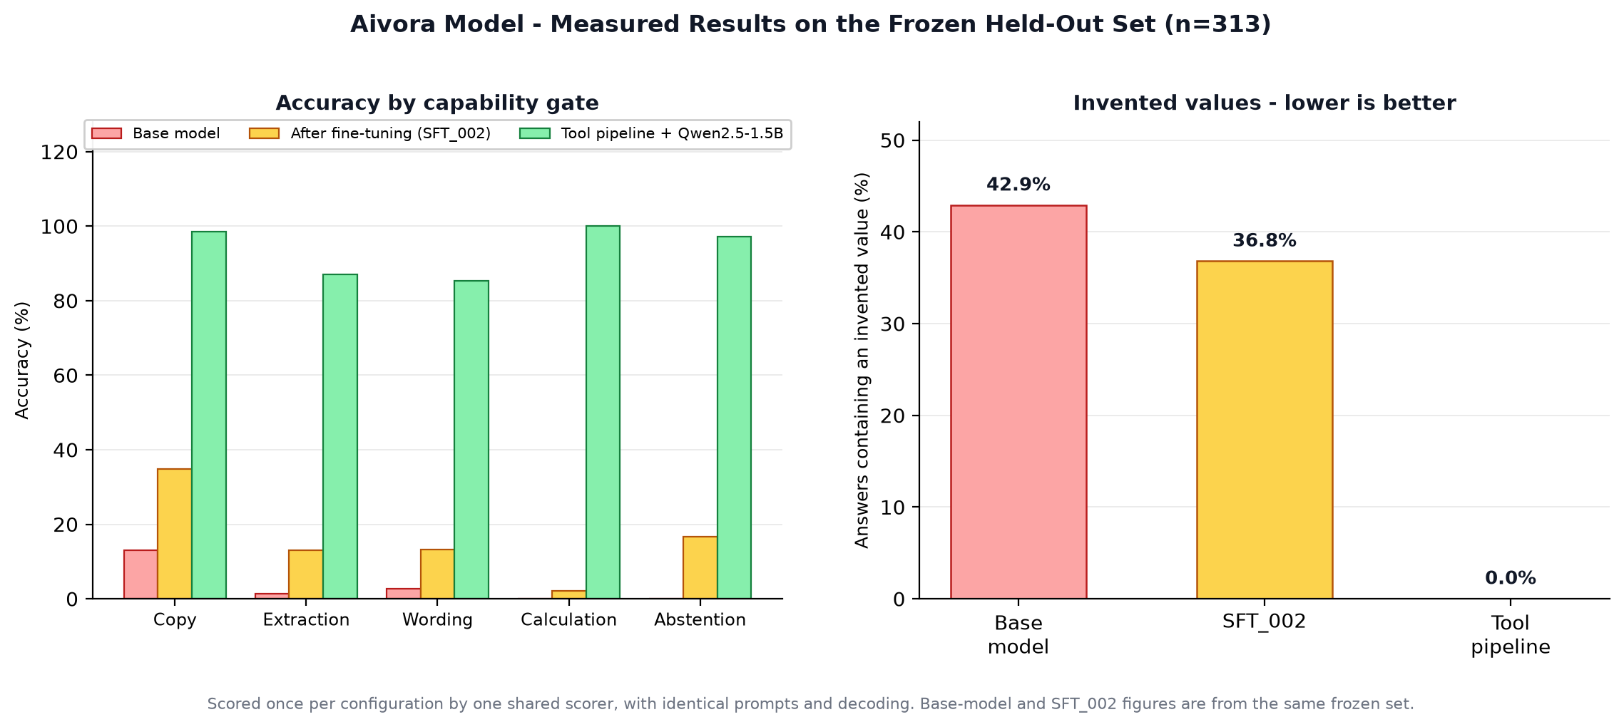
Figure 3. Accuracy by capability gate, and the rate of invented values.
Gate | Base model | SFT_002 | Tool pipeline + Qwen2.5-1.5B
Copy | 13.0% | 34.8% | 98.6%
Extraction | 1.4% | 13.0% | 87.0%
Wording | 2.7% | 13.3% | 85.3%
Calculation | 0.0% | 2.1% | 100%
Abstention | 0.0% | 16.7% | 97.2%
Invented values | 42.9% | 36.8% | 0.0%

6.1 Paired Comparisons
Exact McNemar tests on identical items. (measured)
Comparison | Better | Worse | p
SFT_002 vs base model | 10 | 0 | 0.0020
SmolLM2-135M vs SFT_002 | 14 | 4 | 0.0309
Tool pipeline vs SFT_002 | 44 | 0 | < 0.0001

6.2 The Parameter-Matched Result
SmolLM2-135M-Instruct has 135M parameters against this model's 101.7M. On identical items the pre-trained model wins (p = 0.0309). With size approximately held constant, the gap does not come from capacity - it comes from pre-training data. The model is under-trained, not undersized, and that distinction determines what would actually fix it. (measured)

7. Capabilities and Limitations

7.1 What the model does adequately
- Produces fluent, well-formed financial prose.
- Follows the chat template it was fine-tuned on.
- Copies a short literal value from a prompt in about a third of cases after SFT_002.

7.2 What it does not do
- Reliable extraction. 13.0% on the frozen set after fine-tuning.
- Arithmetic of any kind. 2.1% on calculation. It is never asked to compute in production.
- Structured output. Asked for a JSON object, it returns prose: measured on 5 October 2026 it answered "Revenue = $5,200,000 - the EBIT entry." for a context stating $10,000,000 - an invented figure in an unparseable format.
- Abstention. Left to itself it invents a value on 36.8% of answerable items rather than declining.
Deployment rule. This model must not be used to state a financial figure without external validation. In the Aivora application the span-validation layer makes that structurally impossible: the invented $5,200,000 above was blocked and became an abstention.

7.3 Defects found and corrected during development
Defect | Effect | Resolution
Repetition detector counted prompt tokens | Killed 76.7% of greedy answers after 2-3 tokens | Window restricted to generated tokens
Thousands separators split on the comma | "4,532.00" parsed as 4 and 532.0; large figures understated | Whole-token numeric parsing
Abstention markers missed real refusal wording | Honest refusals scored as hallucinations | Markers extended; SFT data aligned to production wording
Loss-based early stopping | Accepted SFT_001, which had lost the ability to copy | Capability gates A-E
Byte-level eval-set hash | Platform-dependent; raised a false alarm and could not detect real change | Content hash over parsed items

8. Checkpoints
Checkpoint | Stage | Status
checkpoints/final/checkpoint_247850.pt | Pre-trained base | Frozen baseline, tagged AIVORA_PRE_TRAINING_BASELINE
checkpoints/sft_001/ | First SFT attempt | Rejected - gate A fell from 5/6 to 0/6
checkpoints/sft_002/ | Corrected SFT | Accepted - passed all five gates
checkpoints/sft_003/ | Third SFT run | Loaded by the application by default

All checkpoints and their evaluation outputs are preserved, including the failed run. A failed experiment that is deleted has to be repeated.

9. Loading and Running the Model
from models import DeepSeekConfig, DeepSeekV3
import torch
model = DeepSeekV3(DeepSeekConfig.default())
state = torch.load('checkpoints/sft_002/sft_002_best.pt',
map_location='cpu')
model.load_state_dict(state.get('model_state_dict', state))
model.eval()
Greedy decoding, as used for every evaluation in this document:
out = model.generate(ids, max_new_tokens=160, temperature=1e-5,
top_k=1, stop_on_repetition=True,
eos_token_id=enc.eot_token)
Hardware: runs on CPU in roughly 4 GB of RAM. No GPU required for inference.

10. Recommendations
- Do not continue fine-tuning this checkpoint for extraction accuracy. The parameter-matched comparison in section 6.2 shows the limit is pre-training data, and fine-tuning does not add pre-training.
- Keep the model for generation and the tool pipeline for anything numeric. This is what the application already does.
- If a from-scratch model remains a goal, the binding constraint is the token budget: approximately 2B unique tokens would be needed to reach a compute-optimal ratio at this parameter count, against 120.9M today.
- Retain gate-based checkpoint selection. It caught a regression that loss endorsed.
- Commission a fresh held-out set before any further capability claim. Four defects have been found in the current one, and three of them were authored by the same process that measures against it.

11. Glossary
Term | Definition
MoE | Mixture of Experts. Several feed-forward networks per layer with a router selecting a subset per token.
MLA | Multi-head Latent Attention. Keys and values compressed into a shared low-rank space to shrink the cache.
MTP | Multi-Token Prediction. An auxiliary head predicting a further future token during training.
RoPE | Rotary Position Embedding, applied to a subset of dimensions.
BPE | Byte Pair Encoding. The GPT-2 subword vocabulary, 50,257 tokens.
Prompt masking | Setting prompt token targets to the ignore index so loss is computed only on answer tokens.
Token / parameter ratio | Unique training tokens divided by parameters. Approximately 20 is compute-optimal; this model is at 1.19.
Capability gate | A pass/fail behavioural test used to accept or reject a checkpoint, replacing loss-based selection.
SFT | Supervised Fine-Tuning on prompt and answer pairs.
Frozen set | Held-out evaluation items, never trained on and never used for selection.
Invented value | A number in an answer that does not appear in the source. The headline safety metric.
Over-refusal | Declining a question the source does answer.
McNemar test | An exact paired test for two systems measured on identical items.
Wilson interval | A confidence interval for a proportion, reliable at small n and near 0% or 100%.

